**Final Project: Deep Learning from Scratch**

In this project we will implement a simple neural network for classification of small vectors.

Write code for computing the objective loss function “soft-max” and its gradient with respect to wj and the biases. Make sure that the derivatives are correct using the gradient test. You should submit the results of the gradient test.

**Question 1- Softmax**

In this question we should write the code for computing the objective loss function “soft-max” and its gradient with respect to given wj and the biases.

The code is in the provided files.

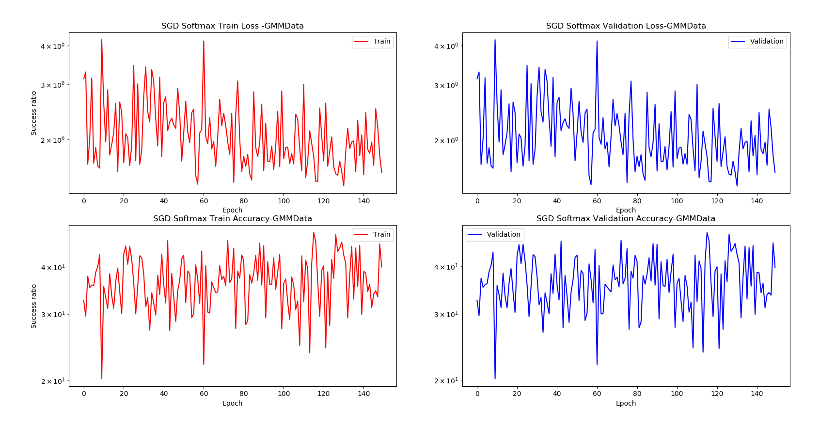The results:

For the GMM data we get an average of about 40% accuracy on the train/validation data.

The gradient test results:

For x:

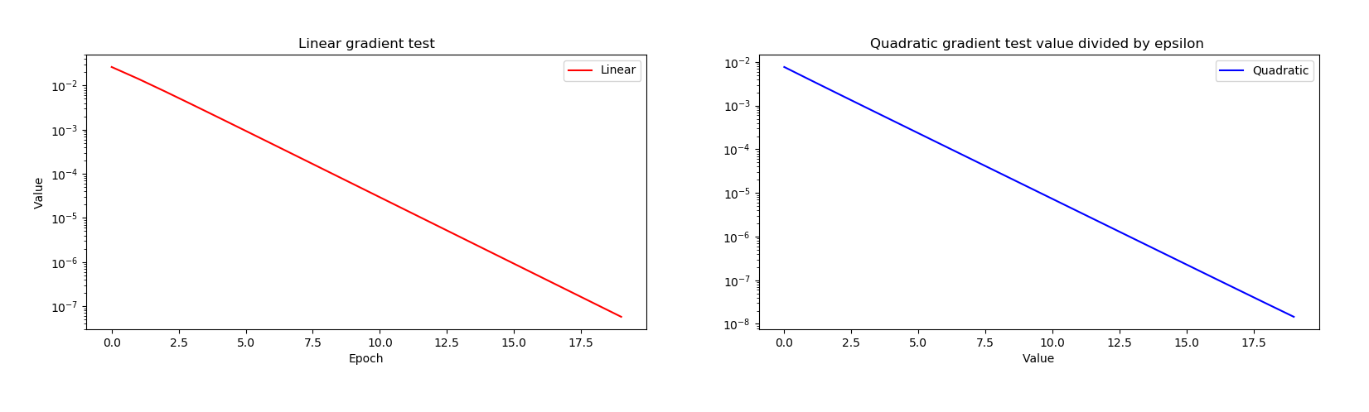

For W:

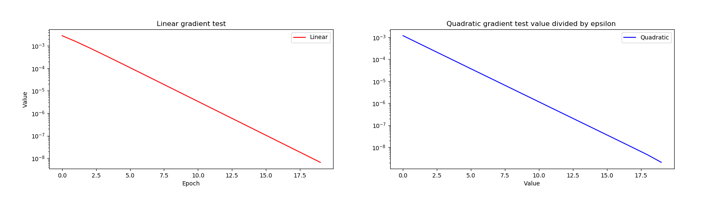

For b:

