

Lora final delivery report

Copyright

NSLComm Ltd

Kineret 12, Airport City

POB: 1033

ISRAEL

VAT Number: 515229169

*Notice*

The content of this document is subject of copyright of NSLComm. Therefore, this document shall not be disclosed to any third party without the prior written approval of NSLComm.

**Approval signatures**

|  |  |  |  |
| --- | --- | --- | --- |
|  | Name | Date | Signed |
| **Author** | Gilad Danin | 17/07/23 |  |
| **Reviewers** |  |  |  |
| **Ext. Reviewers** |  |  |  |
| **Approved** |  |  |  |

**Document control**

|  |  |  |  |  |
| --- | --- | --- | --- | --- |
| Rev | Date | Section | Description of change | Reason for change |
| 1.0.0 |  |  |  |  |
|  |  |  |  |  |

**Related documents**

|  |  |  |
| --- | --- | --- |
| No. | Document name | Document reference |
|  |  |  |
|  |  |  |
|  |  |  |
|  |  |  |

Contents

1. Scope 5

2. Glossary 6

3. Chapter 7

3.1. Sub Chapter Section 7

3.2. Chapter 7

3.3. Table 8

List of Figures:

Figure 1-Satellite 8

List of Tables:

Table 1-Table Example 9

# Scope

# Glossary

Each document shall include a table of glossary terms:

|  |  |
| --- | --- |
| Acronyms | |
| Term | Definition |
| SF | Spreading Factor |
| BW | Band Width |
| PER | Packet error rate |
| AFC | Automatic Frequency Control |

# Development History

# Lab Evaluation

## Tests portfolio

At the core of test portfolio lies the signal bandwidth and the encoding spreading factor.

|  |  |
| --- | --- |
| Demand | remark |
| BW - 125,500,500 [KHz] |  |
| SR – 8,10,11 |  |
| Message length - short(16), long(64) |  |
| Fc - 2.2,2.25,2.3[GHz] |  |
| AFC – on ,off |  |
| Low Data Rate Optimizer – on, off |  |
| Dopler |  |
| BW-err - 25% |  |
| Packet format – explicit, implicit |  |

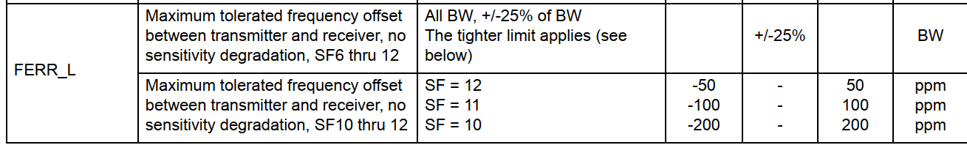

## Packet structure:

preamble, explicit\implicit header, crc, low_data_rate_optimizer, sync_word

## Setup

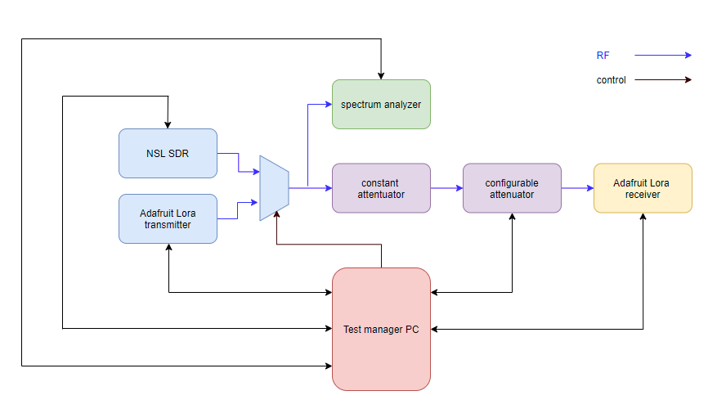

Figure 1: Lab setup

### RF path

RF signal can be generated from two sources:

* NSL SDR which is the DUT
* Adafruit Lora transmitter serves as a reference source for evaluating the DUT performance.

Signal is attenuated by two consecutive stages:

* A constant, TBD attenuator
* A mini circuits RCDAT-6000-90 configurable attenuator:
  1. resolution of 0.25dB
  2. Dynamic range of 0-90dB

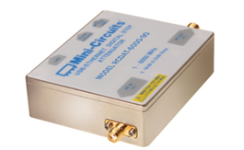

Then it is applied to the Adafruit Lora M0 RFM95 LoRa Radio receiver:

* Based on Semtec SX1276 Lora transceiver.
* Embeds an Arduino controller.

Remark:

The same board is used as a reference transmitter.

In parallel, pre-attenuated signal is injected into a spectrum analyzer for power measurements.

### Control path

The setup is managed by a single, test manager PC whose tasks are:

* Manage all controllable devices.
* Run the tests.

Control is done via serial (UART) or LAN connections.

## Test flow

Main principles lead for the test flow design were:

* For each tested configuration, gain receiving sensitivity at various PER levels, as many as possible.
* Maintain a reasonable testing duration.

Elaborating the term “reasonable testing duration” one must consider that, for maintaining a certain PER level, the total number of received packets should be larger by at least one order. For example, for measuring a true PER of 1e-3 at least 1e4 packets should be received. Considering that the packet rate is around 1 packet/sec, we get to more than 3 hours for a single iteration!

Thus, the following steps were taken:

* Limit the PER scale to 1e-3.
* For reaching test working point use:
  + Accumulated knowledge on system behavior from previous stages
  + Use relatively large (coarse) attenuation steps in the search stage.

Figure 2: Test flow main state machine

The test flow is handled by a principle state machine, described briefly herein:

### Init

* Creating symbols files (currently done off line, see TBD)
* Verify connection with all controllable devices.
* Get the attenuation level such that no bad frames are detected for the least evaluated robust mode, SF = 8. This level, $L_{base}$, is the base line for all tests.

The algorithm for finding :

Figure 3: Finding base attenuation level

Parameters used for this stage are:

* $L_{coasre}$ = 1 dB
* $T_{wp}$ = 10 sec
* $L_{margine}$ = 3 dB

Remark:

The search for the base attenuation level is performed once per HW setup and saved. Later runs uses the saved $L_{base}$

### Config test

* Spreading factor and band width parameters are configured.
* An adequate pre-defined symbols file is determined.

### Find working point

Figure 4: Finding working point

Parameters used for this stage are:

* $L_{coasre}$ = 1 dB
* $T_{wp}$ = 10 sec
* $L_{margine}$ = 3 dB

### Measure

Figure 5: Measurement process

Parameters used for this stage are:

* $L_{fine}$ = 0.25 dB
* $T_{wp}$ = 30 min

## Logging

For each test, a dedicated logger file should be maintained, for which the contents (per test state) are described:

### Config test

The test configuration should be printed at the top of the logger file.

### Find working point

* If process succeeded:

### “Find working point” succeeded with Wp = ….

* If process failed:

### “Find working point failed due to….”

### Measure

|  |  |  |  |
| --- | --- | --- | --- |
| L | N_good | N_bad | PER |
|  |  |  |  |
|  |  |  |  |
|  |  |  |  |

* “L_wp = [L_wp]”

“L_wp = Null”

# Space Evaluation

# Summary