Capstone Project Final Work – Best Culinary Neighbourhood

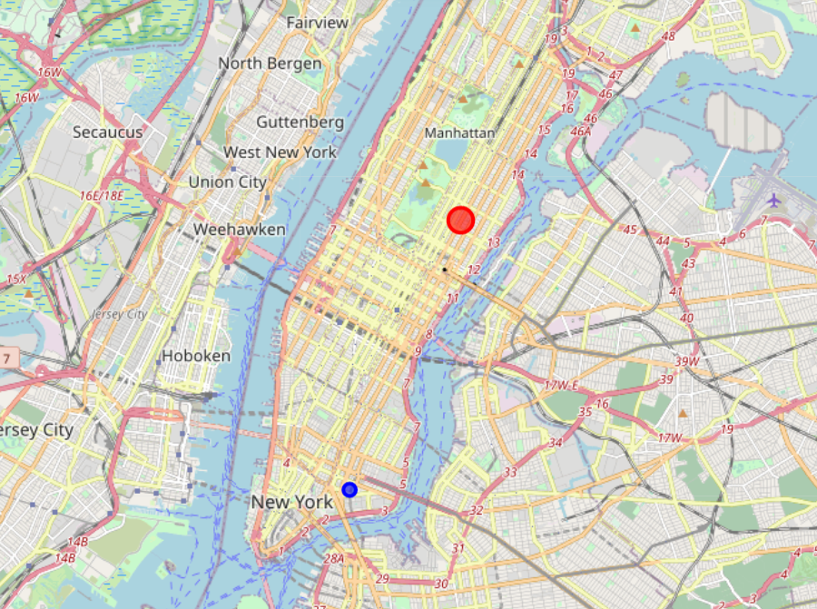

Gilad Goldenberg

27/08/20

# Introduction

Giving a data set of neighborhoods in NY or in any other place, this work examine every neighborhood separately for examine its culinary ‘abilities’.

# Data

This Work uses a basic data set of neighborhoods in NY to analyze it with Fourquare queries that gives the venues in each place and, ofcourse, details about these venues.

* 1. The Basic data set that this work uses for neighborhood analyze is: <https://cocl.us/new_york_dataset> which has its neighborhoods in addition to details about locations and borough name and so.
  2. The data about venues comes from Foursuqaure API with is called for every location separately.

# Method

* 1. Taking the NY data base from <https://cocl.us/new_york_dataset> as dictionary
  2. Creating a call for each neighborhood separately for restaurants in 500 meter radius using its location (latitude/longitude)
  3. Turning data into a panda’s data frame while avoiding neighborhoods that doesn’t have any venues in the json file received from foursquare. Now, each neighborhood has its data frame with its restaurant venues.
  4. Create a convenient data frame of venues for each neighborhood keeping only relevant.
  5. Adding neighborhood name to each data frame so we can use it in the final results. These data frames is saved as a data frame dictionaty of 59 data frames called: “dataframe_filtered”
  6. Now that we have a data frame for each neighborhood, we will call each venue in each data frame for its rating (if it has a rating value), if not, put ‘-1’ rating to the venue. Adding a new column for each data frame ‘rating’ that will contain the rating of the venues.
  7. Now, we will go thru all of the data frame, and look for the hneighborhiid with the highest rating score in average, and the neighborhood with the most resturands that have ratings which also says something about the culinary of the place.
  8. Present the two neighbothood on the map.
  9. Same process can be done on a dataset of neighborhoods of every city in the world !

# Results

The main result is the two neighborhoods:

4.1 The neighborhood with the highest rating score:

Upper east side

4.2 The neighborhood with the most ratings of restaurants venues:

China towm

4.3 The neighborhood on the map:

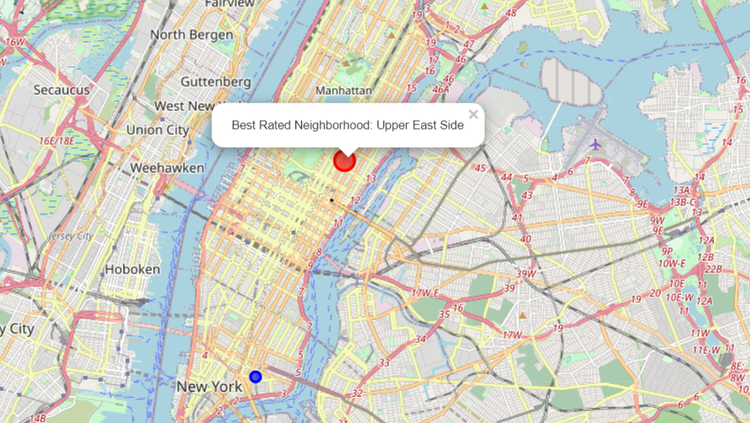

1. Discussions

We can see that the result for the ‘highest score’ for restaurants venues in a specific neighborhood can be iilusive because Upper East side neighborhood has only one venue that got a high rating

1. Conclusions

The work gives a traveler or people who want to live in a new city, a look on the top culinary places in the city. This can help them decide where is the best place to live/travel in the city.

Of course that this work can be implemented for every city in the world.

Also, we can change the venue type from restaurant to hotels/attractions or every type of venues for other people who interested in other things !