Two types of Inbox messages

74564: WCA Inbox Push Question: GU/OPT Japan

Requirements: create 2 type of rich inbox messages.
- News. Keep in inbox regardless if user clicks the simple notification when the message arrive or didn’t click the simple notification.
- Product: Keep in inbox, only if user clicks the simple notification when simple message arrives

In Engage -> Development -> Templates:
Modify/create a ‘Rich Inbox + additionalDevData’ example:

{
"id": 922,
"name": "Rich Inbox No Action-iFrame+devdata",
"type": "inbox",
"platforms": [
"ANDROID",
"IOS"
],
"label": "Inbox message",
"description": "Use to create an HTML message that can be accessed from the inbox in the app. Includes a short preview for the inbox.",
"payload": {
"template": "default",
"additionalDeveloperData": "News or Product...",
"content": {
"messagePreview": {
"subject": "${subject}",
"previewContent": "${preview}",
"additionalDevData": "${devdata}"
},
"messageDetails": {
"richContent": "${body}"
}
}
},
"sections": [{
"label": "Enter a title and a brief preview to display in the app inbox. Write something that entices the recipient to tap to open the full message.",
"customProperties": [{
"id": "${subject}",
"inputRequired": true,
"type": "string",
"placeholder": "Title",
"value": ""
},
{
"id": "${devdata}",
"inputRequired": true,
"type": "boolean",
"placeholder": "news/Product",
"value": true
},
{
"id": "${preview}",
"inputRequired": true,
"type": "string",
"placeholder": "Inbox preview",
"value": ""
}
]
},
{
"label": "Message",
"customProperties": [{
"id": "${body}",
"inputRequired": true,
"type": "htmlContent",
"placeholder": "HTML Content Block",
"value": null
}]
}
]
}

In Engage – when creating a notification select a rich inbox action:
- Select ‘Action- Show Inbox Notification’
- Select ‘Template’- Rich Inbox No Action – iFrame + devdata
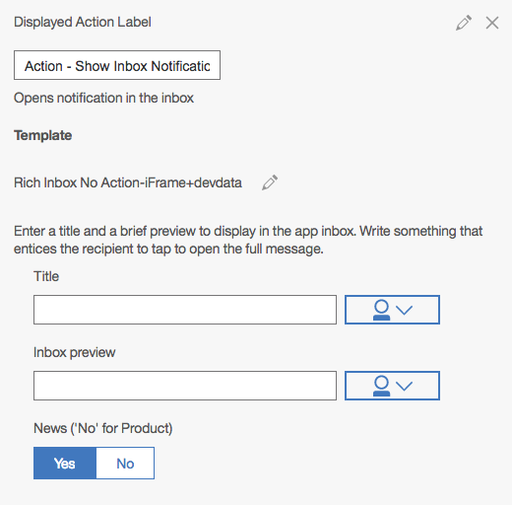
SDK Implementation
----------------------------
- Maintain an Array of inbox messages that need to be kept in inbox (user clicks these messages when they arrived). Keep that file in the app document folder.
Use this keep-message-array when checking if a message should be kept or removed.
- In Inbox MCEInboxActionPlugin Plugins:
In: MCEInboxActionPlugin.m:: showInboxMessage:(NSDictionary*)action payload:(NSDictionary*)payload method:
When a user clicks on the notification, add the rich message id to ‘keep-message-array’

- The remove of unwanted messages can be done either in:
MCEInboxActionPlugin Plugins:
In: MCEInboxActionPlugin.m::syncDatabase:(NSNotification*)notification
or in MCEInboxTableViewController::smartUpdateMessages:(NSMutableArray*)inboxMessages
Loop over all messages and remove the messages that are not in the ‘keep-message-array’.

