AIND

HEURISTIC ANALYSIS horizontal line

GIL AKOS // 17 JUNE 2017

# CUSTOM SCORE 1

*“Keep as many available moves open”*

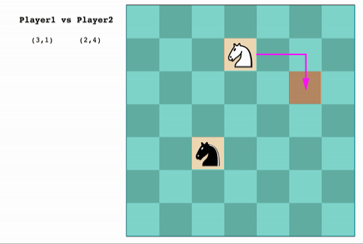

This heuristic optimizes for keeping available as many future moves as compared to the number of open positions on the board. It does not compare its moves to the opponents moves. If there are ten remaining spaces on the board, the best move will have left all ten spaces open for the player to choose.

# CUSTOM SCORE 2

*“Stay as far as possible away from opponent”*

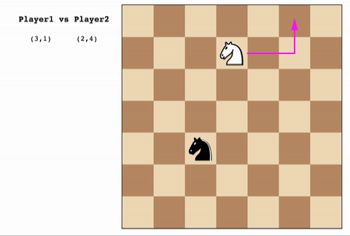

This heuristic optimizes for the maximum “Manhattan” distance in comparison to the opponent. This will generally push the player towards the farthest corner of the board.

# CUSTOM SCORE 3

*“Stay as close as possible to opponent”*

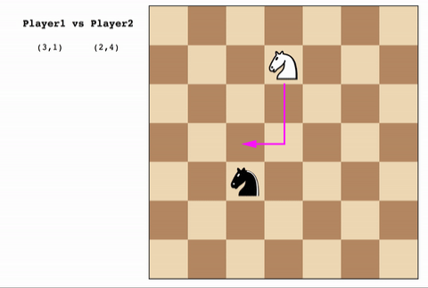

This heuristic optimizes for the minim “Manhattan” distance in comparison to the opponent, as if the player is shadowing the opponent. This will generally match the strategy of the opponent.

# RESULTS

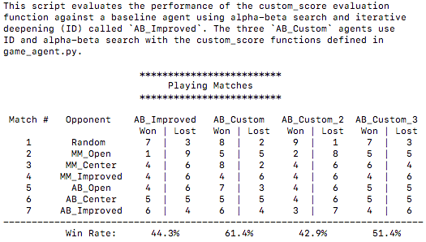

In order from worst to best, the heuristics used in the tournament are Custom Score 2, Custom Score 3, and Custom Score 1 (being the best). As might be obvious on the board when players move in an “L” direction, Custom Score 2 loses most times most likely because it ends up in a corner without a legal move remaining. Because it is imitating its opponent, Custom Score 3 reduces the chance in the game to essentially a 50/50 split. Against an agent with a non-random strategy it does best when the opponent it is “shadowing” is trying to keep as many open spaces on the board. The best results come from Custom Score 1, which like AB_Open optimizes for keeping as many spaces open; however, it takes into account how many of them are legal (legal_moves/open_spaces). This is matches or outperforms the minimax and alpha-beta opponents with a 61% win rate and outperforms the baseline AB_Improved by 17%. Custom Score 1 is the best because it: utilizes the best search algorithm (alpha-beta over minimax); it optimizes for legal moves available but also for keeping as many spaces open as possible for future moves; and it is not dependent upon the strategy employed by the opponent. A player using Custom Score 1 could only be matched in this pool of strategies by Custom Score 3 (“shadowing”) or a strategy that tries to keep the player in the center of the board which is roughly equivalent to keeping as many board spaces open.