 PT. Indo Tambangraya Megah, Tbk
Request for Proposal (RFP)
Version 1.0
10-Oct-2012

ITM Investor Relation Database System
[IT-ITM]

Submitted in partial fulfillment
Of the requirements of
[ITM Investor Relation Database System]/ [IT-ITM]

TABLE OF CONTENTS

COMPANY BACKGROUND AND INTRODUCTION 1
1. Bid Submission 3
2. Project overview 3
3. User Requirement overview 4
4. Project objectives 10
5. Project scope 10
6. Proposed project organization 12
6.1 Organization chart 12
6.2 Qualifications 13
7. Project estimated time frame/effort/cost/duration 14
7.1 Estimated time frame (Vendor Fill in data here) 14
7.2 Estimated effort days (Vendor Fill in data here) 14
7.3 Estimated resource allocation (Vendor Fill in data here) 14
7.4 Estimated cost (Vendor Fill in data here) 15
7.5 Payment Schedule (Negotiable) (Vendor Fill in data here) 15
8. Project approvals 16
9. Appendices 16

COMPANY BACKGROUND AND INTRODUCTION

PT Indo Tambangraya Megah Tbk (ITM) is a leading Indonesian supplier of coal to the world’s energy markets. We aim to set the highest standards in the areas of good corporate governance, environmental compliance and safety. All our activities are conducted in close collaboration with host communities and other stakeholders. The company was listed on the Indonesian Stock Exchange in December 2007.

ITM office is located at Pondok Indah Office Tower III, 3rd floor Jl. Sultan Iskandar Muda, Pondok Indah, Kav. V-TA, Jakarta 12310, Indonesia.

All of the subsidiaries are located in East Kalimantan except Jorong which is situated in South Kalimantan.

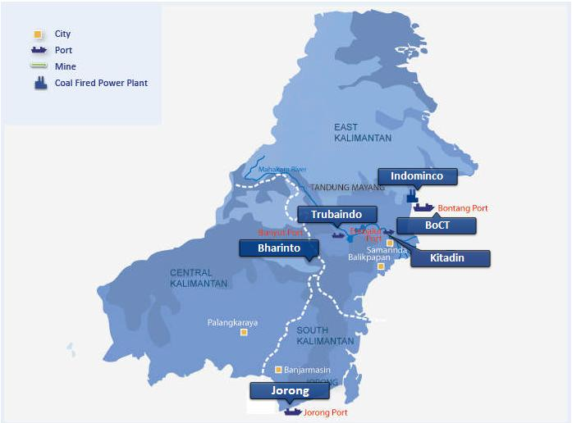

Site Location :
- ITM Head Office – Jakarta: on 1 location.
- ITM Representative Office – Balikpapan: on 1 location.
- PT. Indominco Mandiri - site Bontang: on 3 locations.
- PT. Kitadin- site Tandung Mayang: on 1 location.
- PT. Kitadin - site Embalut). Tenggarong: on 1 location.
- PT. Trubaindo Coal Mining - site Adong: on 1 location.
- PT. Trubaindo Coal Mining - site Bunyut: on 1 location.
- PT. Bharinto Ekatama - site Muara Teweh: on 1 location (currently on site Adong until 2012).
- PT. Jorong Barutama Greston - site Jorong: on 1 location.

Site Addresses
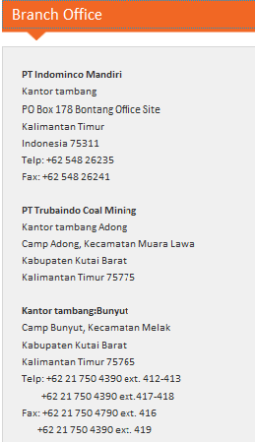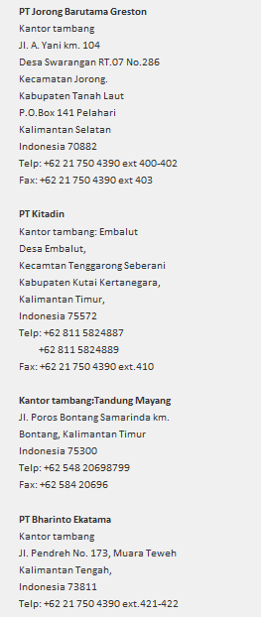

PT. Indo Tambangraya Megah Tbk is seeking qualified bidders “Vendor” to develop, deliver documents and support ITM Investor Relation Database System Development and Implementation. Qualified bidders are defined with experience in procuring, providing, installing and implementing ITM Investor Relation Database System development and implementations including comprehensive after sales support for warranty and non-warranty related issues. Each bidder must provide a list of their qualifications, organization, background and contact information, in order that, experience and performance can be verified. Suppliers that do not meet qualification standards will not be considered.

- Bid Submission

ALL BIDS AND PROPOSALS MUST BE RECEIVED IN THE BUSINESS OFFICE NO LATER THAN CLOSE OF BUSINESS (3:30 PM) ON 22-October-2012. THREE (3) COPIES OF ALL DOCUMENTS ARE REQUIRED. ONE COPY SHOULD BE CLEARLY MARKED AS ORIGINAL.

All bids and proposals are to be marked “ITM Investor Relation Database System” on the outside of the envelope or subject email.

For ease of comparison, please complete attached specifications, print it, and submit with proposal. Failure to do so may result in bid disqualification. The Supplier is free to offer options information. However, PT. INDO TAMBANGRAYA MEGAH TBK is under no obligation to consider or purchase any options proposed.

ALL SEALED BIDS ARE TO BE SUBMITED TO:

PT. INDO TAMBANGRAYA MEGAH Tbk - COAL OPERATION INDONESIA
Pondok Indah Office Tower III, 3rd floor
Jl. Sultan Iskandar Muda, Pondok Indah, Kav. V-TA,
Jakarta 12310, Indonesia

ATTN: Amang Nurpraneko
Email: amang_n@banpuindo.co.id
IT Application Development Manager

- Project overview
PT. INDO TAMBANGRAYA MEGAH TBK currently manually monitors all activities of investors who bought shares ITMG using excel file.

The purpose of developing this application is for some purpose as following:
- To monitor investors profile.
- To monitor meeting activities with big investors, key person profile and all histories
- To monitor Indonesia coal mining companies share prices by end of day.
- To monitor ITMG stock portfolio and distribution.
- To monitor investment strategies each big investors.
- To share all those information via web based for Board of Directors and BANPU management (Thailand).

- User Requirement overview
Application will develop with as following key requirements:

- User Authentication must use Single Sign On with ITM Active Directory.
- Parameter of application :

PARAMETERS
Investor Profile
1 |  | Company
2 |  | Equity Assets |  | Equity Assets Figures
3 |  |  |  | Equity Assets Category (Small, Medium, Large)
4 |  | Investor Type
5 |  | Style
6 |  | Latest Update
7 |  | Address
8 |  | City
9 |  | Zip Code
10 |  | Country
11 |  | Phone
12 |  | Fax
13 |  | Website Address
14 |  | Company Overview
15 |  | Investment Strategy
16 |  | Sector Holdings: |  | Finance
17 |  |  |  | Energy Minerals
18 |  |  |  | Manufacturing
19 |  |  |  | Industrial
20 |  |  |  | Electronics
21 |  | Portfolio Distribution: |  | Mega
22 |  |  |  | Large
23 |  |  |  | Medium
24 |  |  |  | Small
25 |  |  |  | Micro
26 |  | Key Person
27 |  | Meeting Activities: |  | Meeting Date
28 |  |  |  | Meeting Events
29 |  |  |  | Meeting Person
30 |  |  |  | Meeting Person Position
31 |  |  |  | ITM Participants
Shareholdings
1 |  |  | Date
2 |  |  | Shareholding Data file
Peers Data
1 |  |  | Company Data |  | ITMG
2 |  |  |  |  | PTBA
3 |  |  |  |  | BUMI
4 |  |  |  |  | ADRO
5 |  |  |  |  | BYAN
6 |  |  |  |  | HRUM
Share Price
1 |  |  | Date
2 |  |  | Share Price: |  | JKSE
3 |  |  |  |  | ITMG
4 |  |  |  |  | PTBA
5 |  |  |  |  | BUMI
6 |  |  |  |  | ADRO
7 |  |  |  |  | BYAN
8 |  |  |  |  | BRAU
9 |  |  |  |  | HRUM
10 |  |  |  |  | BORN
11 |  |  |  |  | KKGI
12 |  |  |  |  | ARII
13 |  |  |  |  | GEMS

- Application layout for admin user interface :

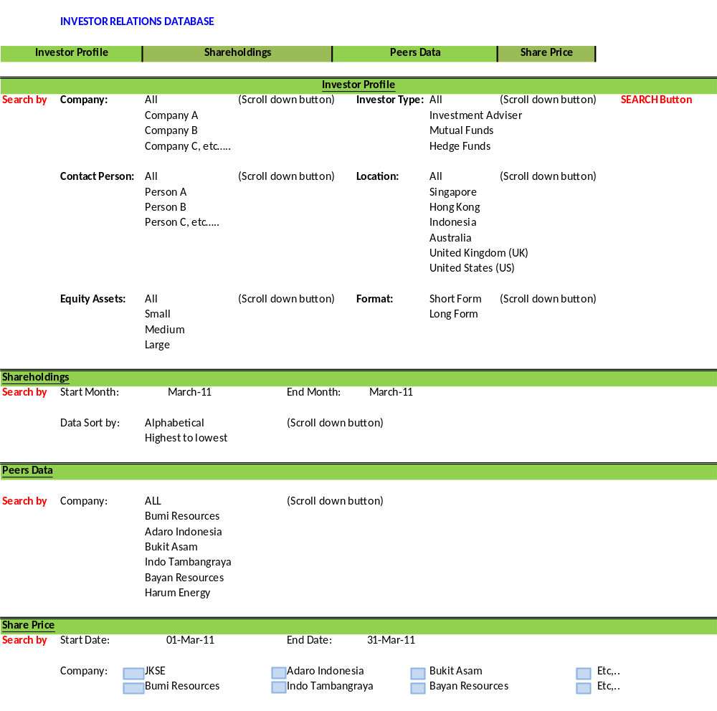

- Application short Form output layout user interface :

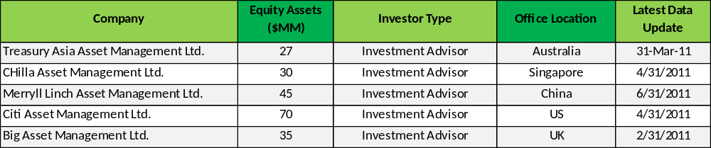

- Application Long Form output layout user interface :

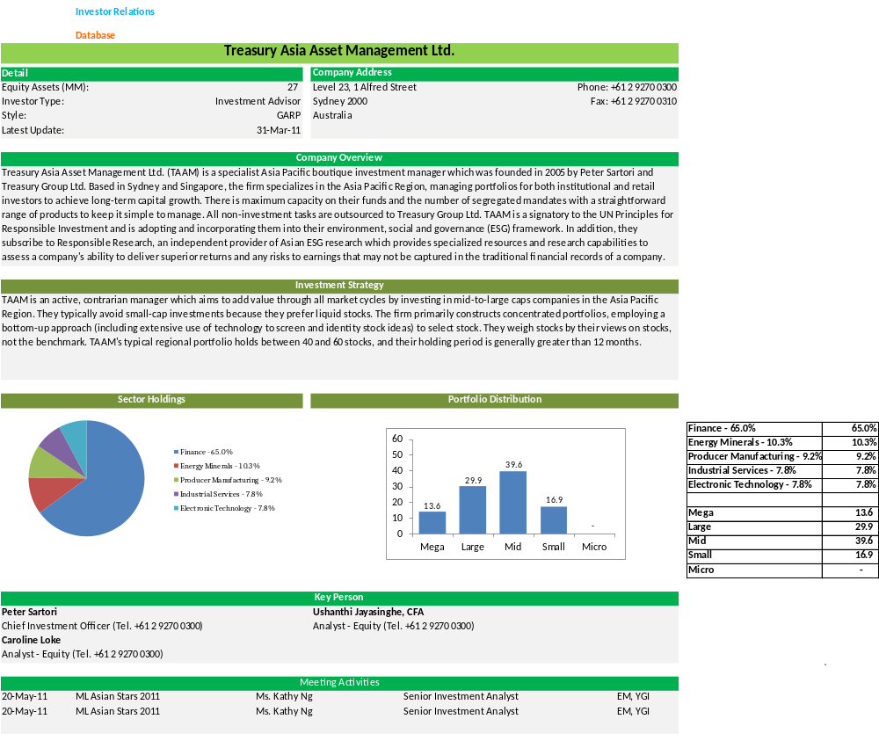

- Shareholding layout user interface :

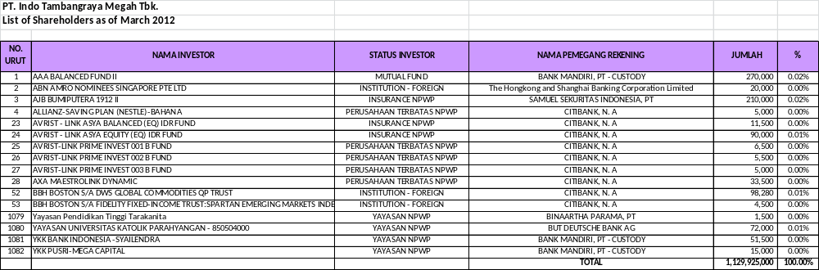

- Coal Mining Peers layout user interface :

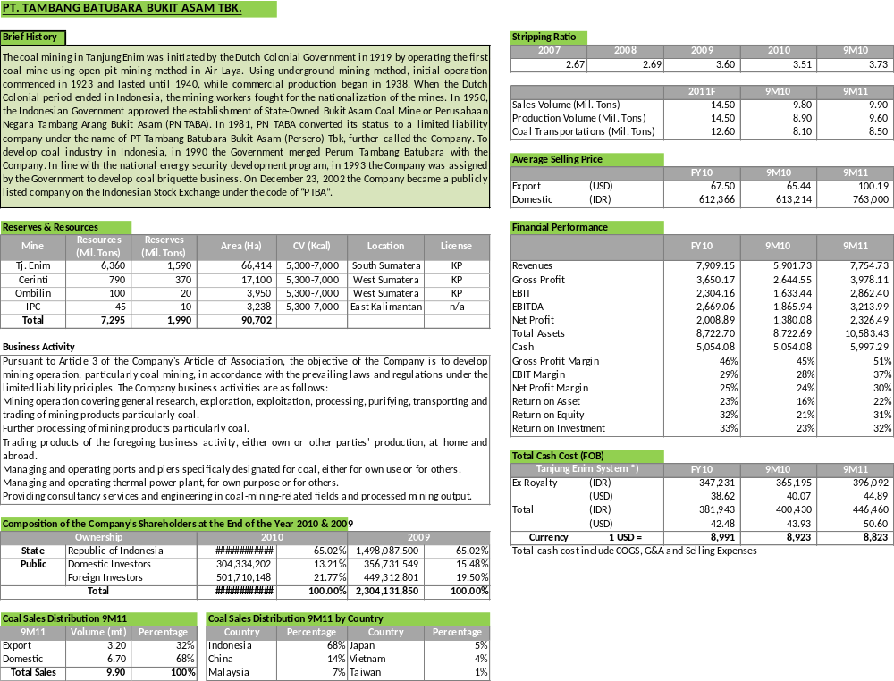

- Share prices output layout user interface :

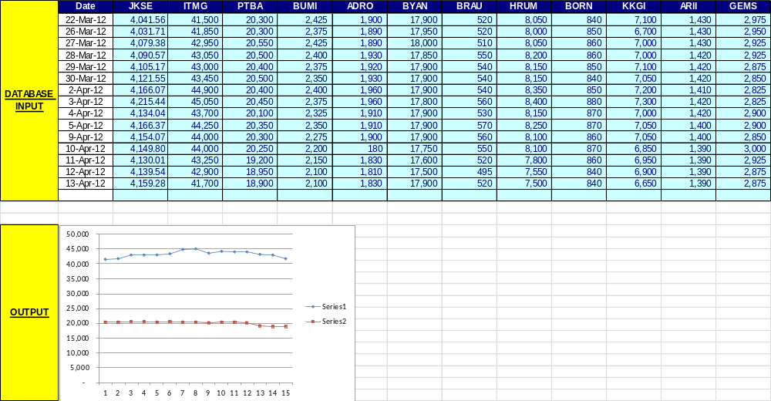

PROPOSED HARDWARE (Vendor Fill in data here if needed)
To meet server performance at high work load period and huge data store minimum hardware sizing recommendation is:

Application server:

• Quad Core (64 bit) above 2.5 GHz
• 2 GB of RAM
• 80 GB hard disk space

Database server:

• Quad Core (64 bit) above 2.5 GHz
• 8 GB of RAM
• 100 GB harddisk space

PROPOSED Application Configuration (Vendor Fill in data here)

Operating System : Enterprise Red hat Linux 64 bits
Database : Microsoft MS SQL 2008 (2 tiers)
Application Programming : PHP or by using CMS (PHP programming)
Web Server : Apache

PROPOSED System Architecture Vendor Fill in data here

Application & Database server, in separated server, centralized in Jakarta Office.

- Project objectives

- To monitor investors profile.
- To monitor meeting activities with big investors, key person profile and all histories
- To monitor Indonesia coal mining companies share prices by end of day.
- To monitor ITMG stock portfolio and distribution.
- To monitor investment strategies each big investors.
- To share all those information via web based for Board of Directors and BANPU management (Thailand).

The objectives of this project are developing and implementing of Investor Database Monitoring System to accommodate ITM Investor relation Division Team requirements and enhance any involvement modules. The new system should work and integrated seamlessly within end of December 2012.

The future enhancement will be easier to developed and maintained.

- Project scope

The scope of this project includes and excludes the following items.

In scope:
  - Develop Investor Database Monitoring System Application using CMS (PHP Programming) as requirements.
  - Design and develop database ERD for application.
  - Develop application user interface as requirements.
  - Develop application report interface as requirements.
  - Working all Investor Database Monitoring system application functionality :
- Testing and Commissioning
- Report generation
- Customization of user interface forms
- Set of documentation that consists of:
- Co-Developed MS PROJECT Schedule for system design and implementation
- Business requirements and software process including flow charts draw with Visio 2003
    - User point of view
    - Technical manual
- Detail system and functionality design
- Systems manuals
- All user manuals

Deliverables produced by contracted vendor:

  - Deliver Investor Database Monitoring System Application using CMS (PHP Programming) as requirements.
  - Deliver application user guide documents and administrator documents.
  - Deliver application technical documents.
  - Deliver Database ERD documents.
  - Deliver Technical user training and support
  - All source code in pre-compiled and compiled versions will be 100% property of PT. INDO TAMBANGRAYA MEGAH TBK
  - Vendor will have no future claims to source configuration.
  - PT. INDO TAMBANGRAYA MEGAH TBK reserves the right to resell the source code
- Vendor has first right of sale
- PT. INDO TAMBANGRAYA MEGAH TBK will not compete with vendor for sales
- PT. INDO TAMBANGRAYA MEGAH TBK gives up rights to sell if buyer is a client or possible client

Organizations affected

The impact of this project on other organizations needs to be determined to ensure that the right people and functional areas are involved and communication is directed appropriately.

Please note that it is the contractor’s responsibility to fully understand and document PT. INDO TAMBANGRAYA MEGAH TBK’s current operating systems.

Organization | How are they affected, or how are they participating?
ITM User | Requirement identification, design approval, and user acceptance testing
IT (Technical) | User acceptance testing, knowledge transfer, system design assistance
IT (AVP) | Internal project management, project Champion
Vendor team | Requirements analysis, design definition and refinement, system development, system testing, documentation, knowledge transfer

- Proposed project organization

Vendor shall propose project organization.

An appropriate project organization structure is essential to achieve success. The following diagram depicts a possible project organization.

The project will be lead by a project manager; vendor and client side will have its own Project coordinator. Project coordinator job description:
- Identifies resources needed
- Assigns individual task responsibilities.
- Manages day-to-day operational aspects of a project and scope.
- Ensures project deliverable are complete

Project coordinator from vendor will also have role as System analyst, and project member cover: implementer and developer

  - Organization chart

According to work plan above, the organization chart of this project would be described in the following chart:

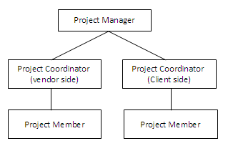

  - Qualifications

According to the implementation plan, these qualifications are needed:

  - Project manager (PM) from PT. Indo Tambangraya Megah
To perform project management role as described briefly in Methodology
Maintain the work breakdown structure, estimate task cost and duration, assign and manage tasks, manage automated project-management tools, staff the project, manage the budget, manage the schedule, manage procurement, and report to the management, control quality--the adherence to standards and procedures.

  - System Analyst (SA) from vendor
To perform integration of business processes that will be map to the new system.
Business Consultant to perform all aspect of developing and implementing tugboat and barge monitoring system application to meet requirements of PT. INDO TAMBANGRAYA MEGAH TBK.
The System analyst responsible for create project work plan, coordinating the project team, to make sure that each project milestone is delivered on time according to the work plan, performing system analyzing and design, coding and to supervise the developer or system implementer to make sure that any code written is correct according to the design.

  - Quality Control (QC) from PT. Indo Tambangraya Megah
To make sure that any deliverable and task is delivered according to the project work plan and specification documented.

  - Developer or System Implementer (DSI) from vendor
The Developer or System Implementer is responsible for production of working code that meets the module specifications. Developer or System Implementer must have a thorough understanding of the specifications for the modules for which he or she will produce code. This person should also understand how those modules fit in the system architecture and the business and technical requirements that they implement.

- Project estimated time frame/effort/cost/duration

The project cost calculation will be based on Fixed COST. The initial estimated Project time frame and cost is included in this proposal based on the requirement definition listed in the attached document that mentions below. Any new requirement which is identified in the middle project is considered as a change request no changes to cost will be allowed.

  - Estimated time frame (Vendor Fill in data here)

The estimated time frame (weeks) for the project is shown below (Vendor Fill in data here)

Project Milestone | 1 | 2 | 3 | 4 | 5 | 6 | 7 | 8 | 9 | 10 | 11 | 12
System Analysis and Design

System Build
User Acceptance Test
User Training for IT Engineer

  - Estimated effort days (Vendor Fill in data here)

The estimated effort days for the project is shown below

Project Milestone | Effort Days (Working days)
System Analysis and Design
System Build
User Acceptance Test
User Training for IT Engineer
Total

  - Estimated resource allocation (Vendor Fill in data here)
And the resource allocation for the project is shown below

Project Milestone | Qualification  (Number of people) | Duration  (Man days)
System Analysis and Design | System Analysts - number of employees
System Build | System Analysts - number of employees
 | System Implementer/Developer - number of employees
User Acceptance Test | System Analysts - number of employees
 | System Implementer/Developer - number of employees
User Training for IT Engineer | System Analys - number of employees
 | System Implementer/Developer - number of employees

Total resource allocation is shown on figure below

Qualification | Total man days
System Analysts
Developer /System Analyst
Grand Total
  - Estimated cost (Vendor Fill in data here)

Qualification | Total man days | Man-day Fee (IDR) | Total Cost
System Analysts
Developer/System Implementer
Total
Discount (...%)
Grand Total
VAT 10%
Grand Total after VAT

  - Payment Schedule (Negotiable) (Vendor Fill in data here)

  - Term of Payment 50% : After User Acceptance Test conducted (UAT Certificate sign off)
  - 50%, After job completion and customer acceptance

- Project approvals

Amang Nurpraneko 10-October-2012
______________________________________ ___________________
IT Application Development Manager Date

- Appendices

