What’s the FREQ?

Lab 1G

Directions: Follow along with the slides and answer the questions in **red** font in your journal.

## Clean it up!

* In Lab 1F, we saw how we could *clean* data to make it easier to use and analyze.
  + You cleaned a small set of variables from the American Time Use (ATU) survey.
  + The process of cleaning and then analyzing data is *very* common in Data Science.
* In this lab, we’ll learn how we can create frequency tables to detect relationships between categorical variables.
  + For the sake of consistency, rather than using the data that you cleaned, you will use the pre-loaded ATU data.
  + Use the data() function to load the atu_clean data file to use in this lab.

## How do we summarize categorical variables?

* When we’re dealing with categorical variables, we can’t just calculate an *average* to describe a *typical* value.
  + (Honestly, what’s the average of categories *orange*, *apple* and *banana*, for instance?)
* When trying to describe categorical variables with numbers, we calculate *frequency tables*.

## Frequency tables?

* When it comes to categories, about all you can do is *count* or *tally* how often each category comes up in the data.
* Fill in the blanks below to answer the following: **How many more *females* than *males* are there in our ATU data?**

tally(~ ____, data = ____)

## 2-way Frequency Tables

* Counting the categories of a single variable is nice, but often times we want to make comparisons.
* For example, what if we wanted to answer the question:
  + **Does one gender seem to have a higher occurrence of physical challenges than the other? If so, which one and explain your reasoning?**
* We could use the following plot to try and answer this question:

bargraph(~phys_challenge | gender, data = atu_clean)

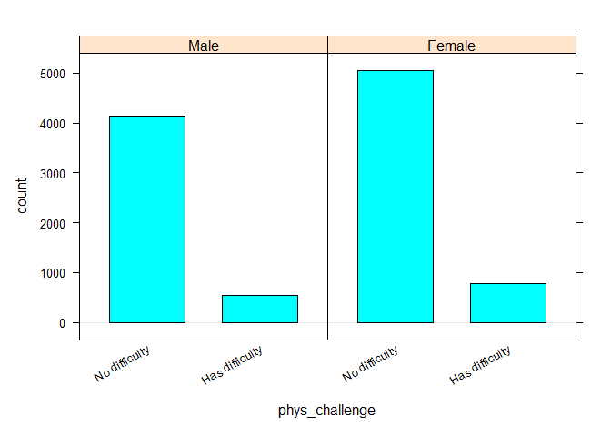

* The split bargraph helps us get an idea of the answer to the question, but we need to provide precise values.
* **Use a line of code, that’s similar to how we facet plots, to obtain a tally of the number of people with physical challenges and their genders.**

## Interpreting 2-way frequency tables

* Recall that there were 1153 more women than men in our data set.
  + If there are more women, then we might expect women to have more physical challenges (compared to men).
* Instead of using *counts* we use *percentages*.
* Include: format = "percent" as an option to the code you used to make your 2-way frequency table. Then answer this question again:
  + **Does one gender seem to have a higher occurrence of physical challenges than the other? If so, which one and explain your reasoning?**
  + **Did your answer change from before? Why?**
* It’s often helpful to display totals in our 2-way frequency tables.
  + To include them, include margins = TRUE as an option in the tally function.

## Conditional Relative Frequencies

* There is as difference between phys_challenge | gender and gender | phys_challenge.

tally(~phys_challenge | gender, data = atu_clean, margin = TRUE)

## gender  
## phys_challenge Male Female  
## No difficulty 4140 5048  
## Has difficulty 530 775  
## Total 4670 5823

tally(~gender | phys_challenge, data = atu_clean, margin = TRUE)

## phys_challenge  
## gender No difficulty Has difficulty  
## Male 4140 530  
## Female 5048 775  
## Total 9188 1305

* At first glance, the two-way frequency tables might look similar (especially when the margin option is excluded). Notice, however, that the totals are different.
* The totals are telling us that R calculates conditional frequencies by column!
* What does this mean?
  + In the first two-way frequency table the groups being compared are Male and Female on the distribution of physical challenges.
  + In the second two-way frequency table the groups being compared are the people with No difficulty and those that Has difficulty on the distribution of gender.
* **Add the option format = "percent" to the first tally function. How were the percents calculated? Interpret what they mean.**

## On your own

* **Describe what happens if you create a 2-way frequency table with a numerical variable and a categorical variable.**
* **How are the types of statistical questions that 2-way frequency tables can answer different than 1-way frequency tables?**
* **Which gender has a higher rate of *part time employment*?**