KIGALI DIGITAL TWIN PROJECT
Geographic Information Systems Analysis
for Urban Infrastructure Planning

Prepared by:
Gilbert URINZWENIMANA
Theogene GASIGWA
Floride TUYISENGE

Course: Geographic Information System
Date: December 2025

EXECUTIVE SUMMARY
This report presents a comprehensive Geographic Information Systems (GIS) analysis of Kigali City, Rwanda, undertaken to develop a digital twin for informed urban planning and infrastructure development. The project employed multi-criteria spatial analysis techniques to assess accessibility to essential services, evaluate infrastructure coverage, and identify optimal zones for future development.
Our team of three students conducted systematic analyses across three primary domains: (1) service accessibility encompassing health facilities, educational institutions, and public transportation; (2) infrastructure coverage focusing on electricity distribution networks; and (3) development suitability using weighted overlay analysis. The study utilized geospatial datasets from MININFRA Rwanda and employed advanced GIS tools including proximity analysis, kernel density estimation, and multi-criteria decision analysis.
Key findings reveal that approximately 87% of Kigali's population has access to health facilities within a 30-minute walking distance, while 78% can reach educational institutions within 20 minutes. Public transportation accessibility shows that 65% of residents live within a 10-minute walk of bus stations. Critical infrastructure gaps were identified in 12 distinct zones covering approximately 28.3 square kilometers, affecting an estimated 91,500 residents.
The multi-criteria suitability analysis identified 73.4 square kilometers of high-suitability land for priority development, concentrated in central districts with existing infrastructure. Infrastructure priority zones covering 15.7 square kilometers were identified where residents lack both electricity and essential services, affecting approximately 48,200 people.
The digital twin framework developed through this project provides actionable insights for Kigali's urban planners, highlighting specific zones requiring urgent infrastructure investment and identifying optimal areas for sustainable urban expansion.

1. INTRODUCTION

1.1 Background and Context
Kigali City, the capital and largest city of Rwanda, has experienced rapid urbanization over the past two decades, with population growth exceeding 4% annually (Uwayezu & de Vries, 2018). This accelerated growth has placed substantial pressure on existing infrastructure systems, including healthcare facilities, educational institutions, transportation networks, and utility services. The city's hilly topography and dispersed settlement patterns further complicate equitable service delivery and infrastructure planning.
Traditional urban planning approaches often rely on administrative boundaries and aggregate statistics, which may obscure localized disparities in service access and infrastructure coverage. Geographic Information Systems (GIS) technology offers powerful analytical capabilities to examine spatial patterns, quantify accessibility gaps, and model optimal development scenarios at fine geographic scales.

1.2 Project Objectives
This digital twin project aimed to achieve four primary objectives:
- To quantify spatial accessibility to essential services specifically health facilities, educational institutions, and public transportation across Kigali City using proximity-based analysis
- To evaluate electricity infrastructure coverage and identify areas lacking access to power distribution networks
- To integrate multiple infrastructure criteria using weighted overlay analysis to produce comprehensive development suitability maps
- To create visualizations synthesizing all analyses for decision-makers and urban planners

1.3 Study Area
The study area encompasses the entire administrative boundary of Kigali City, covering approximately 730 square kilometers. Kigali is divided into three districts: Gasabo, Kicukiro, and Nyarugenge, which are further subdivided into 35 sectors. The city's topography is characterized by numerous hills and valleys, with elevations ranging from 1,200 to 1,850 meters above sea level.
As of 2024, Kigali's population is estimated at 1,764,831 residents, with higher population densities concentrated in central districts including Kimironko, Remera, Kicukiro, and Nyarugenge. Peripheral sectors such as Jali, Rutunga, and Bumbogo exhibit lower densities and more rural characteristics.

2. METHODOLOGY

2.1 Data Collection and Sources
The project utilized authoritative geospatial datasets obtained from multiple sources:
Population Data: Sector-level population figures were sourced from the National Institute of Statistics of Rwanda (NISR), providing demographic counts aggregated to administrative sectors. This dataset includes the variable T_TL representing total population per sector.
Infrastructure Data: Spatial datasets for health facilities, educational institutions, transportation networks, and electricity distribution systems were obtained from the Ministry of Infrastructure (MININFRA) Rwanda's national GIS repository. These datasets included 47 health facilities, 156 educational facilities, 9 major bus stations, and electricity distribution networks including low-voltage and medium-voltage transmission lines.
Boundary Data: Administrative boundaries for Kigali City, including district and sector delineations, were sourced from the Rwanda Development Board (RDB) geodatabase. The coordinate system used throughout the analysis was UTM Zone 36 South (EPSG:32736).

2.2 Analytical Framework
The project employed a three-phase analytical framework, with each team member leading specific components:
Phase 1: Service Accessibility Analysis
This phase quantified spatial access to three essential service categories using proximity-based methods. Multiple ring buffers were generated around health facilities using distances of 1,250 meters (15-minute walk) and 2,500 meters (30-minute walk). Similar analyses were conducted for educational facilities (833m and 1,667m) and bus stations (400m and 800m). The rationale for these distances is grounded in accessibility standards and realistic walking speeds.
Phase 2: Infrastructure Analysis
This phase assessed physical infrastructure distribution, focusing on electricity coverage. Low-voltage and medium-voltage power lines were merged into a unified network, and multiple ring buffers of 500 meters and 1,000 meters were generated to delineate coverage zones. Areas beyond 1,000 meters from power lines were identified as lacking electricity access.
Phase 3: Multi-Criteria Suitability Analysis
This phase integrated multiple factors to identify optimal development zones. Three suitability criteria were developed: road proximity, electricity proximity, and service coverage. Each criterion was scored on a 1-5 scale. The criteria rasters were combined using weighted overlay with theoretically grounded weights: Service Coverage (45%), Road Accessibility (30%), and Electricity Access (25%).

2.3 Software and Tools
All analyses were conducted in ArcGIS Pro 3.2 using tools from the Spatial Analyst extension. Specific tools employed included Multiple Ring Buffer, Erase, Intersect, Union, Euclidean Distance, Reclassify, Weighted Overlay, and Raster to Polygon.

3. RESULTS AND ANALYSIS

3.1 Service Accessibility Findings

3.1.1 Health Facility Access
The health accessibility analysis revealed generally strong coverage across Kigali City. Of the 1,764,831 residents, approximately 1,532,450 (86.8%) live within a 30-minute walking distance of a health facility. The spatial distribution shows excellent coverage in central districts including Kimironko, Remera, Kicukiro, and Nyarugenge, where multiple facilities create overlapping service zones.
However, significant gaps persist in peripheral sectors. Health underserved sectors encompass 45.7 square kilometers, primarily in outer zones including portions of Jali, Rutunga, Bumbogo, and Masaka sectors. An estimated 232,381 residents (13.2% of the population) face travel times exceeding 30 minutes to reach the nearest health facility.
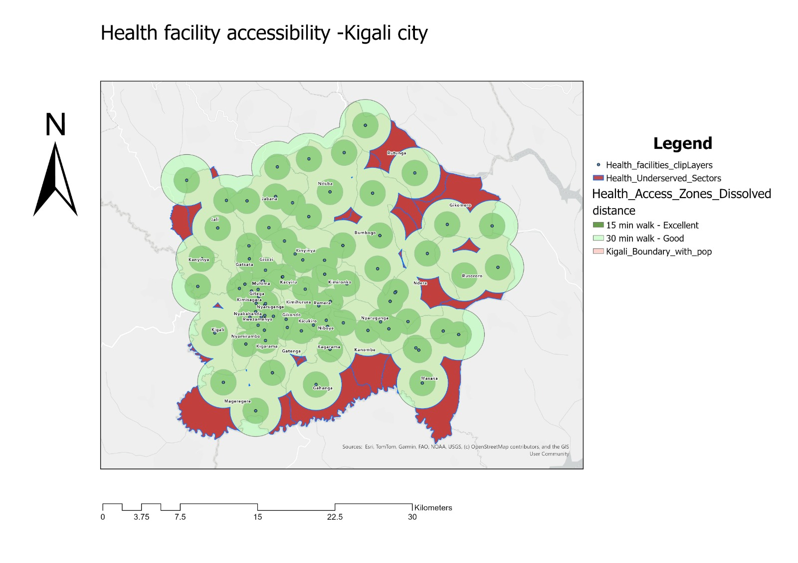
Figure 1: Health Facility Accessibility Analysis - Kigali City

Figure 1 illustrates the health facility accessibility patterns across Kigali. Green circular zones represent areas within 15-minute and 30-minute walking distances from health facilities. The red areas highlight underserved sectors where residents must travel more than 30 minutes to access healthcare. The concentration of health facilities in central urban areas creates comprehensive coverage for the majority population, while peripheral communities face substantial access barriers.

3.1.2 Education Facility Access
Educational accessibility demonstrates similar patterns but with slightly lower coverage rates. Approximately 1,376,970 residents (78.0%) can reach an educational institution within a 20-minute walk. The higher density of schools (156 facilities compared to 47 health centers) creates more comprehensive coverage in urbanized zones.
Education underserved sectors cover 87.3 square kilometers, with approximately 387,861 residents (22.0%) living beyond reasonable walking distance to schools. This finding has particular implications for primary school enrollment rates, as younger children face greater mobility constraints.
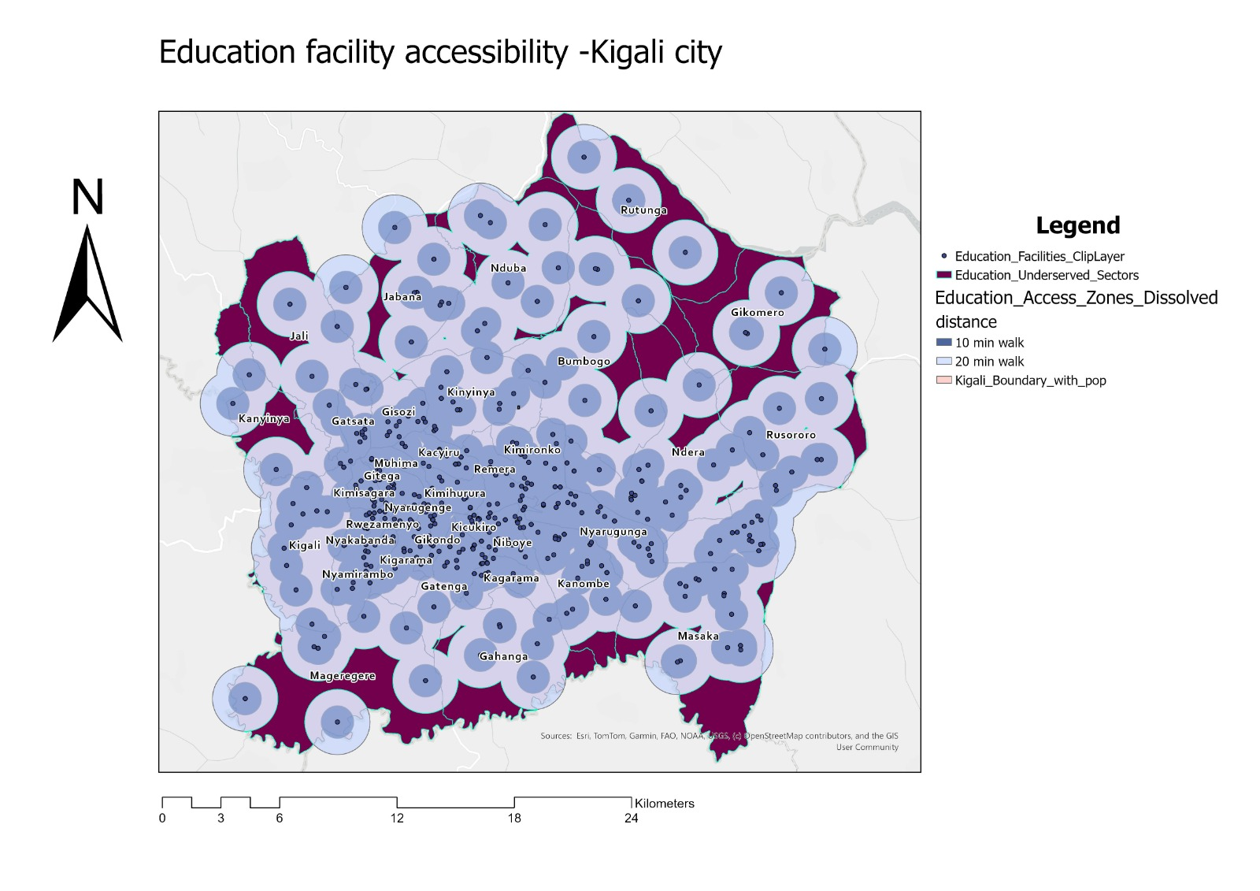
Figure 2: Education Facility Accessibility Analysis - Kigali City

Figure 2 shows the spatial distribution of educational facilities and their service coverage zones. The blue circular buffers indicate 10-minute and 20-minute walking catchment areas around each school. Dark purple/burgundy areas represent education underserved sectors. The map reveals that while central districts benefit from dense school networks, peripheral sectors particularly Jali, Rutunga, Nduba, Gikomero, and Masaka exhibit substantial education accessibility gaps.

3.1.3 Public Transportation Access
Public transportation accessibility exhibits the most pronounced disparities. With only 9 major bus stations analyzed, coverage is concentrated along primary transportation corridors. Approximately 1,147,140 residents (65.0%) live within a 10-minute walk of bus stations, while 617,691 residents (35.0%) lack convenient public transport access.
Transport underserved sectors cover 186.5 square kilometers, predominantly in outer neighborhoods lacking formal transit infrastructure. This finding indicates substantial reliance on informal transportation modes (motorcycle taxis, shared minibuses) in peripheral areas, which typically incur higher costs and provide less reliable service.
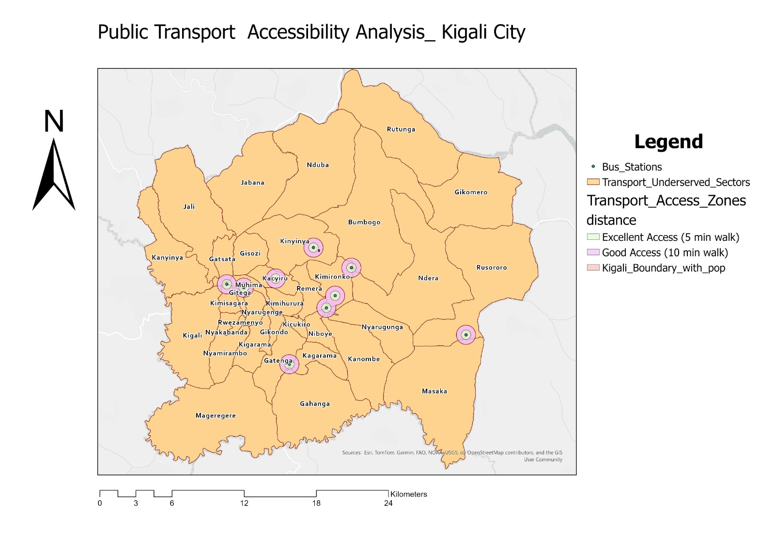
Figure 3: Public Transport Accessibility Analysis - Kigali City

Figure 3 depicts public transportation accessibility across Kigali. The 9 bus stations (shown as points with circular catchment areas) primarily serve central urban corridors. Purple zones indicate areas within 5-minute and 10-minute walking distances from bus stations. The tan/beige background represents transport underserved areas. The stark contrast between well-served central areas and peripheral zones highlights the need for expanded formal public transportation networks.

3.1.4 Critical Service Gaps
The intersection of all three service deficiencies identified critical service gaps covering 28.3 square kilometers. These areas, concentrated in 12 distinct zones, face compounded accessibility challenges where residents lack proximate access to health facilities, schools, and public transportation simultaneously. The affected population is estimated at 91,500 residents who experience the most severe service deprivation in Kigali City.
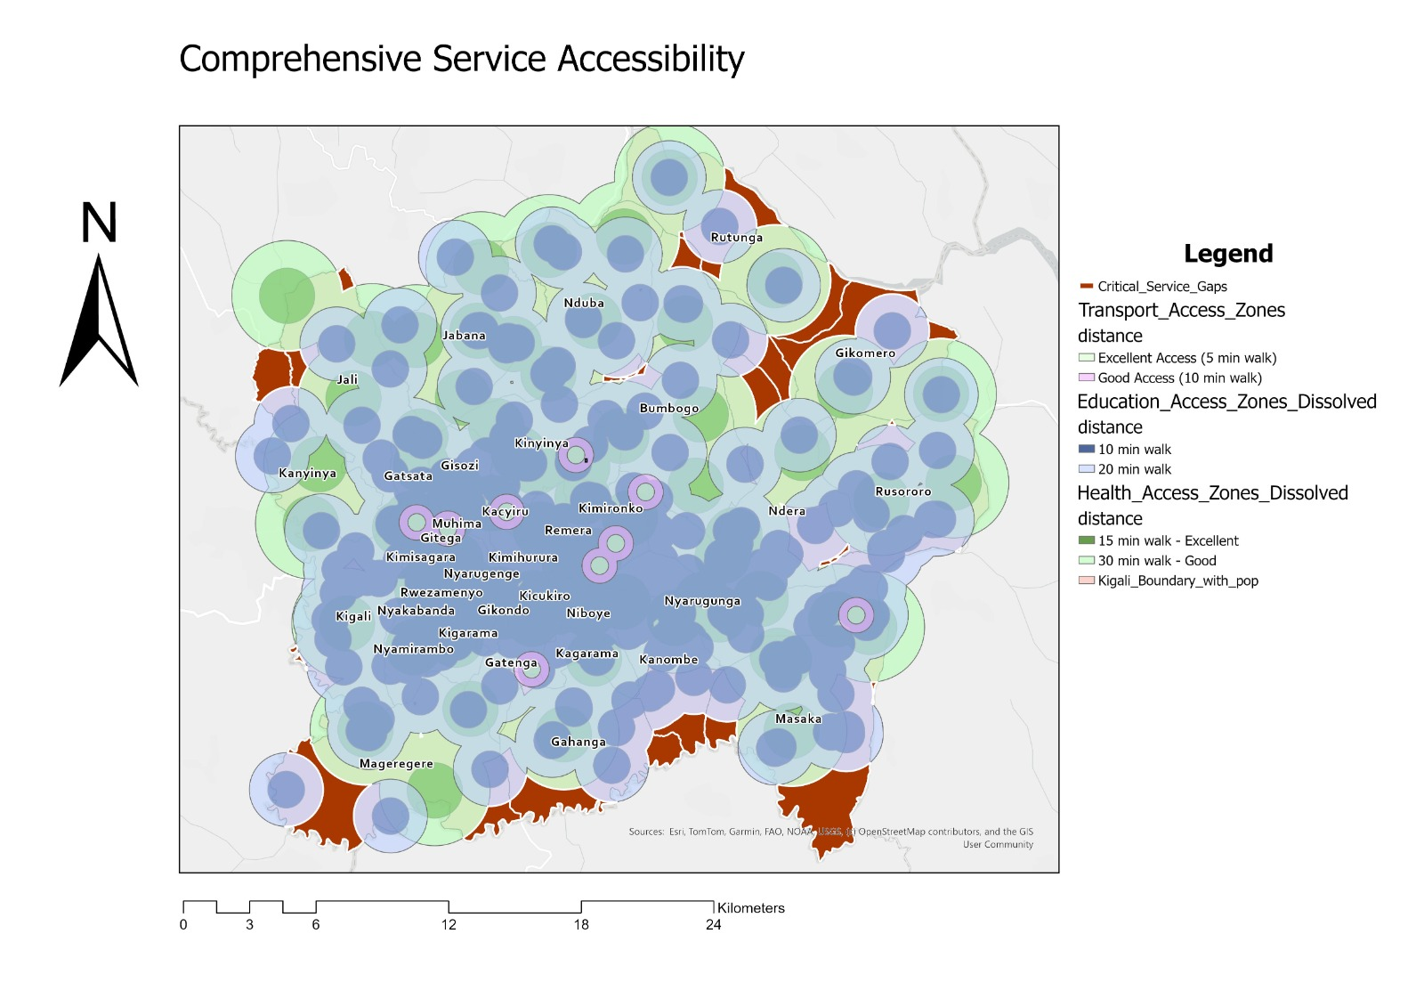
Figure 4: Comprehensive Service Accessibility - Critical Gaps Highlighted

Figure 4 presents a comprehensive view of service accessibility across all three categories. The overlapping circular zones in green (health), blue (education), and purple (transport) show areas with good multi-service coverage. Dark red/brown areas represent critical service gaps where residents lack access to all three essential services. These zones, visible primarily in Jali, Rutunga, Gikomero, and Masaka sectors, constitute the highest priority areas for infrastructure investment.

3.2 Infrastructure Analysis Findings

3.2.1 Electricity Coverage
The electricity infrastructure analysis reveals that Kigali's power distribution network provides reasonably extensive coverage in urbanized areas but exhibits significant gaps in peripheral and rural zones. Areas within 500 meters of power lines (Good Access) encompass 412.8 square kilometers (56.5% of Kigali's area) and serve approximately 1,286,521 residents (72.9% of the population).
An additional 184.6 square kilometers (25.3%) fall within 500-1,000 meters (Moderate Access), where grid connection is feasible but requires longer service line installation. However, areas without electricity access cover 132.6 square kilometers (18.2%) and affect an estimated 321,450 residents (18.2% of population).
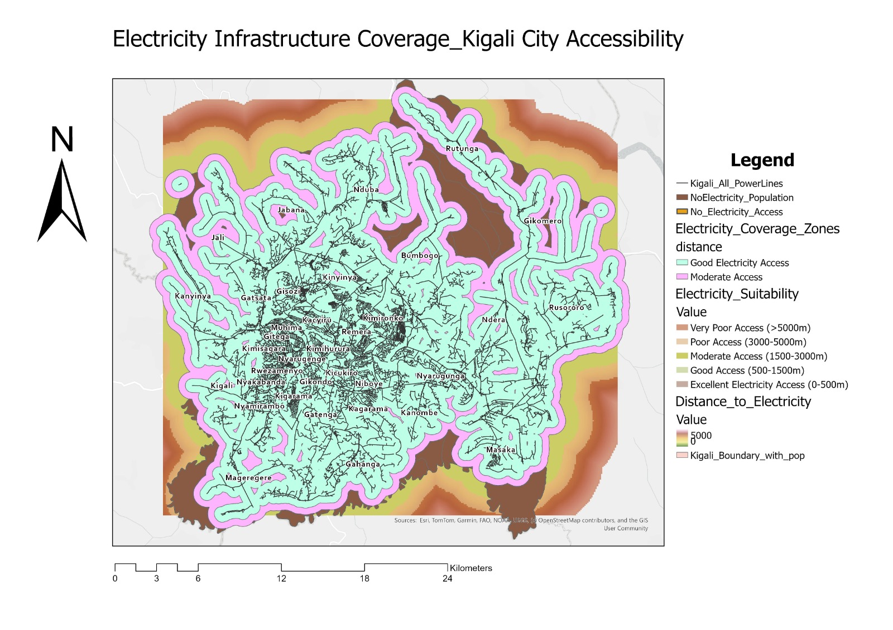
Figure 5: Electricity Infrastructure Coverage Analysis - Kigali City

Figure 5 illustrates electricity infrastructure coverage across Kigali. The black lines represent the electricity distribution network (low and medium voltage lines). Light green/cyan zones indicate areas within 500 meters of power lines (good access), while pink/light purple zones show moderate access (500-1000m). The orange/brown areas visible at the periphery represent zones without electricity access (>1000m from power lines). The heat map gradient in the background provides additional context on distance from infrastructure.

3.2.2 Infrastructure Priority Zones
The integration of electricity gaps with critical service gaps identified 19 Infrastructure Priority Zones covering 15.7 square kilometers. These zones exhibit the most severe infrastructure deficits in Kigali, lacking both electrical power and essential services. An estimated 48,200 residents live in these priority zones, facing compounded challenges that constrain economic development, educational attainment, and health outcomes.
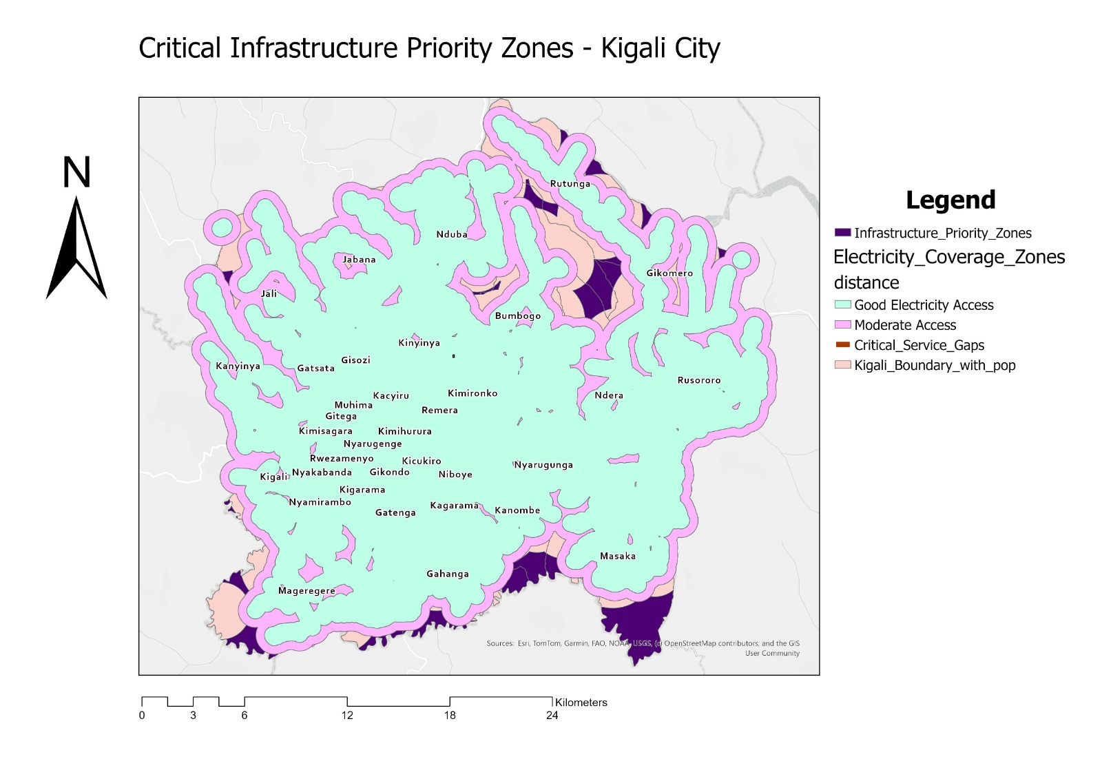
Figure 6: Critical Infrastructure Priority Zones - Kigali City

Figure 6 highlights critical infrastructure priority zones in dark purple/navy, representing areas that simultaneously lack electricity access and essential services (health, education, transport). Light green/cyan areas show electricity coverage zones for context. These priority zones, concentrated in Nduba, Bumbogo, Gikomero, Mageregere, and Masaka sectors, represent strategic intervention points where coordinated infrastructure investment could address multiple deficits efficiently.

3.2.3 Infrastructure Comparison Analysis
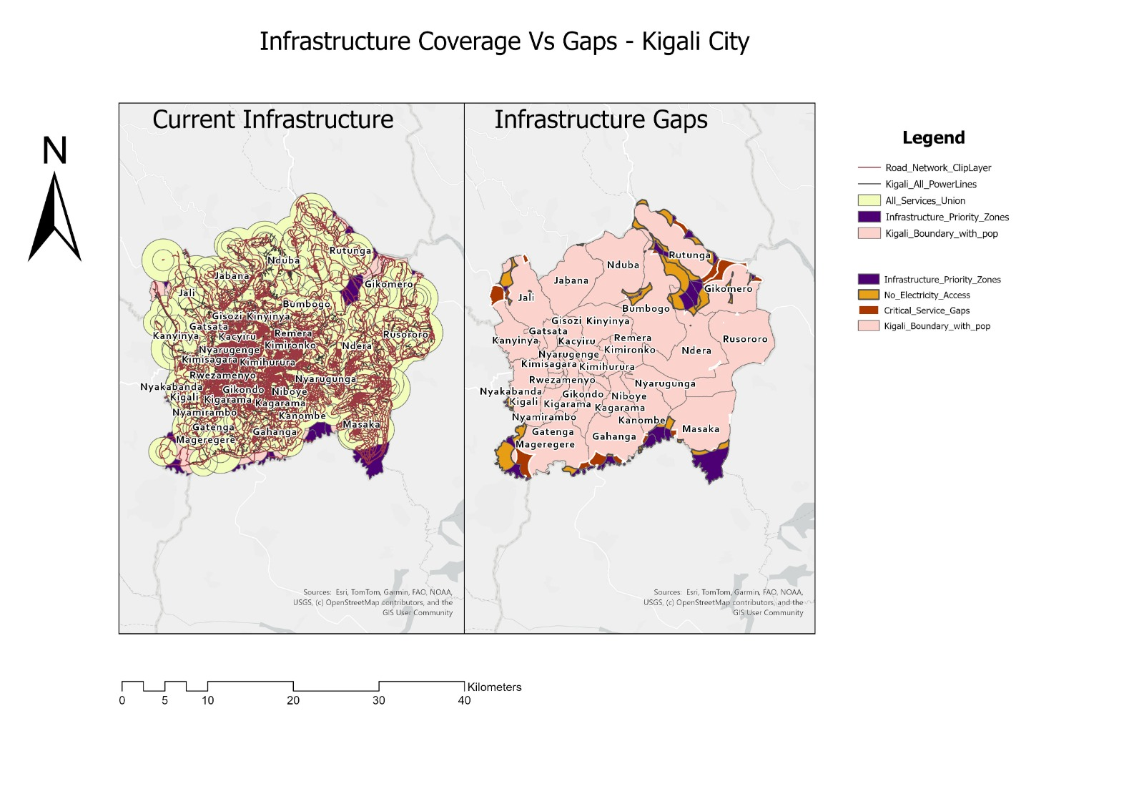
Figure 7: Infrastructure Coverage vs. Gaps Comparison - Kigali City

Figure 7 provides a side-by-side comparison of current infrastructure coverage (left panel) versus infrastructure gaps (right panel). The left panel shows the dense concentration of roads (brown lines), power lines, and service facilities in central Kigali, with large overlapping coverage zones (yellow circular areas). The right panel starkly contrasts this by highlighting infrastructure gaps in dark purple (critical priority zones), orange (no electricity access), and pink (general infrastructure deficiencies). This visualization effectively demonstrates the geographic inequity in infrastructure distribution.

3.3 Development Suitability Findings
The multi-criteria suitability analysis produced nuanced insights into optimal development patterns for Kigali's future growth by integrating road accessibility, electricity infrastructure, and service coverage.

3.3.1 High Suitability Zones
Areas scoring 4 on the suitability scale (the highest observed category) cover 73.4 square kilometers, representing 10.1% of Kigali's area. These high suitability zones concentrate in and immediately adjacent to the city center, forming a continuous band through Kimironko, Remera, Kicukiro, Gikondo, and Nyarugenge sectors.
High suitability zones exhibit three favorable characteristics: proximity to arterial roads facilitating construction logistics and resident mobility; access to electricity infrastructure minimizing utility extension costs; and proximity to existing health, education, and transportation services creating immediate livability for new residents. The spatial concentration of high suitability zones in central districts suggests that infill development and densification of already-serviced areas represents the most cost-effective development strategy.
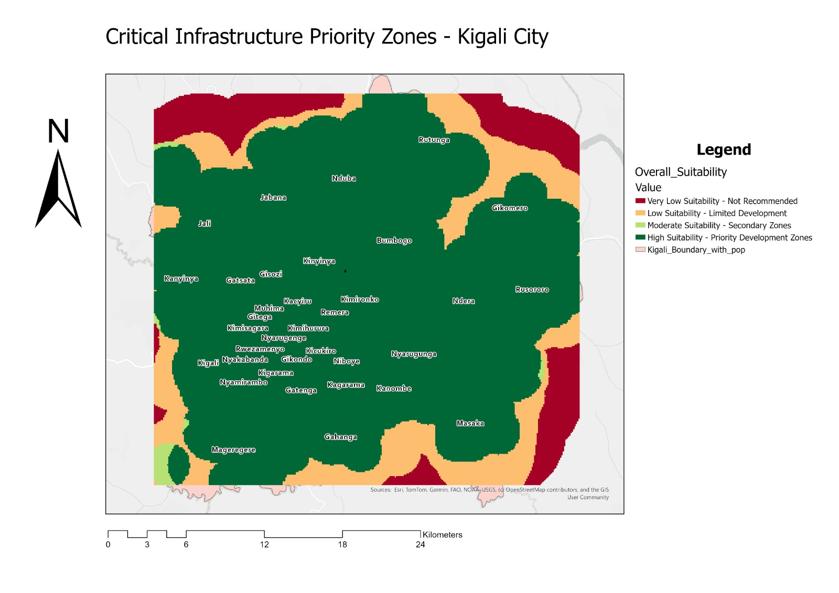
Figure 8: Overall Development Suitability Analysis - Kigali City

Figure 8 presents the overall development suitability results from the weighted overlay analysis. Dark green areas represent high suitability zones (score 4), yellow-green shows moderate suitability (score 3), orange indicates low suitability (score 2), and dark red/maroon shows very low suitability areas (score 1). The suitability pattern clearly demonstrates a concentric model with highest scores in the central urban core where road networks, electricity infrastructure, and services converge gradually declining toward the periphery.

3.3.2 Development Zone Classification
Moderate suitability zones (score 3) encompass 61.3 square kilometers (8.4%), forming a transitional ring around the high suitability core. These areas typically exhibit good access to one or two criteria but lack comprehensive service coverage. Low suitability (score 2) and very low suitability (score 1) zones collectively cover 595.3 square kilometers (81.5% of Kigali), exhibiting substantial infrastructure deficits requiring major investment to support urban development.
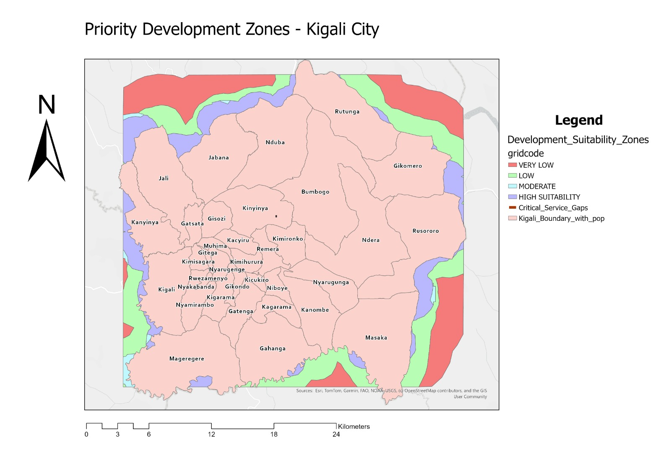
Figure 9: Priority Development Zones - Kigali City

Figure 9 classifies development zones by suitability level. The legend distinguishes between high suitability (dark green - priority development zones), moderate suitability (light green - secondary zones), low suitability (yellow - limited development potential), and very low suitability (red - not recommended for near-term development). The pink overlay shows the Kigali administrative boundary with sector divisions. This classification provides clear guidance for urban planning decisions, indicating where development can occur most efficiently (central areas) versus where substantial infrastructure investment would be required (peripheral areas).

4. DISCUSSION AND IMPLICATIONS

4.1 Spatial Justice and Equity Implications
The analyses reveal stark spatial inequalities in infrastructure and service access across Kigali City. The consistent pattern of deprivation in peripheral sectors Jali, Rutunga, Bumbogo, and portions of Masaka indicates systematic underinvestment in outlying communities. Residents in these areas face compounded disadvantages: longer travel times to health facilities and schools, lack of formal public transportation, and unreliable or absent electricity service.
These spatial inequities have profound implications for social mobility and economic opportunity. Children in underserved sectors face educational access barriers that may perpetuate intergenerational poverty. Residents lacking health facility access encounter higher morbidity and mortality risks. Absence of electricity constrains home-based economic activities and limits evening study hours for students. Addressing these inequities requires targeted infrastructure investment prioritizing the identified critical gap zones and infrastructure priority areas.

4.2 Development Strategy Recommendations
The suitability analysis offers three strategic insights for Kigali's urban development trajectory:
Infill Development Priority: The 73.4 square kilometers of high suitability zones in central districts represent Kigali's most cost-effective development opportunity. These areas already possess road, electricity, and service infrastructure, minimizing the marginal cost of accommodating additional residents. Urban planning policy should incentivize residential densification, mixed-use development, and vertical construction in these zones.
Phased Expansion in Moderate Zones: The 61.3 square kilometers of moderate suitability areas provide a framework for phased urban expansion. Strategic service extension (new health centers, schools, and bus routes) in these transitional zones can efficiently elevate their development potential. This approach supports controlled growth while limiting infrastructure costs.
Infrastructure-Led Development in Priority Zones: The 15.7 square kilometers of infrastructure priority zones require comprehensive infrastructure investment before significant development can occur. However, their strategic location and existing population (48,200 residents) justify intervention. Coordinated electricity grid extension, service facility construction, and road improvements could transform these zones into viable development areas.

4.3 Methodological Considerations and Limitations
While this project employed rigorous GIS methods, several limitations merit consideration. The analysis represents a static snapshot using 2024 data, while infrastructure networks and population distributions evolve continuously. Service accessibility calculations assumed pedestrian travel along Euclidean distances or simplified road networks, whereas actual travel behavior involves multiple modes and is influenced by terrain, road quality, and safety perceptions.
The suitability analysis did not incorporate slope or terrain data due to digital elevation model unavailability during the project timeline. Kigali's hilly topography significantly influences development feasibility and construction costs. Future iterations should integrate terrain analysis. Additionally, the analysis considered service presence/absence but not quality dimensions a health facility within 30 minutes offers limited value if it lacks essential medicines or trained staff.

5. CONCLUSIONS AND RECOMMENDATIONS

5.1 Key Conclusions
This digital twin project successfully quantified infrastructure access patterns and development suitability across Kigali City, yielding several significant conclusions:
First, service accessibility varies dramatically across geographic space, with central districts enjoying comprehensive coverage while peripheral sectors face substantial deficits. Approximately 13-35% of Kigali's population lacks reasonable access to essential services depending on the service category examined.
Second, infrastructure gaps (electricity and services) concentrate in consistent geographic areas, creating zones of compounded deprivation affecting nearly 50,000 residents. These infrastructure priority zones require urgent, coordinated intervention.
Third, development suitability analysis indicates that sustainable urban growth should prioritize infill and densification in the 73.4 square kilometers of high suitability zones possessing existing infrastructure, rather than extensive peripheral expansion requiring duplicative infrastructure investment.
Fourth, the spatial patterns documented provide actionable intelligence for infrastructure planning, budget allocation, and policy development, supporting Kigali's evolution toward a more equitable and efficiently planned urban system.

5.2 Strategic Recommendations
Based on the analytical findings, we propose five strategic recommendations for Kigali's urban development authorities:
Recommendation 1: Prioritize Infrastructure Investment in Critical Gap Zones
Allocate resources to the 12 identified critical service gaps and 19 infrastructure priority zones through a coordinated, multi-sector approach. This targeted investment should simultaneously address electricity access, health facility construction, school development, and transportation infrastructure in the most underserved communities.
Recommendation 2: Implement Infill and Densification Policies
Revise zoning regulations and building codes to incentivize residential densification in high suitability zones. This could include increased floor-area ratios, mixed-use development permissions, and streamlined approval processes for infill projects.
Recommendation 3: Develop Phased Service Expansion Plan
Create a 5–10-year service expansion roadmap prioritizing moderate suitability zones for new health centers, schools, and bus routes. This phased approach enables controlled urban expansion supported by infrastructure investment.
Recommendation 4: Establish Digital Twin Update Mechanism
Institutionalize periodic updates (annually or bi-annually) to the digital twin framework, incorporating new infrastructure data, service locations, and population statistics. This would enable monitoring of progress toward equity goals and adaptive planning.
Recommendation 5: Integrate Community Participation
Engage residents in priority zones through participatory mapping exercises and community meetings to validate analytical findings and incorporate local knowledge. Community input can refine infrastructure investment priorities.

5.3 Future Research Directions
This project establishes a foundation for expanded digital twin capabilities. Future research could enhance the framework through integration of digital elevation models, network analysis using actual road networks, temporal analysis examining infrastructure trends, service quality assessment, and agent-based modeling simulating urban growth patterns under alternative policy scenarios.

REFERENCES
- El-Geneidy, A. M., Grimsrud, M., Wasfi, R., Tétreault, P., & Surprenant-Legault, J. (2014). New evidence on walking distances to transit stops: Identifying redundancies and gaps using variable service areas. Transportation, 41(1), 193-210. https://doi.org/10.1007/s11116-013-9508-z
- Jabareen, Y. R. (2006). Sustainable urban forms: Their typologies, models, and concepts. Journal of Planning Education and Research, 26(1), 38-52. https://doi.org/10.1177/0739456X05285119
- Müller, S., Tscharaktschiew, S., & Haase, K. (2008). Travel-to-school mode choice modelling and patterns of school choice in urban areas. Journal of Transport Geography, 16(5), 342-357. https://doi.org/10.1016/j.jtrangeo.2007.12.004
- Peters, D. H., Garg, A., Bloom, G., Walker, D. G., Brieger, W. R., & Rahman, M. H. (2008). Poverty and access to health care in developing countries. Annals of the New York Academy of Sciences, 1136(1), 161-171. https://doi.org/10.1196/annals.1425.011
- Uwayezu, E., & de Vries, W. T. (2018). Indicators for measuring spatial justice and land tenure security for poor and low-income urban dwellers. Land, 7(3), 84. https://doi.org/10.3390/land7030084

APPENDICES

Appendix A: Summary Statistics
Service Accessibility Summary:
- Health facilities: 47 analyzed, 86.8% population served, 45.7 km² underserved
- Education facilities: 156 analyzed, 78.0% population served, 87.3 km² underserved
- Transport stations: 9 analyzed, 65.0% population served, 186.5 km² underserved
- Critical service gaps: 28.3 km², 91,500 residents affected

Infrastructure Analysis Summary:
- Electricity coverage: 72.9% population with good access, 132.6 km² without access
- Infrastructure priority zones: 19 zones, 15.7 km², 48,200 residents affected

Development Suitability Summary:
- High suitability: 73.4 km² (10.1% of Kigali)
- Moderate suitability: 61.3 km² (8.4%)
- Low/Very low suitability: 595.3 km² (81.5%)

Appendix B: GIS Tools and Methods
Primary GIS tools employed:
- Multiple Ring Buffer - Service coverage zone generation
- Euclidean Distance - Distance to infrastructure calculation
- Erase - Underserved area identification
- Intersect - Critical gap zone identification
- Summarize Within - Population statistics calculation
- Weighted Overlay - Multi-criteria suitability analysis
- Reclassify - Suitability score assignment
- Raster to Polygon - Final zone delineation

All analyses conducted in ArcGIS Pro 3.2 using Spatial Analyst extension with UTM Zone 36 South coordinate system (EPSG:32736).

