Project 2: Website Proposal
(Plan for Project 4)
Gilbert Anderson Design: Freelance Web Design Portfolio Website
Gilbert Anderson
CMST 386: Principles of Web Design and Technology II
University of Maryland Global Campus
July 20, 2026

1. Client and Topic
This proposal is for a portfolio website of my own work, and I want to be upfront that there is no outside client here since I will be both the designer and the subject matter: it is a freelance web design and development portfolio site branded as Gilbert Anderson Design. The topic is my own HTML5, CSS3, and JavaScript project work, my design process, and the services I would offer, all aimed at potential freelance clients and employers who are trying to evaluate whether I can actually do this work.

2. Development Process and Engagement
Since I am building this website for myself rather than for an outside client, there is no stakeholder to loop in through review cycles the way there would be on a client project, so I am treating myself as the client and building in my own research process instead. I plan to look through five to seven established freelance web designer portfolios to see what structure and calls to action actually work, and I will ask two or three peers and instructors for informal feedback on my draft copy and navigation since I have found in past projects that other people catch confusing wording that I have stopped noticing. I am also planning to pull from my actual coursework, including Project 1 through Project 3 from this class, and use that as the raw material for the case studies and portfolio samples, because in my opinion using real completed work will make the site far more credible than filler content ever could.

3. Testing
Before launch, I intend to test the site against the plan laid out in this proposal by walking through every path a visitor might actually take, browsing the portfolio, opening a case study, submitting the contact form, and reading a blog post, so that I can confirm each page loads, the links resolve, and the forms behave the way they are supposed to. I also want to hand the site to two outside reviewers, a classmate and a non-technical friend, and ask them to complete specific tasks like finding my resume or picking out my strongest project, since watching someone else navigate tends to expose confusing spots that I would never notice on my own. I will test in Google Chrome, Mozilla Firefox, Microsoft Edge, and Safari, and on both a desktop screen and a mobile phone, because in my experience a site that looks fine in one browser can still break in subtle ways in another.
Beyond that general pass, I also want to check each major section against its own specific question so I am not just eyeballing the whole site at once and calling it good:
• Home: does the hero and featured-work strip actually make someone want to click into a case study, or does it just sit there?
• About: does it sound like an actual person with real experience, or does it read like generic filler copy?
• Services: is it obvious what I offer and roughly what it costs, or does someone have to email me just to find out?
• Portfolio and case studies: do the challenge, solution, and result sections actually explain my thinking, or do they just show screenshots with no context?
• Testimonials: do the quotes sound specific and credible, or do they read like something I made up myself?
• Blog: is the writing actually useful to someone building a site, or is it only there to check an SEO box?
• Contact: is it completely clear how to reach me, and does the form actually send where I expect it to?

4. Description
Gilbert Anderson Design is a one-person freelance web design and development practice, and its goal is fairly simple: to design and build small, fast, accessible websites for individuals, nonprofits, and small businesses that cannot afford a large agency but still need a professional online presence. The purpose of this particular website is to act as a portfolio and sales tool, so it needs to present my completed work, explain my process, and give visitors an easy way to reach out, all without making them dig for it.
I also want a concrete goal to design against rather than a vague hope that it works, so my target is to generate at least three qualified freelance inquiries a month by six months after launch, since that is roughly what it would take for this to function as a real secondary income stream and not just a line on my resume.
In my view, the intended target audience actually breaks into two overlapping groups, and I think it is worth being specific about both since they want different things from the same site. The first group is small-business and nonprofit owners, typically somewhere between thirty and sixty years old, with moderate technical comfort, who tend to be browsing on a phone during off-hours and want to see proof of past work and a sense of pricing before they ever reach out. The second group is hiring managers and recruiters, usually twenty-five to forty-five, who are reviewing the site quickly on a laptop between other tasks and care more about clean code, accessibility, and organized case studies than they do about persuasive sales copy. Because this audience splits between what I would call the buyer and the evaluator, the site has to balance a certain amount of business-minded persuasion with technical transparency, so I am planning to keep the plain-language project summaries up front and let visitors drill into the technical detail, things like markup choices, accessibility notes, and performance, only if they actually choose to. That split is really what shapes the navigation, how deep the content goes, and the overall tone of the writing throughout the site.
Putting a face on those two groups makes them easier to design for than a paragraph of demographics does, so I sketched out three quick personas to keep in mind while I build:
Maria Contreras
Owner, Contreras Family Bakery — 34, Sacramento, CA
Runs the bakery's day-to-day and handles her own marketing
Browses on her phone between customers and after closing
Wants real pricing and finished examples before she reaches out
Tom Reyes
Program Director, a small youth mentoring nonprofit — 52, Columbus, OH
Manages the org's outdated website on top of a dozen other duties
Works from a laptop during business hours, not especially tech-savvy
Wants proof the site will be easy for staff to maintain after I hand it off
Priya Nakamura
Technical Recruiter — 29, Austin, TX
Reviews fifteen or more candidate portfolios a week
Skims quickly on a laptop between screening calls
Cares about clean code and organized case studies more than sales copy
Maria and Tom represent the buyer side of the audience I described above, and Priya represents the evaluator side, so between the three of them I have a concrete stand-in for both instincts I am designing toward.
The unique content I will personally create includes all of the copywriting, three portfolio case studies documenting real projects, including this course's Project 1 through Project 3, original screenshots of my own work, and a short blog series on web design topics I have opinions about. Content I will pull from other sources will be limited to properly licensed stock photography for decorative imagery, and any client testimonial quotes I am given explicit permission to publish. Since the portfolio is not tied to a fast-moving business with constant news, I expect to update it monthly at minimum, adding a new case study or blog post, with smaller edits happening more often whenever I finish a project worth featuring.

5. Growth and Maintenance
I expect the site to grow mostly through its portfolio and blog sections as I finish more freelance and coursework projects, and I imagine the homepage's featured work will gradually shift to highlight whatever is strongest and most recent rather than staying static. To make the site easier to maintain down the road, I am planning to build every page from a shared header, footer, and navigation structure and a single external stylesheet, so that a design change only needs to happen in one place instead of across ten separate files, which I think will save me a lot of frustration later.
The ongoing maintenance tasks I have identified are checking that all the links and forms still work, reviewing analytics, and keeping my resume and skills list current. I plan to do the link and form checks monthly along with the analytics review, update my resume and skills list quarterly or right after finishing a major project, and do a fuller content refresh, meaning photos, case studies, and testimonials, roughly every six months.

6. Organization
I am organizing the website content around a single flat information architecture with only one level of depth beneath the homepage, so that every major section is reachable in one click from the global navigation and no page ever needs more than two clicks total to reach. The main sub-topics are who I am and my background, what services I offer, examples of completed work, what past clients have said, ongoing writing about web design, and how to get in touch, and I tried to keep that list short enough that it fits comfortably in a navigation bar without overwhelming anyone.
The site will include ten HTML5 pages: a Home page, an About page, a Services page, a Portfolio index page, three individual case study pages covering a nonprofit redesign, a small business e-commerce project, and a startup landing page, a Testimonials page, a Blog index page, and one sample Blog Post page. Every page shares an identical header with a logo and a persistent top navigation bar linking to all seven top-level sections, plus a footer that repeats those links along with contact information and social icons, so the navigation stays consistent no matter where a visitor happens to land.
The homepage layout leads with a hero headline and a call to action, followed by a three-column value proposition row, a featured-work strip that links into the case studies, a testimonial preview, and then the footer. Interior pages, like the case studies, follow a template of breadcrumb, hero image, a two-column layout pairing a project-info sidebar with the case-study narrative, an image gallery, and a closing call to action. The wireframes and site map below show this layout in more detail and illustrate how all ten pages connect through the global navigation.
I also want every page to follow the same four design principles rather than just looking however feels right in the moment while I am building it: alignment, so text and graphic elements line up on a consistent grid instead of floating around with no relationship to each other; proximity, so related items, like a case study's thumbnail, title, and summary, sit close enough together that a visitor reads them as one unit; contrast, so unrelated sections, like the navigation bar and the footer, look visually distinct enough that nobody confuses one for the other; and repetition, so headings, spacing, and button styles stay consistent from page to page. That last one is really just the visual half of the same maintainability goal I described back in the Growth and Maintenance section.
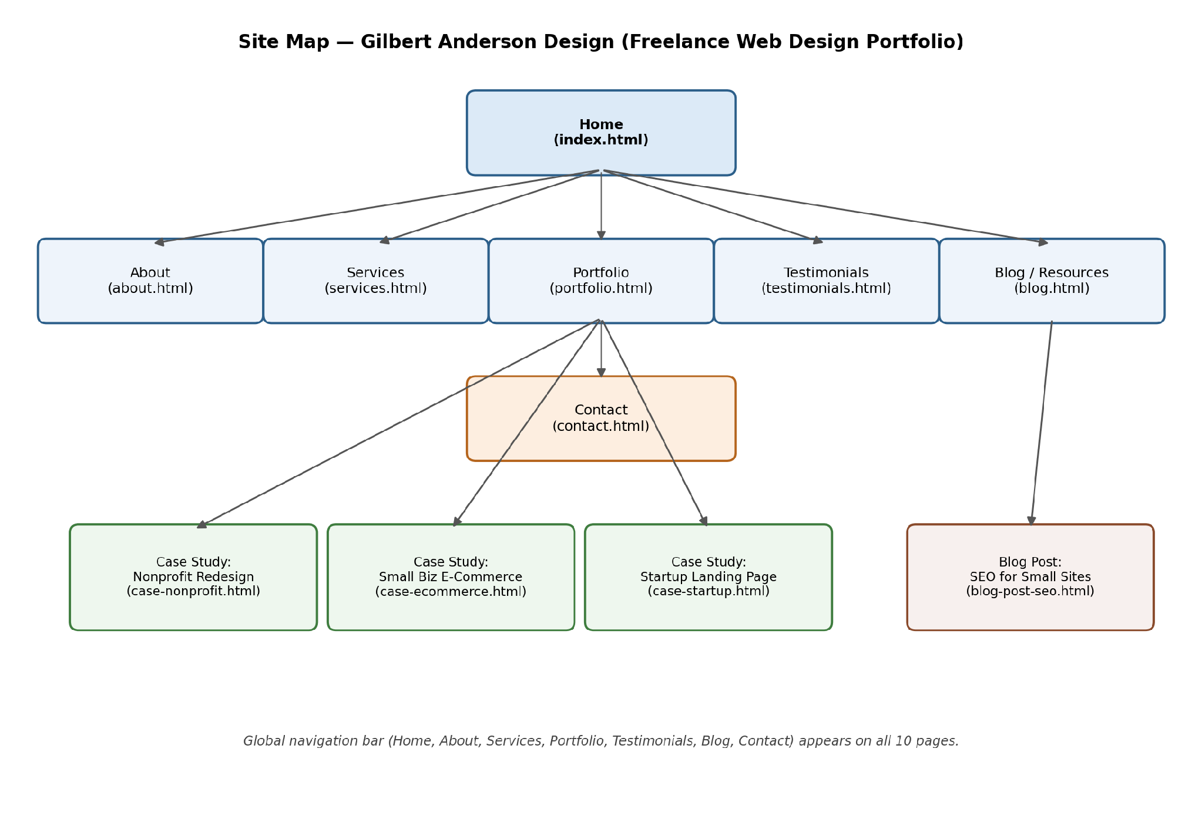
Figure 1. Site map showing all ten planned pages and their relationship to global navigation.
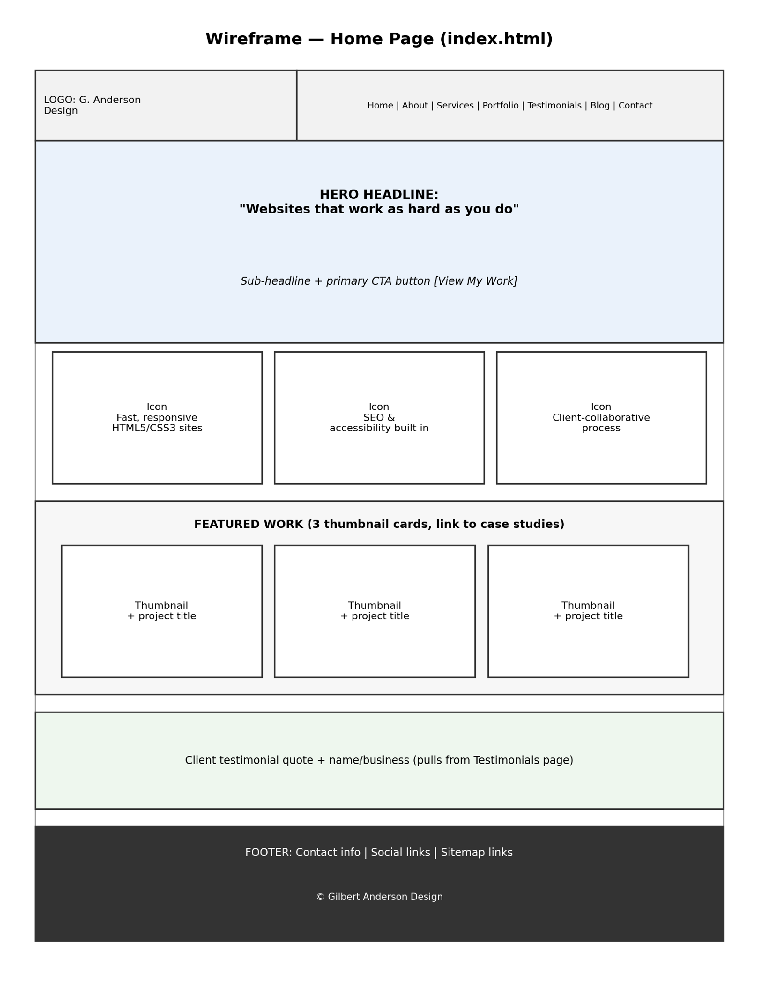
Figure 2. Wireframe of the home page (index.html).
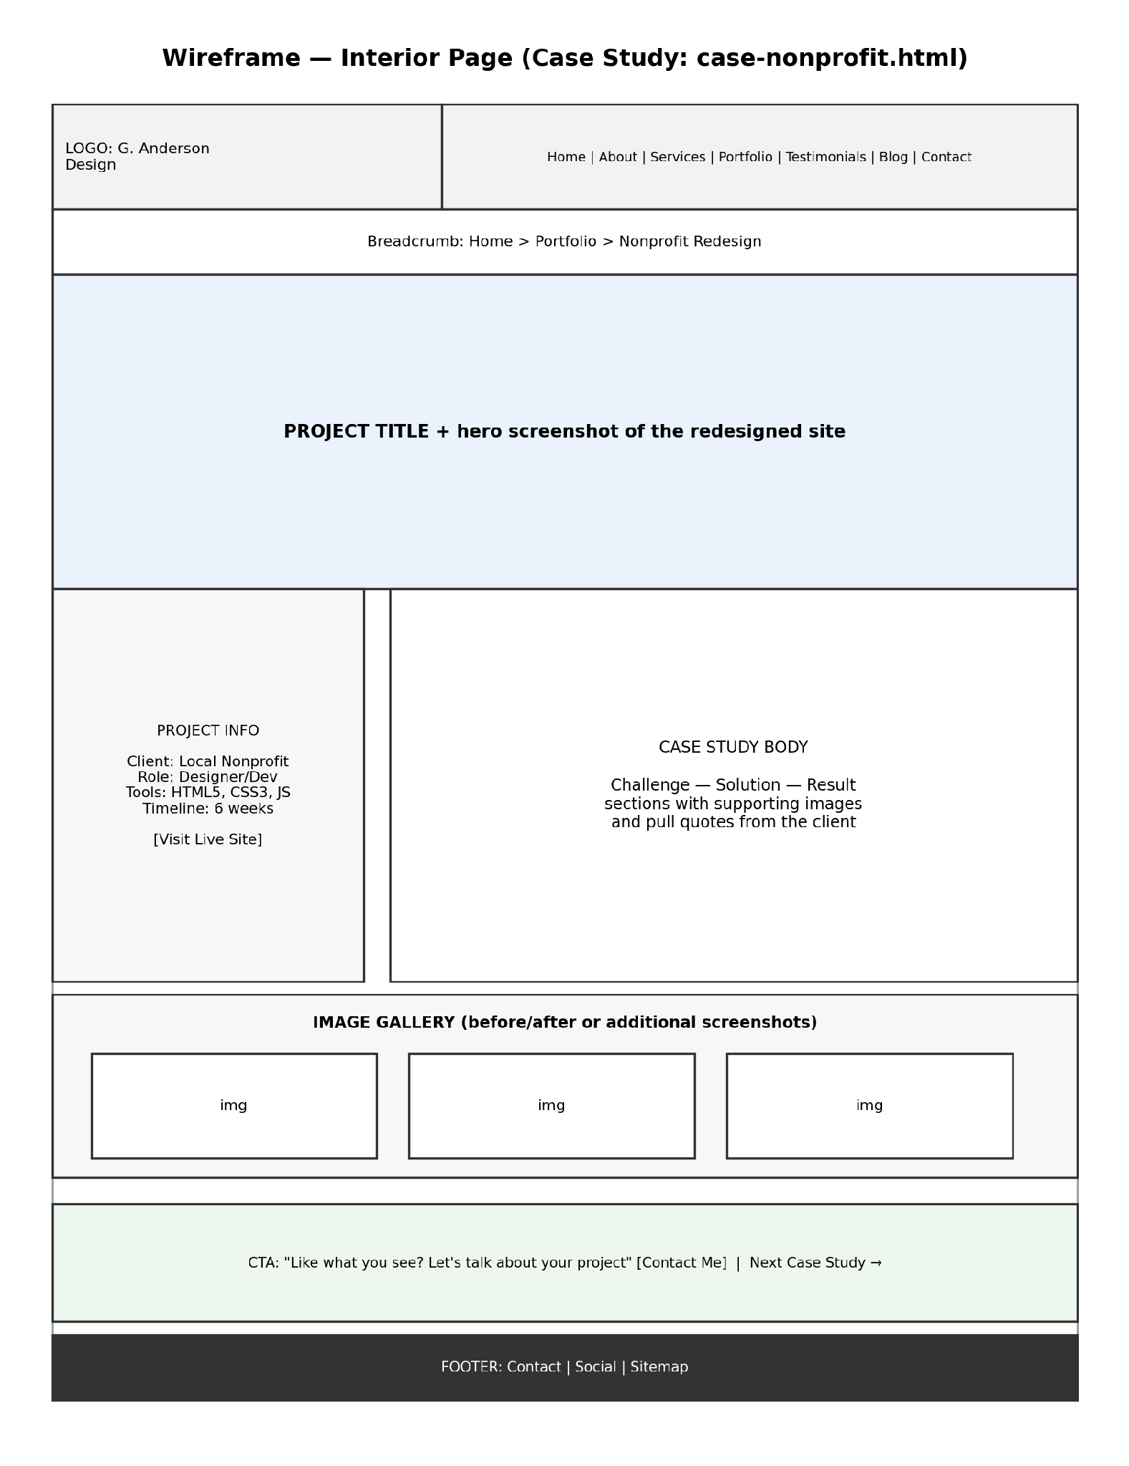
Figure 3. Wireframe of a representative interior page (case-nonprofit.html).
Version 2 (alternate wireframes)
The two wireframes below are an alternate, higher-fidelity pass at the same home page and interior page layouts described above, produced as a second iteration for comparison.
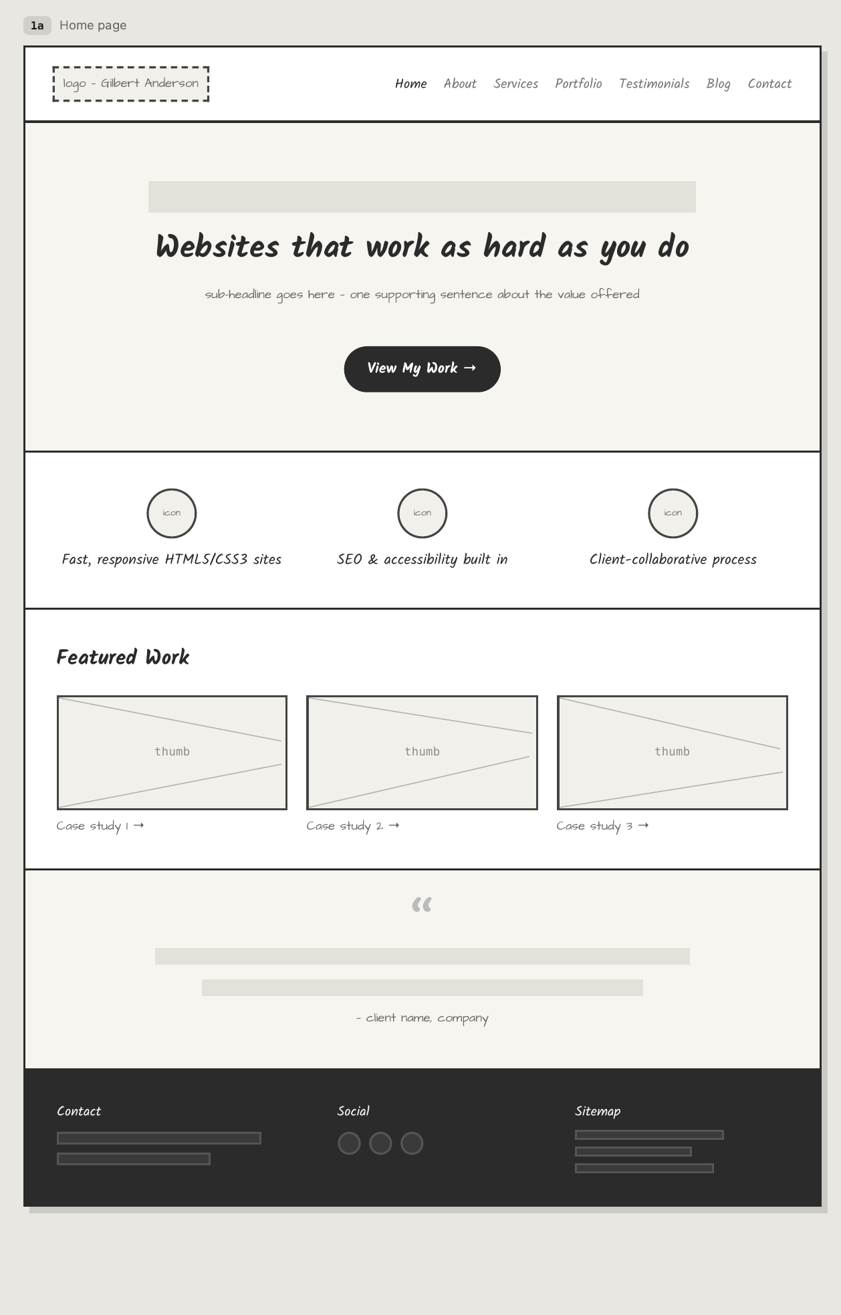
Figure 2b. Version 2 wireframe of the home page (index.html).
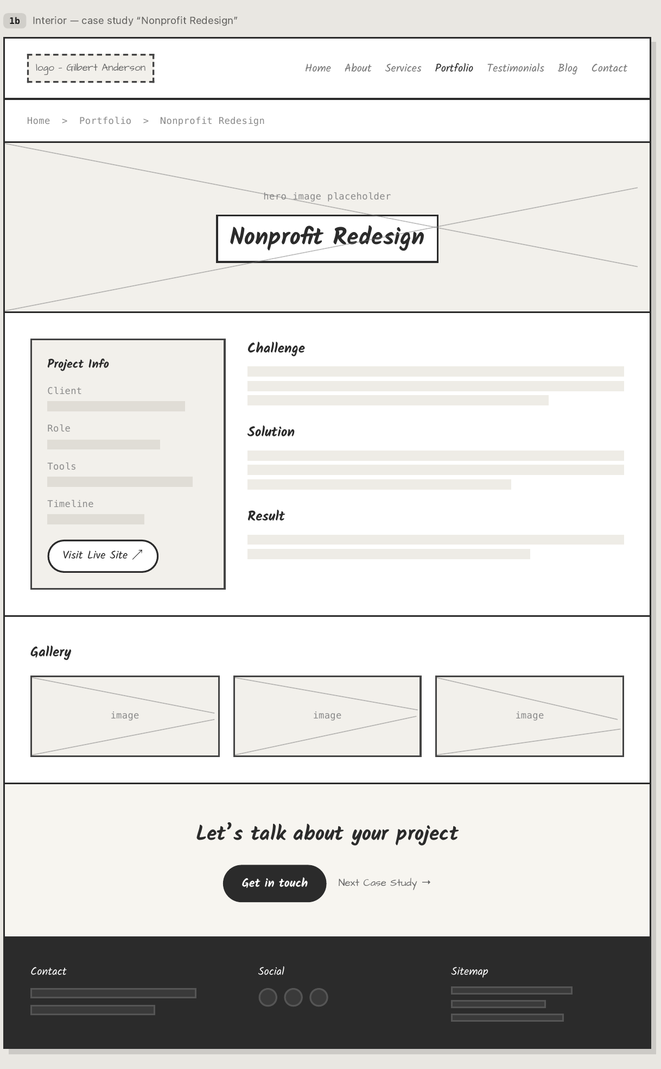
Figure 3b. Version 2 wireframe of the interior page (case-nonprofit.html).

7. Security
This website will not include an e-commerce component, since it is a portfolio and lead-generation site rather than a storefront, so there is no need for a shopping cart or payment processing at all. No content on the site will be password protected either, because in my opinion every page here is meant to be publicly viewable to prospective clients and employers, and restricting anything would work directly against the purpose of showing my work openly. The site will not ask visitors to create accounts, since the only real interaction is a one-way contact form rather than anything personalized or persistent. That said, as the designer and developer I still plan to take several concrete steps to help secure the site beyond whatever the host handles on its own: serving the entire site over HTTPS, sanitizing and validating all contact-form input on both the client and server side to guard against injection attacks, keeping any third-party scripts or plugins to a minimum and staying current on updates, and never storing anything sensitive, like form submissions, in a publicly accessible file or directory.

8. Web Hosting
I want to select a web host through an actual structured comparison rather than just grabbing the first option I come across, so my criteria will include reliability in the form of a published uptime guarantee of at least 99.9 percent, support for static HTML5, CSS3, and JavaScript hosting with a free SSL certificate included, straightforward FTP or Git-based deployment, a reasonable cost for what is ultimately a low-traffic personal site, and responsive customer support in case something breaks close to a deadline. I plan to compare at least three hosts against these criteria before committing to one, since I think it is worth resisting the pull toward whichever host happens to be the most heavily advertised.
To keep the comparison honest instead of just going with gut feeling, I will score each host from one to five on every criterion, add up the totals, and let whichever host actually comes out on top win the decision rather than talking myself into whichever one has the flashiest homepage.
As for special technology, the site needs an SSL certificate so everything can be served over HTTPS, both because browsers now flag non-secure sites and because it protects the contact form submission; it does not need a shopping cart, since there is no e-commerce component to speak of. The site will primarily run on HTML5 and CSS3, with a light amount of JavaScript for interactive pieces like the portfolio filter and the mobile navigation toggle, and a small bit of server-side scripting, something like PHP or a form-handling service, will be needed just to process the contact form, since static HTML cannot send an email on its own.
For a domain name, I identified gilbertandersondesign.com as an available option, and I chose it mainly because it combines my full name with the word design, which I think is specific enough to avoid getting confused with unrelated Andersons while still being easy to say, spell, and remember for a client who wants to find me again later. Using my real name also builds personal-brand recognition in a way that a more generic name like webstudio simply would not, at least in my opinion.

9. Marketing
I plan to market the website mostly through direct outreach and my own existing network rather than paid advertising, so that means sharing the link on LinkedIn and other professional profiles, including it in email signatures and freelance-platform profiles, and referencing it directly whenever I pitch a potential client or employer. Based on what I have learned so far in this course, I intend to apply several SEO elements while planning and building the site: descriptive, keyword-relevant page titles and meta descriptions for every page, a clear single-h1 heading hierarchy throughout, descriptive alt text on all images including the case-study screenshots, semantic HTML5 structure so search engines can actually parse the content accurately, and internal links between related pages, for example linking each case study back to the Services page, using descriptive anchor text rather than a generic click here.

10. Project Reflection
Working through the planning documents for this proposal ended up teaching me almost as much as the writing itself did. For the two wireframes, I chose not to use the two GUI tools suggested in the assignment, Justinmind and Framebox, and instead built the wireframes programmatically in Python using the Matplotlib library, treating each layout element as a labeled rectangle placed at specific coordinates. I personally found this approach pretty simple once I had it set up, arguably simpler than learning a brand new drag-and-drop interface, since I already write Python fairly regularly for other coursework, and defining positions in code let me adjust spacing precisely and rerun the script instantly instead of manually dragging boxes around a canvas. The catch is that it is less visual while I am actually designing, since I cannot see the layout until I run the script, so I found myself sketching rough versions on paper first and translating them into code afterward.
Building the site map and flowchart diagram taught me how much decision-making actually goes into information architecture before a single page of HTML ever gets written. Deciding that the site should stay flat, with every page no more than one click from the homepage, forced me to be honest about which pages genuinely deserved to be top-level navigation items and which ones, like individual blog posts or case studies, belonged nested a level deeper, and seeing those relationships drawn out as boxes and arrows made gaps in my navigation plan obvious in a way that a plain text outline never had. Like the wireframes, I did not use one of the three listed diagramming tools, meaning diagrams.net, Gliffy, or draw.io; I used Matplotlib again so that the whole proposal's visuals would share one consistent style and so I could keep the diagram source under version control alongside my other project files instead of depending on a separate account or service. Though I enjoy the simplicity of draw.io and Matplotlib, I decided to use a more professional design tool. I tried Figma Design first, but the last wireframes were made in Claude Design, my new favorite.
The main challenge I ran into while developing the primary navigation was reconciling two different audiences with different priorities inside a single, short navigation bar: business-minded visitors who want to see Services and Portfolio first, and evaluator-minded visitors like recruiters who want About and technical case-study detail instead. I resolved this by keeping the navigation itself audience-neutral, meaning Home, About, Services, Portfolio, Testimonials, Blog, and Contact in that order, and pushing the audience-specific framing into the page content itself, such as leading each case study with a plain-language summary before getting into the technical detail, rather than trying to build two separate navigation paths that would have made an already seven-item menu even more cluttered.
For anyone new to building a project like this, I suspect the most common challenges would be underestimating how much planning a ten-page site actually requires before writing any code at all, and struggling to keep navigation and page templates consistent across many separate HTML files without some kind of shared include or template system, which is really the exact maintenance problem I planned around in the Growth and Maintenance section above.

References
Nielsen Norman Group. (n.d.). Personas. https://www.nngroup.com/topic/personas/
HubSpot. (n.d.). Target audience: How to find yours. https://blog.hubspot.com/marketing/target-audience
Elementor. (n.d.). How to choose a web host: The ultimate guide for web creators. https://elementor.com/blog/how-to-choose-a-web-host/
Moz. (n.d.). Meta description. https://moz.com/learn/seo/meta-description
W3C Web Accessibility Initiative. (n.d.). Introduction to web accessibility. https://www.w3.org/WAI/fundamentals/accessibility-intro/

