Project 1: Web Project Proposal
Course: CMST 387 6300 — Principles of Web Design and Technology III
Student: Gilbert Anderson
Proposed site: CMST 387 Web Design Resource Hub
Deployment target: https://cmst387-umgc-ganderson58.azurewebsites.net

Project Overview
This proposal describes a Web Design Resource Hub: an educational site that collects practical guidance across the five core areas of this course — User Experience Design, Accessibility and Inclusive Design, Web Application Security, Website Optimization, and Responsive Web Design — into a single, well-organized reference for students and early-career web developers.
The site has an unusual obligation. A resource hub that teaches accessibility must itself be accessible; a hub that teaches responsive design must itself be responsive; a hub that teaches optimization cannot ship a bloated page. The site is therefore its own primary demonstration, and every claim it makes is verifiable by inspecting the site that makes it. Failing any of these standards would undermine the content directly.
Intended audience. Students in web development programs, career-changers learning front-end development, and working developers needing a quick reference. This audience is global and linguistically diverse — web development draws heavily from non-native English speakers reading English-language documentation. It includes developers with disabilities, who are underserved by technical documentation that is itself inaccessible. It spans a wide device and bandwidth range: developers read documentation on desktop workstations while coding, and on phones while commuting or away from a desk.
Site scope. A homepage introducing the hub, five topic sections corresponding to the course areas above, and a responsive contact form. Full page inventory appears in the Site Structure section, with wireframes and a site map in Sections 13 and 14.
Accessibility targets throughout are stated against WCAG 2.2 Level AA, the current W3C Recommendation and the standard aligned with Section 508 expectations for educational content.

Proposed Site Structure
Home | Introduces the hub, states its purpose, and provides entry points to all five topic areas
UX Design | Design principles, usability heuristics, user research methods, UX artifacts
Accessibility & Inclusive Design | WCAG conformance, assistive technology, inclusive design methodology
Web Application Security | HTTPS/TLS, input validation, XSS and CSRF defense, secure headers, authentication
Website Optimization | Performance budgets, image optimization, caching, Core Web Vitals
Responsive Web Design | Mobile-first method, fluid grids, breakpoints, responsive media
Contact | Responsive, accessible contact form with validation and confirmation
About | Scope of the hub, author, accessibility statement

1. Design Principles for Navigability
Navigation will be grounded in established principles rather than ad-hoc decisions.
Consistency and predictability. The primary navigation will appear in the same location with the same ordering on every page, satisfying WCAG 2.4.5 (Multiple Ways) and 3.2.3 (Consistent Navigation). Users build a mental model of a site within the first few pages; relocating or reordering navigation destroys that model and disproportionately harms users with cognitive disabilities and screen reader users who navigate by landmark.
Recognition over recall. Nielsen's heuristic applies directly to reference material. Persistent breadcrumbs, a visible "you are here" state in the navigation, and descriptive link text ("Read the guide to responsive images" rather than "Click here") let users orient themselves without holding site structure in working memory. A reader who arrives from a search engine on an interior page must be able to tell immediately where they are.
Visibility of system status. Loading states, form validation, and confirmation messages will be announced both visually and programmatically through ARIA live regions, so sighted and non-sighted users receive the same feedback at the same time.
Clear information scent. Section labels will use terms the audience actually searches for. "Website Optimization" is more findable than "Performance Engineering"; "Web Application Security" is more findable than "Hardening." Labels are a navigation decision: a link is findable only when its wording matches the reader's vocabulary.
Progressive disclosure. Each topic section opens with a plain-language overview before descending into technical specifics, so a beginner is not confronted with the same density as a practitioner looking up a detail.
Forgiveness. No page will be a dead end; every page offers onward routes to related topics. Form errors will be recoverable without loss of entered data.

2. Optimizing Layout for Desktop and Mobile
The site will use a mobile-first responsive approach, building the single-column small-screen layout first and progressively enhancing to multi-column arrangements at larger viewports. Mobile-first enforces content prioritization: if a module cannot justify its place in a 375px column, it rarely deserves prominence at 1440px.
Implementation will use CSS Grid and Flexbox with fluid units (rem, %, fr, clamp()) rather than fixed pixel widths, so layout responds to both viewport size and user-set text size. Breakpoints will be placed where the content breaks rather than at named device widths, which age poorly as devices change.
The layout must satisfy WCAG 1.4.10 (Reflow): content remains usable at 320 CSS pixels wide without two-dimensional scrolling. This is the same requirement as supporting 400% zoom on a 1280px desktop display — a single technical solution serving both low-vision desktop users and mobile users, a clear instance of the curb-cut effect.
Desktop-specific optimizations. Wider viewports gain a persistent sidebar table of contents for long technical articles, and a constrained reading measure of 60–75 characters rather than full-width text, which becomes difficult to track across a wide monitor.
Mobile-specific optimizations. Navigation collapses to a labeled menu button — labeled "Menu" rather than relying on an unlabeled hamburger icon. Touch targets meet WCAG 2.5.8 (Target Size, Minimum) at 24×24 CSS pixels, with 44×44 for primary actions and adequate spacing to prevent mis-taps. Hover-dependent interactions are avoided entirely, since hover does not exist on touch; anything revealed on hover is also reachable by focus and tap.
Code samples, which this site will contain heavily, present a specific responsive challenge: they cannot reflow arbitrarily without changing meaning. They will scroll horizontally within their own container rather than forcing the whole page to scroll sideways, with a visible scroll affordance.
Performance is treated as an accessibility concern: responsive images via srcset, compressed assets, and core content that functions without JavaScript.

3. Accessibility Testing Methods
The following methods could be employed to verify the design. No user testing will be conducted as part of this project; this section identifies appropriate methods and the distinct defect classes each surfaces.
Automated scanning would run continuously against every build (see Section 5). Automated tools reliably catch missing alternative text, insufficient contrast, missing form labels, and invalid ARIA. They are fast and repeatable, but industry estimates consistently place automated detection at roughly 30–40% of WCAG issues. A tool can confirm alt text exists; it cannot judge whether the text is meaningful, or whether a heading structure is logical.
Manual keyboard-only testing would verify that every interactive element is reachable and operable via Tab, Shift+Tab, Enter, Space, and arrow keys; that focus order follows visual order; that focus indicators remain visible and unobscured (2.4.11); and that no keyboard trap exists. This is the highest-yield manual test relative to time invested.
Screen reader testing across NVDA with Firefox, JAWS with Chrome, and VoiceOver with Safari, plus TalkBack on Android, would confirm content is announced in sensible order with correct roles, states, and names. Multiple pairings matter because screen reader and browser combinations differ meaningfully in ARIA support. For this site, screen reader testing of code blocks deserves specific attention, since punctuation-dense samples are announced poorly by default.
Expert heuristic evaluation against WCAG 2.2 AA success criteria and Nielsen's ten heuristics provides structured expert review at low cost.
Cognitive walkthrough would step through core tasks — "find guidance on preventing XSS," "submit a question through the contact form" — asking at each step whether a first-time user would know what to do and would recognize progress toward the goal.
Usability testing with participants with disabilities most directly validates real-world usability and would be the recommended next step beyond this proposal. Automated and expert methods find violations; only testing with actual assistive technology users reveals whether the site is genuinely usable rather than merely conformant.
Zoom, reflow, and simulation testing would complete coverage: 400% browser zoom, text-only zoom, Windows High Contrast Mode, and color-blindness simulators.

4. Features Supporting Specific Impairments
Visual impairments. Semantic HTML with correct heading hierarchy and ARIA landmarks provides screen reader structure. Meaningful images — including diagrams explaining responsive breakpoints or request flows — receive descriptive alternative text, with complex diagrams additionally described in adjacent body text, since a one-line alt cannot carry a full architectural diagram. Decorative images receive alt="". Text contrast meets 4.5:1, and 3:1 for large text and UI components (1.4.11). Syntax highlighting in code samples will be contrast-checked, as popular highlighting themes routinely fail against their backgrounds. Color never carries meaning alone. The site supports 400% zoom and honors user text spacing (1.4.12). A "skip to main content" link opens the tab order.
Auditory impairments. Any video tutorial carries accurate synchronized captions (1.2.2) and a full transcript (1.2.1), with audio description of essential visual information where a demonstration shows code on screen (1.2.5). Text remains the primary format for technical content rather than video-only explanation, which serves deaf users, non-native speakers, and anyone who prefers to scan rather than watch. No information is conveyed by sound alone.
Motor impairments. Full keyboard operability with no keyboard traps (2.1.1, 2.1.2) is baseline. Targets meet 2.5.8 with generous spacing. Any drag-based interaction provides a single-pointer alternative (2.5.7, Dragging Movements). The contact form imposes no time limit (2.2.1) and preserves entered data on validation failure, so a slow typist is never forced to re-enter a long question. "Copy code" buttons give keyboard users an alternative to manually selecting text across a multi-line block.
Cognitive impairments. Plain language, short paragraphs, and generous white space reduce load. Consistent navigation prevents disorientation. Multi-step technical processes are broken into numbered steps with visible progress. Technical jargon is defined on first use and collected in a glossary — significant on a site whose subject matter is dense with acronyms (CSRF, TLS, LCP, ARIA). Error messages identify the problem and state the fix (3.3.3). Autoplay, unexpected motion, and flashing are avoided (2.3.1), and prefers-reduced-motion is honored. Icons pair with text labels rather than standing alone.
Organizing by impairment category is a useful device, but the intent is universal: captions serve someone in a quiet library, plain language serves a tired reader at midnight, and large targets serve anyone using a phone one-handed.

5. Automated Compliance Tools
Automated checking would operate at three layers so defects are caught as early as possible.
During development, the axe DevTools browser extension and WAVE (WebAIM) give immediate in-browser feedback while a page is being built. Lighthouse, built into Chrome DevTools, contributes an accessibility score alongside the performance metrics this site also cares about.
In continuous integration, Pa11y CI or axe-core would run against every push to the project's GitHub repository, wired into the existing GitHub Actions workflow that deploys this site to Azure App Service. Configuring the build to fail on new violations prevents regressions from reaching production — the decisive advantage of automation over periodic manual audits. This also demonstrates the site's own subject matter, since the same pipeline can run Lighthouse CI for optimization budgets.
For ongoing monitoring, the IBM Equal Access Accessibility Checker and ARC Toolkit add rule coverage beyond axe, and crawlers such as Siteimprove or Tenon.io can scan the full site on a schedule and trend results over time.
Supporting checks include the W3C Markup Validation Service (valid HTML underpins assistive technology support), the WebAIM Contrast Checker during design, and readability scoring through the Hemingway Editor or Flesch-Kincaid analysis.
Two caveats must accompany any automated program. First, these tools verify roughly a third of WCAG criteria; a clean scan is a floor, not a certificate of conformance. Second, rule sets must be kept current as standards evolve — a stale scanner silently stops testing against the standard it claims to enforce.

6. Cultural Differences and Language Needs
The site declares its language with the lang attribute (3.1.1) and marks inline-language passages with lang on the containing element (3.1.2), so screen readers switch pronunciation rather than reading foreign text with English phonetics.
Content will be written in plain, idiom-free English. This matters acutely for a technical audience: web development documentation is read worldwide by non-native English speakers, and idioms, sports metaphors, and cultural shorthand ("out of the box," "silver bullet," "down to the wire") are exactly the constructions that fail those readers and defeat translation tools. Technical acronyms will be expanded on first use.
Formats will not assume a single locale. Dates appear unambiguously ("March 4, 2026" rather than 3/4/26, which reads as April 3 in much of the world). Times state their zone. The contact form accepts international name, address, and phone formats rather than enforcing US-only patterns — and notably will not require a "first name / last name" split, which misrepresents naming conventions in much of the world.
Examples and imagery will represent a range of ages, ethnicities, abilities, and backgrounds rather than defaulting to a narrow stereotype of who writes code. Sample data in code examples will use varied, non-US-centric names and addresses, since example code is itself a quiet signal about who the material is written for. Icons will be checked for culturally specific meanings.
Structurally, the design accommodates text expansion — translated German or Spanish text can run 30% longer than English — by avoiding fixed-width containers that would clip or overflow. Where translation is offered, professionally translated key pages are preferable to machine translation for security guidance, where a mistranslation could produce an insecure implementation. Right-to-left support via CSS logical properties is a reasonable enhancement.

7. Collecting User Feedback for Inclusivity
Feedback mechanisms must themselves be accessible, or they systematically exclude the users whose input matters most.
An accessibility feedback link will appear in the site footer on every page, offering multiple channels — form, email, and an alternative contact method — since a user blocked by an inaccessible form needs a different route to report exactly that problem.
The contact form itself doubles as a general feedback channel, with an optional category selector so accessibility reports can be triaged distinctly from content questions.
A short, optional on-page prompt ("Was this page helpful?") would gather lightweight per-page signal without a modal interruption, and would remain fully keyboard- and screen-reader-operable.
Analytics identify friction indirectly: high-exit pages, failed internal searches (a direct signal of vocabulary mismatch between the site's terms and the reader's), and rage-clicks. Analytics reveal where users struggle but never why, so they generate questions rather than answers.
Selecting methods deliberately rather than by convenience. Rohr (2022) frames UX research methods along three dimensions — attitudinal vs. behavioral, qualitative vs. quantitative, and context of use — and that framework explains why no single mechanism above is sufficient. Analytics are behavioral and quantitative: they record what users did, at scale, but cannot explain intent. Surveys and the "was this helpful?" prompt are attitudinal: they capture what users say, which may diverge from what they do. Usability testing is behavioral and qualitative: small samples, but it reveals causes. An inclusive feedback program needs coverage across all three dimensions, because a program built only from analytics will systematically miss the users whose difficulties cause them to leave before generating any signal at all — exactly the users this site most needs to hear from.
Community channels — a public issue tracker on the project's GitHub repository — suit this audience specifically, since developers are already comfortable filing issues and will often supply precise reproduction steps and environment details.
Recruited usability sessions and an advisory panel of compensated participants including assistive technology users, ESL developers, and beginners would provide structured qualitative input on a recurring basis.
Feedback must close the loop. Reports that vanish without acknowledgment train users to stop reporting. A published response commitment and a visible changelog of accessibility fixes demonstrate that input produces change.

8. Inclusive Design Methodologies
Gilbert (2019) frames inclusive design as a practice spanning compliance, assistive technology, and design strategy rather than a checklist applied at the end — the position this proposal adopts throughout. Two of that work's arguments shape the sections above directly: that understanding how assistive technologies actually operate is a prerequisite for designing for them (which is why Section 3 specifies screen reader and browser pairings rather than treating "screen reader testing" as a single undifferentiated activity), and that legal compliance is a floor rather than a goal (which is why this proposal targets AA and deliberately exceeds it where the audience benefits).
The project further draws on the Microsoft Inclusive Design framework and its three principles: recognize exclusion, solve for one, extend to many, and learn from diversity. Its most useful instrument here is the persona spectrum, which reframes disability as a spectrum of permanent, temporary, and situational constraints. One-handed use covers a developer with a permanent limb difference, a developer with a broken wrist, and a developer holding a coffee on a train. Designing for the permanent case serves all three and sharply increases the population served by any accommodation.
Universal Design's seven principles — equitable use, flexibility in use, simple and intuitive use, perceptible information, tolerance for error, low physical effort, and appropriate size and space — provide a design-stage checklist complementing WCAG's verification-stage criteria.
POUR (Perceivable, Operable, Understandable, Robust) organizes the work around WCAG's own conceptual structure.
Personalization philosophy: respect existing system preferences rather than requiring reconfiguration. Honoring prefers-reduced-motion, prefers-color-scheme, and prefers-contrast means a user who has already configured their operating system gets an appropriate experience immediately, with no per-site setup. Site-level controls (Section 10) supplement these defaults rather than replacing them.
Personalization specific to this hub's purpose: content is layered so a beginner and a practitioner can use the same page differently — a plain-language summary and a "why this matters" framing above, with implementation detail, specification references, and edge cases disclosed progressively below. This is personalization through content structure rather than through user profiling, which avoids collecting personal data the site has no need to hold — itself a security and privacy decision consistent with the hub's own material.
Two further commitments: inclusive research recruitment, ensuring participants include disabled users, ESL speakers, and beginners rather than treating a convenience sample as representative; and progressive enhancement, so the site delivers a functional experience on older browsers and constrained connections rather than failing entirely.

9. Accessible Interactive Elements
Every interactive element will be built on native HTML controls wherever possible. A <button> is focusable, keyboard-operable, and correctly announced with no additional work; a <div> styled to look like a button is none of those things until substantial ARIA and JavaScript recreate what the browser already provided. Native-first is the single most effective decision in this section.
Each control exposes an accessible name, role, and state. Icon-only controls receive aria-label or visually hidden text. Toggles expose aria-pressed or aria-expanded so state is announced, not merely displayed visually.
Focus management will be explicit. Focus indicators remain clearly visible and never obscured by sticky headers (2.4.11). Opening a modal moves focus into the dialog and traps it there until dismissal; closing returns focus to the triggering element. Without this, keyboard users are silently stranded behind an invisible overlay.
Custom widgets — the accordions and tabbed code samples this site will use for progressive disclosure — follow WAI-ARIA Authoring Practices Guide patterns for expected keyboard behavior: arrow keys within a tab list, Escape to close, Home/End for first and last.
The contact form, as the site's primary interactive element, receives particular attention: programmatically associated <label> elements, related inputs grouped in <fieldset> with <legend>, aria-describedby conveying format requirements before submission rather than only after failure, aria-invalid marking errors, an error summary at the top of the form linking to each problem field, and messages that name the field and explain the fix. Autocomplete attributes (1.3.5) let browsers fill known values, reducing effort for users with motor and cognitive disabilities.
Dynamic content announces itself through appropriately scoped ARIA live regions — polite for status updates, assertive reserved for genuine urgency, since overuse produces an interruption stream users learn to tune out.
CAPTCHAs will be avoided in favor of honeypot fields and server-side validation. This is both an accessibility decision — CAPTCHAs are broadly hostile to users with visual and cognitive disabilities — and a worked example of the security/accessibility tradeoff the hub's own security section discusses.

10. User Customization Mechanisms
The baseline commitment is that the site works with browser and OS settings out of the box. Sizing text in rem rather than px means browser text-size preferences take effect immediately. Honoring prefers-color-scheme, prefers-contrast, and prefers-reduced-motion means system-level choices are respected without configuration. The site remains fully usable at 200% and 400% zoom and does not defeat browser reader modes or user stylesheets.
On top of that baseline, an accessibility settings panel — reachable from every page and itself fully keyboard-accessible — would offer:
- Text size controls stepping through defined scales, with layout that reflows rather than clipping.
- Contrast and theme options including light, dark, and high-contrast, all meeting or exceeding 4.5:1. Dark mode has practical appeal for this audience, who often work in dark editors, but it will be implemented as a genuine contrast-checked palette rather than an inverted filter.
- Reduced motion, disabling animations, transitions, and parallax.
- Line spacing and reading width, constraining measure to 60–75 characters — a meaningful aid for dyslexic readers working through long technical prose.
- Dyslexia-friendly typeface as an opt-in alternative.
- Underlined links for users who cannot distinguish links by color alone.
- Code sample font size, adjustable independently of body text, since monospace faces render smaller at equivalent point sizes and code density is a known readability barrier.
Preferences persist across sessions via localStorage and apply site-wide, so settings are configured once rather than re-selected each visit. Controls use clear text labels rather than icons alone, and a visible "reset to defaults" option lets users recover from a configuration that made things worse.
The guiding constraint: customization supplements good defaults, it does not excuse them. A site that is inaccessible until reconfigured has shifted its own obligation onto the user.

11. Information Architecture
The IA is organized by learning topic rather than by content type. Grouping everything into "Articles," "Tutorials," and "References" would force users to already know what format their answer lives in — the precise knowledge a learner lacks. The five course areas provide a natural, mutually comprehensible top level.
Structure would be validated through card sorting (open sorting to learn users' own mental groupings, closed sorting to test the proposed structure) and tree testing, which measures whether users can locate items in a proposed hierarchy independent of visual design. Tree testing is especially valuable here because topic boundaries genuinely blur — image optimization is arguably Optimization, Responsive Design, and Accessibility — and testing reveals where users actually expect to find such material.
Depth will be constrained to roughly three clicks to any resource, with a broad, shallow hierarchy preferred over a deep one. Categories will be mutually exclusive where possible, with deliberate cross-linking for genuinely cross-cutting topics rather than arbitrary assignment to one section.
Multiple navigation paths (2.4.5) accommodate different strategies: browsers use the topic navigation; searchers use site search with synonym mapping so "a11y," "accessibility," and "WCAG" all resolve, and "speed," "performance," and "optimization" converge; returning users use breadcrumbs and a quick-links block.
To cater to varying comprehension levels, every topic page is layered: a plain-language summary and a "why this matters" framing first, then core guidance, then advanced detail and specification references. This serves a beginner and a practitioner without forcing either to read the other's version — the single most important IA decision for an audience whose expertise ranges from first-semester student to working professional.
Page titles and headings will be descriptive and unique (2.4.2, 2.4.6), forming a navigable outline for screen reader users, who commonly move through a page by heading rather than reading linearly.

12. Readability Guidelines
Content will target approximately an 8th-grade reading level for overview and introductory material, measured with Flesch-Kincaid or the Hemingway Editor. WCAG 3.1.5 (Reading Level) sets lower secondary education as a AAA criterion; while this proposal targets AA overall, readability is a reasonable place to exceed baseline, because it is where technical documentation most reliably fails its readers.
A necessary qualification: technical accuracy sometimes requires technical vocabulary. The standard applied is not "eliminate all difficult words" but "never make a reader look up a term the page could have defined." Where precision demands a term like "cross-site request forgery," the page defines it in plain language on first use rather than assuming it.
Specific guidelines to be followed:
- Plain language principles per plainlanguage.gov: active voice, common words over formal alternatives ("use" over "utilize"), concrete rather than abstract phrasing.
- Short sentences and paragraphs — roughly 15–20 words per sentence, 3–4 sentences per paragraph — with one idea per paragraph.
- Front-loaded content, stating the conclusion first and supporting detail after. Readers scan; burying the actual recommendation in the fourth paragraph guarantees it is missed.
- Descriptive headings and subheadings breaking text into scannable sections.
- Bulleted lists and tables for parallel or comparative information rather than dense prose.
- Defined jargon and a glossary for recurring terminology, with acronyms expanded on first use per page rather than only once site-wide, since search traffic lands readers mid-site.
- Meaningful link text describing its destination out of context, since screen reader users often navigate by pulling up a list of links alone.
- Commented, explained code samples, since a code block is content a reader must parse: each is preceded by a plain-language statement of what it does and why.
- Typographic support: minimum 16px body text, line height near 1.5, measure constrained to 60–75 characters, left-aligned rather than justified text (justification creates uneven "rivers" of white space that impede dyslexic readers), and mixed case rather than all-caps.
Content would be validated by readability scoring on every substantive page and, ideally, by comprehension testing in which readers explain a concept in their own words — the only reliable test of whether writing was understood rather than merely scored.

Conclusion
The decisions in this proposal share a premise: accessibility and inclusive design are structural properties established during architecture and content design, not a remediation pass applied before launch. Retrofitting accessibility costs more and produces worse results than designing for it from the start.
The proposed Web Design Resource Hub targets WCAG 2.2 Level AA conformance, verified through automated scanning in the deployment pipeline, structured manual testing, and — as a recommended extension beyond this project — usability testing with developers who use assistive technology daily. The site's distinguishing constraint is that it must embody every practice it documents. The measure of success is not a passing automated score but whether a reader can find and understand what they need on the first attempt, using whatever device, connection, and assistive technology they have.

Wireframes and Site Map
The low-fidelity wireframes and site map below translate the structural and accessibility decisions described in Sections 1 through 12 into concrete page layouts. Each wireframe shows both the desktop (1280px and above) and mobile (375px) arrangement of the same content, and annotates the specific accessibility features called out elsewhere in this proposal.
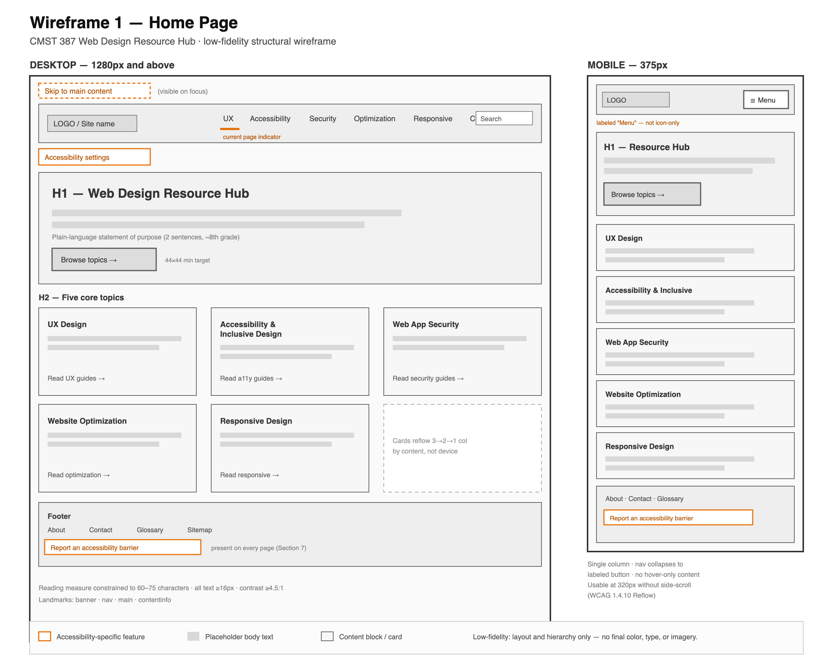
Figure 1. Home page wireframe (desktop and mobile).
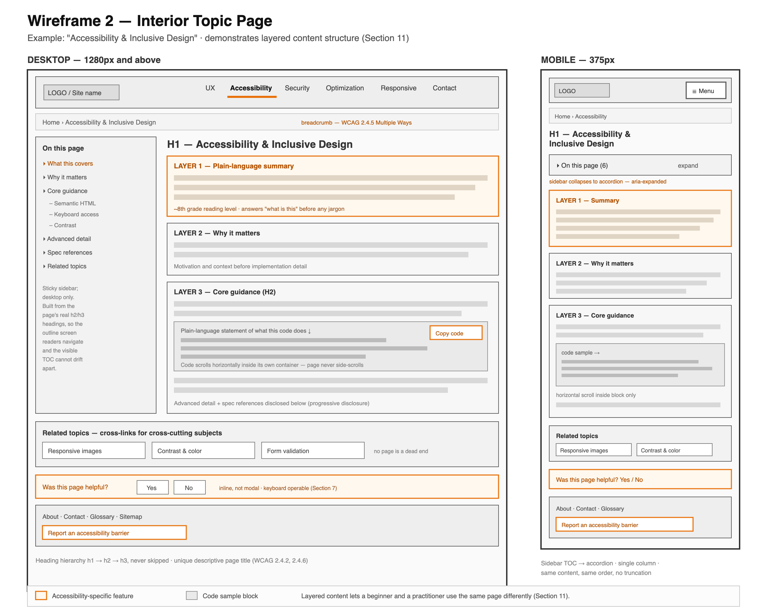
Figure 2. Interior topic page wireframe (desktop and mobile).
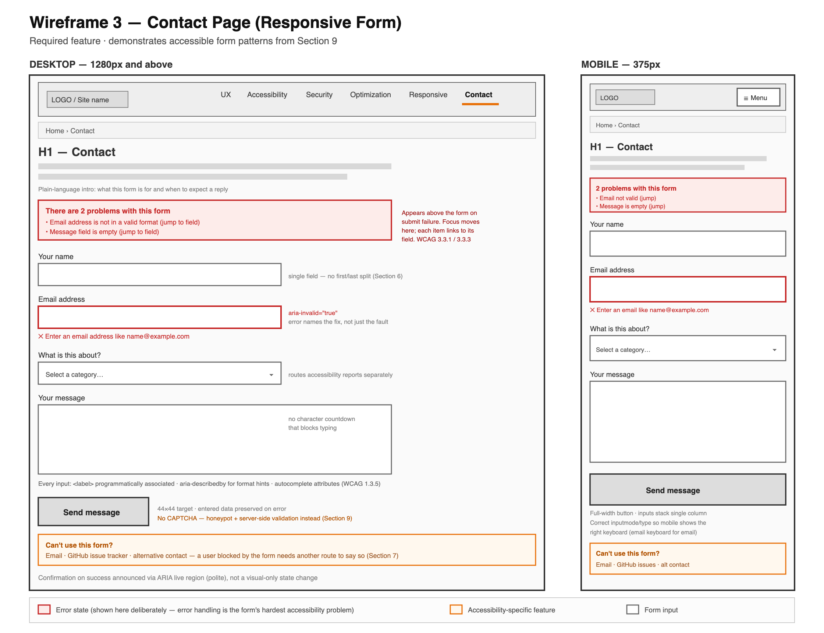
Figure 3. Contact page wireframe with responsive form (desktop and mobile).
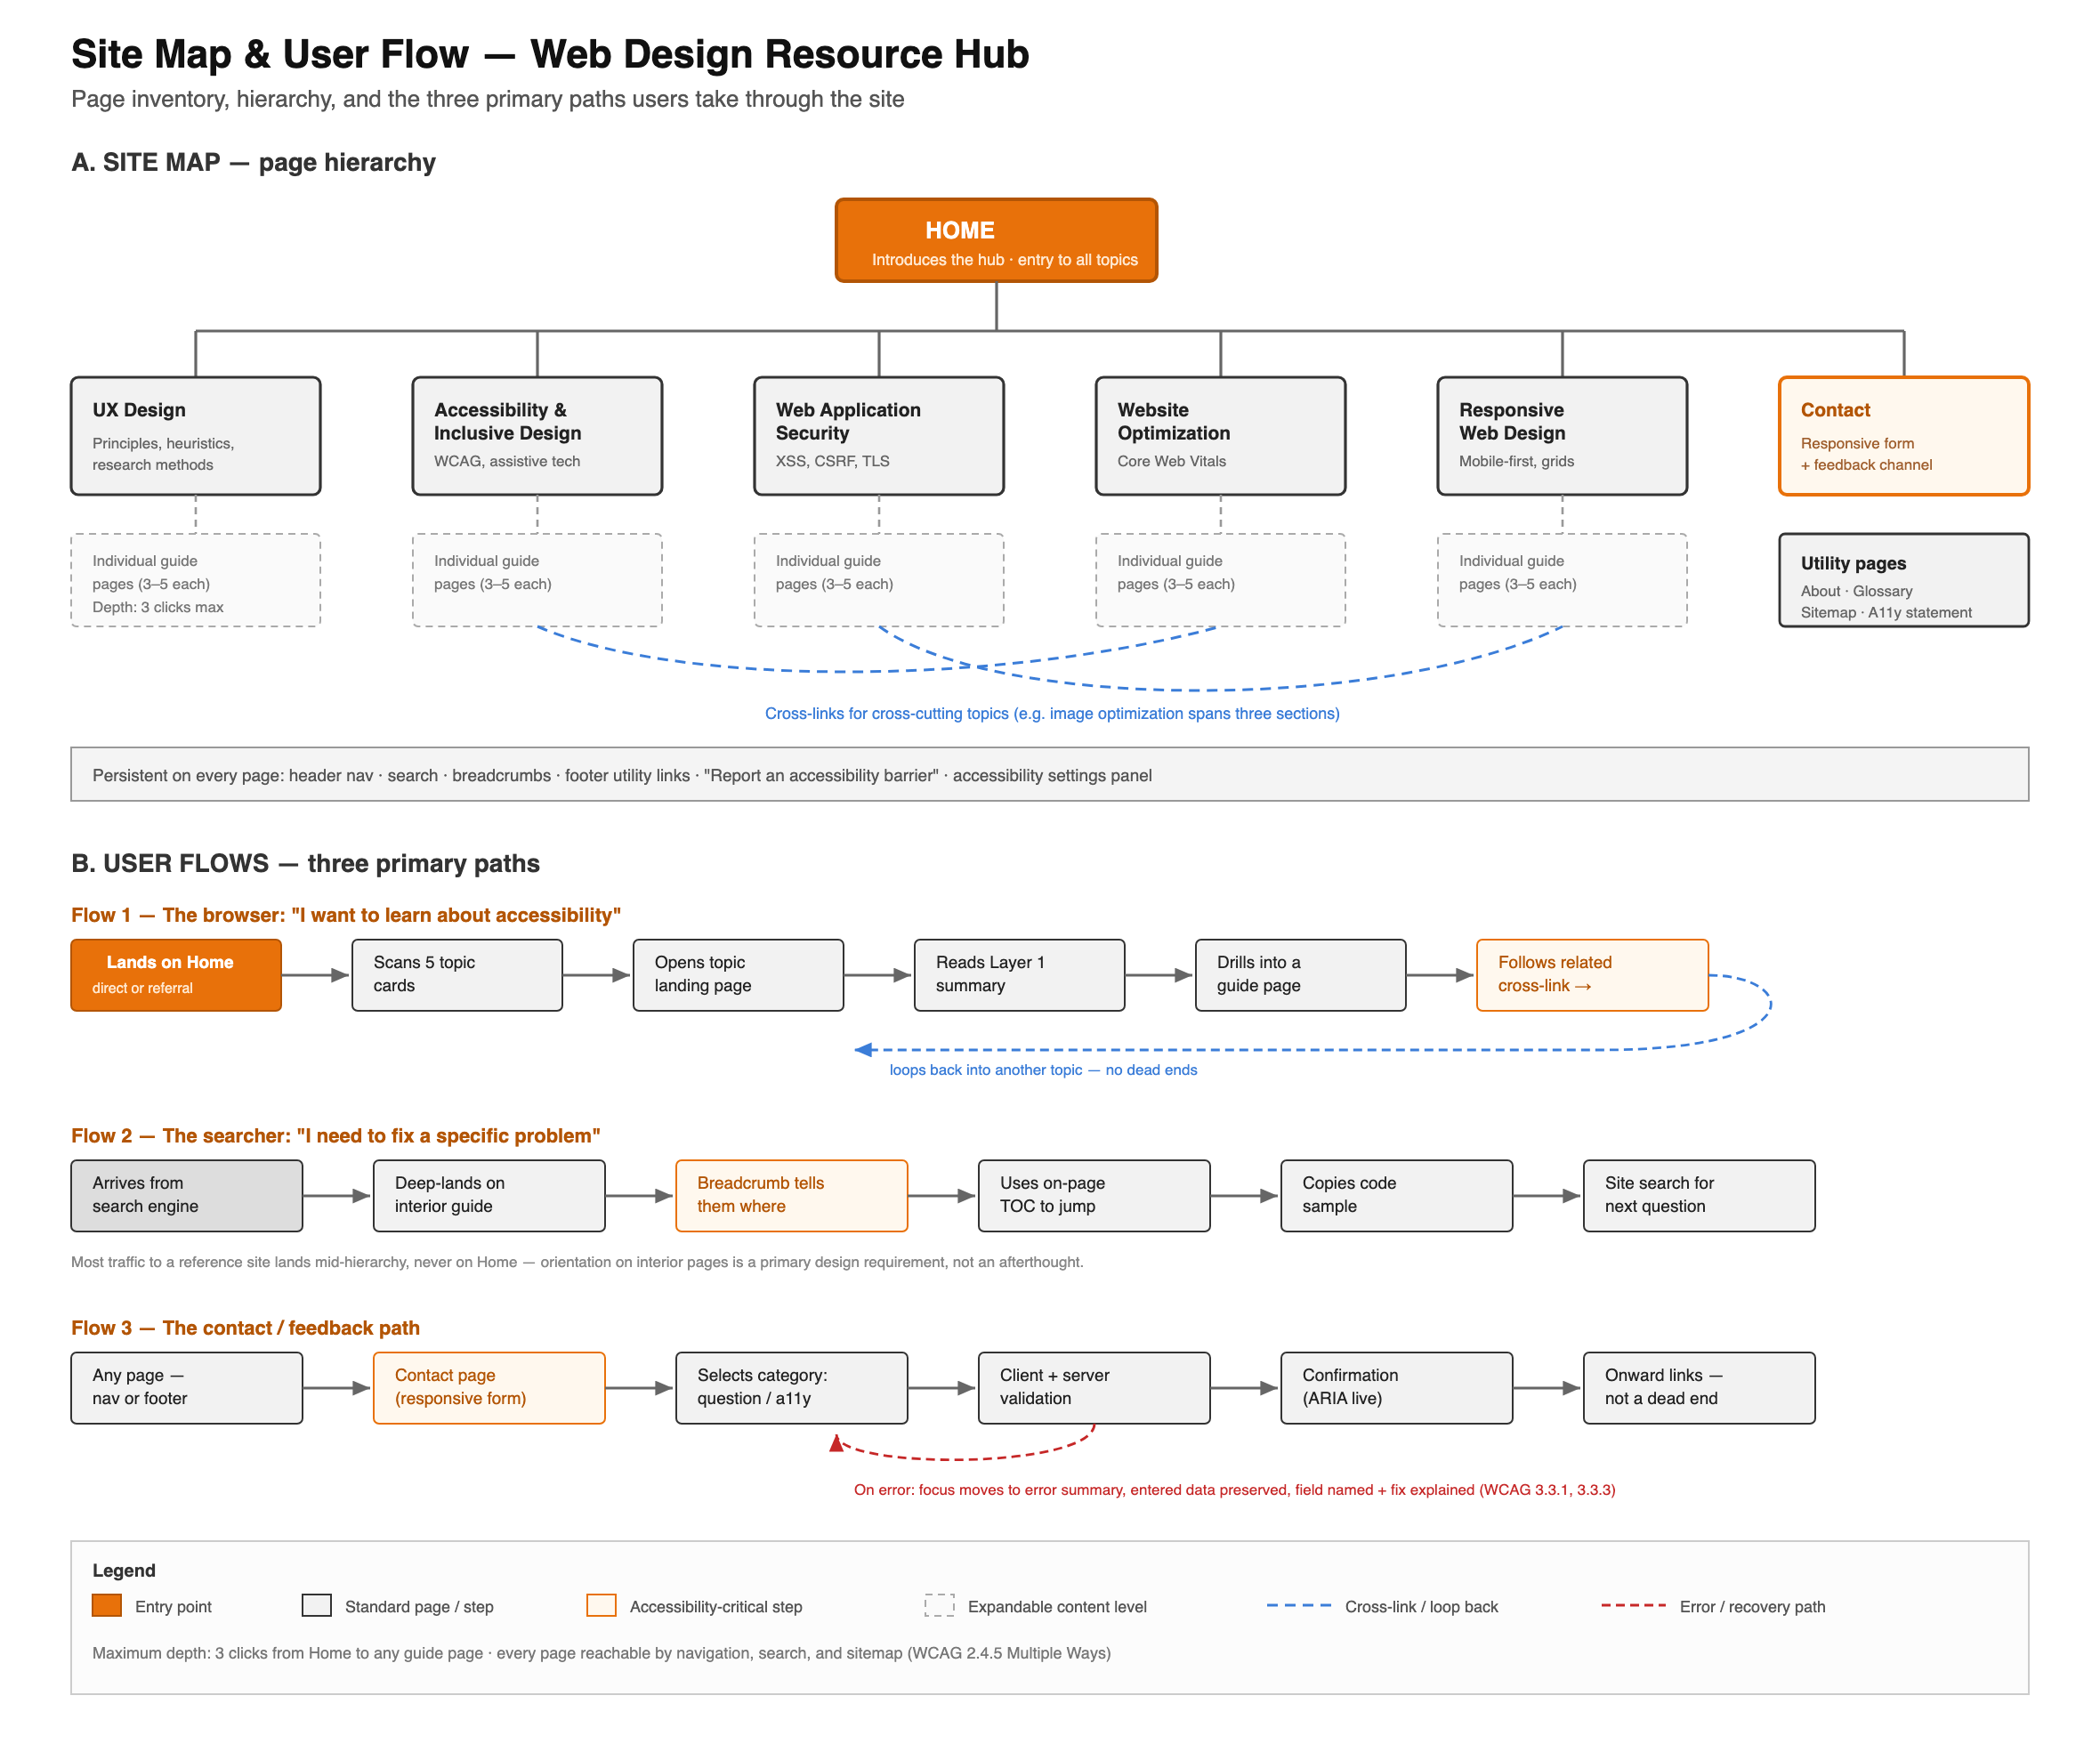
Figure 4. Site map and user flow diagram.

References
Carnaghan, I. (2024). Unit 1 lesson. University of Maryland Global Campus.
Carnaghan, I. (2024). Unit 2 lesson. University of Maryland Global Campus.
DeNardis, N. (2021). Introduction to user experience design [Video course]. Pearson Publishing. https://learning.oreilly.com/course/introduction-to-user/
Gilbert, R. M. (2019). Inclusive design for a digital world: Designing with accessibility in mind. Apress. https://doi.org/10.1007/978-1-4842-5016-7
Nielsen, J. (1994). 10 usability heuristics for user interface design. Nielsen Norman Group. https://www.nngroup.com/articles/ten-usability-heuristics/
Rohr, C. (2022, July 17). When to use which user-experience research methods. Nielsen Norman Group. https://www.nngroup.com/articles/which-ux-research-methods/
WebAIM. (n.d.). Web accessibility in mind. Utah State University. https://webaim.org/
World Wide Web Consortium. (2023). Web Content Accessibility Guidelines (WCAG) 2.2. https://www.w3.org/TR/WCAG22/
World Wide Web Consortium. (n.d.). ARIA authoring practices guide. https://www.w3.org/WAI/ARIA/apg/

