Project 1: Web Project Proposal
Course: WDDE 385 - Principles of Web Design and Technology III
Student: Gilbert Anderson

WDDE 385 Web Design Resource Hub
Gilbert Anderson
WDDE 385: Principles of Web Design and Technology III
University of Maryland Global Campus
Deployment target: https://cmst387-umgc-ganderson58.azurewebsites.net

Project Overview
This proposal is for a Web Design Resource Hub, which is an educational site collecting practical guidance across the five core areas of this course, those being user experience design, accessibility and inclusive design, web application security, website optimization, and responsive web design, pulled together into a single organized reference for students and early-career web developers.
I want to be upfront that this site carries an unusual obligation compared to most class projects, since a resource hub that teaches accessibility has to be accessible itself, one that teaches responsive design has to be responsive itself, and one that teaches optimization cannot ship a bloated page without undercutting its own content. That means the site is its own primary demonstration and every claim it makes can be checked by inspecting the site making the claim, which in my opinion raises the stakes on the decisions below considerably.
The audience I am building for is students in web development programmes, people changing career into front-end development, and working developers who need a quick reference, and that group is global and linguistically diverse since web development draws heavily on people reading English-language documentation as a second language. It also includes developers with disabilities, who are badly served by technical documentation that is itself inaccessible, and it spans a wide range of devices and connections, since developers read documentation on desktop workstations while they are coding and on phones while they are commuting or away from a desk.
The scope is a homepage introducing the hub, five topic sections matching the course areas above, and a responsive contact form, with the full page inventory in the Site Structure section below and the wireframes and site map in the Wireframes and Site Map section. Every accessibility target throughout this proposal is stated against WCAG 2.2 Level AA, which is the current W3C Recommendation and the standard aligned with Section 508 expectations for educational content.

Proposed Site Structure
Page | Purpose
Home | Introduces the hub, states its purpose, and provides entry points to all five topic areas
UX Design | Design principles, usability heuristics, user research methods, UX artifacts
Accessibility & Inclusive Design | WCAG conformance, assistive technology, inclusive design methodology
Web Application Security | HTTPS/TLS, input validation, XSS and CSRF defense, secure headers, authentication
Website Optimization | Performance budgets, image optimization, caching, Core Web Vitals
Responsive Web Design | Mobile-first method, fluid grids, breakpoints, responsive media
Contact | Responsive, accessible contact form with validation and confirmation
About | Scope of the hub, author, accessibility statement

1. Design Principles for Navigability
I want the navigation on this site to come out of established principles instead of whatever felt reasonable while I was building each page, so the first one I am committing to is consistency, which means the primary navigation appears in the same location with the same ordering on every single page, satisfying WCAG 2.4.5 on Multiple Ways and 3.2.3 on Consistent Navigation. Users build a mental model of a site within the first few pages they visit, so moving or reordering the navigation destroys that model, and it does the most damage to people with cognitive disabilities and to screen reader users who navigate by landmark.
The second principle is recognition over recall, which is one of Nielsen's heuristics and applies directly to reference material, so I am planning on persistent breadcrumbs, a visible indication of which section you are currently in, and link text that describes where the link goes, meaning something like "read the guide to responsive images" instead of "click here." That matters more here than it would on most sites because a reader arriving from a search engine lands on an interior page instead of the homepage, and they need to be able to tell where they are immediately without reconstructing the site structure in their head.
I also want the site to make its own state visible, so loading states, form validation, and confirmation messages are announced both visually and programmatically through ARIA live regions, which means sighted and non-sighted users get the same feedback at the same moment instead of one group getting it late or not at all.
Section labels will use the words the audience actually searches for, since "Website Optimization" is far more findable than "Performance Engineering" would be, and "Web Application Security" is more findable than "Hardening," and I think labelling is genuinely a navigation decision rather than a copywriting one, because a link is only findable when its wording matches the vocabulary in the reader's head.
Each topic section opens with a plain-language overview before it descends into technical specifics, so that somebody new to the topic is not hit with the same density as a practitioner looking up one detail. Finally, no page on this site will be a dead end, since every page offers onward routes into related topics, and form errors will always be recoverable without losing what the user already typed.

2. Optimizing Layout for Desktop and Mobile
I am building this mobile-first, which means writing the single-column small-screen layout first and then progressively enhancing it into multi-column arrangements at larger viewports, and I am doing it that way because mobile-first forces content prioritization on you, since if a module cannot justify its place in a 375 pixel column it rarely deserves prominence at 1440 pixels either.
The implementation will use CSS Grid and Flexbox with fluid units, meaning rem, percentages, fr, and clamp(), instead of fixed pixel widths, so that the layout responds to both the viewport size and whatever text size the user has set in their browser. I am planning to place breakpoints wherever the content actually breaks instead of at named device widths, since device-width breakpoints age badly as new devices come out.
The layout has to satisfy WCAG 1.4.10 on Reflow, which requires that content remain usable at 320 CSS pixels wide without two-dimensional scrolling, and what makes that criterion worth understanding instead of just complying with is that it is the same requirement as supporting 400 percent zoom on a 1280 pixel desktop display, so one technical solution serves both low-vision desktop users and mobile users at the same time, which is a clear instance of the curb-cut effect.
On desktop specifically, wider viewports get a persistent sidebar table of contents for the longer technical articles, along with a reading measure constrained to 60 to 75 characters instead of full-width text, since a line of text running the full width of a large monitor becomes genuinely difficult to track from one line to the next. On mobile, the navigation collapses into a menu button labelled with the word "Menu" rather than an unlabelled hamburger icon, touch targets meet WCAG 2.5.8 on Target Size at 24 by 24 CSS pixels with 44 by 44 for primary actions and enough spacing to prevent mis-taps, and hover-dependent interactions are avoided completely since hover does not exist on touch devices, which means anything revealed on hover also has to be reachable by focus and by tap.
Code samples are the one piece of content on this site that presents a specific responsive problem, since this hub will contain a lot of them and they cannot rewrap arbitrarily without changing what they mean, so they will scroll horizontally inside their own container with a visible scroll affordance instead of forcing the whole page to scroll sideways.
I am also treating performance as an accessibility concern instead of a separate topic, so that means responsive images through srcset, compressed assets, and core content that still functions without JavaScript.

3. Accessibility Testing Methods
The methods below are ones that could be employed to verify this design, and I want to be clear that no user testing is being conducted as part of this project, so this section identifies which methods would be appropriate and what class of defect each one actually catches.
Automated scanning would run continuously against every build, as described in Section 5, and it reliably catches missing alternative text, insufficient contrast, missing form labels, and invalid ARIA, which makes it fast and repeatable. Industry estimates consistently put automated detection at roughly 30 to 40 percent of WCAG issues though, since a tool can confirm that alt text exists but cannot judge whether that text is meaningful, and it can confirm a heading structure exists but not whether the structure is logical.
Manual keyboard-only testing would verify that every interactive element is reachable and operable using Tab, Shift+Tab, Enter, Space, and the arrow keys, that focus order follows visual order, that focus indicators stay visible and unobscured per 2.4.11, and that no keyboard trap exists anywhere, and in my opinion this is the highest-yield manual test relative to the time it takes.
Screen reader testing would run across NVDA with Firefox, JAWS with Chrome, and VoiceOver with Safari, plus TalkBack on Android, to confirm that content is announced in a sensible order with correct roles, states, and names. Testing multiple pairings matters because screen reader and browser combinations differ meaningfully in how well they support ARIA, and for this site specifically the code blocks deserve their own attention during that testing, since punctuation-dense samples get announced poorly by default.
Expert heuristic evaluation against the WCAG 2.2 AA success criteria and Nielsen's ten heuristics gives structured expert review at fairly low cost, and a cognitive walkthrough would step through the core tasks a reader actually comes here for, meaning things like finding guidance on preventing cross-site scripting or submitting a question through the contact form, asking at each step whether a first-time user would know what to do next and would recognize that they were making progress.
Usability testing with participants who have disabilities is the method that most directly validates real-world usability, and it would be the recommended next step beyond this project, since automated and expert methods find violations while only testing with actual assistive technology users reveals whether the site is genuinely usable rather than merely conformant. Rounding that out, zoom and reflow testing at 400 percent browser zoom, text-only zoom, Windows High Contrast Mode, and colour-blindness simulators would complete the coverage.

4. Features Supporting Specific Impairments
For visual impairments, I am starting from semantic HTML with a correct heading hierarchy and ARIA landmarks, since that is what gives a screen reader structure to work with in the first place. Meaningful images, including diagrams explaining responsive breakpoints or request flows, get descriptive alternative text, and complex diagrams also get described in the adjacent body text, since a one-line alt attribute cannot realistically carry a full architectural diagram. Decorative images get an empty alt attribute so they are skipped entirely. Text contrast meets 4.5 to 1, with 3 to 1 for large text and user interface components under 1.4.11, and I plan to contrast-check the syntax highlighting in code samples specifically, since popular highlighting themes routinely fail against their own backgrounds. Colour never carries meaning on its own, the site supports 400 percent zoom, it honours user text spacing under 1.4.12, and a skip to main content link opens the tab order on every page.
For auditory impairments, any video tutorial carries accurate synchronized captions under 1.2.2 and a full transcript under 1.2.1, along with audio description of essential visual information wherever a demonstration is showing code on screen, per 1.2.5. Text stays the primary format for technical content here instead of video-only explanation, which serves deaf users, people reading in a second language, and anyone who would simply rather scan than watch, and no information on the site is conveyed by sound alone.
For motor impairments, full keyboard operability with no keyboard traps under 2.1.1 and 2.1.2 is the baseline, targets meet 2.5.8 with generous spacing, and any drag-based interaction provides a single-pointer alternative under 2.5.7 on Dragging Movements. The contact form imposes no time limit under 2.2.1 and preserves what has been entered when validation fails, so that somebody who types slowly is never forced to re-enter a long question, and the copy code buttons on code samples give keyboard users an alternative to manually selecting text across a multi-line block.
For cognitive impairments, plain language, short paragraphs, and generous white space all reduce load, while consistent navigation prevents disorientation and multi-step technical processes get broken into numbered steps with visible progress. Technical jargon is defined on first use and collected into a glossary, which matters more here than it would on most sites since the subject matter is dense with acronyms like CSRF, TLS, LCP, and ARIA. Error messages identify the problem and also state how to fix it under 3.3.3, autoplay and unexpected motion and flashing content are avoided under 2.3.1, the prefers-reduced-motion setting is honoured, and icons are always paired with text labels instead of standing on their own.
Organizing these by impairment category is a useful way to make sure nothing gets missed, but the intent behind all of them is universal, since captions serve somebody sitting in a quiet library, plain language serves a tired reader at midnight, and large targets serve anybody using a phone one-handed.

5. Automated Compliance Tools
I want automated checking operating at three layers so that defects get caught as early as possible rather than all at once at the end.
During development, the axe DevTools browser extension and WAVE from WebAIM give immediate in-browser feedback while a page is being built, and Lighthouse, which is built into Chrome DevTools, contributes an accessibility score alongside the performance metrics this site cares about anyway.
In continuous integration, Pa11y CI or axe-core would run against every push to the project's GitHub repository, wired into the same GitHub Actions workflow that already deploys this site to Azure App Service. I am deliberately leaving that check non-blocking rather than gating the deploy job on it, since a scanner failure landing close to a deadline should not by itself hold up a release, and a weaker policy stated honestly is better than a stronger one I would end up quietly overriding. It is still a real advance over periodic manual audits even without gating the release, since a manual audit only catches what broke between audits while a build check surfaces the regression the moment it happens, and the failed check stays visible on the commit either way. It also demonstrates the site's own subject matter, since the same pipeline can run Lighthouse CI for optimization budgets.
For ongoing monitoring, the IBM Equal Access Accessibility Checker and ARC Toolkit add rule coverage beyond what axe catches, and crawlers like Siteimprove or Tenon.io can scan the full site on a schedule and trend the results over time. Supporting those, the W3C Markup Validation Service matters because valid HTML underpins assistive technology support in the first place, the WebAIM Contrast Checker gets used during design instead of after it, and readability scoring runs through the Hemingway Editor or Flesch-Kincaid analysis.
Two caveats have to accompany any automated program though. The first is that these tools verify roughly a third of the WCAG criteria, so a clean scan is a floor instead of a certificate of conformance. The second is that rule sets have to be kept current as the standards evolve, since a stale scanner quietly stops testing against the standard it still claims to enforce, and nothing about the passing result tells you that has happened.

6. Cultural Differences and Language Needs
I am declaring the site's language with the lang attribute under 3.1.1 and marking any inline-language passages with lang on the containing element under 3.1.2, so that screen readers switch pronunciation instead of reading foreign text with English phonetics.
I am writing the content in plain, idiom-free English, and in my opinion that matters acutely for a technical audience specifically, since web development documentation is read worldwide by people whose first language is not English, and idioms, sports metaphors, and cultural shorthand like "out of the box" or "silver bullet" or "down to the wire" are exactly the constructions that fail those readers and defeat translation tools at the same time. Technical acronyms get expanded on first use.
Formats will not assume a single locale either, so dates appear unambiguously as something like "March 4, 2026" rather than 3/4/26, which reads as April 3 across much of the world, and times state their zone explicitly. The contact form accepts international name, address, and phone formats instead of enforcing US-only patterns, and notably it will not require a first name and last name split, since that misrepresents naming conventions in much of the world.
Examples and imagery will represent a range of ages, ethnicities, abilities, and backgrounds instead of defaulting to a narrow stereotype of who writes code, and the sample data inside code examples will use varied, non-US-centric names and addresses, since in my opinion example code is itself a quiet signal about who the material was written for. Icons get checked for culturally specific meanings before they go in.
Structurally, the design has to accommodate text expansion, since translated German or Spanish text can run 30 percent longer than the English original, which means avoiding fixed-width containers that would clip or overflow once the text grows. Where translation gets offered, professionally translated key pages are preferable to machine translation for the security guidance in particular, because a mistranslation there could produce an insecure implementation instead of just an awkward sentence, and right-to-left support through CSS logical properties is a reasonable enhancement to plan for.

7. Collecting User Feedback for Inclusivity
I want the feedback mechanisms themselves to be accessible, since otherwise they systematically exclude the exact users whose input matters most, and that would defeat the purpose of collecting feedback at all.
An accessibility feedback link appears in the site footer on every page and offers multiple channels, meaning a form, an email address, and an alternative contact method, and the reason for offering more than one is that somebody blocked by an inaccessible form needs a different route available to report that specific problem. The contact form doubles as a general feedback channel with an optional category selector, so that accessibility reports can be triaged separately from ordinary content questions, and a short optional on-page prompt asking whether the page was helpful would gather lightweight per-page signal without interrupting anybody with a modal, while staying fully keyboard and screen-reader operable.
I would use analytics to identify friction indirectly through things like high-exit pages, failed internal searches, which are a direct signal that the site's vocabulary does not match the reader's, and rage-clicks, but analytics only ever reveal where users struggle and never why, so they generate questions instead of answers.
That distinction is worth being deliberate about rather than just collecting whatever is easy, and Rohr's framework organizing UX research methods along three dimensions, attitudinal versus behavioral, qualitative versus quantitative, and context of use, is what explains why no single mechanism above is sufficient on its own. Analytics are behavioral and quantitative, so they record what users did at scale but cannot explain intent, while surveys and the "was this helpful" prompt are attitudinal and capture what users say, which may not match what they actually do, and usability testing is behavioral and qualitative, which gives small samples but reveals causes. An inclusive feedback program needs coverage across all three dimensions, because a program built only from analytics will systematically miss the users whose difficulties make them leave before they ever generate a signal, and those are exactly the users this site most needs to hear from.
A public issue tracker on the project's GitHub repository suits this audience specifically, since developers are already comfortable filing issues and tend to supply precise reproduction steps and environment details without being asked, and beyond that, recruited usability sessions and an advisory panel of compensated participants including assistive technology users, developers reading in a second language, and beginners would provide structured qualitative input on a recurring basis.
Whatever gets collected, the loop has to close, since reports that vanish without acknowledgment train people to stop reporting, so a published response commitment and a visible changelog of accessibility fixes are what actually demonstrate that the input produces change.

8. Inclusive Design Methodologies
Gilbert frames inclusive design as a practice spanning compliance, assistive technology, and design strategy instead of a checklist applied at the end, and that is the position I am adopting throughout this proposal. Two of that book's arguments shape the sections above directly, the first being that understanding how assistive technologies actually operate is a prerequisite for designing for them, which is why Section 3 names specific screen reader and browser pairings instead of treating screen reader testing as one undifferentiated activity, and the second being that legal compliance is a floor instead of a goal, which is why I am targeting AA and then deliberately exceeding it where the audience benefits.
Beyond that, I am drawing on the Microsoft Inclusive Design framework and its three principles, which are recognize exclusion, solve for one and extend to many, and learn from diversity. The most useful instrument in it for this project is the persona spectrum, which reframes disability as a spectrum of permanent, temporary, and situational constraints, so that one-handed use covers a developer with a permanent limb difference, a developer with a broken wrist, and a developer holding a coffee on a train all at once. Designing for the permanent case serves all three of them, which sharply increases the population served by any given accommodation.
Universal Design's seven principles, meaning equitable use, flexibility in use, simple and intuitive use, perceptible information, tolerance for error, low physical effort, and appropriate size and space, give me a design-stage checklist that complements WCAG's verification-stage criteria, and POUR, meaning perceivable, operable, understandable, and robust, organizes the work around WCAG's own conceptual structure.
The personalization philosophy I am committing to is respecting the preferences a user has already set rather than making them reconfigure everything again, so honouring prefers-reduced-motion, prefers-color-scheme, and prefers-contrast means somebody who has already configured their operating system gets an appropriate experience immediately with no per-site setup, and the site-level controls described in Section 10 supplement those defaults instead of replacing them.
The personalization that is specific to this hub's purpose is layered content, so that a beginner and a practitioner can use the same page differently, with a plain-language summary and a "why this matters" framing up top and the implementation detail, specification references, and edge cases disclosed progressively below. That is personalization through content structure instead of through user profiling, which also means the site avoids collecting personal data it has no need to hold, and in my opinion that is a security and privacy decision consistent with the hub's own material rather than a separate concern.
Two further commitments round this out. The first is inclusive research recruitment, meaning participants have to include disabled users, people reading in a second language, and beginners, instead of treating a convenience sample as representative. The second is progressive enhancement, so that the site delivers a functional experience on older browsers and constrained connections instead of failing outright.

9. Accessible Interactive Elements
I am building every interactive element on this site on native HTML controls wherever that is possible, because a button element is focusable, keyboard-operable, and correctly announced with no additional work at all, whereas a div styled to look like a button is none of those things until a substantial amount of ARIA and JavaScript rebuilds what the browser already gave you for free, and that rebuild is where the bugs live. Native-first is in my opinion the single most effective decision in this whole section.
Each control has to expose an accessible name, role, and state, so icon-only controls get an aria-label or visually hidden text, and toggles expose aria-pressed or aria-expanded so that their state is announced instead of only displayed visually.
Focus management gets handled explicitly rather than left to the browser, so focus indicators stay clearly visible and never get obscured by sticky headers under 2.4.11, opening a modal moves focus into the dialog and traps it there until dismissal, and closing it returns focus to whatever triggered it, since without that last part keyboard users end up silently stranded behind an overlay they cannot see.
Custom widgets, meaning the accordions and tabbed code samples this site uses for progressive disclosure, follow the WAI-ARIA Authoring Practices Guide patterns for expected keyboard behavior, so arrow keys move within a tab list, Escape closes, and Home and End jump to first and last.
The contact form is the site's primary interactive element so it gets particular attention, which means programmatically associated label elements, related inputs grouped in a fieldset with a legend, aria-describedby conveying format requirements before submission instead of only after a failure, aria-invalid marking the fields that are wrong, an error summary at the top of the form linking to each problem field, and messages that name the field and explain how to fix it. Autocomplete attributes under 1.3.5 let browsers fill in known values, which reduces effort for users with motor and cognitive disabilities.
Dynamic content announces itself through appropriately scoped ARIA live regions, with polite for status updates and assertive reserved for genuine urgency, since overusing assertive produces a stream of interruptions that users quickly learn to tune out entirely.
I am also avoiding CAPTCHAs completely in favour of honeypot fields and server-side validation, and that is both an accessibility decision, since CAPTCHAs are broadly hostile to users with visual and cognitive disabilities, and a worked example of the security and accessibility tradeoff that the hub's own security section discusses.

10. User Customization Mechanisms
The baseline commitment is that the site works with browser and operating system settings out of the box, so sizing text in rem instead of px means browser text-size preferences take effect immediately, and honouring prefers-color-scheme, prefers-contrast, and prefers-reduced-motion means system-level choices are respected without anybody configuring anything. The site stays fully usable at 200 and 400 percent zoom and does not defeat browser reader modes or user stylesheets.
On top of that baseline I am planning an accessibility settings panel, reachable from every page and itself fully keyboard-accessible, offering text size controls that step through defined scales with layout that reflows instead of clipping, contrast and theme options including light, dark, and high-contrast that all meet or exceed 4.5 to 1, a reduced motion setting that disables animations and transitions and parallax, line spacing and reading width controls that constrain the measure to 60 to 75 characters, which is a meaningful aid for dyslexic readers working through long technical prose, a dyslexia-friendly typeface as an opt-in alternative, underlined links for users who cannot distinguish links by colour alone, and a code sample font size adjustable independently of the body text, since monospace faces render smaller at equivalent point sizes and code density is a known readability barrier. Dark mode has obvious practical appeal for this audience since a lot of them work in dark editors, but I want it built as a genuine contrast-checked palette rather than an inverted filter.
Preferences persist across sessions through localStorage and apply site-wide, so they get configured once instead of being re-selected on every visit, the controls use clear text labels instead of icons on their own, and a visible reset to defaults option lets somebody recover from a configuration that made things worse for them.
The constraint guiding all of this is that customization supplements good defaults instead of excusing them, since a site that is inaccessible until it gets reconfigured has just shifted its own obligation onto the user.

11. Information Architecture
I am organizing the information architecture by learning topic rather than by content type, since grouping everything into articles, tutorials, and references would force a reader to already know what format their answer lives in, and that is exactly the knowledge a learner does not have yet. The five course areas give a natural top level that everybody can follow.
I would validate that structure through card sorting, using open sorting to learn the groupings readers come up with on their own and closed sorting to test the structure I proposed, and through tree testing, which measures whether users can locate items in a proposed hierarchy independently of the visual design. Tree testing is especially worth doing here because the topic boundaries genuinely blur, since image optimization is arguably Optimization, Responsive Design, and Accessibility all at once, and testing is what reveals where users actually expect to find that material instead of where I assumed they would.
Depth stays constrained to roughly three clicks to any resource, with a broad shallow hierarchy preferred over a deep one, and categories stay mutually exclusive where that is possible, with deliberate cross-linking for the genuinely cross-cutting topics instead of arbitrarily assigning them to one section and hoping nobody looks in the other.
Multiple navigation paths under 2.4.5 accommodate the different strategies readers actually use, so browsers use the topic navigation, searchers use site search with synonym mapping that resolves a11y, accessibility, and WCAG to the same place and converges speed, performance, and optimization, and returning users use breadcrumbs and a quick-links block.
To cater to varying comprehension levels, every topic page is layered, opening with a plain-language summary and a "why this matters" framing, then core guidance, then advanced detail and specification references. That way a beginner and a practitioner can both use the page without either of them being forced to read through the other's version first, and in my opinion that is the single most important IA decision on a site whose audience ranges from first-semester student to working professional. Page titles and headings stay descriptive and unique under 2.4.2 and 2.4.6, which forms a navigable outline for screen reader users, since they commonly move through a page by heading instead of reading it linearly.

12. Readability Guidelines
I am targeting roughly an 8th-grade reading level for the overview and introductory material, measured with Flesch-Kincaid or the Hemingway Editor. WCAG 3.1.5 on Reading Level sets lower secondary education as a AAA criterion, and while this proposal targets AA overall, readability is a reasonable place to exceed the baseline, because in my opinion it is where technical documentation most reliably fails the people reading it.
One qualification is necessary though, which is that technical accuracy sometimes genuinely requires technical vocabulary, so the standard I am applying is not to eliminate every difficult word but to never make a reader look up a term the page could have defined for them. Where precision demands a term like cross-site request forgery, the page defines it in plain language on first use instead of assuming it.
The specific guidelines are plain language principles from plainlanguage.gov, meaning active voice, common words over formal alternatives like using "use" instead of "utilize," and concrete rather than abstract phrasing. Sentences run roughly 15 to 20 words and paragraphs run 3 to 4 sentences with one idea each. Content gets front-loaded so the conclusion comes first and the supporting detail after it, since readers scan and burying the actual recommendation in the fourth paragraph guarantees it gets missed. Headings and subheadings stay descriptive and break the text into scannable sections, and bulleted lists and tables carry parallel or comparative information instead of forcing it into dense prose.
Jargon gets defined and collected into a glossary, with acronyms expanded on first use on every page instead of only once site-wide, since search traffic lands readers in the middle of the site instead of at the beginning. Link text describes its destination out of context, because screen reader users often navigate by pulling up a list of links on its own. Code samples get commented and explained, since a code block is content the reader has to parse, so each one is preceded by a plain-language statement of what it does and why. Typographic support means a minimum of 16px body text, line height near 1.5, measure constrained to 60 to 75 characters, left-aligned rather than justified text, since justification creates uneven rivers of white space that impede dyslexic readers, and mixed case instead of all-caps.
I would validate all of that through readability scoring on every substantive page and, ideally, through comprehension testing where readers explain a concept back in their own words, since that is the only reliable test of whether the writing was actually understood instead of just scoring well.

Conclusion
The decisions I have made throughout this proposal share one premise, which is that accessibility and inclusive design are structural properties established during architecture and content design rather than a remediation pass applied right before launch, since retrofitting accessibility costs more and produces worse results than designing for it from the start does.
The Web Design Resource Hub targets WCAG 2.2 Level AA conformance, verified through automated scanning in the deployment pipeline, structured manual testing, and, as a recommended extension beyond this project, usability testing with developers who use assistive technology daily. What distinguishes this site from most class projects is that it has to embody every practice it documents, so the measure of success is not a passing automated score but whether a reader can find and understand what they need on the first attempt, using whatever device, connection, and assistive technology they happen to have.

Wireframes and Site Map
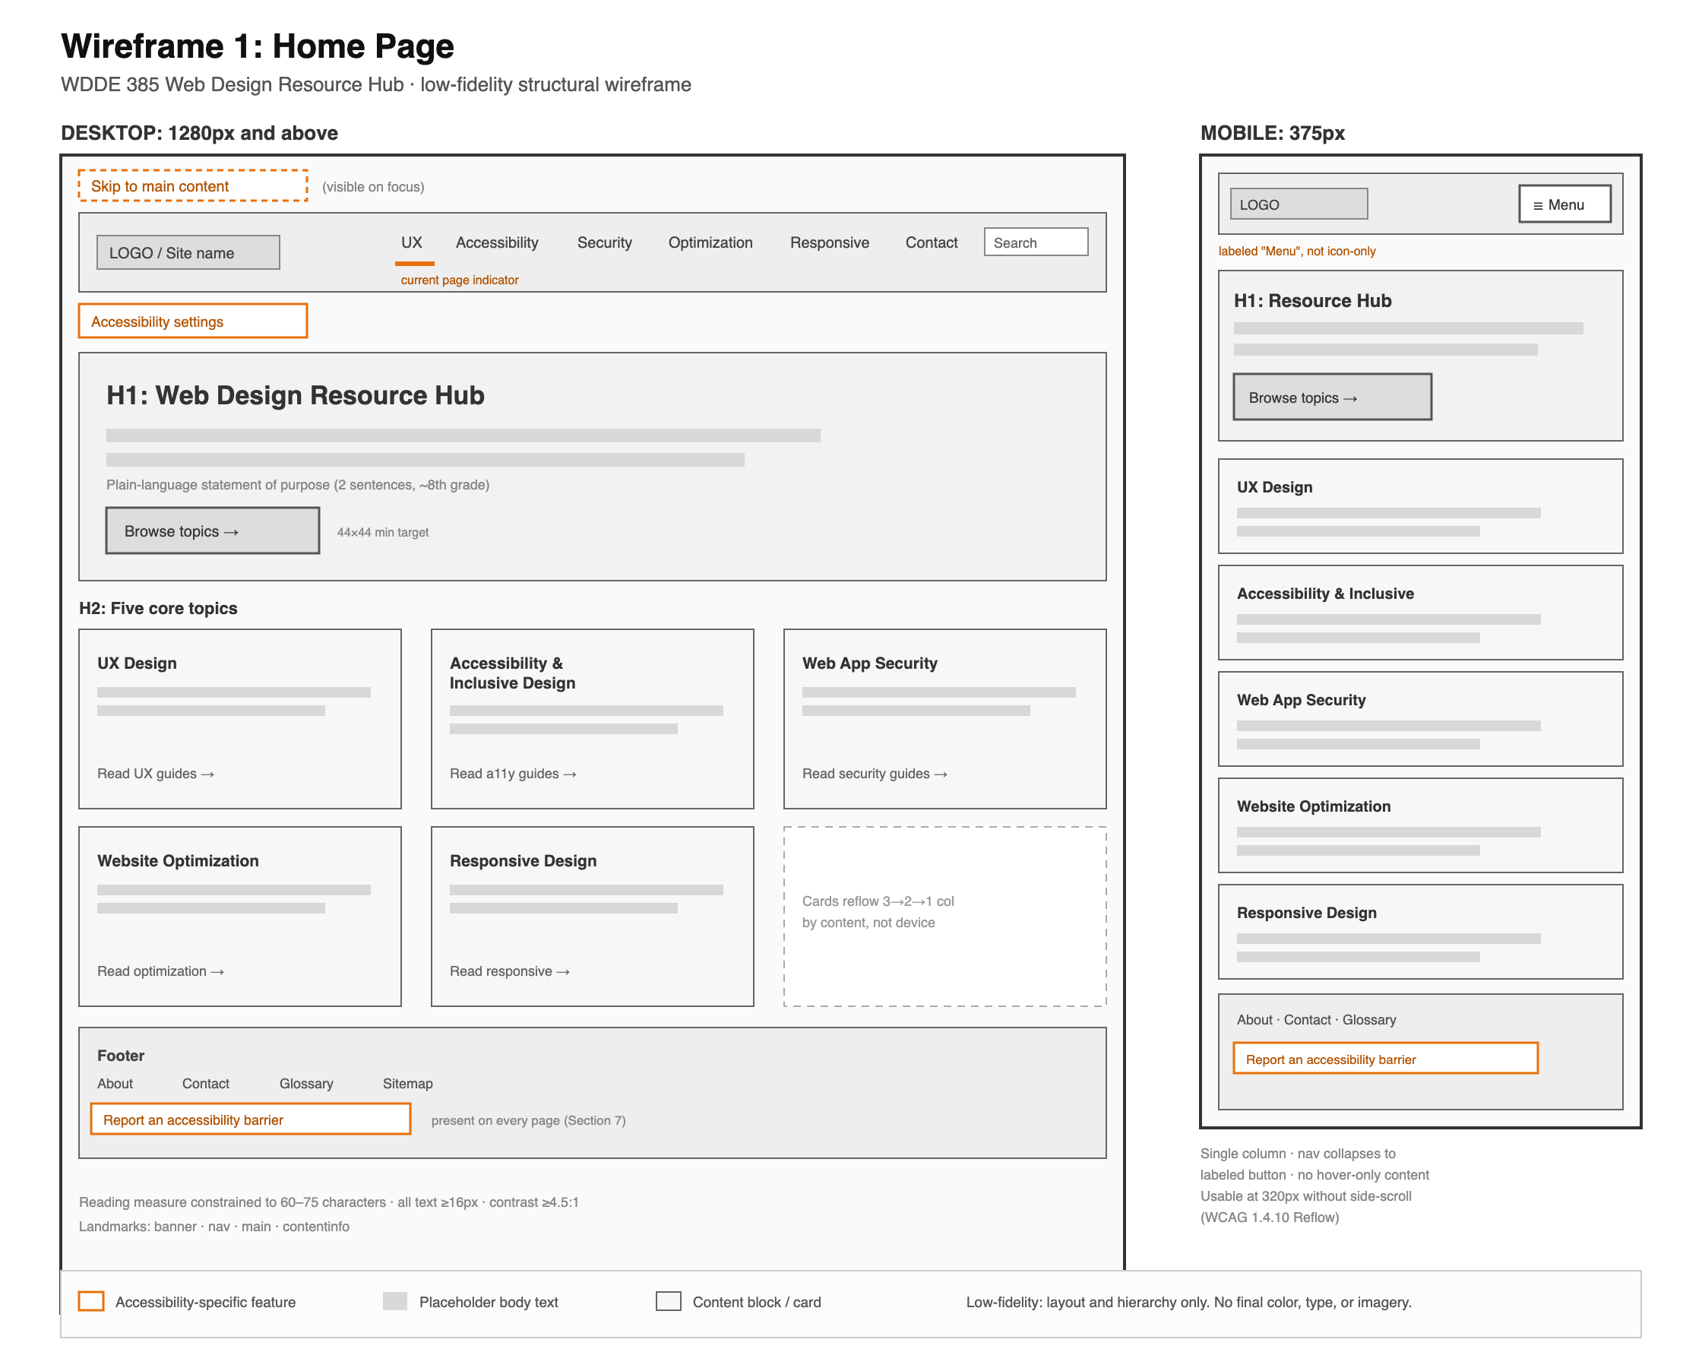
Figure 1. Home page wireframe (desktop and mobile).
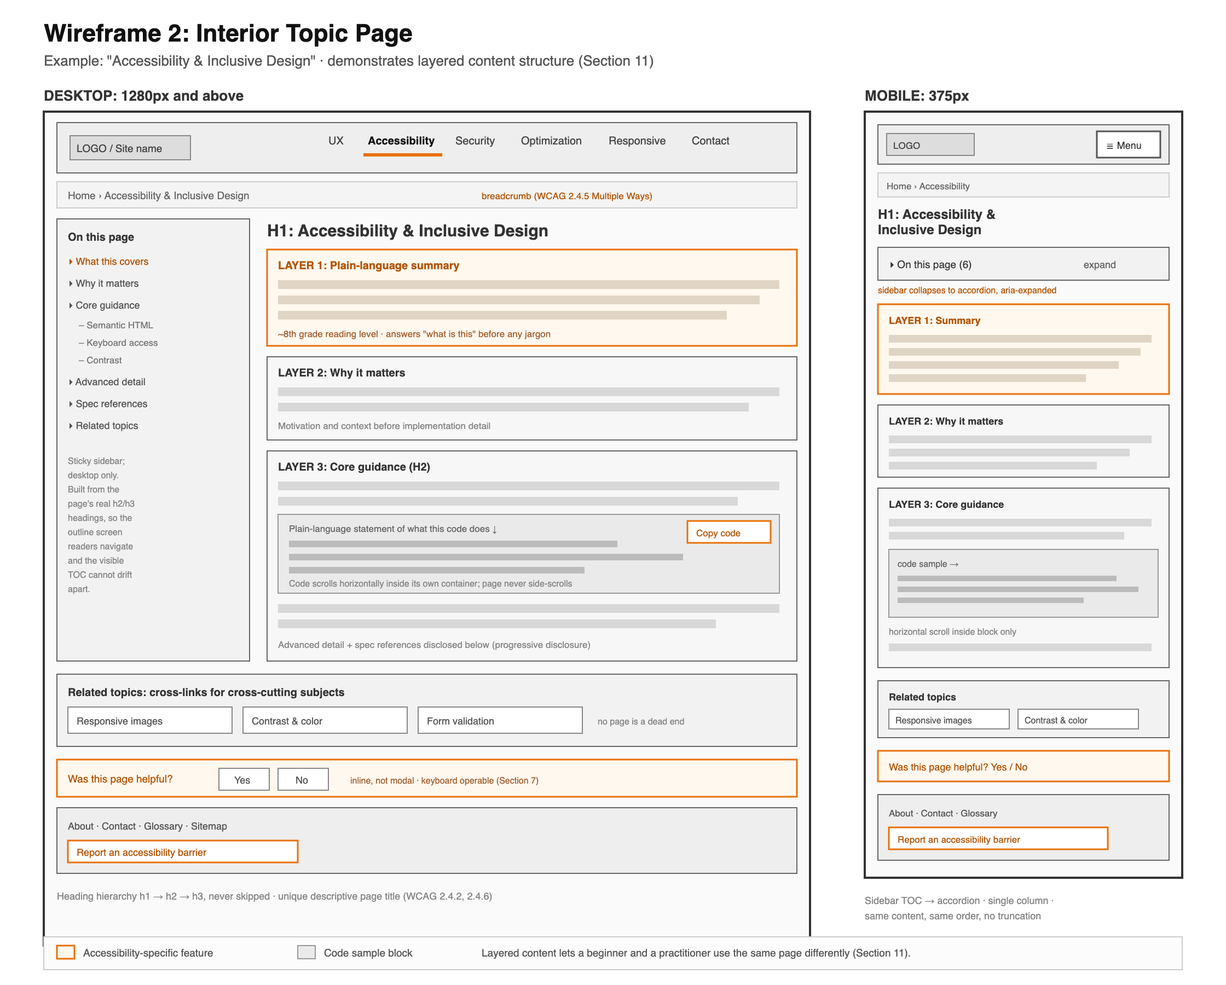
Figure 2. Interior topic page wireframe (desktop and mobile).
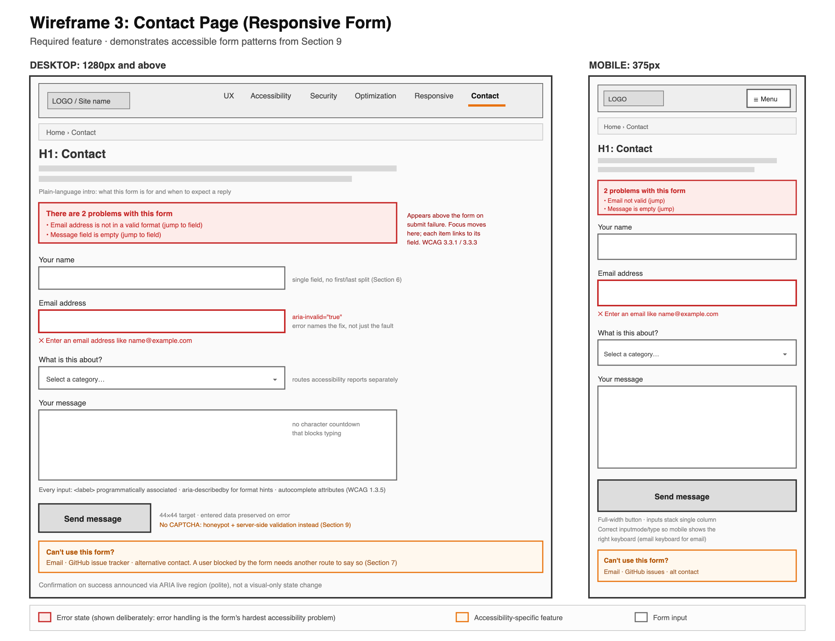
Figure 3. Contact page wireframe with responsive form (desktop and mobile).
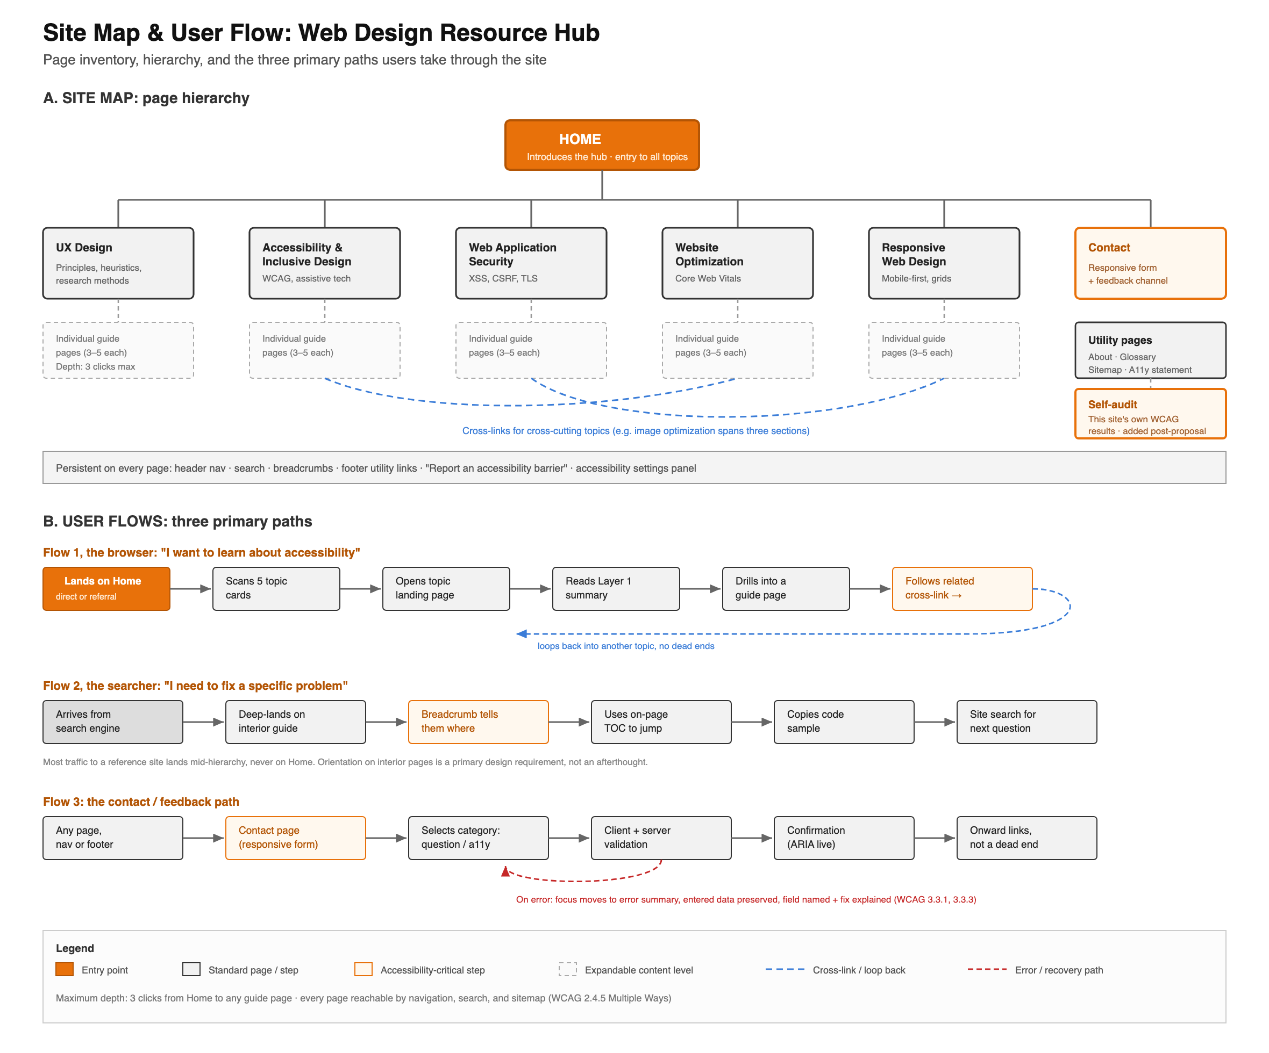
Figure 4. Site map and user flow diagram.

References
Carnaghan, I. (2024). Unit 1 lesson. University of Maryland Global Campus.
Carnaghan, I. (2024). Unit 2 lesson. University of Maryland Global Campus.
DeNardis, N. (2021). Introduction to user experience design [Video course]. Pearson Publishing. https://learning.oreilly.com/course/introduction-to-user/
Gilbert, R. M. (2019). Inclusive design for a digital world: Designing with accessibility in mind. Apress. https://doi.org/10.1007/978-1-4842-5016-7
Nielsen, J. (1994). 10 usability heuristics for user interface design. Nielsen Norman Group. https://www.nngroup.com/articles/ten-usability-heuristics/
Rohr, C. (2022, July 17). When to use which user-experience research methods. Nielsen Norman Group. https://www.nngroup.com/articles/which-ux-research-methods/
WebAIM. (n.d.). Web accessibility in mind. Utah State University. https://webaim.org/
World Wide Web Consortium. (2023). Web Content Accessibility Guidelines (WCAG) 2.2. https://www.w3.org/TR/WCAG22/
World Wide Web Consortium. (n.d.). ARIA authoring practices guide. https://www.w3.org/WAI/ARIA/apg/

