Movie Proposal – Austin Gilbert (Director), Chase Davis, Ben Linser, David Sexter

The movie will start by showing a square farm area during the night. The area will contain a basic red and brown farm house, eating metallic trough for the cow and a fence surrounding the farm area. The area will also be lit up by moonlight and the stars in the sky revealing the green landscape of the farm, there may be a few bushes or grass tufts and also a few random assortments of seeds on the ground. Other than that, the sky will be a really dark blue or a black color since it is night time. The fence will be a basic brown color with two vertical post at each end connecting two horizontal posts. When the movie starts a cow will be eating from the trough near the farm house and a chicken will be walking away from the farm house, grazing on some seeds on the ground. Eventually a UFO will appear and the cow will look up from its trough. The UFO will slowly circle around the farm house and then extend its landing gear and land next to the chicken, scaring it enough to make it lay an egg. The UFO will then take off and move to abduct the chicken by lowering a green translucent tractor beam to slowly raise the chicken. After that the UFO will rotate and move to shoot the cow with a red laser beam which will then kill the cow. Once the cow is dead, the UFO will leave the area. Initially farm music is playing until the UFO is in sight and then the music will change to “creepy” space music. The cow and chicken will be able to play sounds of mooing or clucking and the UFO will have its own sounds as well for the tractor beam and the laser beam.

Each developer will oversee their own models, Austin Gilbert drawing the environment and background and is also the director, Chase David drawing the cow, David Sexter drawing the UFO, and Ben Linser drawing the chicken. The camera will be moving around through the movie, for instance when the movie starts, there will be a close-up of the cow and the chicken, showcasing the component while rotating around them also showcasing the area. Once that is done an overview of the whole area will be shown so you can see the UFO approach from the distance. The camera will then do a close-up of the UFO as it lands, showcasing that component. The camera will then back up a bit so you can see the chicken lay the egg and get abducted, then back up even further to show the cow dying. The camera will then finish by showing the overview once again to see the UFO leaving the farm area.

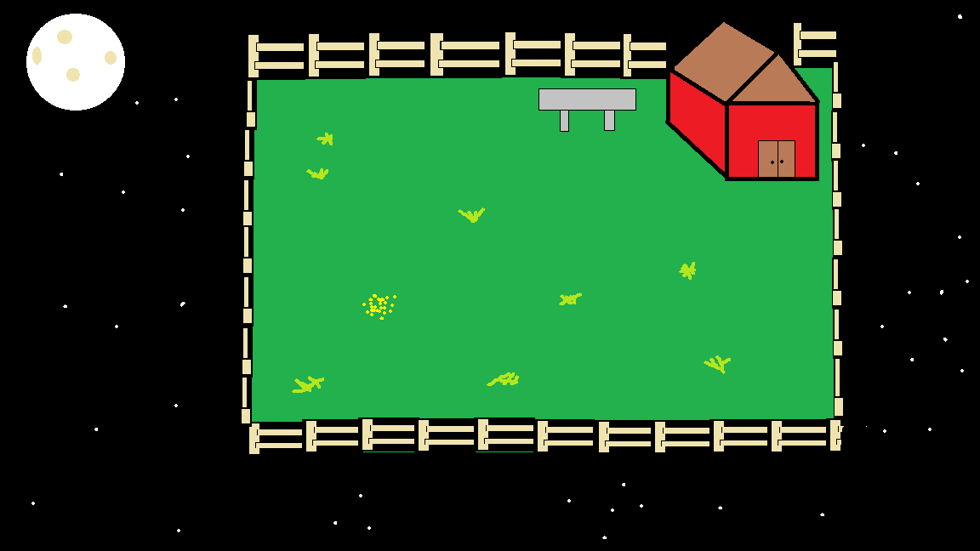

Chase Davis - Cow:

I will handle the drawing and movement of a cow. The Cows body be a rectangular prism. The cows head will be a cube. The cow will have no ears. The cow will have no fur. The cow’s legs will be rectangular prisms that are darker at the end for the hoofs. The cow will have eyes that are a part of the head texture. This cow will have a few spots on its body. The cow will have a tail that moves. The cow will be seen eating and move accordingly. The cow will have a snout that is a texture mapped rectangular prism. The cow will be white cow with black spots. The cow will have no utters.

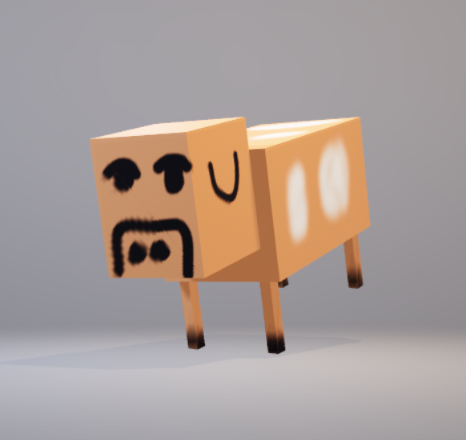

Ben Linser – Chicken

The component of the film that is my responsibility is a chicken. This chicken will spend the first portion of the film wandering around the farm field area, minding its own business, spending it’s time how chickens do. It will spend some time eating seeds off of the ground, and maintaining its home in an enclosure. Eventually the chicken will wander over to the cow and harmlessly interact with the cow. This interaction will entail the cow looking at the chicken like it’s a nuisance. My chicken will poke at the cow’s legs, as it is curious why the cow is there, and trying to figure what it is. Once the UFO appears the chicken will freak out and pop out an egg because it is scared. Panicked, the chicken will run away and try to hide back in his little enclosure. As the UFO moves around, the chicken will poke out and look around, waiting for the UFO to go away. Eventually, the chicken will go cautiously work its way outside and move slowly. Before it makes it too far, the UFO is going to pick up the chicken with the tractor beam. While the chicken is being picked up, it will be flapping its wings to try and fight the beam and escape. Unfortunately, this won’t work and the chicken will be captured by the UFO. In terms of appearance, the chicken will have a blocky shape that resembles, but not copies, the shape of a Minecraft chicken. The general coloring will be brown with light grey portions to give it some shading and depth. Similarly, the beak and legs will be yellow, with shading to give it depth.

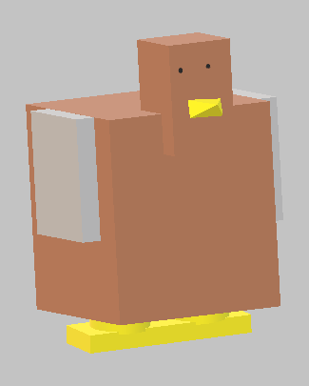

David Sexter - UFO:

My component will be the ufo. The ufo will be done it a typical ufo saucer style with a view port on the top of the saucer and a small dome for the tractor beam to project out of on the underside of the saucer. It will have three or four legs that are articulated to extend in and out. There will also be a device for the laser beam to come out of. The color of the main saucer will be a bright green, the view port will be an opaque and a light silver, the legs will be a gold-like color, and the laser will and the laser beam will be red. I will attempt to make the edges to be as smooth as possible but if it proves to be detrimental to the movie I will make it look more like a dodecagon or octagon for the saucer as well as adjusting the viewport to be more like half of a die, matching the rest of the ship.

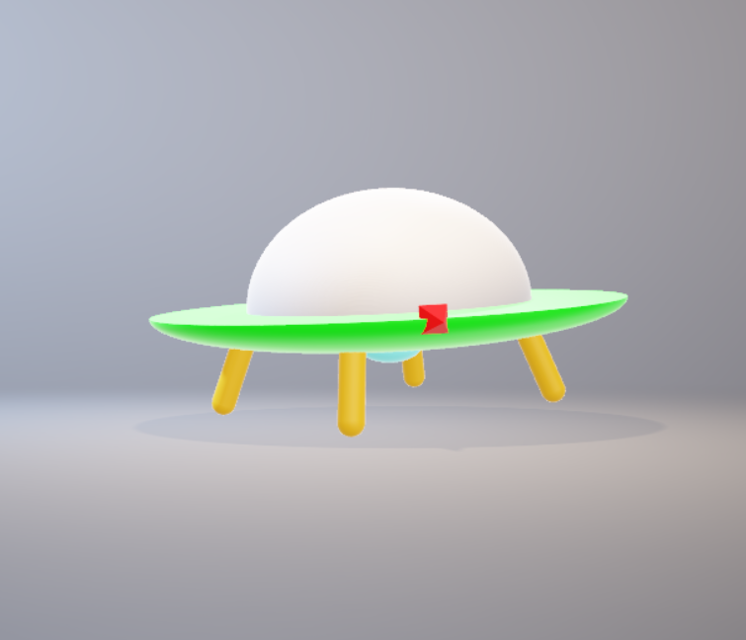

Story Board:

Frame 1 Frame 2

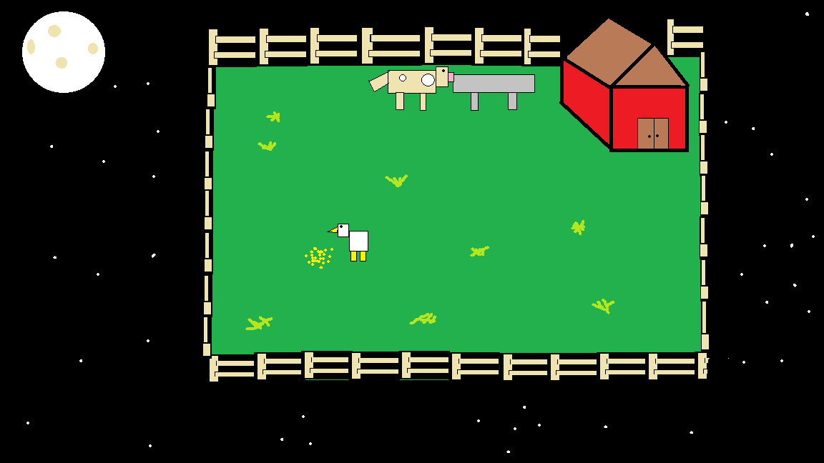 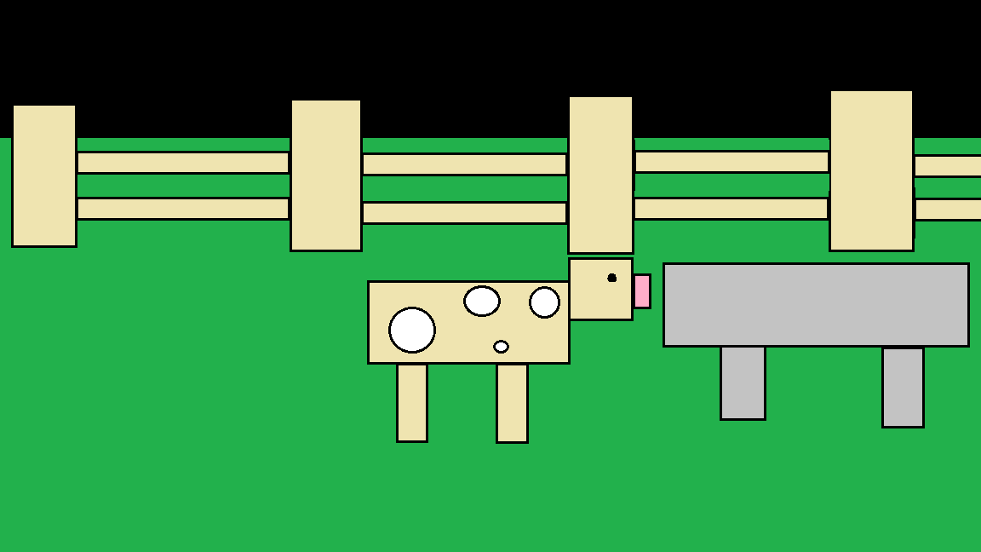

Frame 3 Frame 4

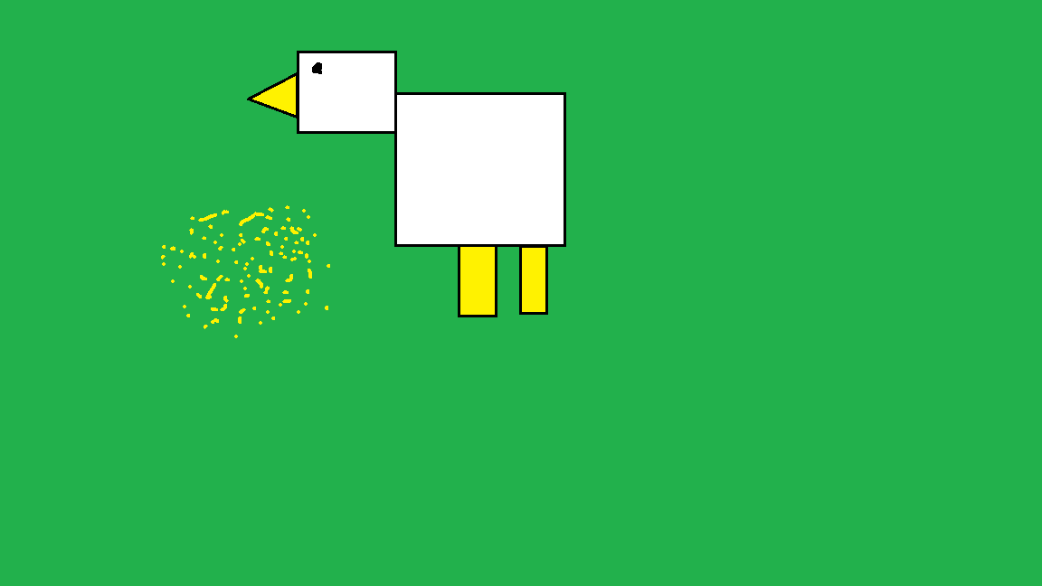 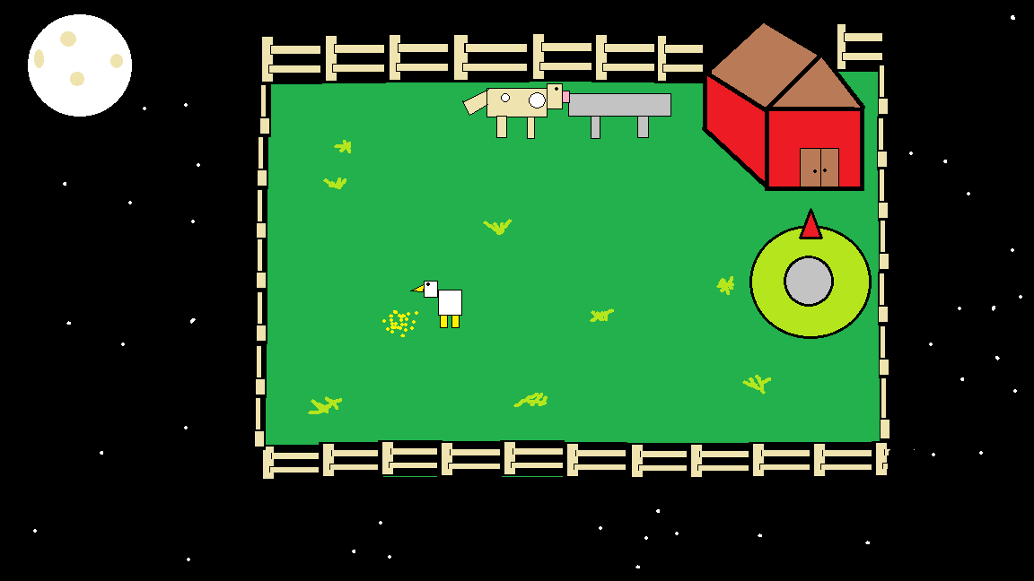

Frame 5 Frame 6

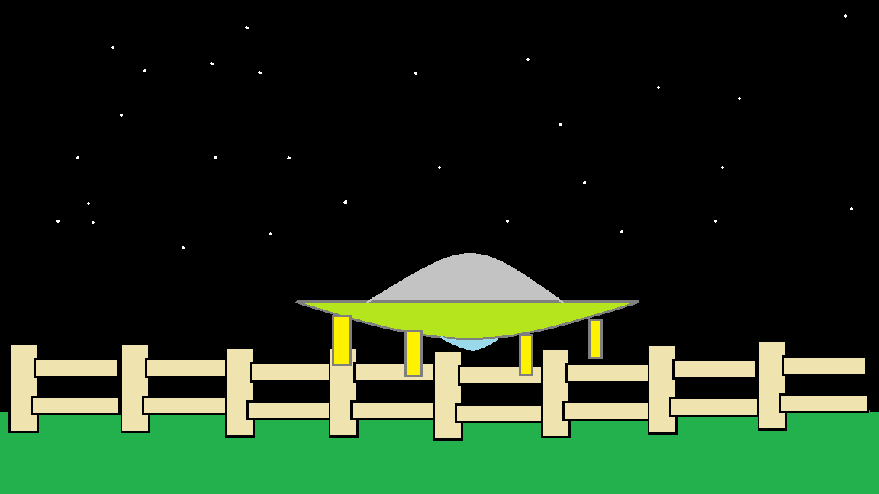 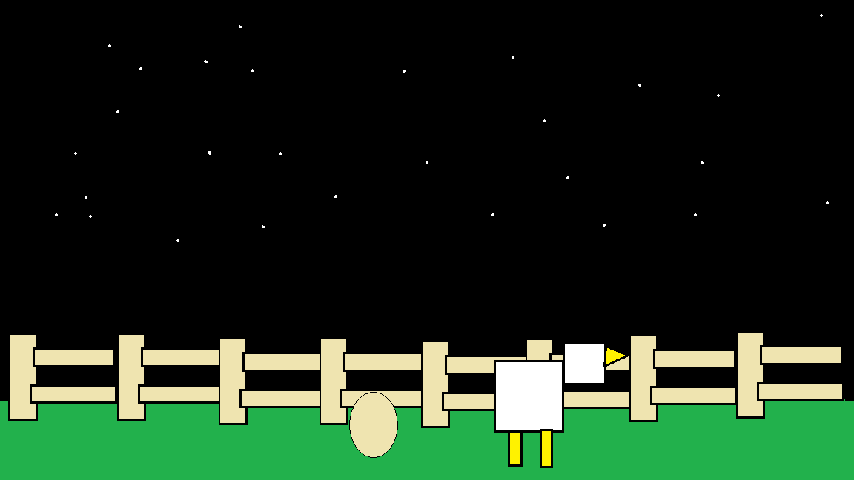

Frame 7 Frame 8

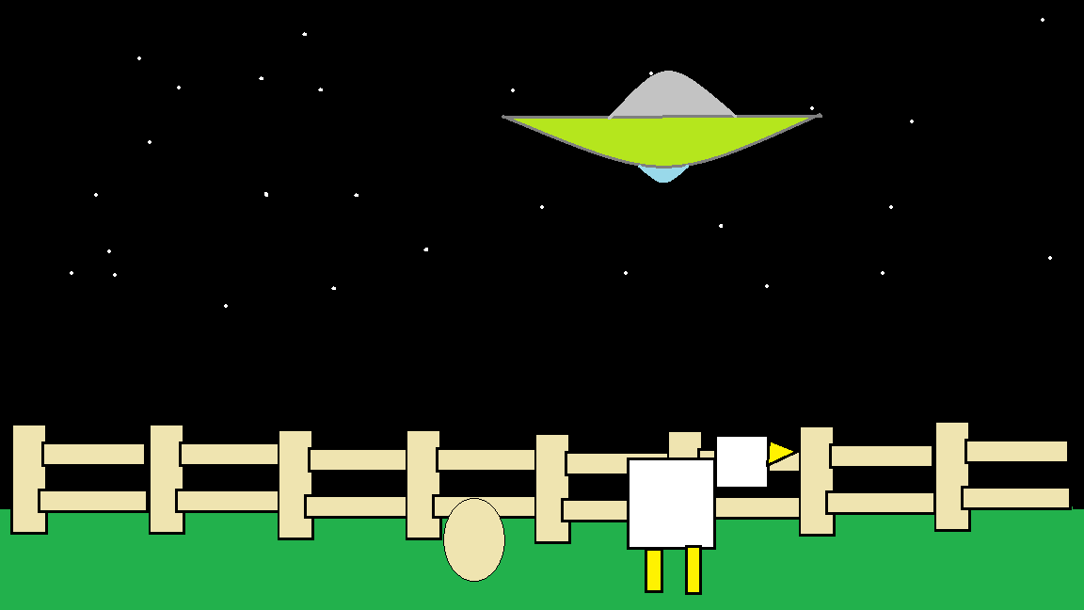 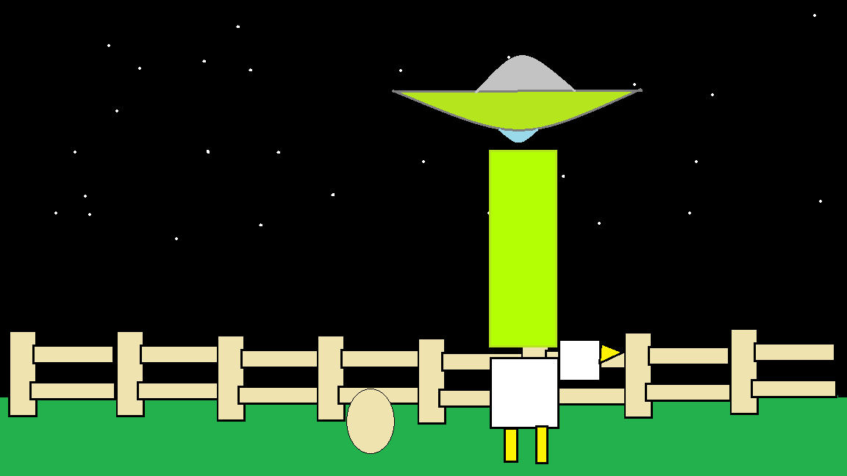

Frame 9 Frame 10

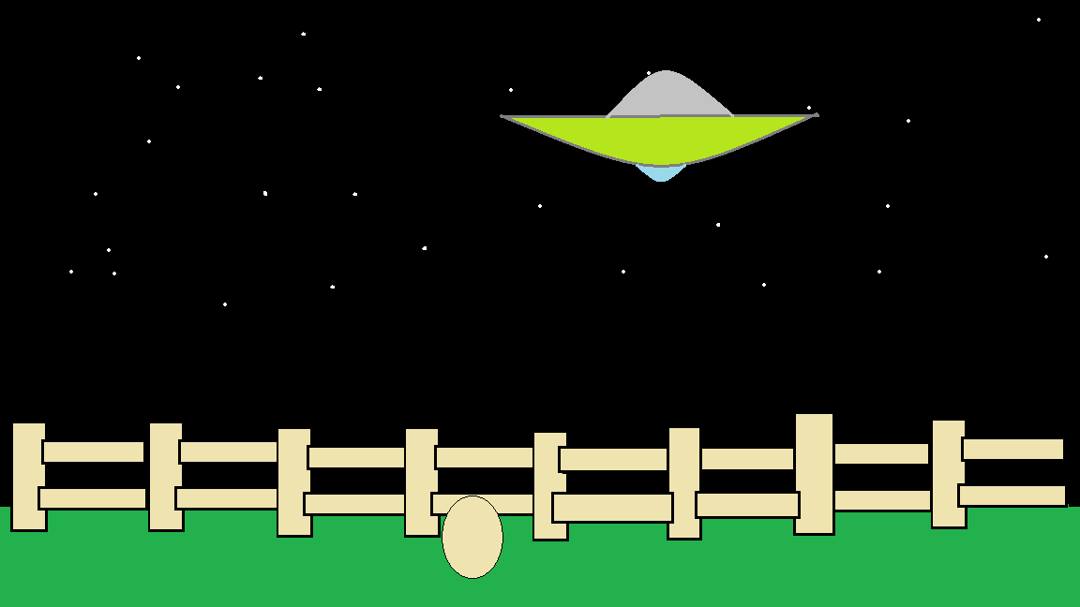 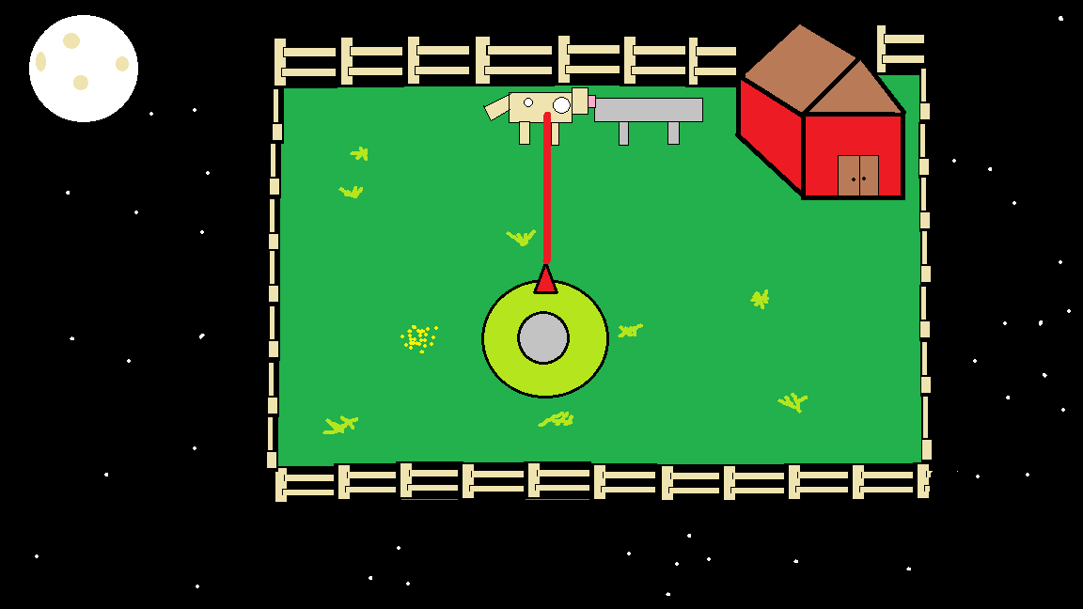

Frame 11 Frame 12

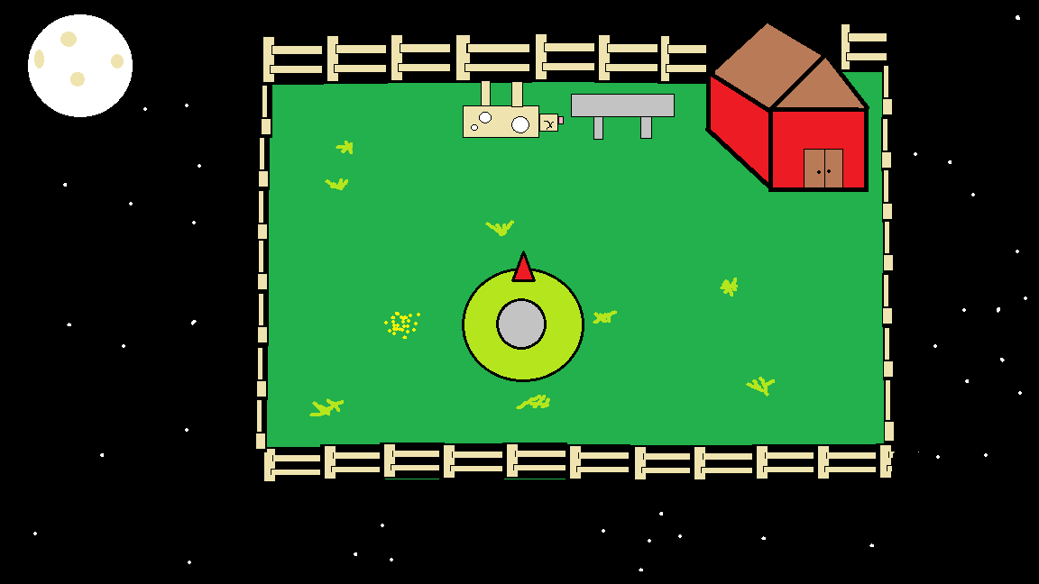 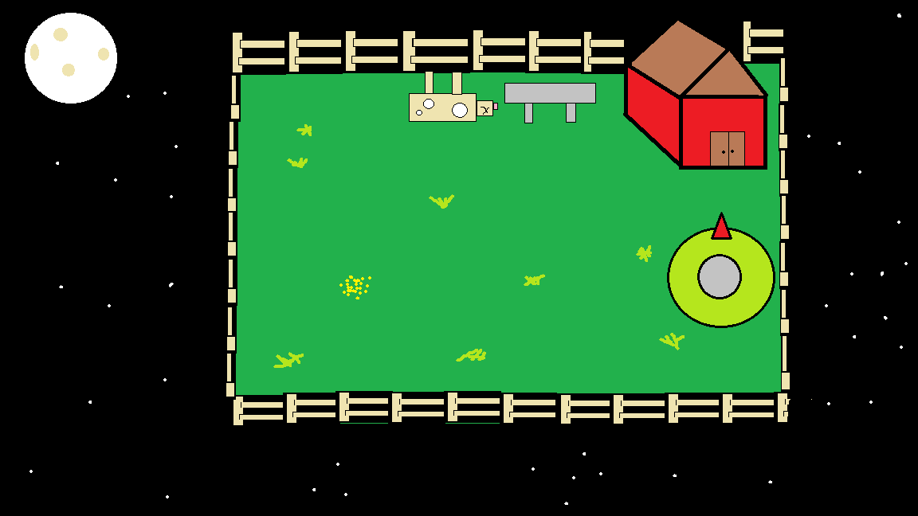

Frame 13

