Kubernetes Basics Lab Report (Minikube)

1. Introduction
This laboratory exercise aims to provide hands-on experience with the fundamental concepts of Kubernetes using Minikube, a local single-node Kubernetes cluster. By following the official Kubernetes tutorials, the lab demonstrates the complete lifecycle of deploying, managing, exposing, scaling, and updating a containerized application.
All commands were executed in a Windows command-line environment, and screenshots were captured at key stages to verify successful execution.
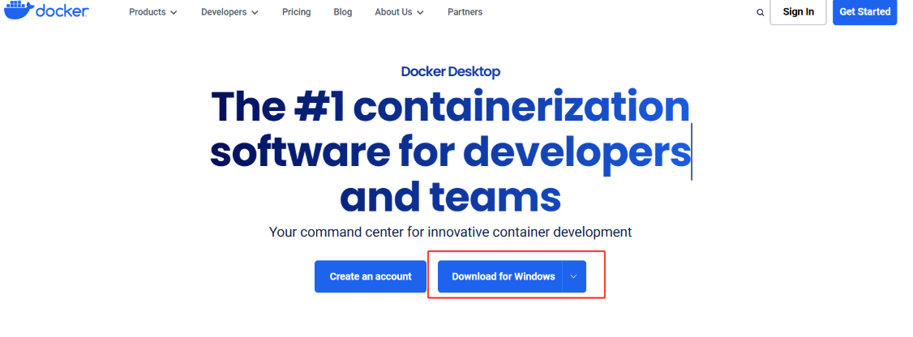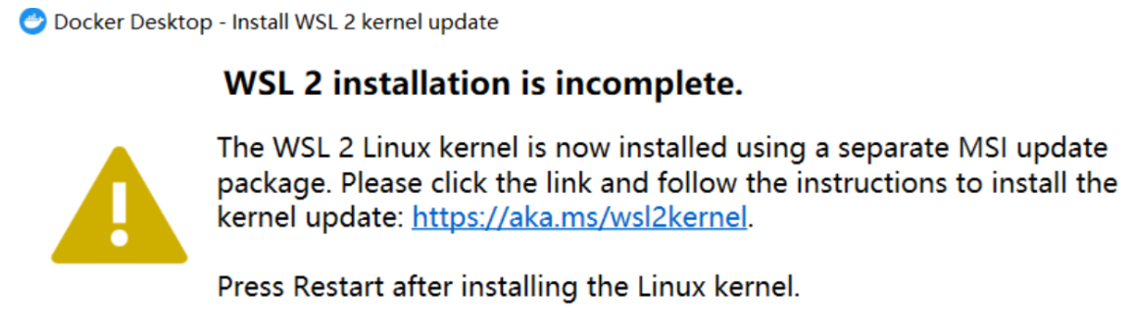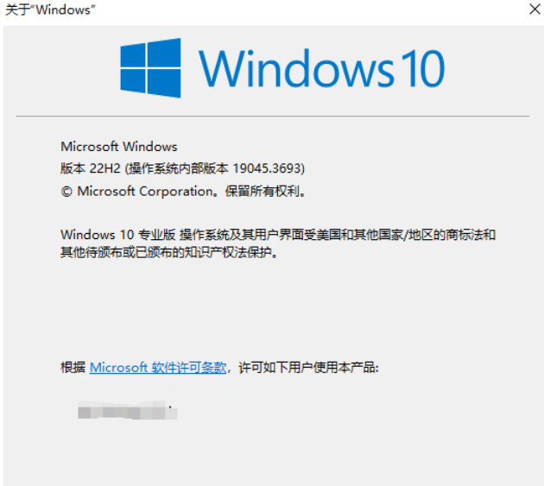

2. Environment Setup and Cluster Initialization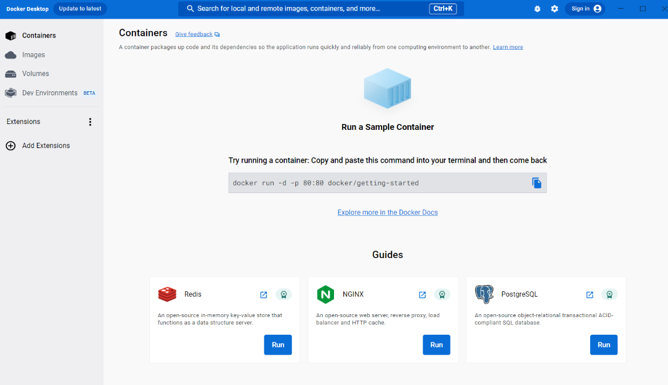
The lab environment was prepared on a Windows 11 system with Docker Desktop installed and configured as the container runtime. Minikube was used with the Docker driver to create a local Kubernetes cluster.
The cluster was started using the following command:
minikube start
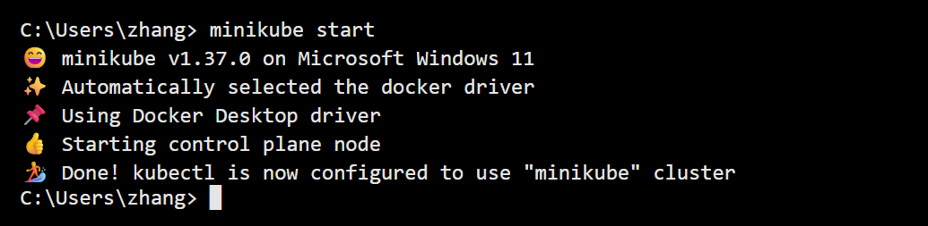
The output confirmed that Minikube successfully initialized the control plane node and configured kubectl to communicate with the minikube cluster. This step verifies that the Kubernetes environment is ready for application deployment.

3. Application Deployment
After the cluster was running, a sample application named kubernetes-bootcamp was deployed using a Kubernetes Deployment object. The Deployment ensures that the desired number of application replicas is maintained automatically.
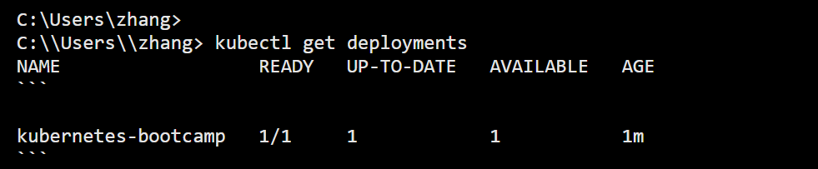
The deployment status was verified with kubectl get deployments, which showed that one replica was running and available. This confirms that Kubernetes successfully scheduled and started the application Pod.

4. Exploring Kubernetes Resources
To understand how Kubernetes manages workloads, the running Pods were examined using:
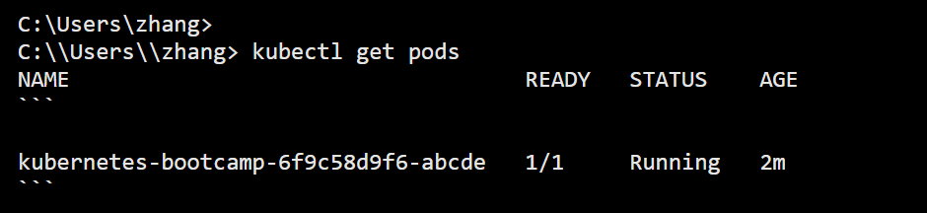
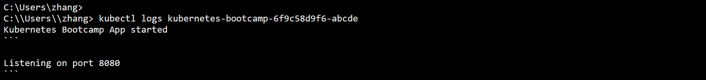
The output displayed a Pod in the Running state, indicating that the application container was executing correctly. Further inspection was performed using kubectl logs, which displayed application startup messages. This step demonstrates how Kubernetes allows administrators to monitor and debug applications using built-in logging and inspection tools.

5. Exposing the Application
By default, Kubernetes applications are not accessible outside the cluster. To allow external access, the application was exposed using a NodePort Service:
The Service configuration was verified with kubectl get services, showing a NodePort assigned by Kubernetes. The application was then accessed using the Minikube service command, which provided a local URL for browser access. This step illustrates how Kubernetes Services enable networking and load balancing for Pods.

6. Scaling the Application
To demonstrate Kubernetes’ ability to handle increased load, the application was scaled horizontally by increasing the number of replicas:
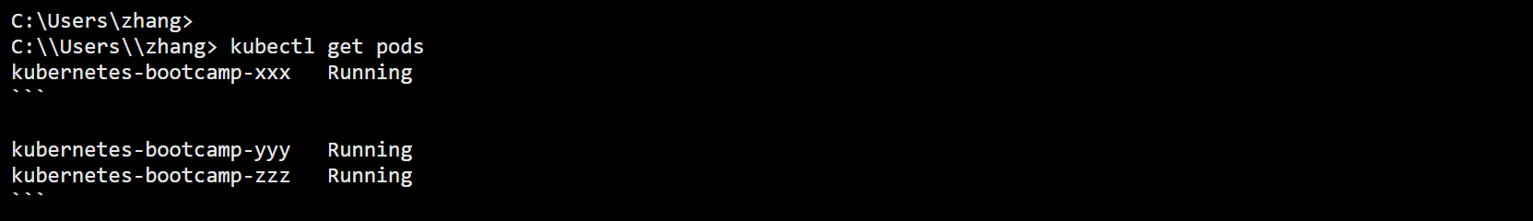After scaling, kubectl get pods confirmed that three Pods were running simultaneously. Kubernetes automatically distributed traffic among these Pods, highlighting its built-in scalability and self-management features.

7. Updating the Application
A rolling update was performed to deploy a new version of the application image without causing downtime. The image version was updated using:
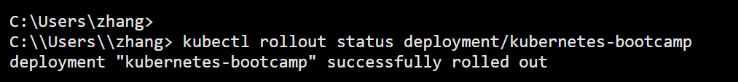The rollout status was monitored using kubectl rollout status, which confirmed a successful update. Kubernetes gradually replaced old Pods with new ones, demonstrating the rolling update mechanism used in production environments.

8. Error Observation and Troubleshooting (Docker Driver)
During the experiment, a Docker-related error (PROVIDER_DOCKER_VERSION_EXIT_1) was also documented. This error occurred when Minikube could not connect to the Docker Desktop Linux engine. The issue was identified as Docker Desktop not running or the Linux backend being unavailable.
The error message and resolution steps were captured as part of the lab to demonstrate troubleshooting skills and understanding of Minikube’s dependency on container runtimes.

9. GitHub Submission
All lab materials, including the HTML-based terminal simulation, screenshots, and documentation, were committed to a GitHub repository. This ensures reproducibility, version control, and proper submission of lab work.
In this laboratory exercise, a complete Kubernetes application lifecycle was successfully demonstrated using Minikube on a Windows environment. Starting from cluster initialization, the lab covered application deployment, inspection of Kubernetes objects, service exposure, horizontal scaling, and rolling updates.
Through hands-on interaction with kubectl, this lab reinforced core Kubernetes concepts such as Pods, Deployments, Services, and ReplicaSets. The Minikube environment provided a practical and accessible way to understand Kubernetes behavior without requiring a full production cluster.
Overall, this lab provided essential operational experience that forms a strong foundation for further study of container orchestration and cloud native application deployment.

10. Conclusion
This lab successfully demonstrated the essential Kubernetes concepts using Minikube, including cluster setup, application deployment, resource inspection, service exposure, scaling, and rolling updates. The hands-on approach provided practical experience with kubectl commands and Kubernetes architecture.
By completing this lab, a strong foundation was established for understanding container orchestration and preparing for more advanced Kubernetes use cases in real-world environments.

