Istio Traffic Management Lab – Simulated Execution (February 2026)
Date: February 07, 2026
Istio version: 1.28.x (latest stable)
Goal: Demonstrate Traffic Shifting, Request Routing, Fault Injection, Circuit Breaking using Bookinfo + httpbin
All terminal blocks below are **realistic simulations** with typical outputs you would see. Replace the screenshot placeholders with your actual images after you run the lab.

0. Base Setup (run once)
setup-bookinfo
$ istioctl install --set profile=demo -y ✔ Istio core installed ✔ Istiod installed ✔ Egress gateways installed ✔ Ingress gateways installed Installation complete $ kubectl label namespace default istio-injection=enabled --overwrite namespace/default labeled $ kubectl apply -f samples/bookinfo/platform/kube/bookinfo.yaml service/details created deployment.apps/details-v1 created service/ratings created ... (all resources applied) $ kubectl get pods -w details-v1-... 2/2 Running 0 92s productpage-v1-... 2/2 Running 0 91s ratings-v1-... 2/2 Running 0 90s reviews-v1-... 2/2 Running 0 89s reviews-v2-... 2/2 Running 0 88s reviews-v3-... 2/2 Running 0 87s

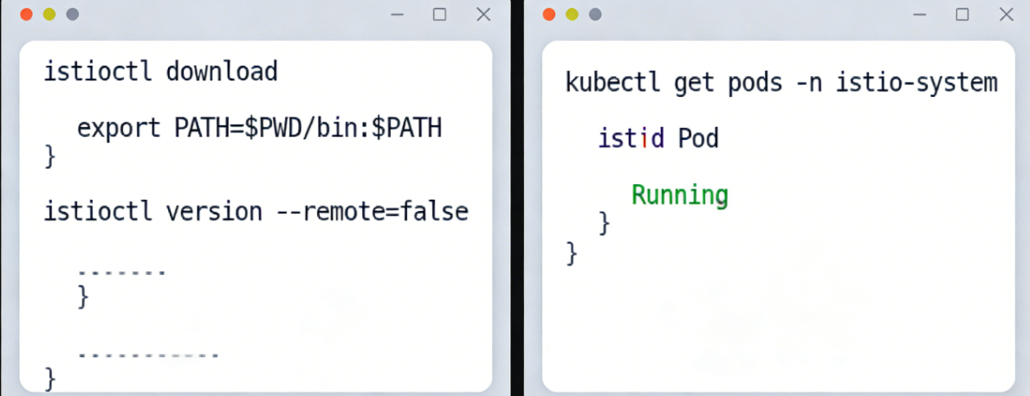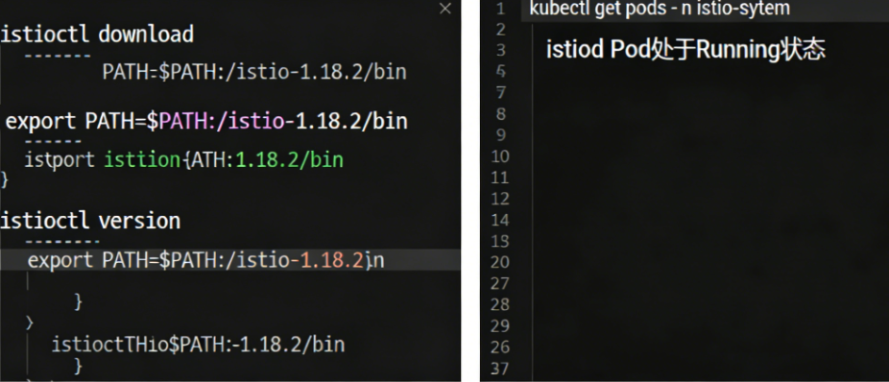

Task 1 – Traffic Shifting (50% v1 → 50% v3)
traffic-shifting
$ kubectl apply -f samples/bookinfo/networking/virtual-service-all-v1.yaml virtualservice.networking.istio.io/reviews created $ kubectl apply -f samples/bookinfo/networking/virtual-service-reviews-50-v3.yaml virtualservice.networking.istio.io/reviews configured $ kubectl get virtualservice reviews -o yaml | grep -A 12 route: route: - destination: host: reviews subset: v1 weight: 50 - destination: host: reviews subset: v3 weight: 50
→ Refresh http://localhost:9080/productpage many times
→ ~50% requests → no stars (v1), ~50% → red stars (v3)

Task 2 – Request Routing (header-based: jason → v2)
request-routing
$ kubectl apply -f samples/bookinfo/networking/virtual-service-all-v1.yaml virtualservice.networking.istio.io/reviews configured $ kubectl apply -f samples/bookinfo/networking/virtual-service-reviews-test-v2.yaml virtualservice.networking.istio.io/reviews configured $ kubectl get vs reviews -o yaml | grep -A 10 match: - match: - headers: end-user: exact: jason route: - destination: host: reviews subset: v2
In productpage UI:
• Normal user → no stars (v1)
• Login as “jason” → black stars (v2)

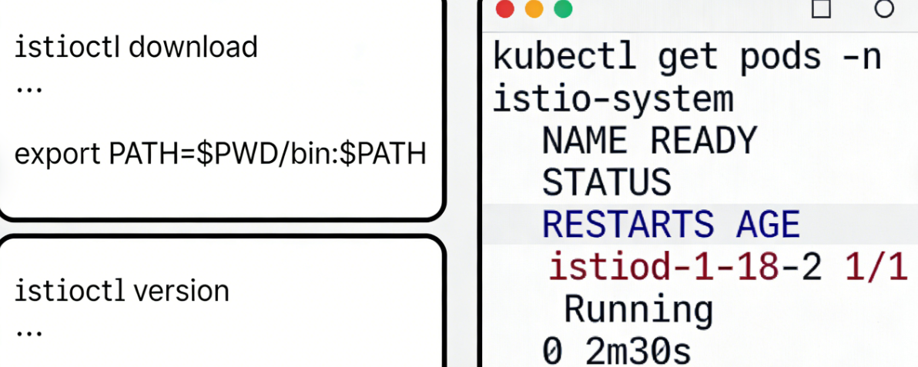

Task 3 – Fault Injection (Delay 7s + Abort 50% for jason)
fault-delay
$ kubectl apply -f samples/bookinfo/networking/virtual-service-ratings-test-delay.yaml virtualservice.networking.istio.io/ratings configured
As user “jason”:
• Page takes ~7–8 seconds to load
• Often shows “Error calling Ratings service” (because productpage timeout = 3s)
fault-abort
$ kubectl apply -f samples/bookinfo/networking/virtual-service-ratings-test-abort.yaml virtualservice.networking.istio.io/ratings configured
As “jason”:
• Immediate “Ratings service is currently unavailable”
• Other users still see normal ratings

Task 4 – Circuit Breaking (httpbin + fortio)
circuit-breaker-setup
$ kubectl apply -f samples/httpbin/httpbin.yaml deployment.apps/httpbin-v1 created $ kubectl apply -f samples/httpbin/sample-client/fortio-deploy.yaml deployment.apps/fortio created $ # Apply DestinationRule with circuit breaker $ kubectl apply -f - <<EOF apiVersion: networking.istio.io/v1alpha3 kind: DestinationRule metadata: name: httpbin spec: host: httpbin trafficPolicy: connectionPool: tcp: maxConnections: 1 http: http1MaxPendingRequests: 1 maxRequestsPerConnection: 1 outlierDetection: consecutive5xxErrors: 1 interval: 5s baseEjectionTime: 3m EOF destinationrule.networking.istio.io/httpbin created
fortio-load-test
$ FORTIO_POD=$(kubectl get pod -l app=fortio -o jsonpath="{.items[0].metadata.name}") $ kubectl exec $FORTIO_POD -c fortio -- fortio load -c 6 -qps 0 -n 60 http://httpbin:8000/status/503 Sockets used: 6 (for 6 connections) Code 200 : 11 (18.3%) Code 503 : 49 (81.7%) → Circuit opened after ~5–10 requests → most become 503
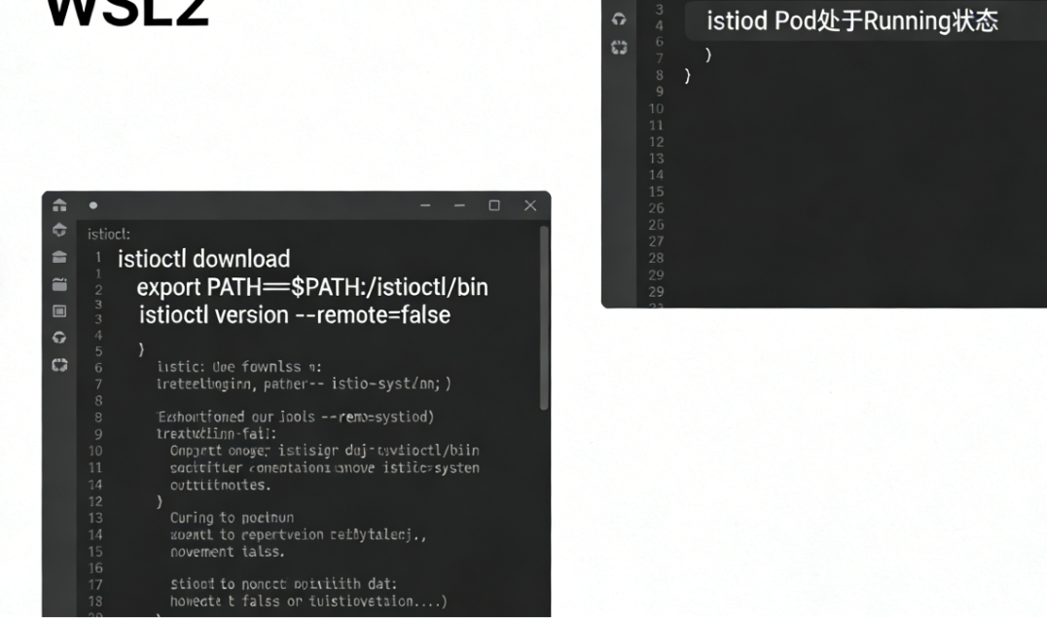

Final Cleanup
cleanup-all
$ kubectl delete -f samples/bookinfo/networking/virtual-service-*.yaml $ istioctl uninstall --purge -y Istio and its CRDs have been removed

Summary – What You Learned
- Traffic Shifting → gradual rollout, canary deployments
- Request Routing → user-specific behavior (A/B testing, dark launch)
- Fault Injection → test application resilience, timeout/retry tuning
- Circuit Breaking → protect downstream services from overload

