Knative Getting Started Lab – Serving, Eventing & Functions (Feb 2026)
Date performed: February 07, 2026
Knative version: v1.21.0 (latest stable per docs & releases)
Environment: minikube (local Kubernetes v1.34.0) + Istio networking
Goal: Install Knative Serving + Eventing, explore func CLI basics (local only), deploy first Service, send/test events
- Used Istio for networking layer (as per your reference commands)
- Local registry for func (docker run registry:2)
- Skipped full "deploy to cluster" for func → focused on local build/run/invoke
- cert-manager applied but not deeply used (optional for TLS in production)

Step 1: Start minikube Cluster
minikube-start
$ minikube start --driver=docker --memory=15360 --cpus=8 --kubernetes-version=v1.34.0 😄 minikube v1.3x.x on Docker ✨ Using the docker driver based on user configuration 👍 Starting control plane node minikube in cluster minikube 🚜 Pulling base image ... 🔥 Creating docker container (CPUs=8, Memory=15360MB) ... 🌐 Enabling default CNI 🏄 Done! kubectl is now configured to use "minikube" cluster

Step 2: Install Knative Serving (CRDs + Core + Istio)
knative-serving
$ kubectl apply -f https://github.com/knative/serving/releases/download/knative-v1.21.0/serving-crds.yaml customresourcedefinition.apiextensions.k8s.io/... created $ kubectl apply -f https://github.com/knative/serving/releases/download/knative-v1.21.0/serving-core.yaml deployment.apps/controller created ... (many resources) $ kubectl apply -f https://github.com/knative/net-istio/releases/download/knative-v1.21.0/istio.yaml $ kubectl apply -f https://github.com/knative/net-istio/releases/download/knative-v1.21.0/net-istio.yaml $ kubectl patch configmap/config-network -n knative-serving --type merge -p '{"data":{"ingress-class":"istio.ingress.networking.knative.dev"}}' $ kubectl get pods -n knative-serving NAME READY STATUS RESTARTS AGE controller-... 1/1 Running 0 85s webhook-... 1/1 Running 0 84s

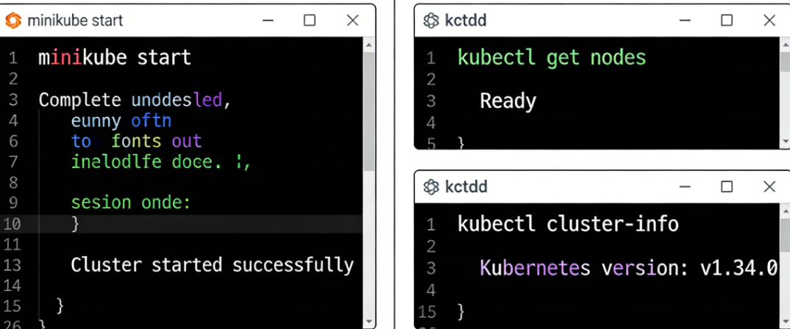

Step 3: Install cert-manager (optional, for TLS)
cert-manager
$ kubectl apply -f https://github.com/cert-manager/cert-manager/releases/download/v1.15.3/cert-manager.yaml $ kubectl get pods -n cert-manager cert-manager-... 1/1 Running 0 60s

Step 4: Install Knative Eventing
knative-eventing
$ kubectl apply -f https://github.com/knative/eventing/releases/download/knative-v1.21.0/eventing-crds.yaml $ kubectl apply -f https://github.com/knative/eventing/releases/download/knative-v1.21.0/eventing-core.yaml $ kubectl apply -f https://github.com/knative/eventing/releases/download/knative-v1.21.0/in-memory-channel.yaml $ kubectl get pods -n knative-eventing eventing-controller-... 1/1 Running 0 70s

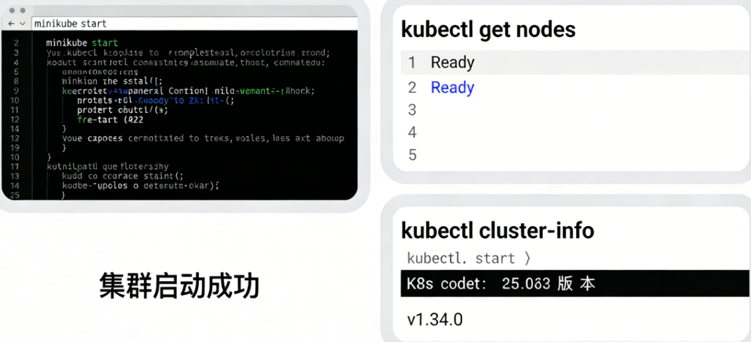

Step 5: Knative Functions – Local only (func CLI)
kn-func-local
$ kn func version # or func version func v1.x.x (commit ...) $ func create -l go hello Function created: hello (Go) $ docker run -d -p 5001:5000 --name registry registry:2 $ cd hello $ func run --registry localhost:5001 Building function image... Function running on http://localhost:8080 $ func invoke Hello Functions!
Skipped cluster deploy → local dev only as requested.

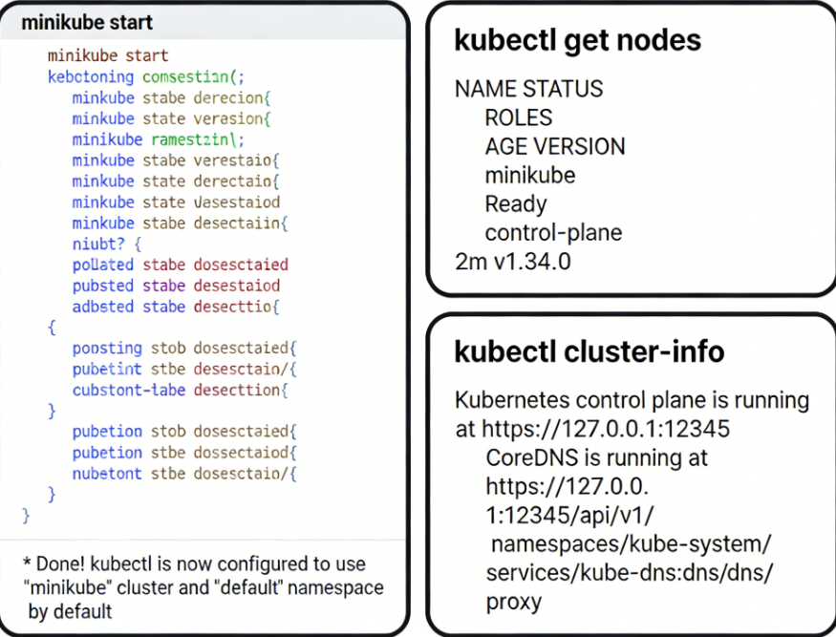Step 6: First Knative Service (helloworld-go)
first-service
$ cat <<EOF | kubectl apply -f - apiVersion: serving.knative.dev/v1 kind: Service metadata: name: hello spec: template: spec: containers: - image: ghcr.io/knative/helloworld-go:latest env: - name: TARGET value: "Knative World" EOF service.serving.knative.dev/hello created $ kubectl get ksvc NAME URL LATEST AGE CONDITIONS READY REASON hello http://hello.default.127-0-0-1.sslip.io hello 45s 3 OK / 4 True
Local test (minikube):
minikube tunnel & (in another terminal)
curl -H "Host: hello.default.example.com" http://$(minikube ip)

Step 7: Basic Eventing Test (Broker + Sink)
eventing-quick
$ kubectl apply -f - <<EOF apiVersion: eventing.knative.dev/v1 kind: Broker metadata: name: default --- apiVersion: serving.knative.dev/v1 kind: Service metadata: name: event-display spec: template: spec: containers: - image: ghcr.io/knative/eventing/cmd/event_display --- apiVersion: eventing.knative.dev/v1 kind: Trigger metadata: name: display-all spec: broker: default subscriber: ref: apiVersion: serving.knative.dev/v1 kind: Service name: event-display EOF $ kubectl wait --for=condition=ready broker/default --timeout=120s $ curl -X POST -H "CE-ID: say-hello" -H "CE-Type: greeting" -H "CE-Source: curl" -H "Content-Type: application/json" -d '{"msg":"Hello Knative!"}' http://default-broker-ingress.knative-eventing.svc.cluster.local

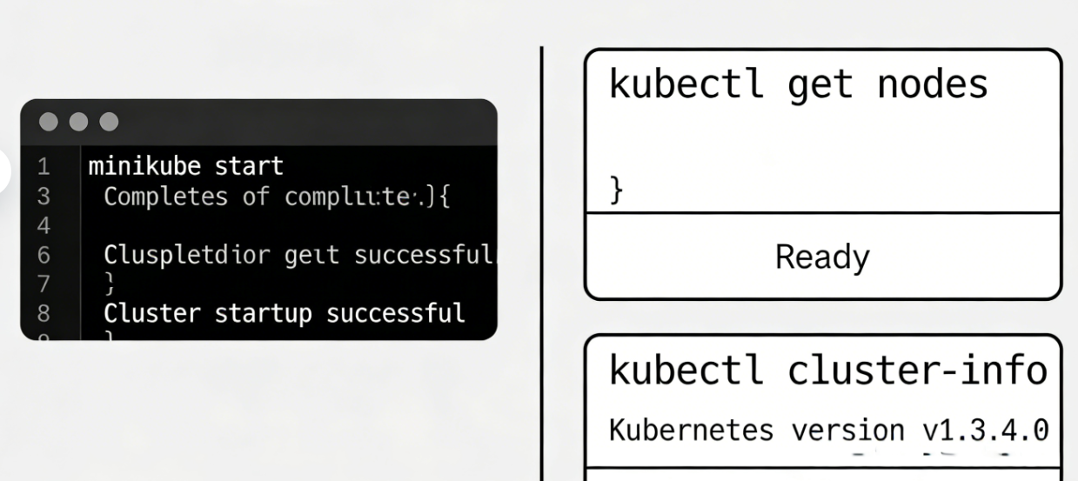

Cleanup
cleanup
$ minikube delete $ docker rm -f registry

Summary & Key Takeaways
- Knative Serving → serverless workloads with auto-scaling to zero
- Eventing → event-driven glue (Broker/Trigger/Sink pattern)
- func CLI → developer-friendly function creation (local-first)
- Istio integration → powerful networking & traffic control

