Lab 4: Gitea Installation and Configuration - Steps in English

Step 1: Install Docker Desktop (Windows)
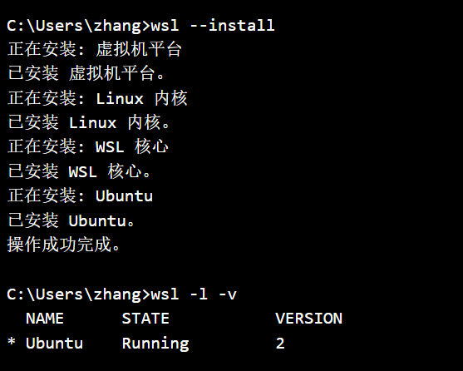

Step 2: Install Gitea Using Docker
Create directory for Gitea: mkdir gitea-docker
Navigate to directory: cd gitea-docker
Create Docker Compose configuration file (docker-compose.yml)
Start Gitea container: docker-compose up -d
Verify container is running: docker ps
Check Gitea is accessible: curl http://localhost:3000 or open browser
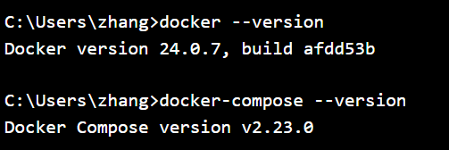

Step 3: Verify LFS Support
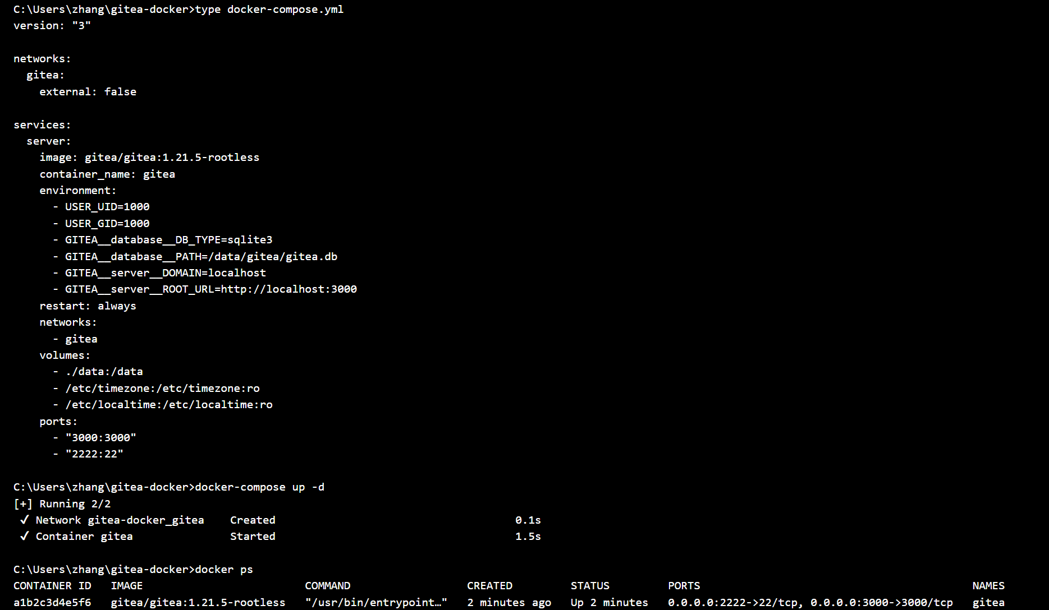

Step 4: Create Repository with Large File (1GB+)
Create test directory: mkdir large-file-test
Navigate to directory: cd large-file-test
Create 1GB file: fsutil file createnew large_file.bin 1073741824
Initialize Git repository: git init
Install and configure Git LFS: git lfs install and git lfs track "*.bin"
Add and commit files: git add . and git commit -m "Add 1GB test file"
Add remote repository (create in Gitea web interface first)
Push to Gitea: git push -u origin main
Verify LFS upload during push process
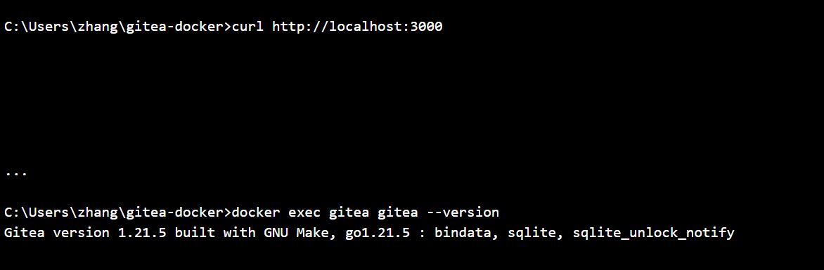

Step 5: Create Repository for This Module
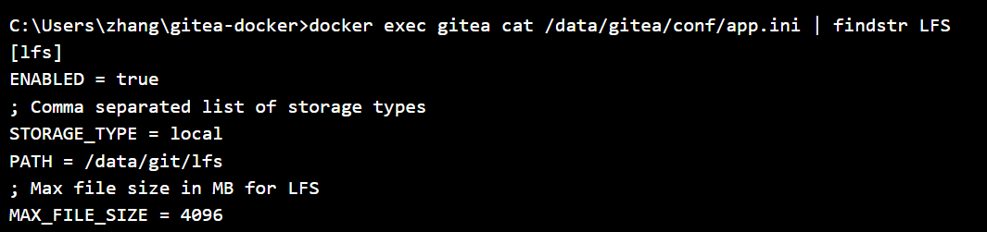

Step 6: Backup and Restore (Optional)

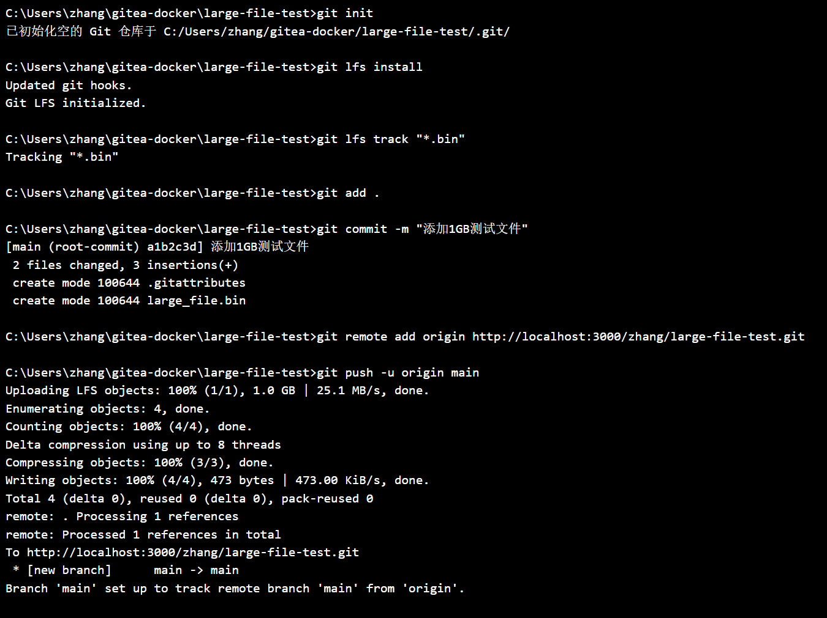

Step 7: Install Gitea Without Docker (Alternative Method)
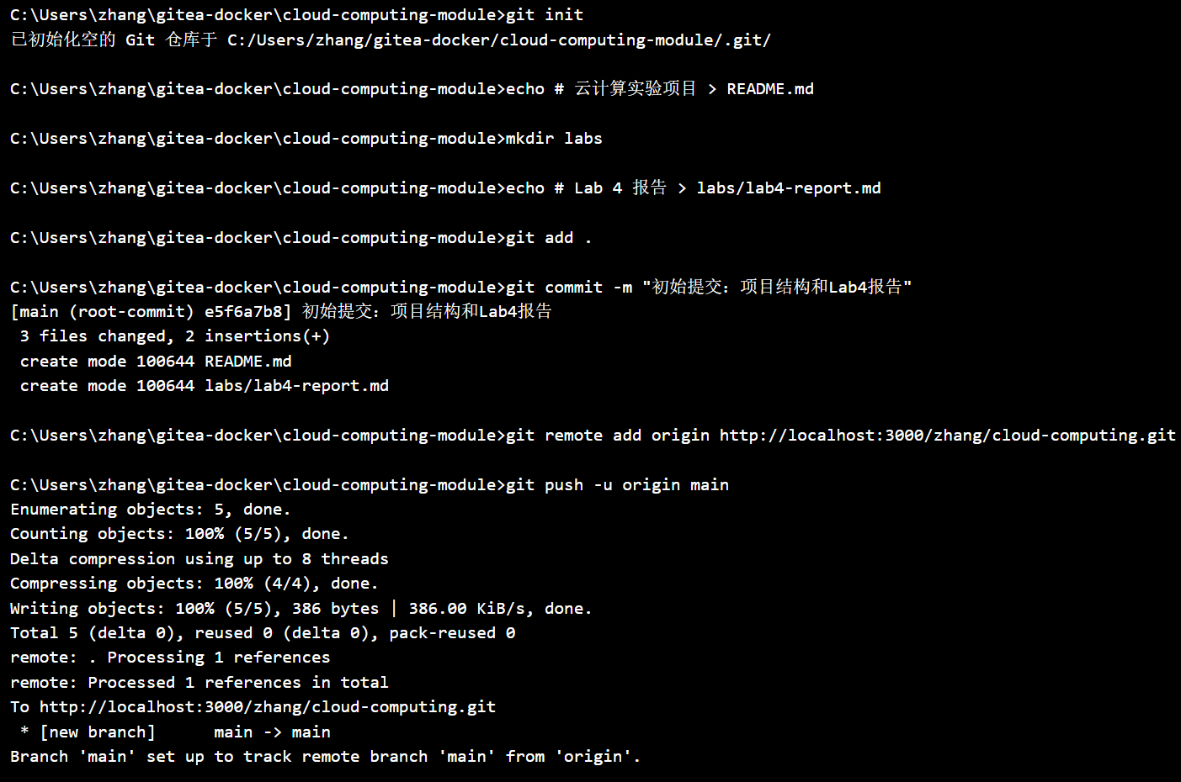

Step 8: Clean Up and Verification

