Istio Getting Started Tutorial

Introduction
This document provides a comprehensive, step-by-step walkthrough of the official Istio Getting Started tutorial. Istio is an open-source service mesh that provides traffic management, security, observability, and policy enforcement for microservices applications.
Note: This tutorial assumes you have a running Kubernetes cluster. If you're using Minikube from the previous tutorial, ensure it's running with sufficient resources (at least 4GB RAM and 2 CPUs recommended for Istio).

What is a Service Mesh?
A service mesh is a dedicated infrastructure layer that handles service-to-service communication. Istio as a service mesh provides:
- Traffic Management: Intelligent routing, load balancing, and fault injection
- Security: Automatic mTLS, authentication, and authorization
- Observability: Metrics, logs, and distributed tracing
- Policy Enforcement: Rate limiting, quotas, and access controls

1. Prerequisites

Required Components
Before starting, ensure you have the following installed and configured:
- Kubernetes Cluster (version 1.24 or newer)
- kubectl command-line tool
- Minikube (for local development) or access to a cloud Kubernetes cluster
- Sufficient cluster resources (4+ GB RAM, 2+ CPUs)

1 Verify Kubernetes Cluster
Check that your Kubernetes cluster is running and accessible:
kubectl cluster-info kubectl get nodes
Expected output (when using Minikube):
NAME STATUS ROLES AGE VERSION minikube Ready control-plane 15d v1.28.0

2 Check Available Resources
Istio requires adequate resources. Check your cluster's capacity:
kubectl describe node minikube | grep -A 10 -B 5 "Capacity:"
Warning: If using Minikube with limited resources, increase them before proceeding:
minikube stop minikube start --memory=8192 --cpus=4

2. Download and Install Istio

1 Download Istio
Download the latest Istio release:
# Download the latest Istio release curl -L https://istio.io/downloadIstio | sh -
Alternatively, download a specific version:
# Download a specific version (e.g., 1.20.0) curl -L https://istio.io/downloadIstio | ISTIO_VERSION=1.20.0 sh -

2 Add Istio to Your PATH
Navigate to the Istio package directory and add the `istioctl` CLI to your path:
# Change to the Istio package directory cd istio-* # Add istioctl to your PATH (Linux/macOS) export PATH=$PWD/bin:$PATH # For permanent addition, add to your shell profile echo 'export PATH="$PATH:'$PWD'/bin"' >> ~/.bashrc # For bash echo 'export PATH="$PATH:'$PWD'/bin"' >> ~/.zshrc # For zsh
For Windows (PowerShell):
$env:Path += ";$pwd\bin"

3 Verify istioctl Installation
Check that `istioctl` is correctly installed:
istioctl version --remote=false
Expected output (version may vary):
no running Istio pods in "istio-system" 1.20.0

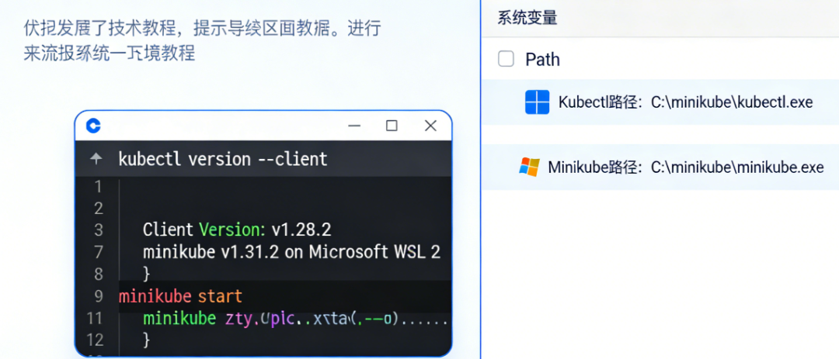3. Install Istio on Your Cluster

1 Choose an Installation Profile
Istio offers several installation profiles. List available profiles:
istioctl profile list
Expected output:
Istio configuration profiles: default demo empty external minimal openshift preview remote
Profile Recommendations:
- demo: For evaluation (default for this tutorial)
- default: For production according to Istio's default settings
- minimal: Minimal set of components for Istio's traffic management
- remote: For multi-cluster meshes with remote clusters

2 Install with Demo Profile
The demo profile is ideal for learning and evaluation:
istioctl install --set profile=demo -y
Expected output:
✔ Istio core installed ✔ Istiod installed ✔ Egress gateways installed ✔ Ingress gateways installed ✔ Installation complete

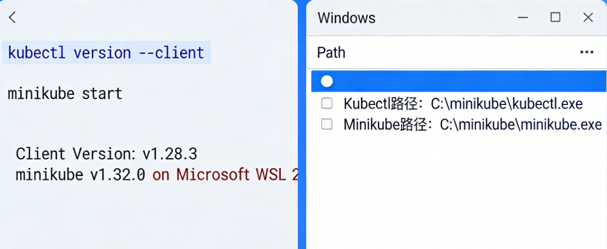

3 Verify the Installation
Check that all Istio components are running correctly:
kubectl get pods -n istio-system
Expected output (all pods should be in "Running" status):
NAME READY STATUS RESTARTS AGE istio-egressgateway-5cfd6b65f8-rzrhp 1/1 Running 0 2m istio-ingressgateway-5c46d8d6c6-pqzwv 1/1 Running 0 2m istiod-7d5d8c8bc8-2vj94 1/1 Running 0 2m
Check services:
kubectl get svc -n istio-system

4 Install Additional Addons (Optional)
Istio includes optional addons for monitoring and visualization:
kubectl apply -f samples/addons kubectl rollout status deployment/kiali -n istio-system
Available Addons: Prometheus (metrics), Grafana (dashboards), Kiali (service mesh visualization), Jaeger (distributed tracing).

4. Deploy the Sample Application

1 Enable Automatic Sidecar Injection
Label the default namespace for automatic Istio sidecar injection:
kubectl label namespace default istio-injection=enabled
Verify the label was applied:
kubectl get namespace -L istio-injection

2 Deploy the Bookinfo Application
The Bookinfo application is a sample microservices application composed of four services:

Product Page
Calls Details and Reviews

Details
Book information service

Reviews
Book reviews (3 versions: v1, v2, v3)

Ratings
Rating service (called by Reviews v2)
Deploy the application:
kubectl apply -f samples/bookinfo/platform/kube/bookinfo.yaml
Expected output:
service/details created serviceaccount/bookinfo-details created deployment.apps/details-v1 created service/ratings created serviceaccount/bookinfo-ratings created deployment.apps/ratings-v1 created service/reviews created serviceaccount/bookinfo-reviews created deployment.apps/reviews-v1 created deployment.apps/reviews-v2 created deployment.apps/reviews-v3 created service/productpage created serviceaccount/bookinfo-productpage created deployment.apps/productpage-v1 created

3 Verify Application Deployment
Check that all services and pods are running:
kubectl get services
Check pods (note each pod now has 2 containers - app + Istio sidecar):
kubectl get pods
Wait for all pods to be ready (2/2 containers):
kubectl wait --for=condition=Ready pods --all --timeout=300s

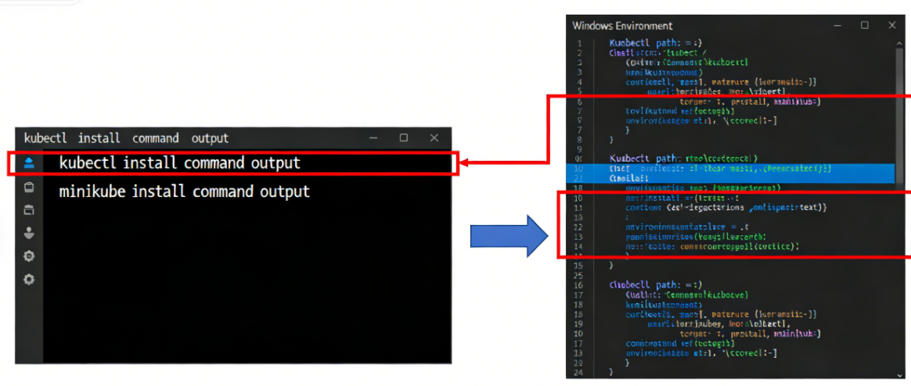

4 Verify the Application is Running Inside the Mesh
Check that sidecars are injected by examining a pod:
kubectl describe pod $(kubectl get pod -l app=productpage -o jsonpath='{.items[0].metadata.name}')
Look for two containers in the output: "productpage" (application) and "istio-proxy" (sidecar).

5. Expose the Application

1 Create an Istio Gateway
An Istio Gateway configures a load balancer for HTTP/TCP traffic:
kubectl apply -f samples/bookinfo/networking/bookinfo-gateway.yaml
Verify the gateway was created:
kubectl get gateway

2 Determine the Ingress IP and Port
Get the ingress host and port (varies by environment):
For Minikube or Docker Desktop:
export INGRESS_HOST=$(minikube ip) export INGRESS_PORT=$(kubectl -n istio-system get service istio-ingressgateway -o jsonpath='{.spec.ports[?(@.name=="http2")].nodePort}')
For cloud providers with external load balancer:
export INGRESS_HOST=$(kubectl -n istio-system get service istio-ingressgateway -o jsonpath='{.status.loadBalancer.ingress[0].ip}') export INGRESS_PORT=80
Set the gateway URL:
export GATEWAY_URL=$INGRESS_HOST:$INGRESS_PORT echo "Gateway URL: http://$GATEWAY_URL/productpage"

3 Verify External Access
Check that the application is accessible from outside the cluster:
curl -s "http://${GATEWAY_URL}/productpage" | grep -o ""
Expected output:
Access the application in your browser:
echo "Open http://$GATEWAY_URL/productpage in your browser"
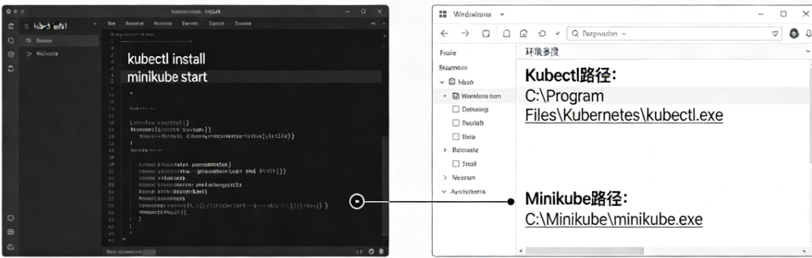

4 Verify All Services are Integrated
Check that the product page displays correctly with reviews and details. Refresh the page multiple times to see different review versions (v1, v2, v3).
Note: The reviews service has three versions. Version 1 shows no ratings, version 2 shows black star ratings, and version 3 shows red star ratings. By default, traffic is routed to all versions.

6. View the Dashboard and Observe Traffic

1 Access the Kiali Dashboard
Kiali provides visualization of your service mesh. Forward the Kiali service to localhost:
kubectl port-forward svc/kiali 20001:20001 -n istio-system &
Access Kiali in your browser:
echo "Open Kiali at http://localhost:20001" echo "Username: admin" echo "Password: admin"

2 Generate Traffic
To see traffic flow in Kiali, generate some load:
# Generate traffic for 2 minutes for i in $(seq 1 100); do curl -s "http://${GATEWAY_URL}/productpage" > /dev/null echo "Request $i completed" sleep 1 done
Alternative: Use the built-in load generator:
# In a separate terminal while true; do curl -s "http://${GATEWAY_URL}/productpage" > /dev/null; done

3 Explore Kiali Features
In the Kiali dashboard:
- Go to Graph to see the service mesh visualization
- Select namespace: default
- Observe traffic flow between services
- Click on services to see details
- Check the Applications, Workloads, and Services tabs

4 Access Other Dashboards (Optional)
Prometheus (metrics):
kubectl port-forward svc/prometheus 9090:9090 -n istio-system &
Grafana (visualization):
kubectl port-forward svc/grafana 3000:3000 -n istio-system &
Jaeger (tracing):
kubectl port-forward svc/tracing 16686:16686 -n istio-system &

7. Traffic Management Examples

1 Apply Default Destination Rules
Destination rules define policies for traffic after routing has occurred:
kubectl apply -f samples/bookinfo/networking/destination-rule-all.yaml
Verify destination rules:
kubectl get destinationrules -o yaml

2 Route Traffic to a Specific Version
Route all traffic to reviews v1:
kubectl apply -f samples/bookinfo/networking/virtual-service-all-v1.yaml
Test by refreshing the product page multiple times. You should only see reviews v1 (no ratings).

3 Implement Content-Based Routing
Route traffic based on user identity:
kubectl apply -f samples/bookinfo/networking/virtual-service-reviews-test-v2.yaml
This configuration routes user "jason" to reviews v2 and all other users to reviews v1.
Test the configuration:
- Access the product page normally (you should see v1)
- Click "Sign in" in the top right
- Login with username: jason, password: any
- You should now see reviews v2 (black star ratings)

4 Implement Traffic Shifting (Canary Deployment)
Shift 50% of traffic to reviews v3:
kubectl apply -f samples/bookinfo/networking/virtual-service-reviews-50-v3.yaml
Test by refreshing the product page multiple times. Approximately half the requests should show v3 (red stars).
Check the virtual service configuration:
kubectl get virtualservice reviews -o yaml

8. Clean Up

1 Delete the Sample Application
Remove the Bookinfo application and its configuration:
samples/bookinfo/platform/kube/cleanup.sh
Or manually delete resources:
kubectl delete -f samples/bookinfo/platform/kube/bookinfo.yaml kubectl delete -f samples/bookinfo/networking/bookinfo-gateway.yaml kubectl delete -f samples/bookinfo/networking/destination-rule-all.yaml

2 Uninstall Istio
Remove Istio from your cluster:
istioctl uninstall --purge -y
Remove the Istio namespace:
kubectl delete namespace istio-system

3 Remove the istio-injection Label
Remove the injection label from the default namespace:
kubectl label namespace default istio-injection-

4 Remove Downloaded Istio Files
Navigate out of the Istio directory and remove it:
cd .. rm -rf istio-*

9. Troubleshooting Common Issues
Issue | Solution
Istio pods stuck in "ContainerCreating" | Check cluster resources. Increase Minikube resources: minikube stop && minikube start --memory=8192 --cpus=4
Application pods not getting sidecars (1/1 instead of 2/2) | Verify namespace label: kubectl get namespace -L istio-injection. Redeploy pods after enabling injection.
Cannot access application via gateway | Check gateway and virtual services: kubectl get gateway,virtualservice. Verify INGRESS_HOST and INGRESS_PORT.
Kiali/Grafana/Jaeger not accessible | Ensure addons were installed: kubectl get pods -n istio-system. Forward correct ports.
"no healthy upstream" errors | Check destination rules and pod readiness. Ensure all services have endpoints: kubectl get endpoints.
Debugging Commands:
# Check Envoy sidecar configuration istioctl proxy-config routes $(kubectl get pod -l app=productpage -o jsonpath='{.items[0].metadata.name}') # Check sidecar logs kubectl logs $(kubectl get pod -l app=productpage -o jsonpath='{.items[0].metadata.name}') -c istio-proxy # Verify mTLS istioctl authn tls-check $(kubectl get pod -l app=productpage -o jsonpath='{.items[0].metadata.name}')

10. Key Takeaways

What You've Learned
- Istio Architecture: Control plane (istiod) and data plane (Envoy sidecars)
- Installation: Using istioctl with different profiles for various use cases
- Sidecar Injection: Automatic injection via namespace labels
- Traffic Management: Gateways, virtual services, and destination rules
- Observability: Using Kiali, Grafana, Prometheus, and Jaeger
- Advanced Routing: Version-based, user-based, and percentage-based traffic routing

Next Steps for Learning
- Security: Implement mTLS and authentication policies
- Resilience: Configure circuit breakers, retries, and timeouts
- Telemetry: Custom metrics and distributed tracing
- Multi-cluster: Set up a service mesh across multiple Kubernetes clusters
- Production Deployment: Move from "demo" to "default" or custom profiles
Congratulations! You've successfully completed the Istio getting started tutorial. You now have a working Istio service mesh and understand the core concepts of traffic management, observability, and configuration.

