**Patient Demographics and Patterns**

Age distribution – Age group with the most admissions and what time of disease.

1. **Age distributions**

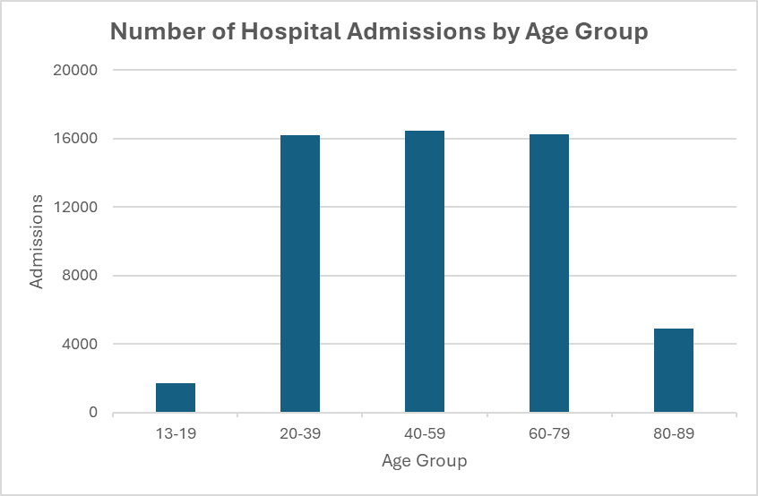

**Insights:**

The majority of hospital admissions occur in the age groups of 20-79 for various diseases. The 40-59 age group has the highest number of admissions at 16,480, closely followed by 60-79 (16,249) and 20-39 (16,179). This indicates that the peak demand for hospital services for various diseases falls within this broad adult demographic.

The 13-19 age group has a comparatively very low number of admissions (1,693), representing a small fraction of the total. This is expected as this age group generally experiences fewer severe health issues requiring hospitalization compared to older adults.

While still substantial, the 80-89 age group has considerably fewer admissions (4,899) than the middle-aged and young-old adult groups. This could be due to several factors:

* A smaller overall population size in this age bracket compared to younger adult groups.
* Increased reliance on alternative care settings (e.g., home care, nursing homes) for chronic conditions that might otherwise lead to hospital stays in younger elderly populations.
* Potentially higher mortality rates reducing the pool of individuals reaching the very old age.

1. **Gender-based health trends**
2. **Compare admission rates across genders**

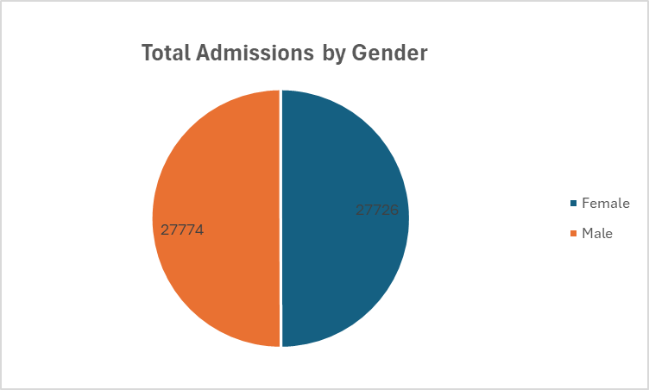

1. **Admissions for specific medical conditions across genders**

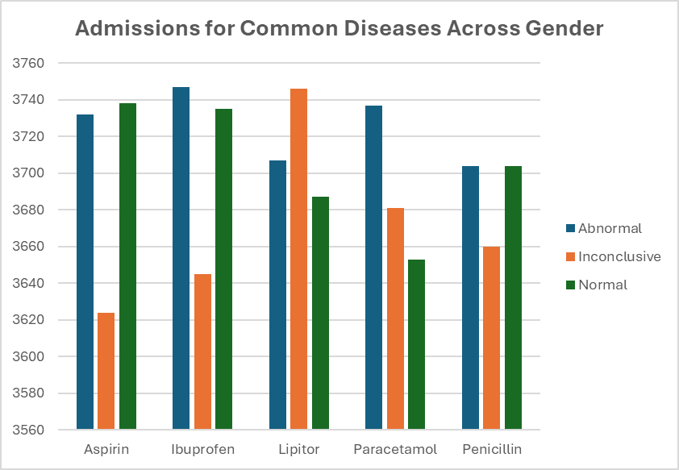

1. **Health outcomes across genders**

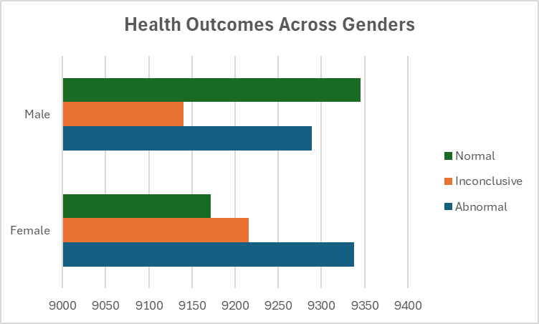

1. **Blood type correlations**

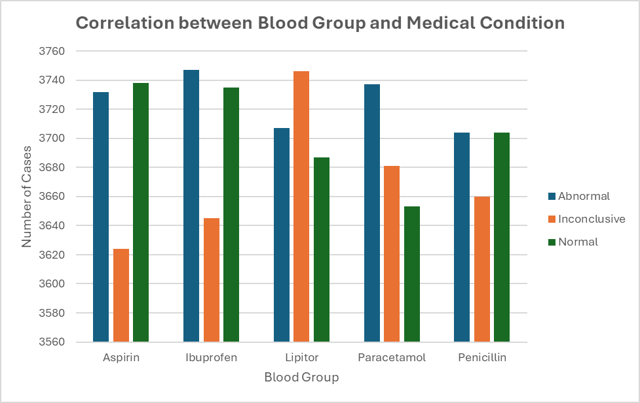

**Medical Condition Analysis**

1. Disease prevalence

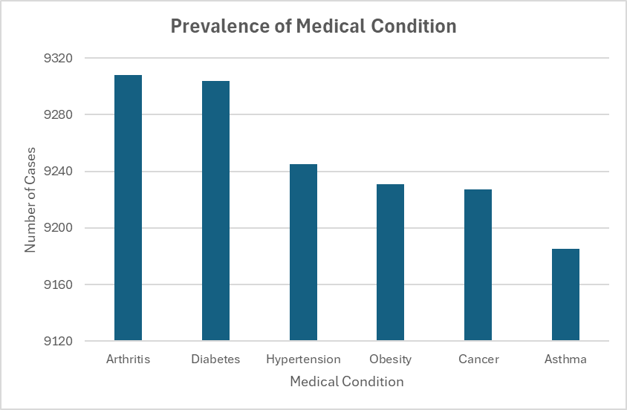

1. Medical condition-age relationships

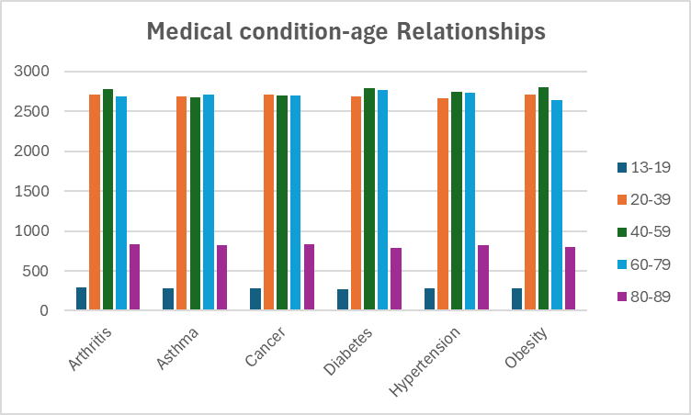

1. **Treatment effectiveness**

1. **Hospital Operations and Efficiency**
2. Admission type patterns

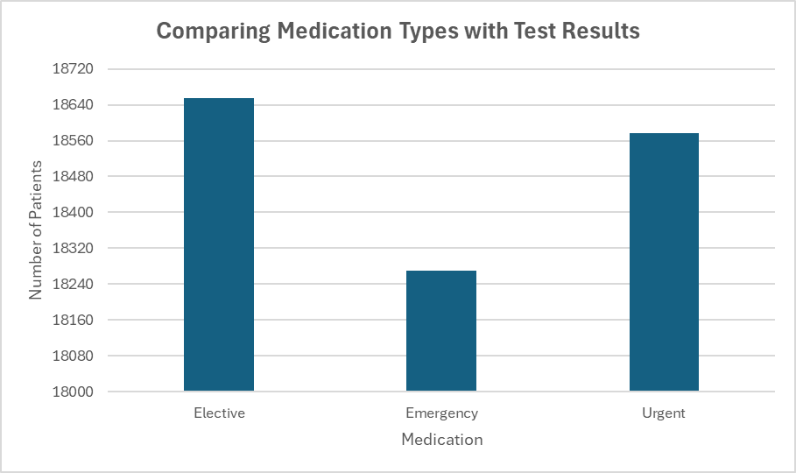

1. Average length of stay analysis
2. By condition

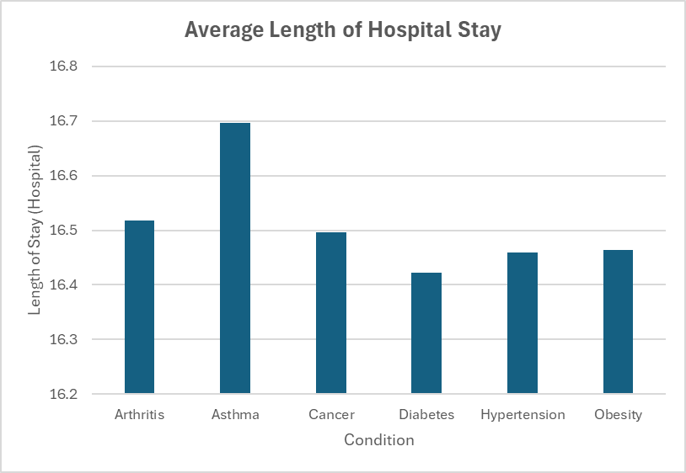

1. By age

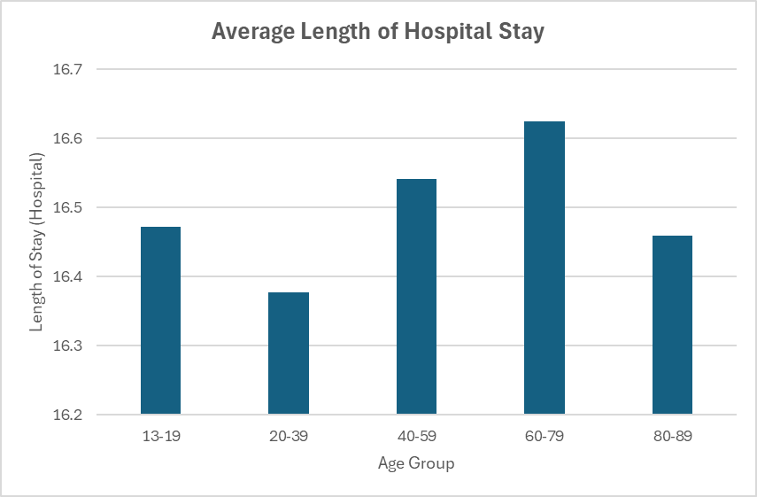

1. By admission type

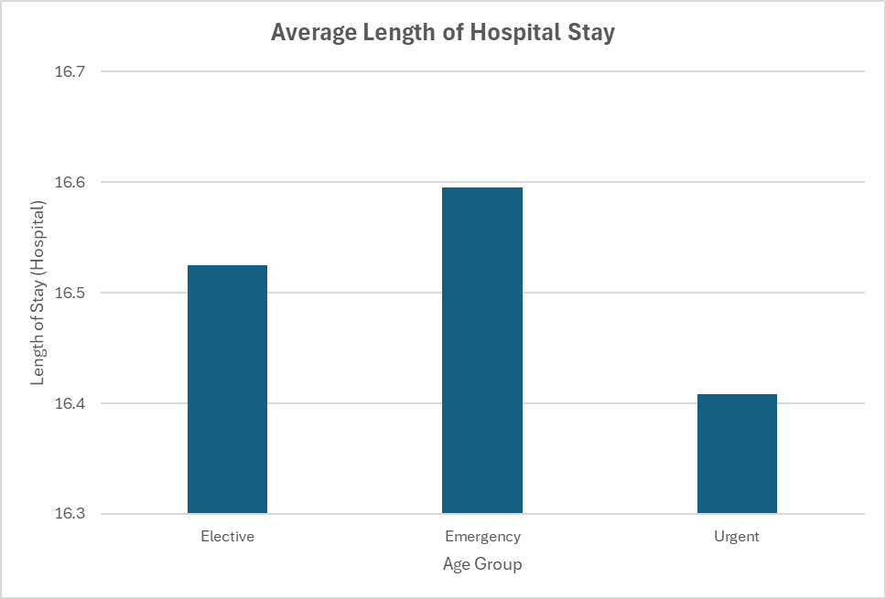

1. Patient volume per physician (Top 10)

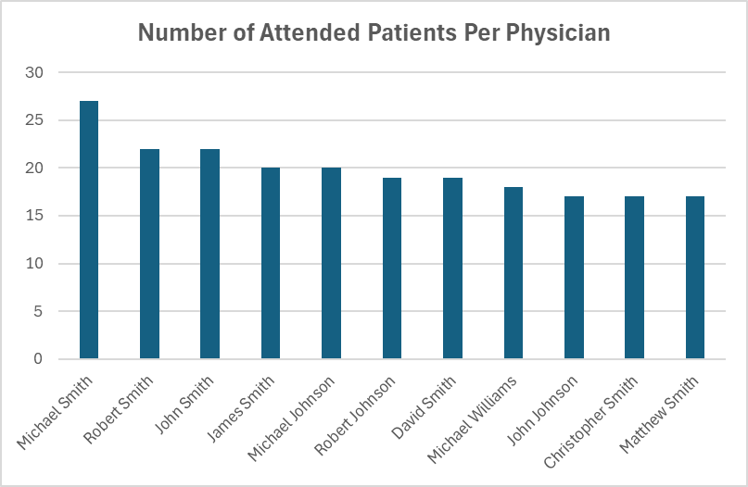

1. **Financial Analysis**
2. Cost variation by condition

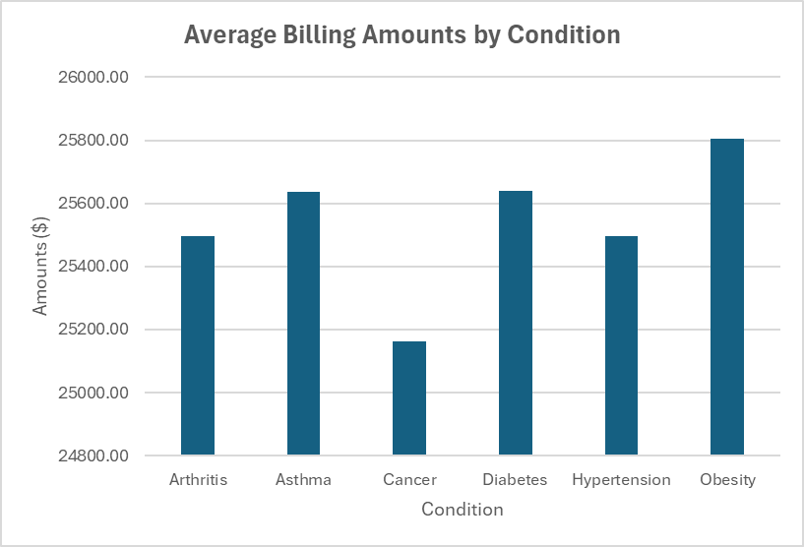

1. Insurance provider impact

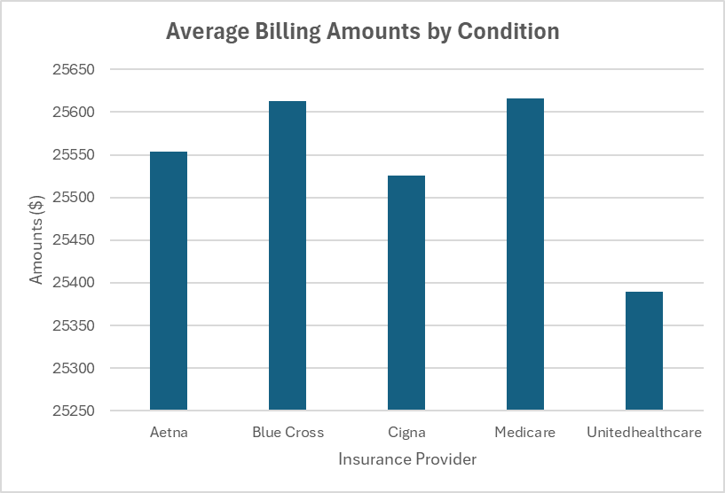

1. Age-cost relationships

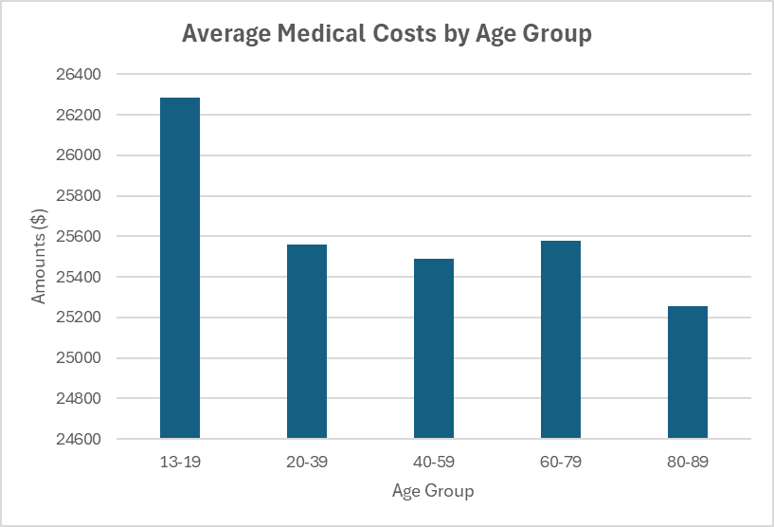

1. Admission type costs

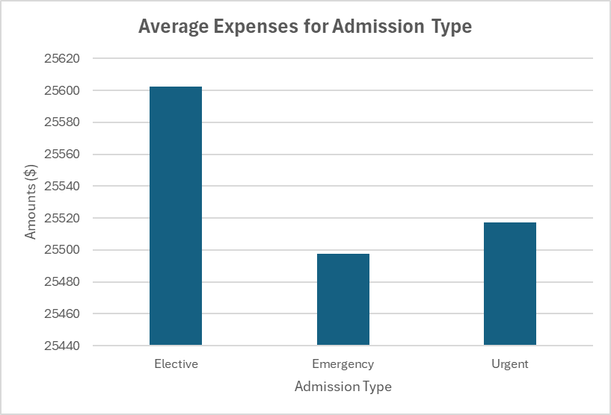

**Predictive Analytics Opportunities**