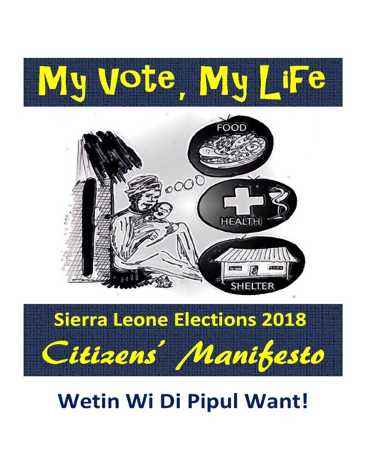

**Movement on National Cohesion**

**IMMEDIATE RELEASE** 9th May, 2022

Remembering May 8, 2002: A Call for Urgent Action on Growing Hate and Division as Sierra Leone Prepares for 2023 Elections.

Yesterday, May 8th, 2022, marked the 22nd anniversary of the protest march led by civil society on the home of the rebel leader, Corporal Foday Sebana Sankoh demanding peace and stability. On that day, Revolutionary United Front (RUF) rebels shot and killed 22 protesters as they approached Mr. Sankoh's resident at Spur Road. Dozens of protesters were critically injured and admitted at the Connaught Hospital in Freetown. Sankoh was arrested on 17th May 2000 by a citizen-led search campaign and was handed over to the British peacekeeping forces in Sierra Leone. His arrest kicked off the UN-backed peace talks in Lomé, Togo.

As we reflect on this day; and noting the progress made in consolidating peace as shown in our 20 uninterrupted years of democracy with two peaceful transfers of power to opposition parties, the Movement on National Cohesion is alarmed by the growing hate and divisiveness in the country as Sierra Leone prepares for the 2023 general elections. We are particularly concerned that political groups are failing to recognize their role in national cohesion and peacebuilding and instead, have embraced hate and violence as a strategy to either retain power propel themselves to leadership.

On this 22nd anniversary of civic action against violence, the Movement on National Cohesion calls on government, opposition parties and the international community to take action against the growing intolerance in the country that has undoubtedly become the biggest governance and development challenge since the end of the war. We are equally concerned that state institutions, especially the Sierra Leone police have often failed to respond to hate and violence in an impartial and professional manner. State institutions are only worsening matters instead of helping.

To deepen national cohesion, the Movement believes ordinary Sierra Leoneans who have always held the country together in a time of crisis are critical to any plans to counter hate and violence. In line with this belief, the Movement is setting up a unifier’s movement of ordinary citizens across the country to promote peace at community and household levels. To achieve this, we call on the following:

1. Well-meaning Sierra Leoneans to continue to promote peace and cohesion in their households and communities and join the Unifiers Movement (UM) that will soon be established. Details of the UM and volunteering opportunities will be unveiled in the coming weeks.
2. Civil Society and the Mass Media should increase the level of sensitization around citizens’ roles in promoting national cohesion and building bridges of accommodation.
3. Sierra Leone police and other state institutions should be professional in managing complaints of incidences of hate.
4. Stakeholders on all sides, especially the political parties, must show restraint in their engagement in politics and refrain from using hate and violence as a political strategy.

**CONTACTS: Mobilization Committee Fundraising Committee Secretariat**

**076 - 470288 076 - 394913 076- 780020**