**COMP 455  
Machine Learning Project**

**Code Instructions**

**Date**: December 3, 2013  
**Name**: William Gilbert Go **Instructor**: Gabriel Murray

The codes run in the Linux command line using Octave. The following are the files that we need to run and make predictions on Octave:

* juiceData.txt – contains the dataset of the sweetness level and pectin amount variables
* plotData.m – plots the data points x and y
* computeCost.m – calculates the cost function for linear regression
* gradientDescent.m – performs Gradient Descent to learn theta parameters
* runLinReg.m – performs linear regression on the dataset and implements plotData, computeCost, and gradientDescent functions

The following are the instructions on how to run the codes:

1. Open the Linux terminal.
2. Go to the directory where the files are saved.
3. Type *octave* to start the Octave application in the command line.
4. Run the runLinReg.m function by typing *runLinReg* in the line.  
   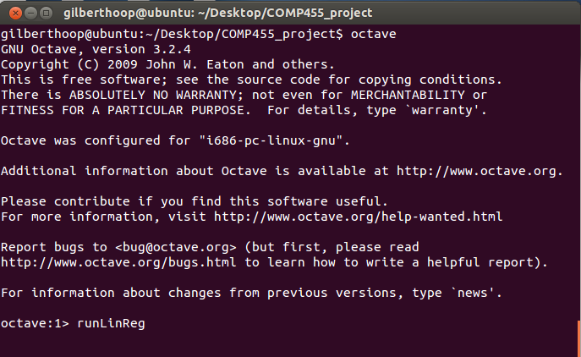
5. You should see a figure or graph which contains the data points from the data set. The graph should have labels for the variables x (the sweetness level) and y (pectin amount).
6. Press enter again to display the linear regression output.
7. Octave has successfully displayed the linear regression for our dataset. You should see the following outputs:   
   