Sales Performance Report – ABC Ltd.

Prepared on: June 14, 2025

This document presents a professional analysis of sales data for ABC Ltd. for June 2025. The purpose is to derive insights that can inform strategic decision-making to boost revenue and optimize operations.

# Executive Summary

This report analyzes sales trends, product performance, and opportunities for growth based on data collected in June 2025. Our findings reveal high-performing products, inconsistent daily revenue, and potential under-utilization of specific inventory. Recommendations are provided for optimizing pricing, inventory planning, and sales targeting.

# 1. Key Metrics and Overview

Total Revenue: $7,125.81

Total Units Sold: 167

Number of Active Sales Days: 25

Number of Products Sold: 5

# 2. Sales Performance by Product

* Device E: $2147.32
* Widget A: $1744.87
* Gizmo D: $1565.84
* Gadget C: $1349.74
* Widget B: $318.04

# 3. Daily Sales Trend

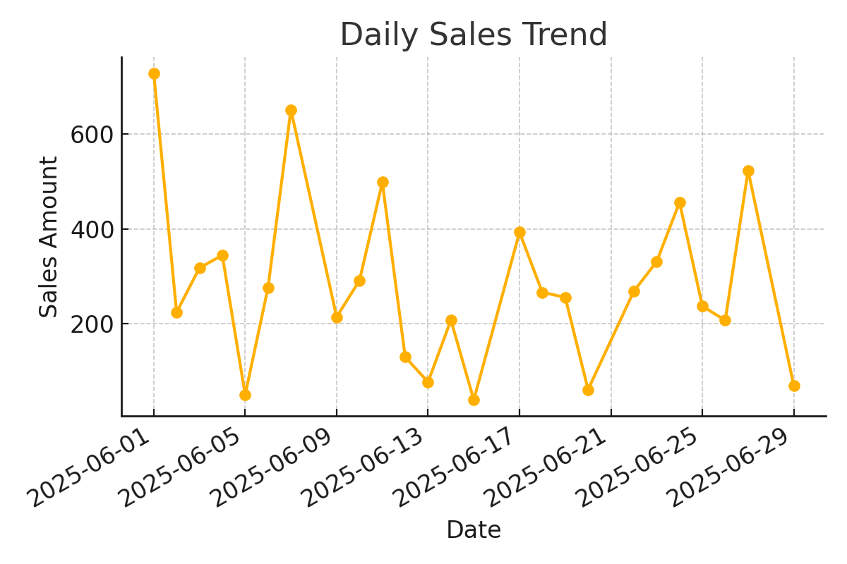

# 4. Quantity vs Sales Amount

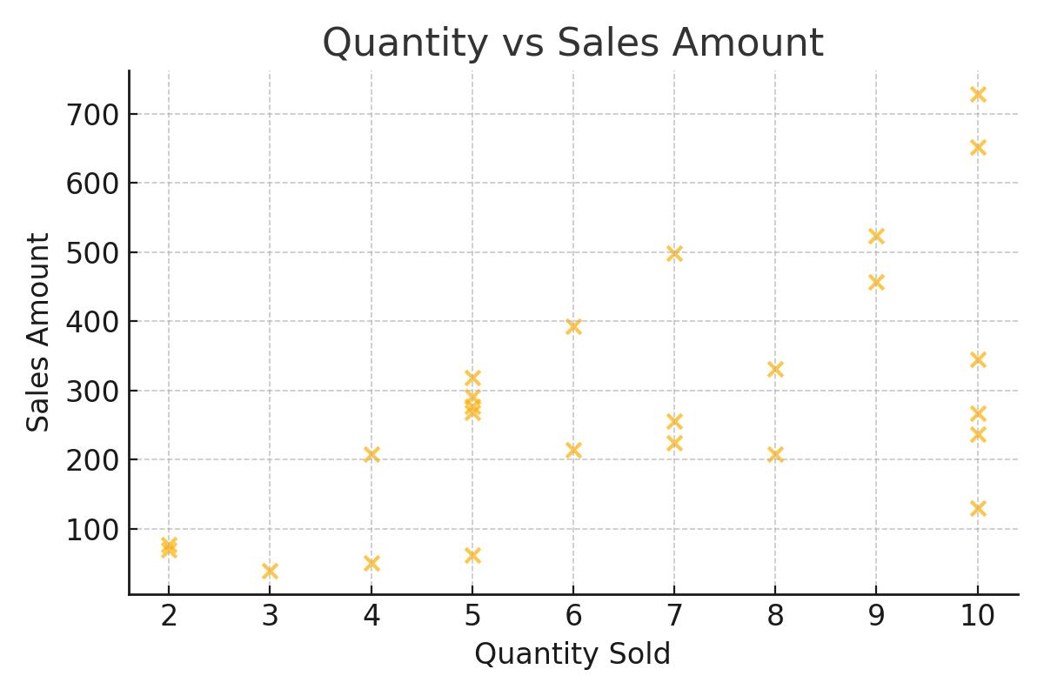

# 5. Recommendations

- Focus marketing on high-performing products such as Device E and Widget A.  
- Investigate low-revenue days to understand sales gaps (e.g., June 8, 16, 21, 28, 30).  
- Consider dynamic pricing for underperforming products.  
- Leverage sales forecasting to balance stock and avoid missed opportunities.