LearnUG
E-Learning Platform

Comprehensive Project Documentation

Version 1.0 • March 2026
Technology: Python (Flask), SQLite/PostgreSQL, Vanilla CSS
Deployment: Render, Vercel, Local Development

Table of Contents
1. Executive Summary
2. Problem Statement
3. System Architecture
4. System Architecture Diagram
5. Core Features
6. What Makes LearnUG Unique
6.1 Cognitive Mirror — AI-Powered Self-Reflection
6.2 Synergy Connect — Peer-to-Peer Learning
6.3 Zero-JavaScript Architecture
6.4 Engagement-Based Attendance
6.5 Transparent Progress System
7. Database Design & ERD
8. Entity Relationship Diagram
9. User Roles & Permissions
10. Page Interaction Flow
11. Technical Implementation Details
12. Deployment Strategy
13. Future Advancements
14. Conclusion

1. Executive Summary
LearnUG is a lightweight, high-efficiency Learning Management System (LMS) purpose-built for the African educational context — specifically targeting environments with low-bandwidth internet connectivity, limited device capability, and a strong need for community-driven collaborative learning.
Unlike conventional LMS platforms (Moodle, Canvas, Blackboard) that require heavy client-side JavaScript frameworks, high bandwidth, and powerful hardware, LearnUG takes a fundamentally different approach:
- Zero-heavy-JavaScript architecture — complex UI components built entirely with CSS
- AI-driven learning analytics — no external AI API dependency, all intelligence derived from behavioral data
- Peer-to-peer synergy matching — algorithmically pairing students for collaborative micro-tutoring sessions
- Adaptive bandwidth modes — three-tier data consumption system that works even on 2G networks
The platform serves three user roles — Students, Lecturers, and Admins — each with purpose-built dashboards, and supports a complete educational workflow from course creation to assessment and grading.

2. Problem Statement

The Digital Divide in African Education
Africa faces a unique set of challenges in digital education that traditional LMS platforms were never designed to address. LearnUG was built from the ground up to solve these specific problems.
Challenge | Impact | LearnUG's Response
Low bandwidth (avg 2-5 Mbps rural) | Heavy LMS platforms fail to load | Zero-JS architecture, bandwidth modes
Expensive data ($2-5/GB East Africa) | Students can't afford platforms | Ultra-low data mode strips non-essential assets
Limited devices (older smartphones) | Feature-heavy apps crash | Pure CSS UI, minimal memory footprint
Isolation in remote learning | High dropout rates | Synergy Connect peer matching system
Lack of personalized learning | One-size-fits-all education | Cognitive Mirror AI-driven insights
Unreliable power supply | Study sessions interrupted | Lightweight pages load fast, reduce battery drain

3. System Architecture
LearnUG uses a three-layer architecture: Client Layer (browser-based, server-rendered HTML/CSS), Application Layer (Flask with 16 route modules and helper utilities), and Data Layer (dual SQLite/PostgreSQL with an automatic compatibility layer).

Technology Stack & Rationale
Technology | Why It Was Chosen
Flask (Python) | Minimal framework overhead, rapid development, easy to deploy on constrained servers
SQLite | Zero-configuration database for local dev, no separate DB server needed
PostgreSQL | Production-grade database for cloud deployments (Render, Vercel)
Vanilla CSS | No TailwindCSS/Bootstrap dependency — complete control over every byte sent to client
Jinja2 Templates | Server-side rendering eliminates client-side JavaScript framework requirements
Mailjet API | Transactional email for notifications, password resets, announcements
Gunicorn | Production-grade WSGI server for Python web applications

Project Structure
learnug/
├── app.py # Application entry point & middleware
├── config.py # Configuration (DB, uploads, API keys)
├── models.py # Database schema & initialization (508 lines)
├── db_compat.py # PostgreSQL/SQLite compatibility layer
├── helpers/
│ ├── attendance.py # Attendance & participation tracking
│ ├── auth.py # Authentication decorators
│ ├── email.py # Mailjet email integration
│ ├── filters.py # Jinja2 template filters
│ ├── notifications.py # In-app notification system
│ └── system.py # System utilities
├── routes/ # 16 route modules
│ ├── admin.py # Admin dashboard & user management
│ ├── assessments.py # Quiz/assessment engine
│ ├── assignments.py # File-based assignment submissions
│ ├── auth.py # Login, registration, password reset
│ ├── courses.py # Course CRUD & enrollment
│ ├── dashboard.py # Role-based dashboards
│ ├── departments.py # Department management
│ ├── discussions.py # Course discussion forums
│ ├── grades.py # Grade tracking & reporting
│ ├── lessons.py # Lesson content management
│ ├── pages.py # Static pages
│ ├── profile.py # User profile management
│ ├── serviceworker.py # PWA service worker
│ └── unique.py # Cognitive Mirror & Synergy Connect
├── templates/ # Jinja2 HTML templates (11 subdirectories)
├── static/ # CSS, images, uploads
├── render.yaml # Render deployment config
├── vercel.json # Vercel deployment config
└── requirements.txt # Python dependencies

Database Compatibility Layer (db_compat.py)
One of the most innovative engineering decisions in LearnUG is the dual-database compatibility layer. This module allows the exact same application code to run on both SQLite (local development) and PostgreSQL (production), without any changes to route handlers or business logic.
- Automatic query translation: Converts SQLite ? placeholders to PostgreSQL %s placeholders
- Syntax adaptation: Translates SQLite-specific functions like STRFTIME() to PostgreSQL equivalents
- Upsert handling: Converts INSERT OR REPLACE to PostgreSQL ON CONFLICT ... DO UPDATE
- DictRow wrapper: Makes PostgreSQL results behave like sqlite3.Row with dict-style access
- Environment-based detection: Automatically selects backend based on DATABASE_URL variable

4. System Architecture Diagram
The diagram below illustrates the three-layer architecture of LearnUG showing all major components and their interconnections.
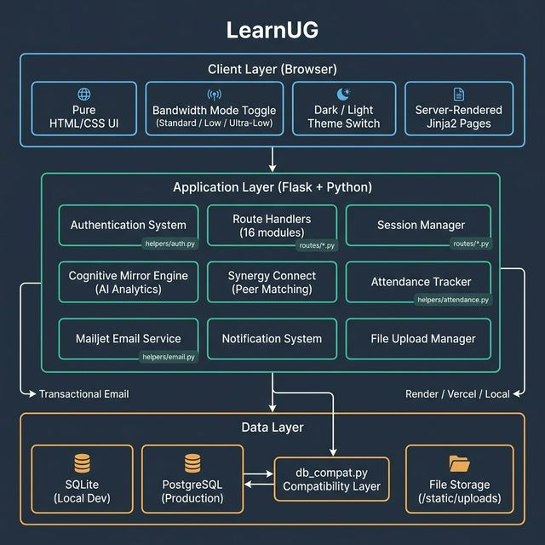
Figure 1: LearnUG System Architecture — Client, Application, and Data Layers

Architecture Layer Breakdown
Layer | Components | Key Responsibility
Client (Browser) | Pure HTML/CSS UI, Bandwidth Toggle, Theme Switch, Jinja2 Pages | Zero-JS rendering, adaptive data consumption
Application (Flask) | 16 Route Modules, Cognitive Mirror, Synergy Connect, Auth, Email | Business logic, AI analytics, peer matching, notifications
Data | SQLite (local), PostgreSQL (prod), db_compat.py, File Storage | Dual-database compatibility, persistent data, uploads

5. Core Features

5.1 Course Management System
Feature | Description
Course Creation | Lecturers and admins create courses with title, description, department, category, cover image
Course Editing | Full CRUD operations with image replacement and department reassignment
Publishing Control | Courses can be published/unpublished — only published courses appear in catalog
Department Organization | Courses organized by academic department for structured navigation
Enrollment System | Students enroll/unenroll freely with progress and participation tracking
Participant Transparency | Dedicated 'Participants' tab shows all enrolled students with progress

5.2 Lesson & Content Delivery
- Lessons are ordered within courses and support rich text content
- File attachments (PDFs, documents, media) can be attached to lessons
- Visibility control: Lecturers can hide/show individual lessons, assessments, and assignments
- Automatic attendance logging: Viewing a lesson logs attendance and awards participation points

5.3 Assessment Engine
- Quiz Builder: JSON-based question storage supporting multiple question types
- Timed Assessments: Optional time limits for quiz completion
- Privacy Mode: Assessments can restrict result visibility to protect student privacy
- Automatic Scoring: Scores calculated and stored immediately upon submission
- Expiration Support: Assessments can have availability windows with due dates

5.4 Assignment Submission System
- Lecturers create assignments with descriptions, due dates, and maximum marks
- Students upload file-based submissions for grading
- Grading and text feedback system for lecturers
- Visibility toggles to hide/show assignments before they are ready

5.5 Discussion Forums
Each course has a built-in discussion forum where students and lecturers can create threads, post replies, and engage in academic conversations. Reply counts are tracked for engagement metrics.

5.6 Notification & Email System
LearnUG integrates with Mailjet for transactional emails including: welcome emails on registration, admin notifications for new lecturer registrations, course publication announcements, password reset emails with tokenized links, and announcement broadcasts targeted by role.

5.7 Admin Control Panel
- User Management: Add, edit, toggle activation, delete users with full cascade cleanup
- Password Management: Direct password reset and email-based reset links
- Lecturer Verification: Manual approval workflow for new lecturer accounts
- Bulk Operations ('Danger Zone'): Clear all student dashboards, clear all lecturer dashboards, clear users by role
- Analytics Dashboard: System-wide statistics, top courses by enrollment, user distribution by role

6. What Makes LearnUG Unique
LearnUG distinguishes itself from all existing LMS platforms through five unique, deeply integrated features that address the specific challenges of African education.

6.1 Cognitive Mirror — AI-Powered Self-Reflection Engine
The Cognitive Mirror is LearnUG's flagship feature — a behavioral analytics engine that transforms raw interaction data into personalized learning insights, all without any external AI API or machine learning model. The intelligence is derived entirely from SQL queries on existing behavioral data.
Analysis | Data Source | Algorithm | Output
Peak Focus Window | attendance.timestamp | Groups activity by hour, finds highest frequency | Badge: Early Bird, Afternoon Achiever, Evening Scholar, or Night Owl
Struggle Detection | attendance × lessons | Identifies lessons viewed 3+ times without passing assessment | List of Critical Reflection Points
Strength Analysis | lesson_progress | Finds quickly completed lessons | List of Knowledge Strongholds
Stored Insights | learning_insights table | Pre-generated insights with relevance scoring | Continuous feed of personalized recommendations

Why this is unique: Most LMS platforms either have no analytics or rely on expensive AI APIs (OpenAI, etc.). LearnUG's Cognitive Mirror uses pure SQL analytics on existing behavioral data — zero API costs, zero latency, full privacy. The intelligence is derived entirely from the patterns within the student's own interaction data.

6.2 Synergy Connect — Peer-to-Peer Collaborative Learning Engine
Synergy Connect algorithmically matches students within the same courses to foster peer-to-peer tutoring relationships. The system compares progress across enrolled students, identifies peers who are further ahead ('Potential Mentors') and peers who are slightly behind ('Potential Learners'), and enables rapid '15-Minute Sync' requests for short, focused peer tutoring sessions.
In remote learning environments, students often feel isolated. Synergy Connect creates an organic community-driven safety net where students help each other, reducing dropout rates and improving comprehension through peer explanation — leveraging the 'protégé effect' from educational research.

6.3 Zero-JavaScript / Low-Bandwidth Architecture
This is the foundational architectural decision that differentiates LearnUG from every other LMS on the market.
UI Component | Traditional LMS | LearnUG
Tabs | JavaScript onClick handlers | CSS :checked pseudo-class + radio buttons
Modals | JavaScript libraries (Bootstrap.js) | CSS :target or checkbox toggles
Accordions | JavaScript expand/collapse | CSS <details>/<summary> or checkbox toggles
Theme Toggle | JavaScript DOM manipulation | Server-side session + CSS variables
Form Validation | JavaScript + library | HTML5 required, pattern, minlength attributes
Page Rendering | Client-side JS (React/Vue) | Server-side Jinja2 templates

Bandwidth Modes
Mode | Behavior | Target Network
Standard | Full design, all animations, full-resolution images | 4G / WiFi
Low Data | Reduced styling, suppressed animations, compressed images | 3G
Ultra-Low Data | Minimal styling, no images (or grayscale), stripped animations | 2G / EDGE

6.4 Attendance as Active Engagement
Unlike traditional LMS platforms where 'attendance' means simply logging in, LearnUG redefines attendance as active participation. Viewing a lesson, downloading a resource, and submitting an assessment all log attendance and award participation points. This data feeds into the Cognitive Mirror, Synergy Connect, Participants tab, and admin analytics.

6.5 Transparent Progress System
Every course has a Participants tab showing all enrolled students with their enrollment date, current progress percentage, and participation points. This gamifies learning through healthy competition and accountability, while giving lecturers instant visibility into class engagement.

7. Database Design
LearnUG uses a comprehensive relational schema with 18 tables organized into five categories.

Core Entities (Blue)
Table | Primary Key | Key Columns | Relationships
users | id (AUTO) | username, email, password_hash, role, full_name, phone, is_active, is_verified, profile_pic_url, reset_token | Central entity — linked to nearly every other table
courses | id (AUTO) | title, description, lecturer_id (FK→users), department_id (FK→departments), category, image_url, is_published | FK → users (teaches), FK → departments (belongs to)
departments | id (AUTO) | name, description | Parent of courses

Content Entities (Green)
Table | Primary Key | Key Columns | Relationships
lessons | id (AUTO) | course_id (FK), title, content, attachment_url, attachment_type, order_num, is_hidden | FK → courses (1:N)
assessments | id (AUTO) | course_id (FK), title, questions_json, time_limit, privacy_mode, is_hidden | FK → courses (1:N)
assignments | id (AUTO) | course_id (FK), title, description, due_date, max_marks, is_hidden | FK → courses (1:N)

Student Activity Entities (Orange)
Table | Primary Key | Key Columns | Relationships
enrollments | id (AUTO) | student_id (FK), course_id (FK), progress, participation_points, last_lesson_id | FK → users, FK → courses, UNIQUE(student, course)
lesson_progress | id (AUTO) | student_id (FK), lesson_id (FK), completed, completed_at | FK → users, FK → lessons, UNIQUE(student, lesson)
submissions | id (AUTO) | assessment_id (FK), student_id (FK), answers_json, score, max_score | FK → assessments, FK → users
assignment_submissions | id (AUTO) | assignment_id (FK), student_id (FK), file_url, grade, feedback | FK → assignments, FK → users
attendance | id (AUTO) | user_id (FK), course_id (FK), lesson_id (FK nullable), activity_type, timestamp | FK → users, FK → courses, FK → lessons

Social Entities (Purple)
Table | Primary Key | Key Columns | Relationships
discussions | id (AUTO) | course_id (FK), user_id (FK), title, content | FK → courses, FK → users
replies | id (AUTO) | discussion_id (FK), user_id (FK), content | FK → discussions, FK → users
announcements | id (AUTO) | user_id (FK), title, content, target_role | FK → users
notifications | id (AUTO) | user_id (FK), title, message, link, is_read | FK → users

AI / Unique Feature Entities (Red)
Table | Primary Key | Key Columns | Relationships
learning_insights | id (AUTO) | user_id (FK), course_id (FK nullable), insight_type, content, relevance_score | Cognitive Mirror data — FK → users, FK → courses
synergy_matches | id (AUTO) | user_a_id (FK), user_b_id (FK), course_id (FK), match_reason, is_active | Peer matching — FK → users (×2), FK → courses, UNIQUE(a,b,course)
user_preferences | user_id (PK/FK) | bandwidth_mode, theme | 1:1 with users — stores bandwidth and theme settings

Performance Indexes
Index Name | Table | Column | Purpose
idx_attendance_user | attendance | user_id | Fast Cognitive Mirror focus window queries
idx_attendance_course | attendance | course_id | Course-level attendance reports
idx_notifications_user | notifications | user_id | Quick notification badge counts
idx_enrollments_student | enrollments | student_id | Student dashboard enrollment lookups
idx_enrollments_course | enrollments | course_id | Course participant counts and lists
idx_lessons_course | lessons | course_id | Course detail page lesson loading
idx_discussions_course | discussions | course_id | Course discussion forum queries
idx_submissions_student | submissions | student_id | Assessment result lookups
idx_lesson_progress_student | lesson_progress | student_id | Progress tracking for Cognitive Mirror

8. Entity Relationship Diagram (ERD)
The diagram below shows the complete database schema with all 18 tables and their foreign key relationships. Tables are color-coded by category: Blue (Core), Green (Content), Orange (Student Activity), Purple (Social), and Red (AI/Unique Features). The 'users' table is the central entity with relationships radiating outward to nearly every other table.
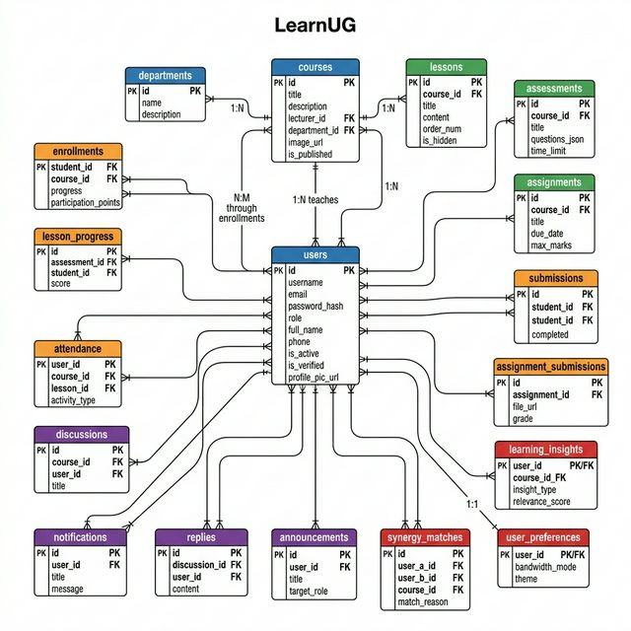
Figure 2: LearnUG Entity Relationship Diagram — 18 tables with foreign key relationships

Relationship Summary
- users 1:N → courses (lecturer teaches courses)
- users 1:N → enrollments (student enrolls in courses)
- users 1:N → attendance (user activity tracking)
- users 1:N → submissions (student submits assessments)
- users 1:N → discussions (user creates discussion threads)
- users 1:N → replies (user writes replies)
- users 1:N → notifications (user receives notifications)
- users 1:N → announcements (admin/lecturer posts announcements)
- users 1:N → learning_insights (AI generates insights per user)
- users 1:N → synergy_matches (peer matching, two FK references)
- users 1:1 → user_preferences (bandwidth mode + theme)
- departments 1:N → courses (department contains courses)
- courses 1:N → lessons (course contains ordered lessons)
- courses 1:N → assessments (course has quizzes/exams)
- courses 1:N → assignments (course has file-based assignments)
- courses 1:N → discussions (course has discussion forums)
- courses 1:N → enrollments (course receives student enrollments)
- courses 1:N → attendance (course tracks student activity)
- lessons 1:N → lesson_progress (tracking individual lesson completions)
- lessons 1:N → attendance (lesson-level activity tracking)
- assessments 1:N → submissions (quiz answers and scores)
- assignments 1:N → assignment_submissions (file uploads and grades)
- discussions 1:N → replies (threaded discussion responses)

9. User Roles & Permissions
LearnUG implements a three-tier role system: Student, Lecturer, and Admin. Each role has a purpose-built dashboard and specific permissions.

Permission Matrix
Feature | Student | Lecturer | Admin
View published courses | ✓ | ✓ | ✓
Enroll in courses | ✓ | — | —
View lessons (non-hidden) | ✓ | ✓ (all) | ✓ (all)
Create courses | — | ✓ | ✓
Create lessons/assessments | — | ✓ (own) | ✓ (all)
Toggle visibility | — | ✓ (own) | ✓ (all)
Take assessments | ✓ | — | —
Submit assignments | ✓ | — | —
Grade submissions | — | ✓ | ✓
Manage users | — | — | ✓
View analytics | — | — | ✓
Bulk clear data | — | — | ✓
Post announcements | — | ✓ | ✓
Use Cognitive Mirror | ✓ | — | —
Use Synergy Connect | ✓ | — | —

Lecturer Verification Workflow
1. New user registers and selects 'Lecturer' role
2. System creates account with is_verified = 0 (pending)
3. System sends notification email to all admin accounts
4. Lecturer attempts login → receives 'pending verification' message
5. Admin opens User Management panel → finds pending lecturer
6. Admin clicks 'Verify' → system sets is_verified = 1
7. System sends verification confirmation email to lecturer
8. Lecturer can now log in and create courses

10. Page Interaction Flow
The diagram below shows how users navigate through LearnUG's pages. Navigation paths are color-coded by role: Green (Student), Blue (Lecturer), Red (Admin), and Gray (Shared/Public). After login, the system checks the user's role and redirects to the appropriate dashboard.
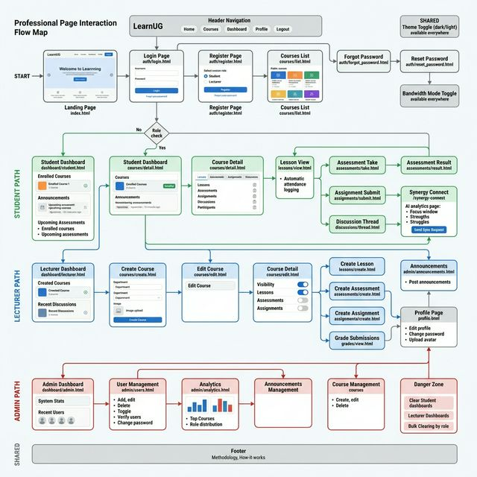
Figure 3: LearnUG Page Interaction Flow — Role-based navigation paths

Public Pages (No Login Required)
Page | Route | Template | Description
Landing Page | / | index.html | Hero section, feature cards, statistics, call-to-action
Login | /login | auth/login.html | Username/email + password form
Register | /register | auth/register.html | Full registration with role selection
Forgot Password | /forgot-password | auth/forgot_password.html | Email-based password reset request
Reset Password | /reset-password/<token> | auth/reset_password.html | Token-validated new password form
Course Catalog | /courses | courses/list.html | Searchable, filterable published course listing
Course Detail | /courses/<id> | courses/detail.html | Tabbed: Lessons, Assessments, Assignments, Discussions, Participants

Student Pages
Page | Route | Template | Description
Student Dashboard | /dashboard | dashboard/student.html | Enrolled courses, announcements, upcoming assessments
Lesson View | /lessons/<id> | lessons/view.html | Lesson content with auto-attendance logging
Take Assessment | /assessments/<id>/take | assessments/take.html | Timed quiz with auto-scoring
Assessment Result | /assessments/<id>/result | assessments/result.html | Score display and answer review
Submit Assignment | /assignments/<id>/submit | assignments/submit.html | File upload for assignment submission
Discussion Thread | /discussions/<id> | discussions/thread.html | Thread view with reply form
Cognitive Mirror | /cognitive-mirror | unique/cognitive_mirror.html | AI-powered learning analytics dashboard
Synergy Connect | /synergy-connect | unique/synergy_connect.html | Peer matching and sync request interface
Grades | /grades | grades/student.html | Combined grade overview across all courses
Profile | /profile | profile.html | Edit profile, change password, upload avatar
Notifications | /notifications | notifications.html | In-app notification feed

Lecturer Pages
Page | Route | Template | Description
Lecturer Dashboard | /dashboard | dashboard/lecturer.html | Created courses, student counts, recent discussions
Create Course | /courses/create | courses/create.html | Course creation form with image upload
Edit Course | /courses/<id>/edit | courses/edit.html | Modify course details and cover image
Create Lesson | /courses/<id>/lessons/create | lessons/create.html | Add lesson with content and attachments
Create Assessment | /courses/<id>/assessments/create | assessments/create.html | Build quiz with JSON question editor
Create Assignment | /courses/<id>/assignments/create | assignments/create.html | Set assignment title, description, due date
Grade Submissions | /grades/<id> | grades/view.html | Review and grade student submissions
Announcements | /admin/announcements | admin/announcements.html | Post role-targeted announcements

Admin Pages
Page | Route | Template | Description
Admin Dashboard | /dashboard | dashboard/admin.html | System-wide statistics and recent user list
User Management | /admin/users | admin/users.html | Full user CRUD, verification, password management
Analytics | /admin/analytics | admin/analytics.html | Charts, top courses, role distribution
Announcements | /admin/announcements | admin/announcements.html | Create and manage announcements
Danger Zone | Various POST routes | Integrated in dashboard | Bulk clear student/lecturer data

Shared UI Elements (All Pages)
- Header Navigation Bar: Home, Courses, Dashboard, Profile, Logout links (role-aware)
- Theme Toggle: Dark/Light mode switch (POST /toggle-theme) — persisted in user_preferences
- Bandwidth Toggle: Standard/Low/Ultra-Low data modes (POST /toggle-bandwidth) — persisted in user_preferences
- Flash Message System: Color-coded alerts for success, error, warning, info notifications
- Footer: Methodology/How-it-Works link, contact information

11. Technical Implementation Details

Security Features
Feature | Implementation
Password Hashing | Werkzeug's generate_password_hash / check_password_hash (PBKDF2 SHA-256)
Session Management | Flask's signed cookie-based sessions with SECRET_KEY
SQL Injection Prevention | Parameterized queries throughout (no string concatenation)
File Upload Security | secure_filename() + unique timestamped filenames
Role-Based Access Control | @role_required decorator enforcing access on every protected route
Account Deactivation | Deactivated users cannot log in (is_active check)
Password Reset Tokens | Cryptographically secure secrets.token_urlsafe(32)
Upload Size Limits | MAX_CONTENT_LENGTH = 100MB maximum upload size

Email Architecture
LearnUG uses Mailjet's v3.1 API with BCC-based broadcasting. Key features: role-targeted notifications (admin always BCC'd), email deduplication via a 'seen' set, and graceful failure handling to prevent blocking the user experience if email delivery fails.

Request Lifecycle
Client Request
→ Flask Route Handler
→ @login_required / @role_required decorator check
→ g.db = get_db() (Database connection from context)
→ Business logic + parameterized SQL queries
→ Jinja2 server-side template rendering
→ HTML response (fully rendered, no client-side JS needed)

12. Deployment Strategy
LearnUG supports three deployment configurations, automatically detected from environment variables.
Environment | Database | Uploads | Server | Config File
Local Development | SQLite (database.db in project root) | static/uploads/ | Flask dev server (port 5000) | —
Render (Primary) | SQLite on persistent disk (/data/database.db) | /data/uploads/ | Gunicorn | render.yaml
Vercel (Secondary) | SQLite in /tmp/ (ephemeral) | /tmp/uploads/ | Serverless functions | vercel.json

The application automatically detects its deployment environment by checking for DATABASE_URL (PostgreSQL), RENDER, or VERCEL environment variables. Local development requires zero external dependencies — just 'pip install -r requirements.txt' and 'python app.py'.

13. Future Advancements
LearnUG has a five-phase roadmap for future development, expanding from enhanced intelligence to full ecosystem integration.

Phase 1: Enhanced Intelligence (Short-Term)
Feature | Description | Impact
Adaptive Difficulty Engine | Auto-adjust quiz difficulty based on Cognitive Mirror data | Personalized assessment paths
Learning Path Recommendations | Suggest next courses based on strength/weakness analysis | Guided educational journeys
Predictive Dropout Alerts | Flag at-risk students using attendance and engagement patterns | Early intervention by lecturers
Spaced Repetition Reminders | Timed review reminders based on forgetting curve algorithms | Long-term knowledge retention
Enhanced Synergy Matching | Match based on complementary strengths/weaknesses | More effective peer tutoring

Phase 2: Community & Engagement (Medium-Term)
Feature | Description | Impact
Gamification System | Badges, streaks, leaderboards, achievement unlocks | Increased motivation and engagement
Live Session Scheduling | Built-in scheduling for virtual study groups and Q&A | Structured collaborative learning
SMS / USSD Integration | Lesson summaries and quiz questions via SMS | Access for students without smartphones
Offline-First PWA | Service workers for offline content access | Learning without internet
Video Compression | Server-side transcoding to ultra-low bitrate | Multimedia learning on any network
Multi-Language Support | Swahili, Luganda, French translations | Regional accessibility

Phase 3: Institutional Scale (Long-Term)
Feature | Description | Impact
Multi-Tenancy | Single deployment serving multiple institutions | Cost-effective institutional adoption
REST + GraphQL API | Public API for SIS/ERP integration | Institutional ecosystem integration
Mobile Native Apps | Android/iOS with QR code scanning | Native mobile experience
Analytics Dashboard | Heatmaps, cohort analysis, completion funnels | Data-driven institutional decisions
Certificate Generation | PDF certificates upon course completion | Formal recognition
Proctoring System | Browser lockdown for high-stakes assessments | Academic integrity
Content Marketplace | Share/reuse content across institutions | Knowledge democratization

Phase 4: AI-Native Features (Visionary)
Feature | Description | Impact
On-Device AI Tutor | Small language models (TinyLlama, Phi-2) for contextual help | AI tutoring without expensive API costs
Auto Quiz Generation | Generate questions from lesson content via NLP | Reduced lecturer workload
Voice-Based Learning | Text-to-speech for lessons, voice navigation | Accessibility for visually impaired
Emotion Detection | Analyze discussion posts to detect frustration | Proactive student support
Knowledge Graphs | Map concept relationships across courses | Deep curriculum understanding

Phase 5: Ecosystem Expansion
The final phase envisions LearnUG as a complete educational ecosystem with integrations including: Mobile Money payment systems (MTN MoMo, Airtel Money) for premium courses and tutor compensation, government education portal integration, research database access, and a comprehensive API layer for third-party tool connectivity.

14. Conclusion
LearnUG represents a fundamentally different approach to learning management systems. Where traditional platforms optimize for feature richness and visual complexity, LearnUG optimizes for accessibility, efficiency, and intelligence within constraints.

Key Differentiators Summary
Aspect | Traditional LMS | LearnUG
Architecture | Heavy JS frameworks | Zero-heavy-JS, server-rendered
Bandwidth Requirement | Requires 4G+ | Works on 2G (ultra-low mode)
AI Features | External API dependency ($$$) | Built-in SQL analytics (free)
Peer Learning | Manual student matching | Algorithmic Synergy Connect
Self-Reflection | Static grade reports | Dynamic Cognitive Mirror
Attendance | Login-based | Engagement-based (participation points)
Database | Single DB requirement | Dual SQLite/PostgreSQL zero-config switching
Deployment | Complex infrastructure | Single-command, 3 platforms
Cost | $1K-50K/year licensing | Free and open-source
Target Audience | Developed world institutions | African educational contexts

LearnUG is not just a platform — it is a statement that world-class educational technology can be built for the contexts that need it most, without compromising on intelligence, design, or user experience.

— End of Document —
Document prepared: March 28, 2026 • Platform version: 1.0 • LearnUG Development Team

