Team R.O.B
Documentation

Table of Contents
Members 2
Kaden Gilbert 2
Nova Solarz 2
Gavin Sloan 2
Nick Clark 2
Jerry Cai 2
Summaries 3
Executive Summary 3
Outcome Summary 3
Statement of Work 3
Project Objectives 3
Project Scope 3
Team Expectations 3
Requirements 4
Hardware Requirements 4
Security Requirements 4
Input Validation: 4
Unit Tests 4
GUI 4
OOP Practices 4
Maintenance Overview 4
Maintenance Timeline 5
Week 1 of Development 5
Week 2 of Development 5
Week 3 of Development 5
Post-Release 5
Problem Statement 6
Coding Standards and Practices Statement 6
L1 Data Flow Diagram 7
UML Diagram 8
Problem Frame 9

Members
Here listed are all of the members of Team R.O.B, along with the roles and duties each of us have taken on.
Note: Though we each have a specified role, we often perform duties that are not entirely contained within that role, as we are a small team and we all do our best to help each other.

Kaden Gilbert
( he / him )
- Team Lead
- Duties:
  - Unify team vision
  - Maintain fair division of labor

Nova Solarz
( it / they / she )
- Documentarian
- Duties:
  - Organize physical documentation
  - Make final passes of each article of documentation before submission to ensure quality and accuracy

Gavin Sloan
( he / him )
- Code Lead
- Duties:
  - Maintain and develop codebase
  - Collaborate with Design lead for structuring of our program

Nick Clark
( he / him )
- Design lead
- Duties:
  - Create diagrams to outline the functionality of our code artifacts
  - Collaborate with Code lead for structuring of our program

Jerry Cai
( he / him )
- Security Lead
- Duties:
  - Locate and notify Code lead about insecure coding practices
  - Hunt for bugs / parts of our program that can be improved

Summaries

Executive Summary
The problem we are trying to solve is eliminating boredom, stress, and restlessness by utilizing entertainment. The process we are taking to resolve this issue is developing a roleplay video game with its design based off of the original Legend of Zelda game. We will be creating a main menu, various map features, background music, and other elements common in retro two-dimensional roleplay games. Our proposed solution is one that will accommodate players of all ages who wish to relax after a long day, on a weekend, or when visiting friends and family. Our primary expected deliverable is our roleplay game that will be gradually developed throughout this project.

Outcome Summary
Our expected outcomes are as follows:
- Our final product will be a fully functional two-dimensional role-play game.
- Implementing at least three separate "levels" in the game.
- Having a final boss by the end of the project's initial development.
- Having enemies located throughout the game's map.
- Having background music that plays during gameplay.
- Having a main menu that displays upon the game's startup.

Statement of Work

Project Objectives
- Create a fully functional two-dimensional role-play game
- Include a graphical user interface (GUI)
- Include multiple "levels" that the game will progress through
- Include background music

Project Scope
The scope of our project is to create a role-play game with a GUI displaying a top-down view, grid/tile-based levels, pixel art, background music, enemies, a final boss, and various game items. We will NOT be creating a game that takes multiple hours of progression to fully complete, multiplayer interaction, or internet connectivity.

Team Expectations
As a team, we expect to develop a fully functional two-dimensional role-play game with a main plot line, multiple "levels" to progress through, and minimal bugs/errors.

Requirements

Hardware Requirements
In order for the developed video game to work, the following hardware is required:
- A working computer, mouse, and keyboard
- A constant power supply to maintain the computer’s operability
- An installation of the most recent Python interpreter

Security Requirements

Input Validation:
- All input needs to be validated whether it’s out of bounds handling, type checking, etc..
- All data with no input or output (yet) has to be null.
- Try and excepts should be used on most if not all validation checks.
- If a try and except fails, display error message to explain why it failed.
- Maybe try to implement a black box function that checks for inputs.

Unit Tests
- Make sure to try and use unit test from the python libraries to run test.
- Try to create a test with each function (if possible).
- Try to do other ways of unit tests.

GUI
- Make sure inputs are working correctly.
- Make sure user can’t crash the GUI by spamming random characters.
- Make sure user can’t break the game.

OOP Practices
- Make sure variables are private especially since we are dealing with OOP.
- Make sure we use getters and setters.
- Make sure we use default constructors and constructors.

Maintenance Overview
The purpose of performing maintenance on this project is to fix various bugs and performance issues users experience while playing the video game. Additionally, new features and game elements must be added to create interest from seasoned players of the game.
The following types of maintenance will be conducted throughout the software’s life-cycle:
- Corrective: fixing any bugs, errors, and glitches that are experienced during gameplay
- Adaptive: allowing the game to remain functional on new, updated, and improved hardware/software environments
- Perfective: constantly improve the performance of the game to maintain an acceptable level of operability
- Preventive: implementing fixes to potential issues, resolving security vulnerabilities, and supporting new computing environments before the become popular enough to cause noticeable problems during gameplay
We will conduct regular testing on our programs to ensure they function as intended. These will be completed before the presentation of a new prototype and will be altered if unsuccessful until an adequate level of success has been reached.
Along with any updates/patches to the game, documentation of these changes, processes, and testing will be completed to communicate progress in the game’s life-cycle.

Maintenance Timeline

Week 1 of Development
- Identify initial software, hardware, security, and user requirements
- Conduct testing on any developed elements to ensure proper functionality
- Document changes, testing, and all communication to track progress

Week 2 of Development
- Reevaluate the project’s requirements, scope, components, storyline, and other implementation elements to suit the needs of the solution to the identified problem
- Conduct testing on any developed elements to ensure proper functionality

Week 3 of Development
- Finalize initial software, hardware, security, and user requirements
- Conduct final testing on any developed elements to ensure proper functionality

Post-Release
- Note bugs, errors, and glitches (if any) that users encounter during gameplay
- Release updates, security patches, and changes for any identified issues to realign the game with its intended functionality
- Design new elements to add to the game to increase the longevity of seasoned players’ interest

Problem Statement
Our project aims to solve problems related to boredom, stress, and/or a lack of entertainment for the average person. By resolving these issues, we hope to provide a fun role-play style video game where the user can spend their free time exploring various “levels”, items, and ultimately defeating a final boss.

Coding Standards and Practices Statement
The following standards and practices will be effect throughout the entire project’s development:
- The Python programming language will be the only programming language used.
- All directories are named in titlecase. ex: Example_Dir_Name
- All variables and functions are written in lowercase snake case.
  - ex) example_var_name, example_function_name(param_1, param_2)
- Constants are named in uppercase snake case.
  - ex) EXAMPLE_CONSTANT_NAME
- Comments must be utilized for each major function.
  - single # for notes and descriptions.
  - triple ### for named sections
    - ex) ### Section Name ###
- All functions should have only one clearly-defined purpose, be no longer than ten lines long.
  - Note: Constructors and to-string functions are exempt from this clause.
  - Any other exceptions to this rule must have a clear rationale written in a comment.
- The program should follow proper OOP etiquette
  - private data attributes are only directly referenced within getters and setters
  - Superclass-subclass paradigm is followed if applicable
- Tiles on the game map will be 16x16 pixels
- Sprites (players, NPCs, items) on the game map will be 32x32 pixels

L1 Data Flow Diagram
Note: This will likely change as development continues. We made major changes after this was created and we are currently in the process of making new diagrams.

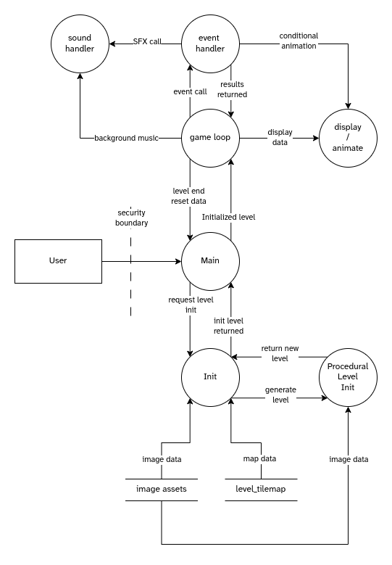

UML Diagram
Note: similar to above, this is a work-in-progress (there are many more classes that have been made that are not currently shown).

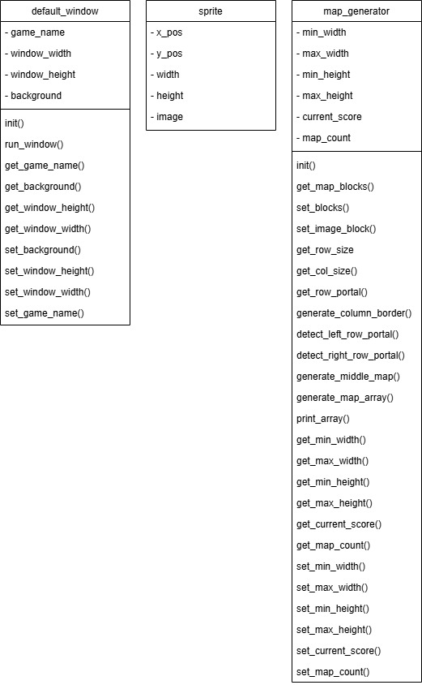

Problem Frame
Note: The requirements are in boxes because dotted circles proved to be elusive (made before meeting on 2025-05-04, revision in progress, yes the text is tiny!).
