# Long Short Term Memory Networks: Theory and Applications

Gilberto Batres-Estrada, Senior Data Scientist, Webstep, Stockholm, Sweden

### Abstract

A Recurrent Neural Network (RNN) is a type of neural network suited for sequential data. Its recurrent connections from one time step to the next introduces a depth in time, which in theory, is capable of learning long term dependencies. There are however two serious issues with vanilla RNNs, the first is the problem of exploding gradients, where the gradient grows without bound leading to instabilities in the system. Growing gradients can in part be alleviated by a technique known as clipping gradients. The second problem is that of diminishing gradients, which has no solution for the vanilla RNN, but for some special cases. The Long Short Term Memory Network, LSTM, (Hochreiter 1991, Hochreiter & Schmidhuber 1997) is a type of RNN designed to solve both of these issues, experienced by RNNs during the training phase. The solution lies in replacing the regular neural units in an RNN with units called memory cells. An LSTM memory cell is composed of four gates controlling the flow of the gradients which dynamically respond to the input by changing the internal state according to the long term interactions in the sequence. The LSTM has been shown to be very successful at solving problems in speech recognition, unconstrained handwritten recognition, machine translation, image captioning, parsing and lately in prediction of stock prices and time series prediction. To combat overfitting, techniques such as dropout have become standard when training these models. We start by presenting the RNN’s architecture and continue with the LSTM and its mathematical formulation. This presentation will focus on the technical aspects of training, regularization and performance.

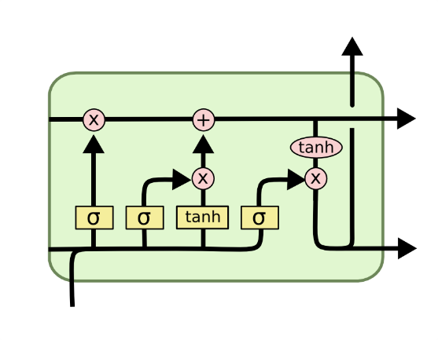

Fig: Long Short Term Memory Cell. Source: http://colah.github.io/posts/2015-08-Understanding-LSTMs/

**Recent Publications**

1. Miquel Noguer Alonso, Gilberto Batres-Estrada, Aymeric Moulin (2017) Deep Learning in Finance: Prediction of stock returns with Long Short Term Memory Networks, chapter 13. Big Data and Machine Learning in Quantitative Investment. John Wiley & Sons, Limited, 2018, ISBN 1119522196, 9781119522195.
2. Gilberto Batres-Estrada (2015) Deep Learning for Multivariate Financial Time Series, KTH Royal Institute of Technology. <http://www.diva-portal.org/smash/get/diva2:820891/FULLTEXT01.pdf>

 Biography

Gilberto Batres-Estrada has a MSc in Theoretical Physics and a MSc in Engineering with specialization in Applied Mathematics and Statistics. He works as a consultant data scientist; his domain of expertise is deep learning. He also conducts independent research in Deep Learning and Reinforcement Learning in Finance with researchers at Columbia University, NY, USA. Batres-Estrada has also made contributions to the book Big Data and Machine Learning in Quantitative Investment, with focus on Long Short Term Memory Networks. Previously he has worked in finance as quantitative analyst; he has also worked building trading algorithms for a hedge fund. As a data scientist Gilberto works daily helping clients to work more data driven and make use of the latest research in machine learning to improve their business.

Email: [gilberto.batres-estrada@live.com](mailto:gilberto.batres-estrada@live.com)

Contact number: +46 70 338 78 68

LinkedIn: www.linkedin.com/in/gilberto-batres-estrada-b1573748

Notes/Comments: Some knowledge in calculus, linear algebra and statistics/probability theory is assumed.