

Diseño de sistemas digitales.

Practica 2: Elaboración de un Circuito Lógico.

Espinoza

Adrian Emilio Vazquez Icedo

Gilberto Espinoza Maciel

Objetivos: Elaboración de un Circuito Lógico con el uso de las compuertas lógicas AND, OR, NOT con la ayuda de un software que simule las compuertas y permita ver de mejor manera sus comportamientos.

Se realizaron dos circuitos lógicos utilizando chips de OR, AND, NOR para realizar pruebas y una tabla de verdad de los dos circuitos.

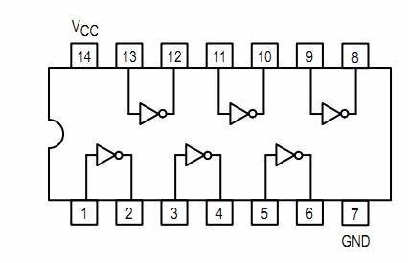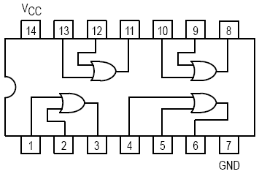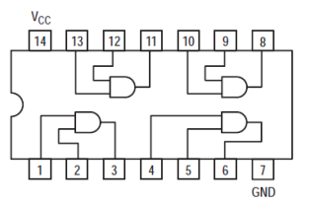AND=74ls08, OR=74ls32, NOT=74ls04

Pruebas en Atanua.

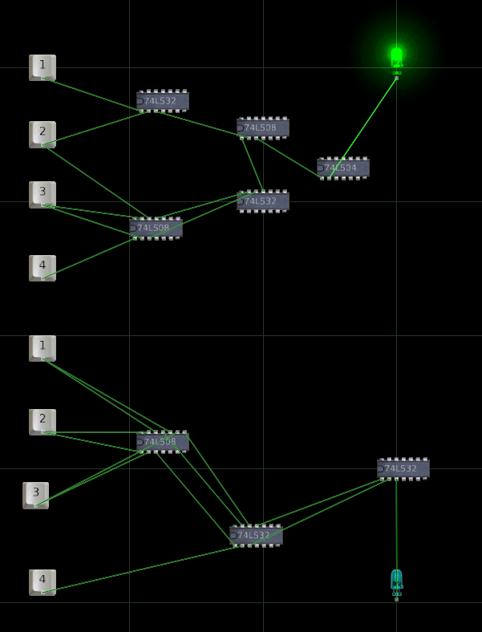

Tablas de verdad

|  |  |  |  |  |
| --- | --- | --- | --- | --- |
| 1 | 2 | 3 | 4 | ( (1+2)((23)+(34)) )’ |
| 0 | 0 | 0 | 0 | 1 |
| 0 | 0 | 0 | 1 | 1 |
| 0 | 0 | 1 | 0 | 1 |
| 0 | 0 | 1 | 1 | 1 |
| 0 | 1 | 0 | 0 | 1 |
| 0 | 1 | 0 | 1 | 1 |
| 0 | 1 | 1 | 0 | 0 |
| 0 | 1 | 1 | 1 | 0 |
| 1 | 0 | 0 | 0 | 1 |
| 1 | 0 | 0 | 1 | 1 |
| 1 | 0 | 1 | 0 | 1 |
| 1 | 0 | 1 | 1 | 0 |
| 1 | 1 | 0 | 0 | 1 |
| 1 | 1 | 0 | 1 | 1 |
| 1 | 1 | 1 | 0 | 0 |
| 1 | 1 | 1 | 1 | 0 |

|  |  |  |  |  |
| --- | --- | --- | --- | --- |
| 1 | 2 | 3 | 4 | ((12)+(13))+((23)+4) |
| 0 | 0 | 0 | 0 | 0 |
| 0 | 0 | 0 | 1 | 1 |
| 0 | 0 | 1 | 0 | 0 |
| 0 | 0 | 1 | 1 | 1 |
| 0 | 1 | 0 | 0 | 0 |
| 0 | 1 | 0 | 1 | 1 |
| 0 | 1 | 1 | 0 | 1 |
| 0 | 1 | 1 | 1 | 1 |
| 1 | 0 | 0 | 0 | 0 |
| 1 | 0 | 0 | 1 | 1 |
| 1 | 0 | 1 | 0 | 1 |
| 1 | 0 | 1 | 1 | 1 |
| 1 | 1 | 0 | 0 | 1 |
| 1 | 1 | 0 | 1 | 1 |
| 1 | 1 | 1 | 0 | 1 |
| 1 | 1 | 1 | 1 | 1 |