

Diseño de sistemas digitales.

Practica 3: Elaboración de un Circuito Lógico y su equivalente lógico con mapas

Adrián Emilio Vázquez Icedo

Gilberto Espinoza Maciel

01 septiembre de 2017

Hermosillo, Sonora

Dado la formula

¬ [(¬A + C) (B + ¬D)]

La reducimos o simplificamos paso a paso para llegar a una expresión más sencilla de que sea lógicamente equivalente.

¬(¬A + C) + ¬(B + ¬D)

(A ¬C) + (¬B D)

Aquí para realizar esta reinterpretación de la expresión utilizamos las leyes de DeMorgan.

A continuación, exhibimos que de hecho ambas expresiones son lógicamente equivalente por medio de tablas de verdad.

|  |  |  |  |  |  |  |  |
| --- | --- | --- | --- | --- | --- | --- | --- |
| A | B | C | D | (¬A + C) | (B + ¬D) | (¬A + C) (B + ¬D) | ¬ [(¬A + C) (B + ¬D)] |
| 0 | 0 | 0 | 0 | 1 | 1 | 1 | 0 |
| 0 | 0 | 0 | 1 | 1 | 0 | 0 | 1 |
| 0 | 0 | 1 | 0 | 1 | 1 | 1 | 0 |
| 0 | 0 | 1 | 1 | 1 | 0 | 0 | 1 |
| 0 | 1 | 0 | 0 | 1 | 1 | 1 | 0 |
| 0 | 1 | 0 | 1 | 1 | 1 | 1 | 0 |
| 0 | 1 | 1 | 0 | 1 | 1 | 1 | 0 |
| 0 | 1 | 1 | 1 | 1 | 1 | 1 | 0 |
| 1 | 0 | 0 | 0 | 0 | 1 | 0 | 1 |
| 1 | 0 | 0 | 1 | 0 | 0 | 0 | 1 |
| 1 | 0 | 1 | 0 | 1 | 1 | 1 | 0 |
| 1 | 0 | 1 | 1 | 1 | 0 | 0 | 1 |
| 1 | 1 | 0 | 0 | 0 | 1 | 0 | 1 |
| 1 | 1 | 0 | 1 | 0 | 1 | 0 | 1 |
| 1 | 1 | 1 | 0 | 1 | 1 | 1 | 0 |
| 1 | 1 | 1 | 1 | 1 | 1 | 1 | 0 |

|  |  |  |  |  |  |  |
| --- | --- | --- | --- | --- | --- | --- |
| A | B | C | D | (A ¬C) | (¬B D) | (A ¬C) + (¬B D) |
| 0 | 0 | 0 | 0 | 0 | 0 | 0 |
| 0 | 0 | 0 | 1 | 0 | 1 | 1 |
| 0 | 0 | 1 | 0 | 0 | 0 | 0 |
| 0 | 0 | 1 | 1 | 0 | 1 | 1 |
| 0 | 1 | 0 | 0 | 0 | 0 | 0 |
| 0 | 1 | 0 | 1 | 0 | 0 | 0 |
| 0 | 1 | 1 | 0 | 0 | 0 | 0 |
| 0 | 1 | 1 | 1 | 0 | 0 | 0 |
| 1 | 0 | 0 | 0 | 1 | 0 | 1 |
| 1 | 0 | 0 | 1 | 1 | 1 | 1 |
| 1 | 0 | 1 | 0 | 0 | 0 | 0 |
| 1 | 0 | 1 | 1 | 0 | 1 | 1 |
| 1 | 1 | 0 | 0 | 1 | 0 | 1 |
| 1 | 1 | 0 | 1 | 1 | 0 | 1 |
| 1 | 1 | 1 | 0 | 0 | 0 | 0 |
| 1 | 1 | 1 | 1 | 0 | 0 | 0 |

Entonces podemos observar en la última columna de ambas tablas que en efecto se cumple la equivalencia lógica de ambas expresiones.

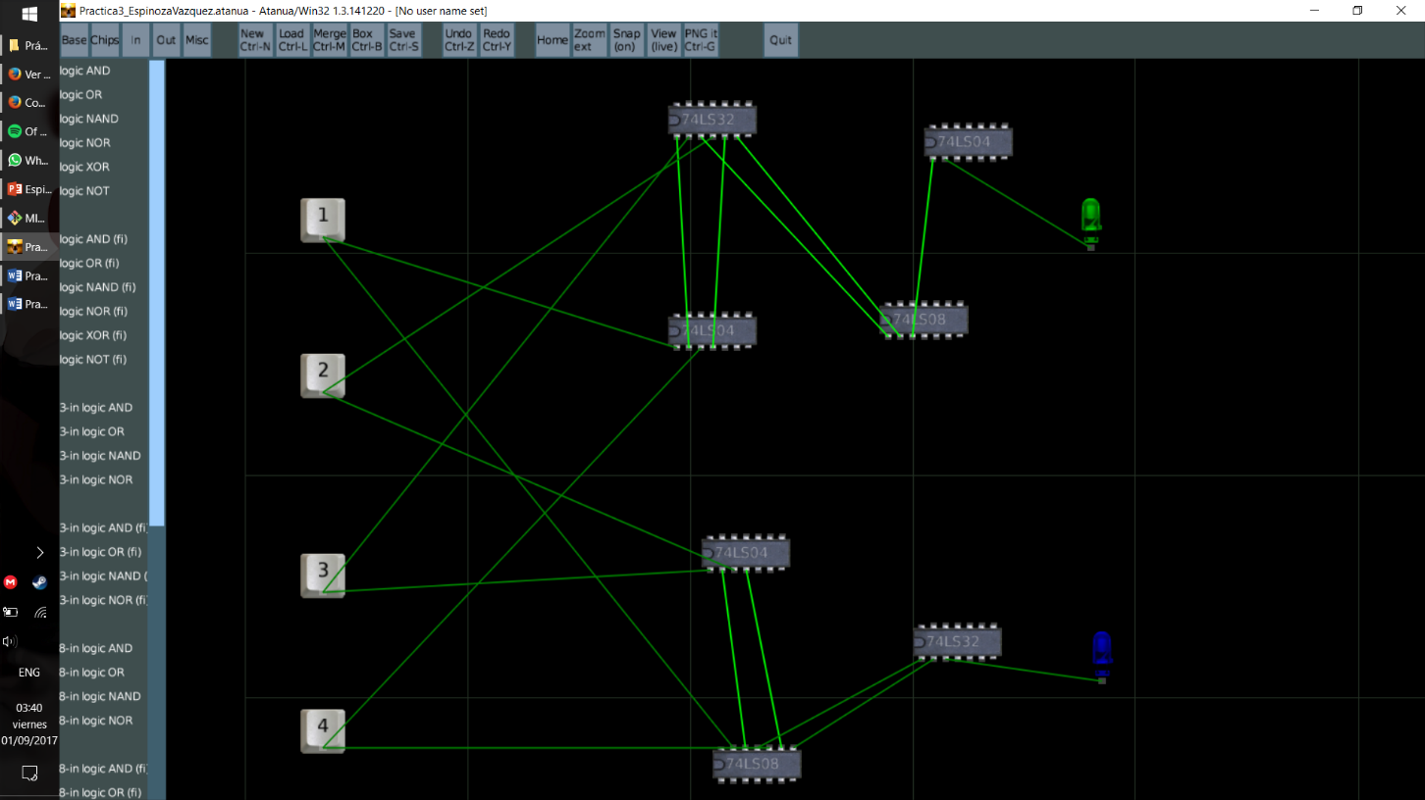

Verificación de los circuitos lógicos en Atanua.