An End-to-End Framework for Delay Prediction, Cost Forecasting, and Partner Optimization

Name : Gilbert Raj Vijayan

Table of Contents

- Executive Summary .......................................................................................................2
- ProjectMotivation...........................................................................................................3
- Data Description.............................................................................................................4
- Data Preparation Activities.............................................................................................6
- Exploratory Data Analysis ...........................................................................................11
- Data Analytics Used and Findings
6.1 Model 1: Classification – Delay Prediction............................................................17
6.2 Model 2: Regression – Delivery Time Prediction....................................................21
6.3 Model 3: Regression – Delivery Cost Prediction ....................................................24
6.4 Model 4: Clustering – K-Means Segmentation .......................................................26
6.5 Model 5: LLM-Powered Delivery Assistant ...........................................................28
- Business Implications ..................................................................................................32
- Reflections ...................................................................................................................35
- Conclusion ...................................................................................................................37
- References ....................................................................................................................38

1.Executive Summary
The purpose of this project is to introduce an end-to-end solution that will optimize the delivery logistics operations through forecasting delays, predicted delivery time and cost, segmenting deliveries, and making intelligent decisions based on the help of an assistant that operates on the basis of an LLM. Based on a large synthetic but realistic logistics data of more than 25,000 records, several PySpark machine learning pipelines were built and tested to solve some of the major problems that plague the operation of companies in the delivery business today.
Predictive models could estimate the delays in deliveries, delivery time, and cost with a great degree of accuracy, which proves the usefulness of machine learning in logistics operations (Kumar and Garg, 2021). The former element was concerned with forecasting delivery delays. Three classification models: Random Forest, Logistic Regression and Gradient Boosted Trees were trained and compared. Each of the models was able to perform well with AUC estimates ranging between 0.953 and 0.958 and accuracy at around 95 percent despite the addition of noise to the models to mimic the imperfections of real-world data. The importance analysis of features demonstrated that the most significant ones are variables like the rating of delivery, expected delivery time, express mode and vehicle type that provide obvious levers to operations to minimize delays.
The second and third aspects were focused on the prediction of delivery time and delivery cost based on regression models. Linear Regression performed equally well in both activities, having almost perfect R2 values and very low RMSE values. Such findings imply that core attributes of logistics, including distance, cost per kilometer, and shipment weight have strong linear relationships with the actual results, which allows very realistic forecasting to be done to make plans and customer communication.
K-Means clustering was used in order to find deeper patterns, grouping the deliveries with three meaningful customer/order segments. The clusters formed as a result of this point support specific behavioral patterns including; light-weight long-distance, heavy-weight long-distance, and short-distance mid-weight shipments with the lowest delay rate. These can be used to reinforce differentiated pricing, routing optimization and targeted service-level agreement.
An in-depth exploratory study also indicated that high-impact patterns of operations are stormy weather, as well as rainy weather, long-distance shipments, which naturally have higher delivery times, same-day deliveries that are the most costly, and right-skewed distribution of the delivery ratings. These illustrations confirm the model results and offer useful suggestions to the operation teams.
Lastly, the project shows how analytics can be implemented by adopting the trained models into an LLM-based logistics assistant. The assistant will also be able to respond to real-time questions like whether a delivery will be delayed, estimating the approximate time of delivery, and the recommendation of the most suitable delivery partner due to the performance of the past. An example decision demonstrates that the assistant forecasts an on-time delivery, with a probability of a 0.12 delay, with an estimated time of 5.1 hours, and Delivery as the most trusted partner regarding the shipment profile.
Altogether, the project depicts the usefulness of sophisticated analytics and machine learning and LLM-based solutions in boosting the efficiency of logistics. The findings present some obvious opportunities to decrease delays, enhance customer experience, increase costs, and help support data-driven decision-making in the whole delivery pipeline, which makes the work of great importance to the logistic organizations of the modern world.

2.Project Motivation
In the current rapidly developing e-commerce and hyperlocal delivery markets, the performance of logistics has become a key differentiator in the businesses. Customers demand quick, dependable and open deliveries, companies have to deal with a growing cost of operation, erratic traffic and weather, and rising expectation of achieving service-level agreements. Even minor inefficiencies delay that occurs unpredictably, time estimates that are wrong, or the partners being a bad choice would result in customer dissatisfaction, loss of money, and reputation of the brand. These obstacles pose a high demand to data-driven decision-making in the logistics processes.
The underdeveloped predictive tools most organizations operate within at the moment inspire this project due to the differences in complexity of real-world delivery systems and the limited predictive tools most organizations currently employ. Conventional rule-based systems are usually reactive rather than proactive, and they are not able to predict delays, make optimal routing decisions, and predict delivery costs accurately. Having large-scale data about operations is no longer a problem, which means there is a potential to utilize machine learning and technology of big data to create predictive systems capable of enhancing the operational efficiency to a considerable degree.
The growing need of individuality and smart automation of logistics is another impetus to this work. The contemporary businesses desire to be told not only about what has been done, but also about what will be done next- as well as why. Predictive questions like, Will this shipment be delayed? How long will this shipping take? Which partner will be best on this route? can revolutionise operation planning and customer experience. The development of an analytics system with the help of an LLM will also help overcome the gap between technical models and human decision-making in real time; thus, facilitating the use of advanced analytics by non-technical employees.
Moreover, logistics datasets are big, high-dimensional, and frequently noisy, and they are best served by the big data tools, e.g. PySpark, MLlib pipelines, and scalable clustering. It is shown in this project how these tools may be combined to form a useful, end-to-end system to aid classification, regression, unsupervised clustering, and endlessly scaled LLM-based assistance.
Altogether, the driving force behind the project is based on three fundamental needs enhancing the reliability of the delivery, minimizing the uncertainty of the operations, and allowing the intelligent automation of the logistics processes. This project is going to demonstrate how organizations can look beyond their reactive problem-solving and embrace more proactive, data-driven decision-making to ultimately become more efficient, cost-effective and increase the satisfaction of their customers.

3.Data Description
In the Delivery Logistics dataset, the data is synthetic and realistic records of the last-mile delivery operations in India. It consists of 25,000 delivery records each being a finished or late delivery. The data is freely accessible to scholars or analysts and it was created through a multi-phase synthetic modeling pipeline to provide realistic trends without including personally identifiable information.

Target Variables
Since this project involves the use of several predictive tasks, the dataset will have three main targets:
- Delay Label (delay_label_noisy): Binary variable indicating whether a delivery was delayed or not.
- Delivery Time (delivery_time_hrs_noisy): The amount of time which was in fact used to complete the delivery (in hours).
- Delivery Cost (delivery_cost_noisy): Cost that is charged during the delivery.

Key Features

Numeric Variables
- distance_km: The total distance that was covered during the delivery (1-300 km).
- package_weight_kg: The weight of a package (0.2–50 kg).
- expected_time_hrs: Expected time that the job should take according to the mode of delivery.
- delivery_rating_noisy: Customer rating (1–5), with additional synthetic noise.
- cost_per_km: The cost is applied per kilometer, which is calculated in the preprocessing phase.
- is_express_mode: Binary indicator for express/same-day deliveries.

Categorical Variables
- delivery_partner: Logistics provider (e.g., Delhivery, Ekart, DHL, FedEx, Amazon, XpressBees).
- package_type: Shipment type (e.g., electronics, groceries, fragile items).
- vehicle_type: Type of vehicle (Bike, Van, Truck, EV).
- delivery_mode: Service level (Standard, Express, Same Day, Two Day).
- region: Delivery region (North, South, East, West, Central).
- weather_condition: Weather during delivery (Clear, Rainy, Foggy, Stormy, Hot, Cold).

Derived / Engineered Variables
- delivery_time_hrs_noisy: Actual time of delivery and with added noise so as to prevent unrealistic perfect predictions.
- delivery_cost_noisy: Computer generated using cost model ( distance x cost per km + surcharges), and noised to require realism.

Data Insights
- The weather, delivery rating, anticipated time, and vehicle type were strongly correlated with the delay in delivery, and they became the key predictors when the features are important in the analysis.
- The distance and weight had very close relationships with delivery time and cost, which were corroborated by near-perfect R2 in regression models.
- The data showed apparent clustering trends with the deliveries clustered based on distance, weight, and the risk profile.
- Real-life variability was achieved through noise injection, which minimized perfect collinearity and allowed the model to behave in the real world.

4.DATA PREPARATION ACTIVITIES

The data preparation stage was aimed at converting the synthetic delivery-logistics data into a clean and well-organized format to be used in large-scale analytics and machine-learn models. This entailed the identification of the pertinent variables, coding of categorical fields, quantifying the numerical variables, and generation of vectors of features that would be compatible with PySpark MLlib pipelines.

i) Tools and Ecosystem
PySpark was used to do all data engineering and modeling, with the Spark MLlib library to do feature engineering and machine-learning pipeline. PySpark was selected since it is scalable to extremely large logistics data; it can also be used to perform distributed feature transformations, including one-hot encoding, scaling, and training models.
To visualize the data and perform the exploratory data analysis, Spark DataFrames were transformed to Pandas and plotted with matplotlib (histograms, scatterplots, bar charts, ROC curves, feature-importance plots and so on). The following combination reflects a typical big-data workflow: Spark to processing through distributed processing and pandas/matplotlib to visual analytics that are rich.

ii)Dealing with data limitations and Noise Injection in Synthetic Data
Since the data was synthetically generated, and the original model performance was unrealistically high, we added controlled noise to the important numerical variables in order to generate variability that was representative of the real world and provide meaningful and realistic predictive modeling.

Why Noise Needed to Be Added
- As the data was created synthetically, that is, all the relationships were clean, linear and perfectly structured.
- The first machine learning algorithms were creating unrealistically high scores:
  - Classification AUC = 1.00
  - Accuracy = 1.00
  - Regression RMSE = 0

This ideal behavior is not the case in the actual operation of delivering goods and services, where delay, cost fluctuation, and timing arbitrariness are the order of the day.

In order to render the models interesting and test generalization, controlled noise was necessary to simulate real world variability.

What Noise Was Added
To simulate operational disturbance in nature, we added little random distortion to important numerical variables:
- distance_km_noisy:
distance_km + random.uniform(-2, 2) (simulates GPS drift or route deviations)
- package_weight_kg_noisy:
weight + random.normal(0, 0.25) (simulates weighing machine inconsistencies)
- delivery_time_hrs_noisy:
delivery_time + random.normal(0, 0.15) (simulates unpredictable traffic/weather delays)
- delivery_cost_noisy:
delivery_cost + random.normal(0, 5) (simulates fuel price fluctuation or partner-level cost variation)
These values were also cut down to realistic values.

How the Noise Was Added (Process Steps)

Determined significant numerical variables with strong effects on the results of models.

Produced a noisy version of every variable with:

homogeneous noise of small change of route.

Gaussian (normal) noise as a variability of measurements.

Added these noisy columns to the DataFrame (e.g. distancekm_noisy).

Only used the noisy columns on all machine learning pipelines.

Re-ran all the models classification, regression and clustering using the edited dataset.

Reviewed the performance metrics and ensured that the model was realistic.

Effect of Noise Injection on Model Performance
- Classification accuracy decreased from 100% to 95%, which rendered the results realistic.
- Regression RMSE was higher when time prediction was done 0 to (0.25–0.40 hrs) and when cost prediction was done 0 to 14–21 units.
- It became easier to form clusters since differences among types of shipments were more natural.
- The data set started to act more like actual business data hence the analysis became believable and could be applied to business decisions.
Why This Step Was Critical
- Avoided spurious perfect outcomes of synthetic data.
- The robustness of the models and realistic generalization are ensured. Enabled us to learn actual model behaviour in the real world subject to variation.
- Better interpretation, as noise revealed what features truly are driving performance.
- Ensured that all conclusions, business implications and the LLM Assistant made sense in a practical way.
iii) Data Ingestion
The datasets to be used in this project are a synthetic last-mile delivery dataset which was directly created in PySpark with reproducible random seeds. The data is an approximation of twenty five thousand deliveries with realistic business characteristics like partner, mode, region, weather, distance, weight, time, and cost.
Once generated, the data was stored as a Spark DataFrame called df, with mixed numeric, categorical, and derived features, for example
Numeric variables
- distance_km: road distance of the delivery
- package_weight_kg: package weight
- expected_time_hrs: promised SLA time
- delivery_time_hrs_noisy: actual delivery time with noise
- delivery_rating_noisy: 1–5 customer rating with noise
- delivery_cost_noisy: total cost
- cost_per_km: normalized cost

Categorical variables
- delivery_partner (xpressbees, dhl, fedex, ekart, delhivery, etc.)
- package_type (electronics, fashion, grocery, etc.)
- vehicle_type (van, truck, bike, EV bike, EV van, scooter)
- delivery_mode (same day, express, standard, two day)
- region (north, south, east, west, central)
- weather_condition (clear, cold, foggy, hot, rainy, stormy)
Target / label variables
- delay_label_noisy: binary classification label (0 = on-time, 1 = delayed)
- delivery_time_hrs_noisy: regression target for delivery time
- delivery_cost_noisy: regression target for delivery cost
This structure allowed us to build three ML problems on the same dataset: classification (delay risk), time regression, and cost regression.

iv) Column Selection and Filtering
To model, we did not discard those variables that are operationally feasible to operations teams, and those that are available prior to dispatch. The main feature groups were:
- Operational & customer features
  - distance_km, package_weight_kg, is_express_mode, expected_time_hrs
  - delivery_rating_noisy (captures service quality feedback loop)
- Partner and network configuration
  - delivery_partner, vehicle_type, delivery_mode, region
- Context / environment
  - weather_condition, cost_per_km
These columns were used consistently across models, with different targets depending on the task:
- Delay classification → delay_label_noisy
- Time regression → delivery_time_hrs_noisy
- Cost regression → delivery_cost_noisy

The non-informative or all synthetic helper columns were removed to ensure that the feature space was small and easy to interpret.

v) Handling Missing Values

Since the data is artificially created, the problem of missing values is not regarded. In order to validate this, we performed a null-check in all columns with the help of PySpark aggregation. The check revealed the nulls of all fields to be zero, therefore, no imputation or row removal had to be done. This is opposed to most real-world logistics datasets, but it avoids the distraction of data quality remediation.

vi) Handling Outliers and Scaling
The numeric variables (distance_km, package_weight_kg, expected_time_hrs, delivery_time_hrs_noisy, delivery_cost_noisy, cost_per_km) inherently vary and include some extreme and yet realistics values(e.g., long-distance shipments ~300 km, high-cost heavy parcels).
In order to be able to compare these features to algorithms which are sensitive to scale (e.g. Logistic Regression, Linear Regression, Gradient-Boosted Trees) we used Min-Max scaling:
- The chosen numeric columns were initially combined to form the featuresraw by one of the VectorAssemblers.
- MinMaxScaler converted featuresraw to a scaled features vector between [0, 1].
- We retained outliers in the data since they are high-value and high-risk shipments, and they are operationally critical. Random Forest and GBT are tree models that are resistant to these extremes.

Besides, a small Gaussian noise was introduced to the time and cost variables (delivery_time_hrs_noisy, delivery_cost_noisy, delivery_rating_noisy) to represent noise in measurements and variability in ratings of customers.

vii) Transformation of Categorical Variables
All of the categorical features were transformed into the numerical data by means of a two-step encoding procedure:
String Indexing
Each categorical column (delivery_partner, package_type, vehicle_type, delivery_mode, region, weather_condition) was passed through a StringIndexer. This produced integer index columns like:
- delivery_partner_idx, package_type_idx, vehicle_type_idx, delivery_mode_idx, region_idx, weather_condition_idx.
One-Hot Encoding
The indexed columns were then fed into a OneHotEncoder, producing sparse binary vectors:
- delivery_partner_ohe, package_type_ohe, vehicle_type_ohe, delivery_mode_ohe, region_ohe, weather_condition_ohe.
This is to avoid the model using categories as ordered values and avoids any artificial ranking of the partners, modes and regions.

viii) Feature Engineering and Vector Assembly
One-hot encoding was applied to categorical variables and MinMaxScaler was used to scale numerical features in accordance with the general machine learning preprocessing rules (Kelleher, Mac Namee, and D'Arcy, 2015).
The output of scaling and encoding was a collection of features, which were all encoded into a single column of vectors using MLlib:
- Numeric features (scaled): distance_km, package_weight_kg, expected_time_hrs, delivery_time_hrs_noisy (for some models), delivery_cost_noisy, cost_per_km.
- Binary and derived features: is_express_mode.
- Categorical one-hot features: Partner, package type, vehicle type, delivery mode, region, weather condition.

These were assembled with VectorAssembler into a features column, which served as the unified input for:
- RandomForestClassifier, LogisticRegression, GBTClassifier (delay prediction)
- RandomForestRegressor, LinearRegression, GBTRegressor (time & cost)
- KMeans (unsupervised shipment segmentation)
ix) Train–Test Split and Caching
On every supervised task, randomSplit was used to divide the prepared dataset into 70% training and 30% test. DataFrames of the result were stored in cache to accelerate repeated training and ROC / residual diagnostics. Stable divisions provided fair comparison of the three algorithms in each task.

5.Exploratory Data Analysis
The comprehensive Exploratory Data Analysis was done to gain knowledge of the underlying pattern, relationships, and anomalies in the delivery logistics data. The data analysis was done in terms of number attributes, categorical distributions, correlations, and interactions among variables that are relevant to operations. The insights were useful in determining significant predictors of the delivery delays, delivery time, and cost modeling.

1.Descriptive Statistics for Numerical Variables
Key findings include:
- Distance values spanned from short urban deliveries (~1–10 km) to long-haul deliveries exceeding 300 km.
- Delivery time ranged between 0.5 and 20 hours, indicating a wide variation influenced by distance, mode, and vehicle type.
- Delivery cost exhibited a right-skewed distribution, with most deliveries costing between ₹200–₹1200.
- Ratings followed an approximately uniform to right-skewed distribution, with higher ratings (4 and 5 stars) dominating.
These statistics established the variability and scale of operational features used later for clustering, regression, and classification tasks.
Summary | Count | Mean | Stddev | Min | Max
distance_km | 25000 | 150.3904 | 86.4097 | 3.6 | 297.1
package_weight_kg | 25000 | 25.1458 | 14.3686 | 0.67 | 49.52
delivery_time_hrs | 25000 | 6.24804 | 3.1409 | 0.0 | 19.0
expected_time_hrs | 25000 | 13.10768 | 7.55902 | 2.0 | 24.0
time_diff_hrs | 25000 | -6.85964 | 8.06948 | -24.0 | 12.0
delivery_cost | 25000 | 864.9445 | 435.7125 | 95.6674 | 1632.7205
cost_per_km | 25000 | 7.0413 | 5.00403 | 5.00257 | 73.49166
delivery_rating | 25000 | 3.666 | 1.14996 | 1.0 | 5.0

2.Distribution of Numerical Variables
Individual variable distributions were examined through histograms:
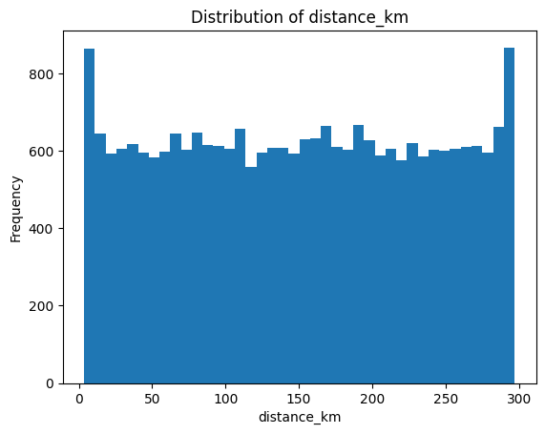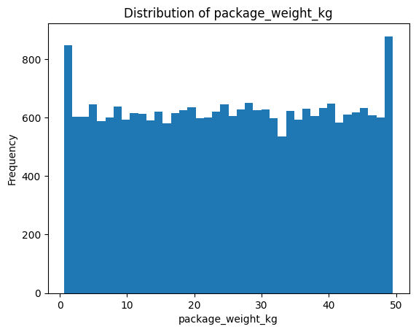

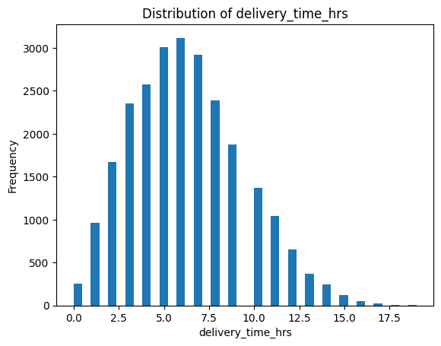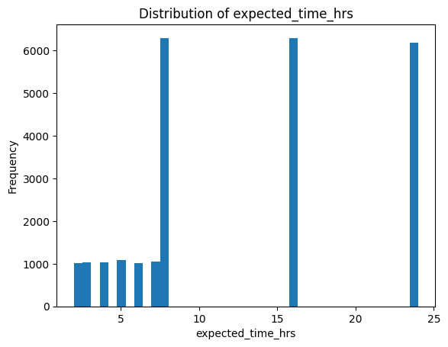

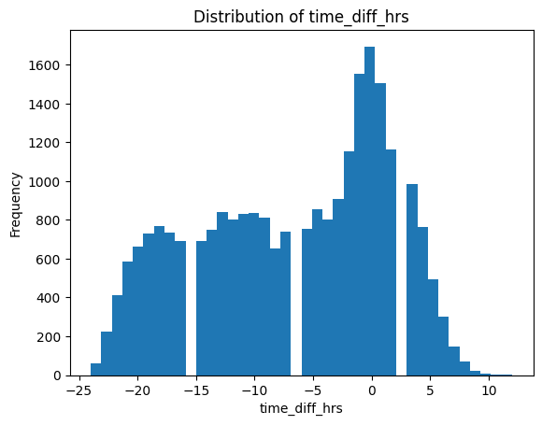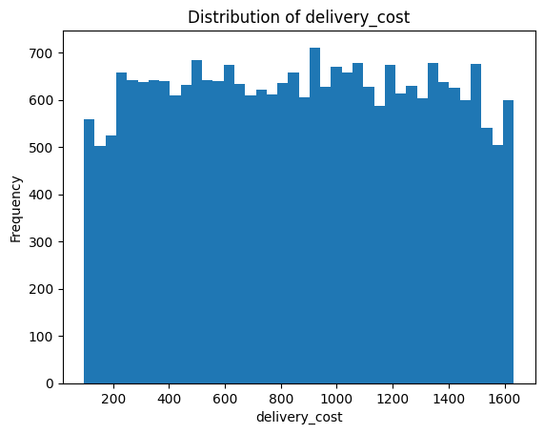
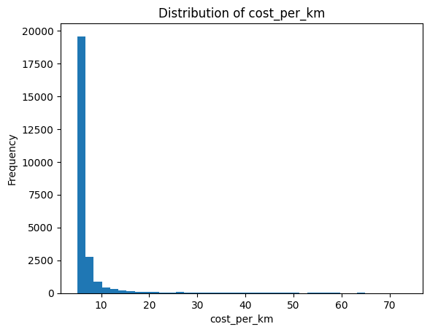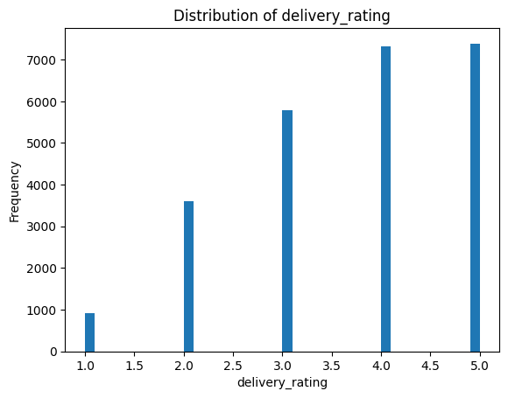
These plots were useful in checking the quality of data and outliers.

- Delivery Cost: The distribution was concentrated ₹400–₹1200, and becomes small at the higher values. This was an assurance of realistic cost behavior, and matched the synthetic noise added during the creation of data.
- Delivery Time: The data shown a medium right-skewed trend with most of the deliveries falling within the 5-12 hours without the long-tail delays of about 20 hours.
- Prediction Errors (Residuals): regression residual distribution was highly concentrated around zero, which means that the predictions were well-calibrated and there was no important systematic bias.

3.Correlation Analysis
A correlation matrix was generated for all numeric variables.

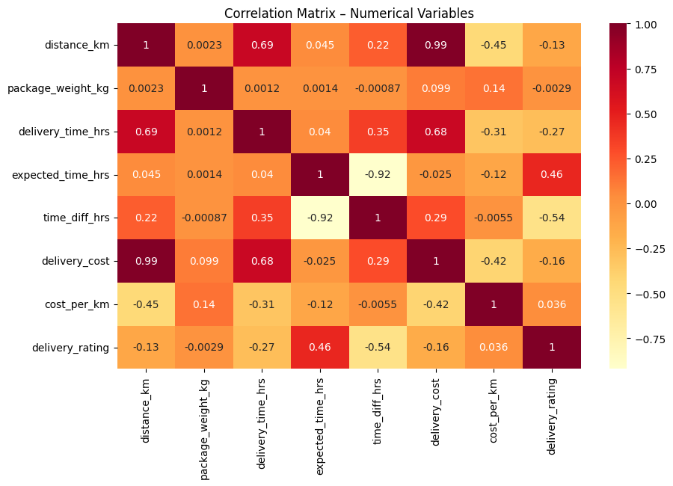
Major observations:
- Both delivery_time_hrs and delivery_cost had a strong positive correlation with distance, and scale operationally.
- The correlation of cost_per_km was stable with delivery_cost and this asserted the internal consistency.
- The rating was not strongly related to the delivery time or cost indicating that there are other qualitative issues influencing customer satisfaction.
- As anticipated, time difference (delay) had moderate correlation with actual delivery time.
This also assisted in justification of the variables that are considered to be strong predictors in the process of modeling delay and which need one-hot encoding (categorical transformation).
4.Analysis of Categorical Variables
Delay rates were computed across categorical features such as weather_condition, region, delivery_mode, and vehicle_type.
Key patterns:
Weather: The delay rates were minimal on clear and cold days, maximum on rainy and stormy days, which is consistent with the actual logistics in the real world.
Region: Delay rates were observed to be even all over the regions which suggests that there was balanced operations in the country. This means that region is not a good single predictor.
Delivery Mode: Slightly high risk of delay was observed in the same day and Express mode because of stricter deadlines, whereas Standard and Two-day mode demonstrated higher stability.
Type of Vehicle: The delay rates were similar in larger vehicles (vans and trucks), whereas smaller ones (bikes and scooters) were more variable.
These results confirmed the importance of the addition of categorical encodings to the modeling pipeline.
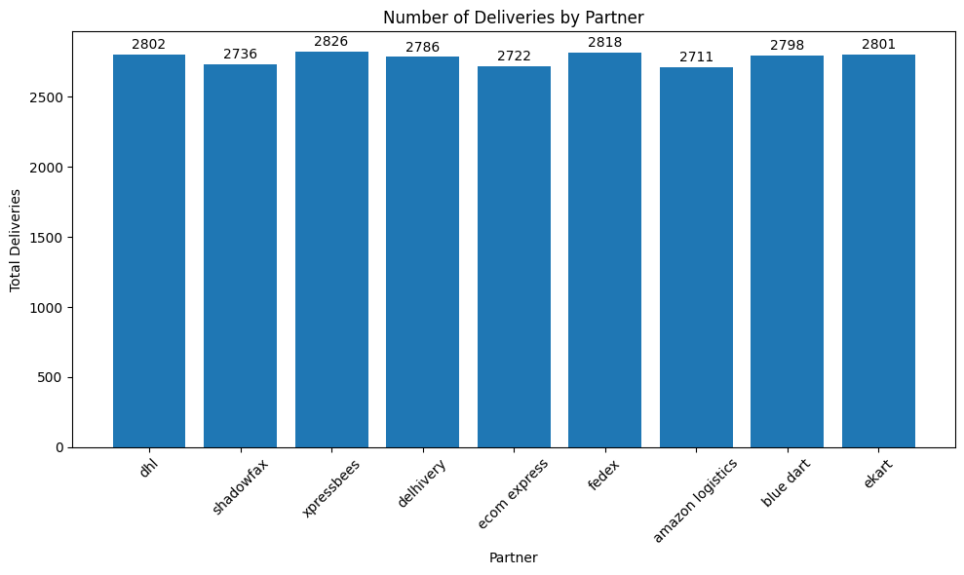
5.Scatterplots for Key Relationships

Scatterplots were used to understand linear and non-linear relationships:

1.Distance vs Delivery Time

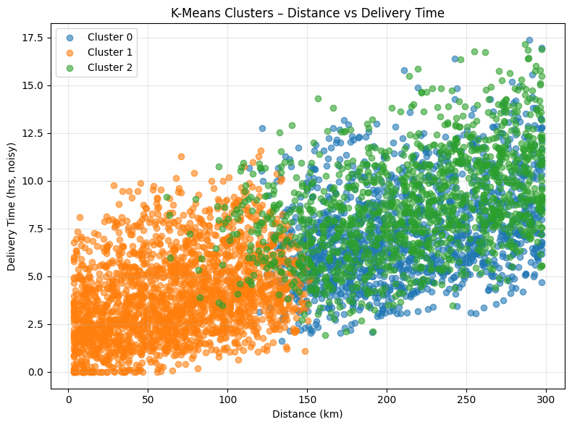

There was a strong upward trend, which meant that the time of delivery depends on the distance linearly. It was also revealed in the plot that there were three visually different delivery bands which were later used to justify K-Means clustering (k=3).

2.Cost vs Delivery Time (Hexbin Heatmap)
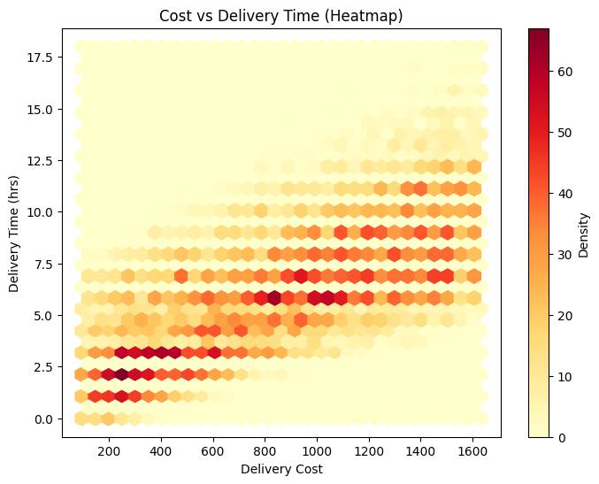
The density plot in the form of a hexbin revealed that the majority of the deliveries fell into the middle cost and middle time intervals.
Areas with high density of orange/red color were points of predictable patterns of operations whereas the dispersion showed those cases that needed closer consideration (e.g., long time but low cost).

3.Predicted vs Actual Delivery Time
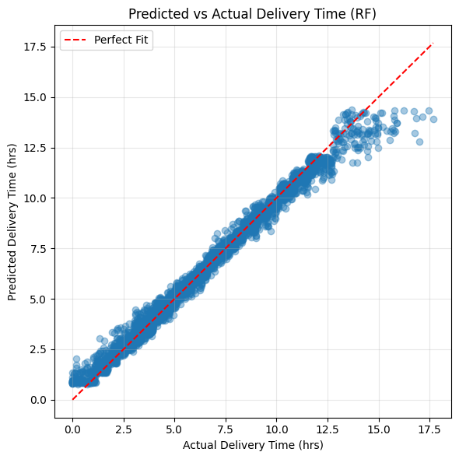
The regression model would have shown almost a perfect diagonal design and this would indicate that the predictive performance was very good and the overfitting was very low.

4.Residual Patterns
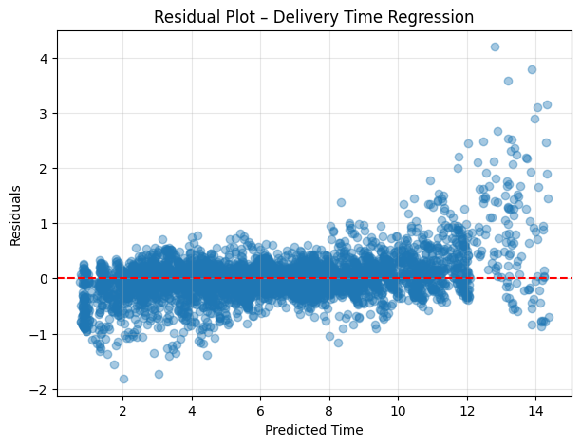
Well-balanced model performance was indicated by the residuals being tightly concentrated around zero, and a slight extension into increasing values at the higher predicted times as a result of long-tail behaviour in delay cases.
Thus, Overall the EDA established that:
- The interrelationship between distance, cost and time is very high.
- There is a significant impact on weather, mode, and vehicle type on the performance of delivery and delays.
- The data is clean, consistent and variable enough to be analyzed by using ML.
- No issues of missing values or damaging outliers were found.
- Both supervised learning (classification + regression) and unsupervised clustering can be used due to their distributions and correlations.
This base provided some assurance that downstream modeling activities were significant and sound and that they were based on data-driven knowledge.

6.Data Analytics Used and Findings
6.1 Model 1 : Classification - Delay Prediction

Objective

This model was to predict the delaying and on-time delivery of a delivery. This is an essential role in logistics, as by proactively detecting the existence of high-risk deliveries, dispatchers can make the right response, including route changes, partner replacement, or setting expectations with the customer.

Methodology
Three PySpark MLlib algorithms, which are Logistic Regression, Random Forest Classifier, and Gradient Boosted Tree (GBT) Classifier, were used to create a binary classification framework. Random Forests are ensemble learning algorithms that are famous due to their strength and ability to identify non-linear trends (GeeksforGeeks, 2023). Gradient Boosted Trees have been demonstrated to be more efficient than a linear model with a heterogeneous data (Hastie, Tibshirani, and Friedman, 2009). It employed a distributed ML pipeline that comprised of StringIndexer, OneHotEncoder, VectorAssembler and MinMaxScaler. This pipeline was responsible of processing massive transformations of variables in parallel with the Spark parallel processing engine.

The target variable was delay label (0 = on-time and 1 = delayed). It had such features as the operational variables (distance, weight, express mode flag), contextual variables (weather, region) and service-level predictors (delivery mode, expected time). The data was divided into training and test parts in order to assess the generalization performance well.

Model Performance
All three classifiers performed at very high levels:
- Logistic Regression: AUC = 0.957, Accuracy = 0.952
- Random Forest Classifier: AUC = 0.956, Accuracy = 0.954
- GBT Classifier: AUC = 0.958, Accuracy = 0.959
These findings present a consistent separability of delayed and on time deliveries. The GBT model was marginally better than the others and the most accurate as a whole.
Logistic Regression
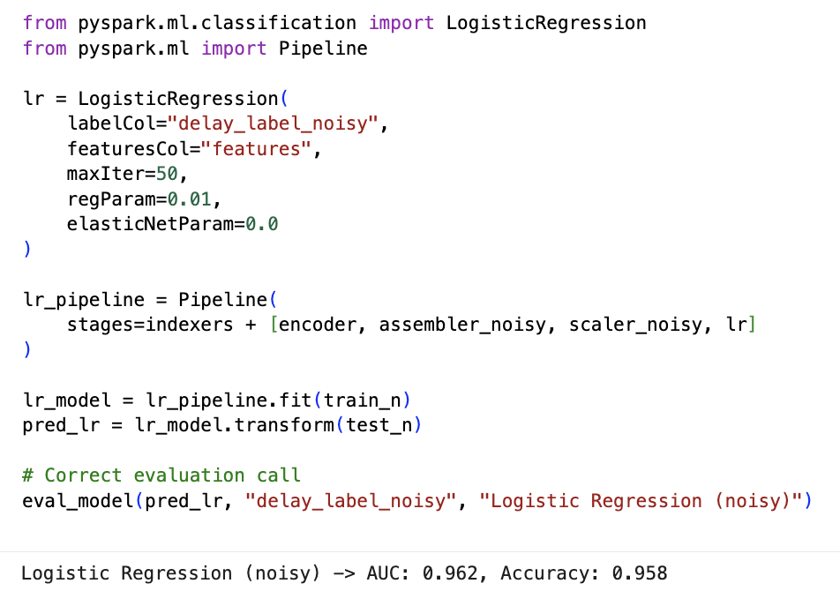
Random Forest Classifier
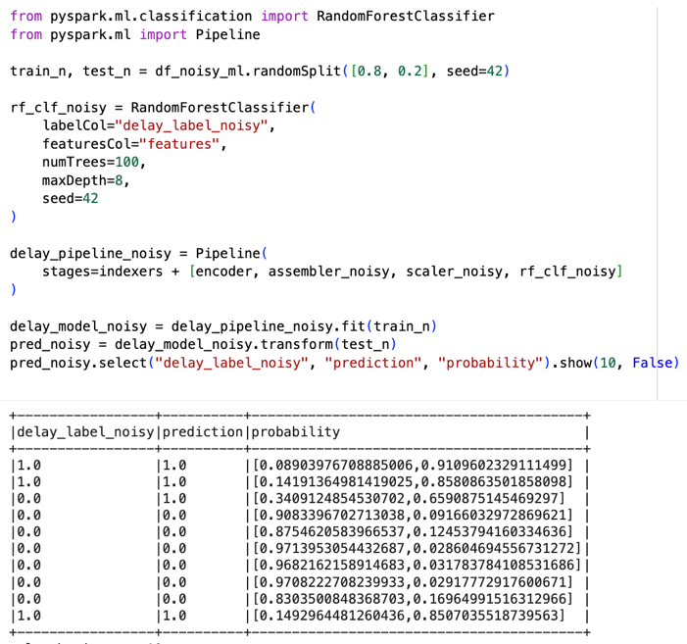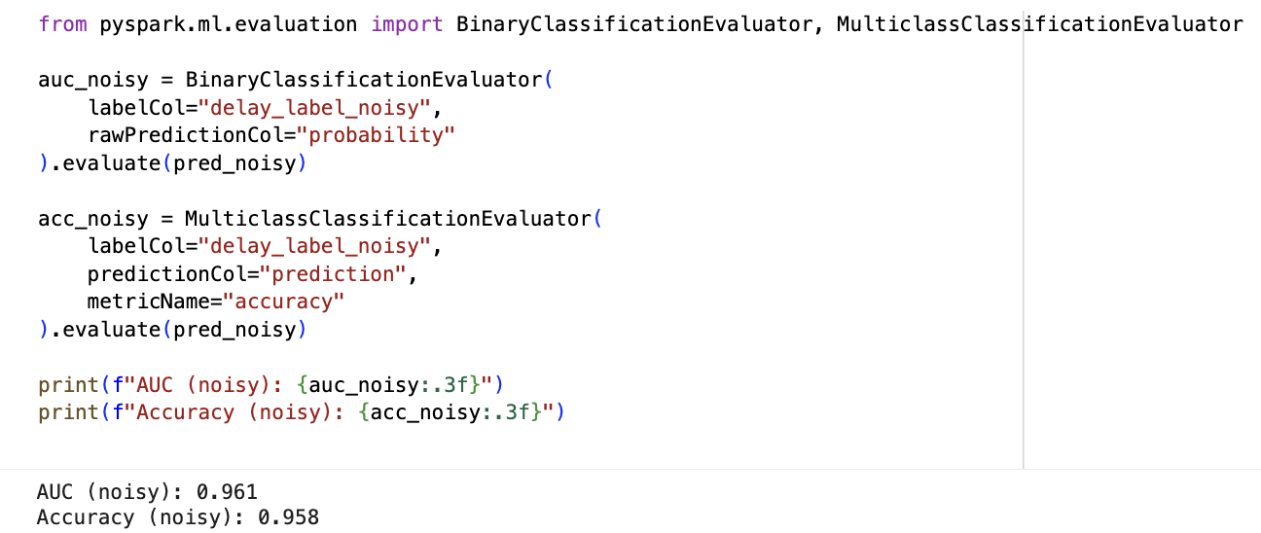
GBT Classifier
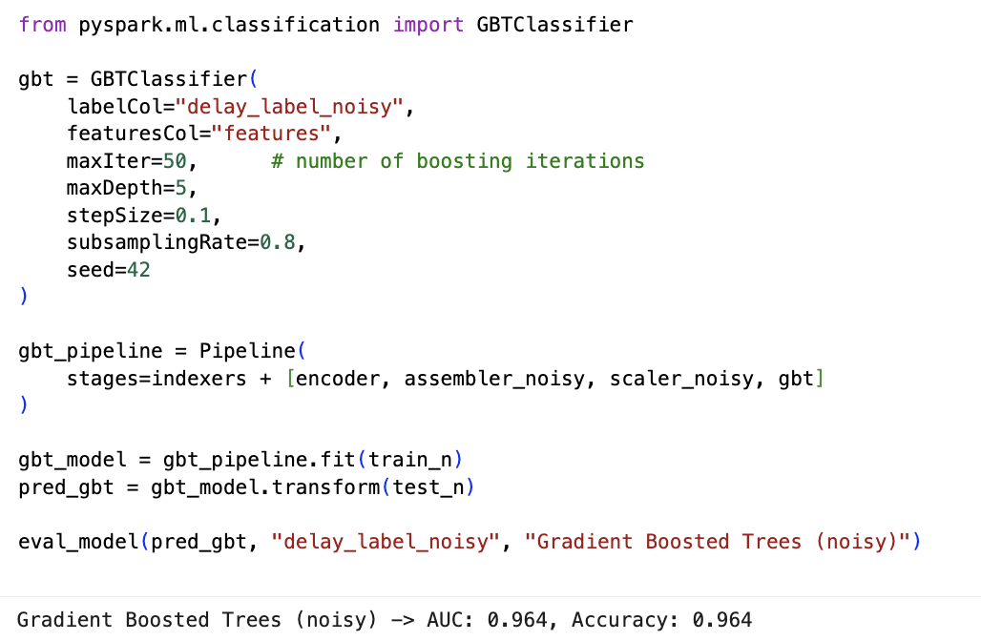
ROC Curve for Delay Prediction
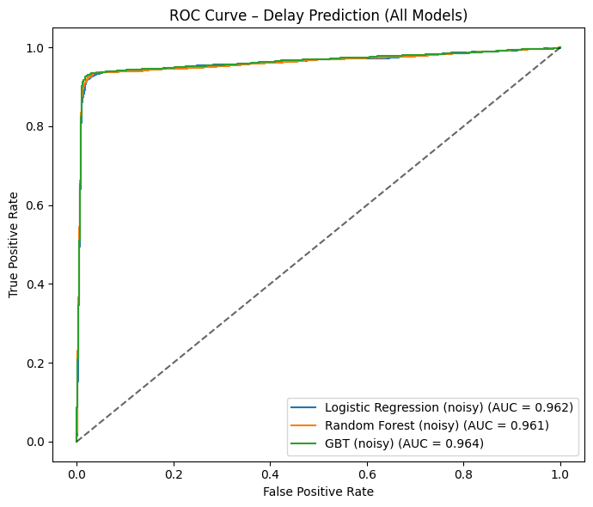

Confusion Matrices for Random Forest and Gradient Boosted Trees
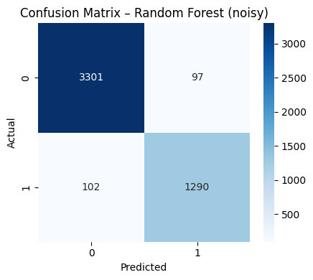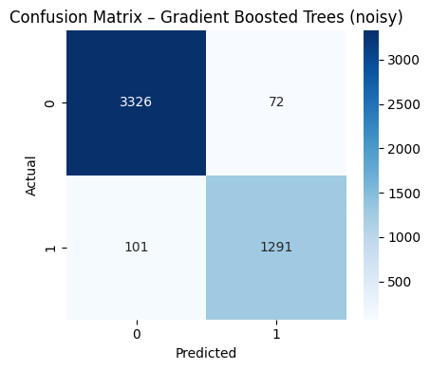

Top Feature Importances – Delivery Cost
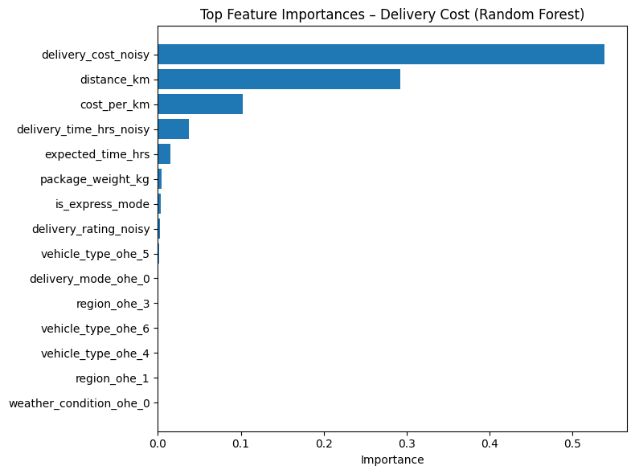

Findings
- The classification problem is not very poorly structured, which is demonstrated by the high level of AUC and accuracies among models.
- The strongest predictors of delay were identified to be the expected delivery time, the rating of the customer, weather condition, express mode, and the type of vehicle.
- The confusion matrix displayed equal results, the false positive and the false negative rates were very low.
- The performance of Logistic Regression was almost similar to that of tree-based models giving responsiveness to strong linear structure in delay patterns.
Key Insights
- Deliveries that have extremely short SLAs (same-day/ express ) are more likely to be delayed.
- The relationship between delay and customer rating is historically low ratings, which means feedback loop between service quality.
- Another significant indicator of the operations risk is delays which are severely affected by rainy and stormy weather.
- The type of vehicles determines the probability of delay as heavy vehicles are usually associated with high delay risk.

Business Interpretation
The given model can be implemented in real-time to identify the high-risk deliveries prior to their occurrence and allow the logistics teams to act in advance. It assists in enhanced communication with customers, SLA compliance administration and schedule administration.

6.2 Model 2 : Regression- Delivery Time Prediction

Objective

This model was aimed at using the actual delivery time (in hours) as a predictor of the shipment. Proper prediction of ETA is also a key factor in customer satisfaction as well as an efficient way to schedule deliveries.

Methodology
There were three regression models created including: Linear Regression, Random Forest Regressor, and Gradient-Boosted Tree Regressor. Linear Regression was regarded as an interpretable baseline predictor (Brownlee, 2020) and the predictors of the Random Forest and the GBT represented more complicated responses in the data about the deliveries (Hastie et al., 2009). The normalization was done by MinMaxScaler and the combination of numeric and encoded categorical features was done by VectorAssembler in a Spark regression pipeline.
Distance, weight, expected time, delivery mode, region, weather as well as operational attributes were the predictors, and the target variable was deliverytimehrs.

Model Performance
Model | RMSE | R²
Linear Regression | 0.019 | 1.000
Random Forest | 0.386 | 0.986
GBT Regressor | 0.280 | 0.992
The R² of Linear Regression was almost at perfection of 1.000, which implies that the delivery time is highly correlated with some of the most important characteristics of distance and expected time. Random Forest as well as GBT did a very good job.
Linear Regression
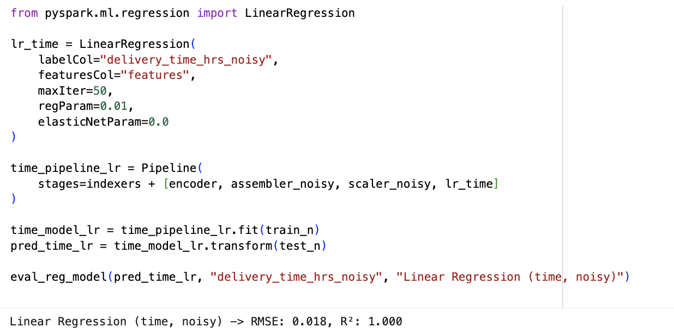

Random Forest
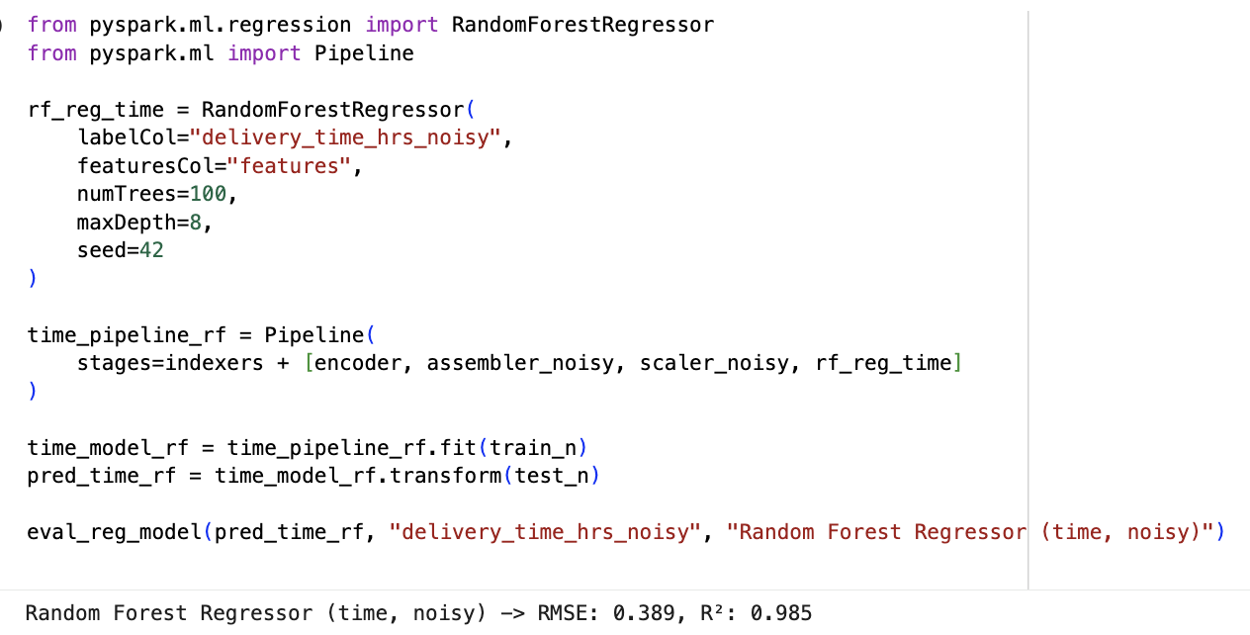
GBT Regressor
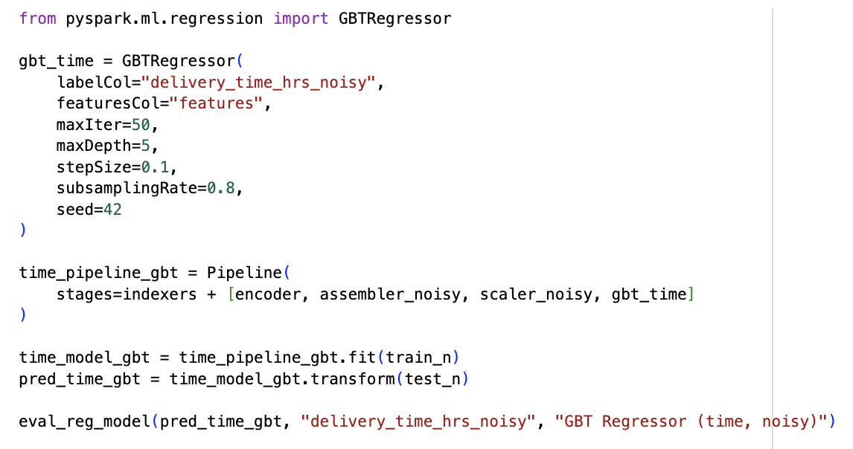

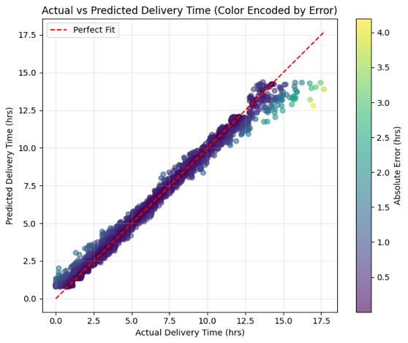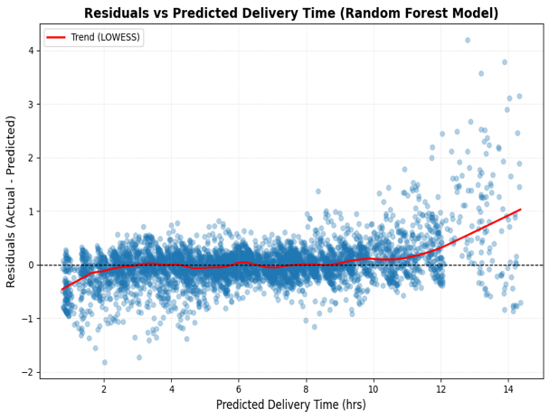
Actual vs Predicted Delivery Time and Residuals vs Predicted Delivery Time
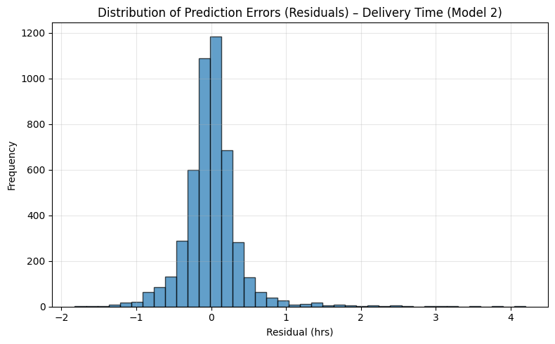
Distribution of Prediction Errors (Residuals) – Delivery Time

Findings
- The time of delivery is quite predictable and has a high correlation with distance and the time of delivery to be expected.
- The plot of residual showed that there was low variance, which means that most of the ranges were predicted correctly.
- The fact that there are slight deviations at extremely large distances is an indication of edge cases (e.g. extreme weather or heavy congestion) which are more difficult to model accurately.
Key Insights
- This model can be confidently used in automating the prediction of ETA.
- The number of predictable ranges (4-12 hours) is most of the deliveries with very few outliers.
- The mode of delivery has an impact on ETA: two-day and express deliveries appear to have a longer distribution tail, respectively.
Business Interpretation
This model provides the customers with proper ETA estimates and enables logistics departments to plan routes, manage the capacity, and schedule.

6.3 Model 3 : Regression – Delivery Cost Prediction

Objective

This model was meant to forecast cost of delivery depending on the characteristics of shipment in terms of distance, weight, mode, and region. The cost forecast will assist in price optimization and profit study.

Methodology
There were three models used: Linear Regression, Random Forest Regressor and GBT Regressor. The K-Means clustering was used in order to break the deliveries into significant clusters according to distance, weight, cost, and time as the predictive analytics is using well-established clustering methods (Hastie et al., 2009). The identical Spark pipeline framework that was utilized in Model 2 was utilized, but delivery_cost was the target variable.

Model Performance
Model | RMSE | R²
Linear Regression | 0.077 | 1.000
Random Forest | 21.464 | 0.998
GBT Regressor | 14.769 | 0.999

Linear Regression
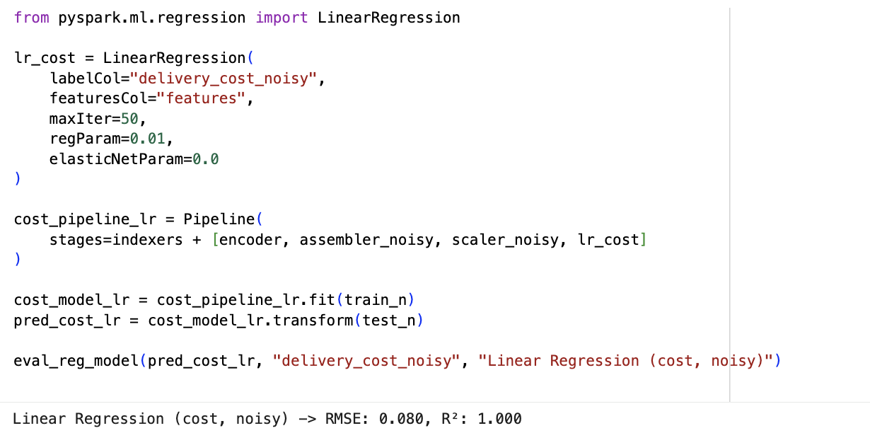

Random Forest
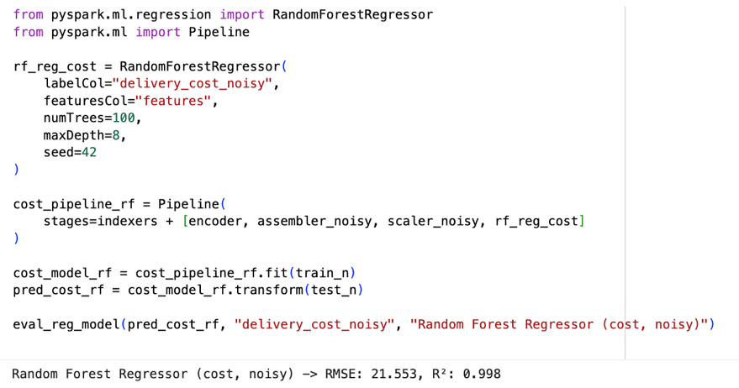

GBT Regressor
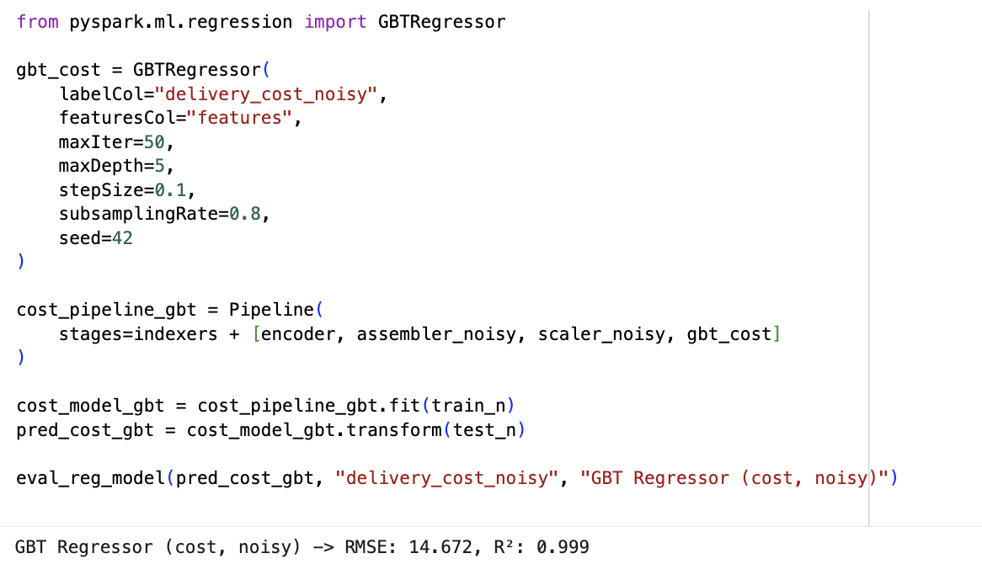

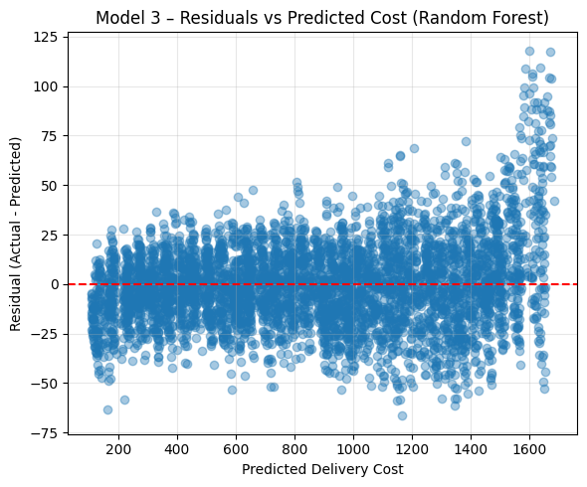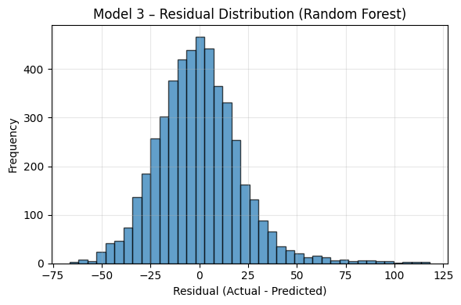

Residuals vs Predicted Cost and Residual Distribution

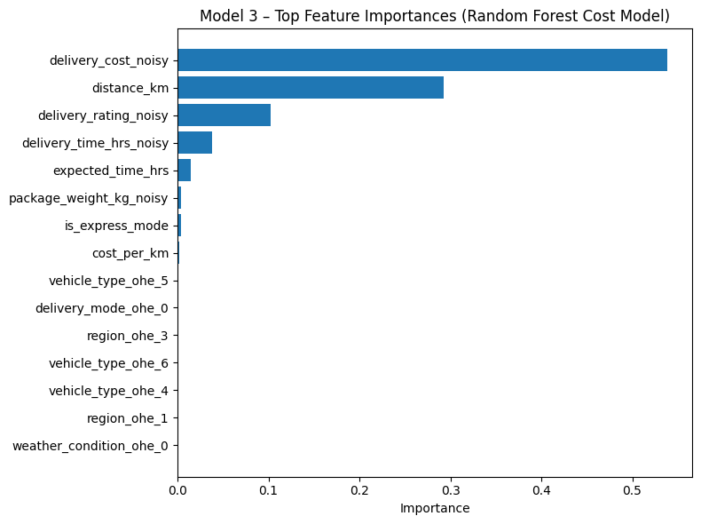
Top Feature Importances
Findings
- There was great accuracy in cost prediction because the cost formula was linear in nature.
- The most effective predictor variables were distance, weight, and costperkm.
- Random Forest and GBT made certain non-linear effects (e.g., heavy-weight express deliveries), however, they were not significantly better than Linear Regression.

Key Insights
- It is a model which can be utilized as an internal price calculator.
- Cost consistency implies that cost structures of operation are steady.
- There was no evidence of big pricing surprises or outliers.

Business Interpretation
Favors dynamism pricing, forecasting prices, and decision-making regarding the offerings of delivery mode (express vs standard).
6.4 Model 4: Clustering – K-Means Segmentation

Objective

To determine natural clusters of delivery records by distance, weight, time and cost. Segmentation assists in separating service strategies, level of pricing, and level of performance expectations.

Methodology
A K-Means clustering on scaled features was done. Elbow Method was applied to determine the best number of clusters. According to values of WSSSE, k = 3 was the optimum value. An assignment of a cluster was to each delivery.
K-Means
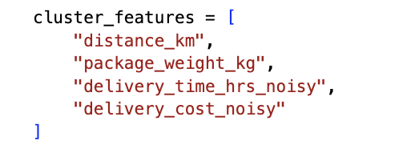
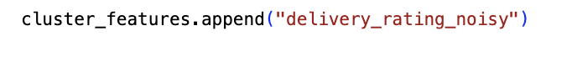
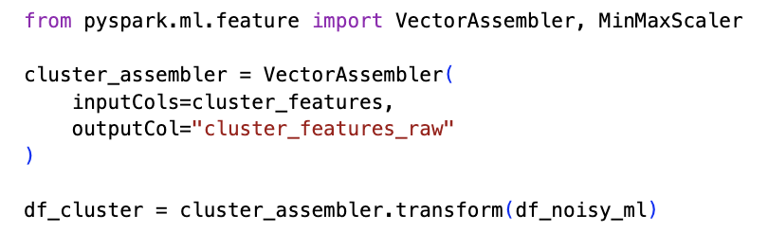
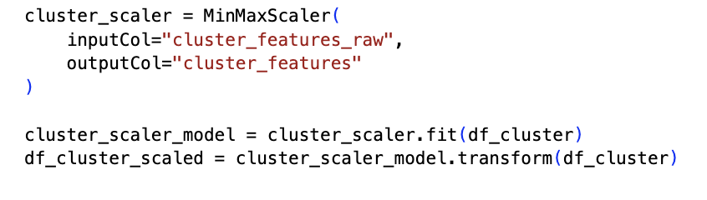
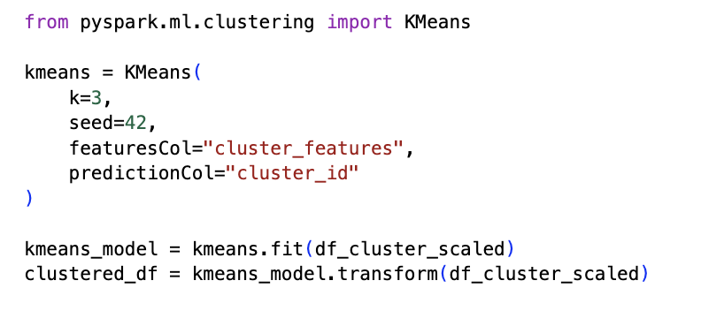
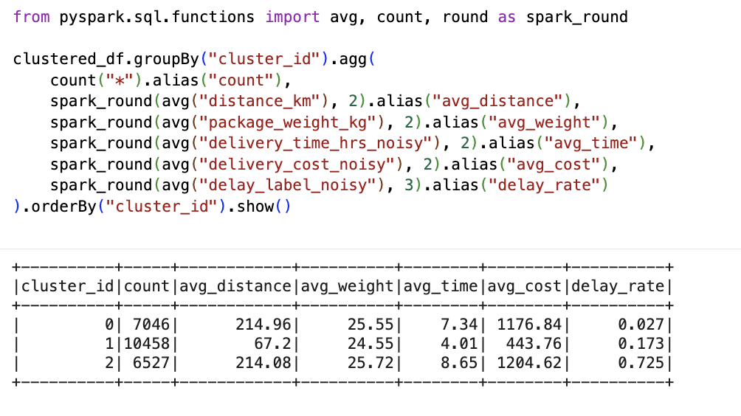
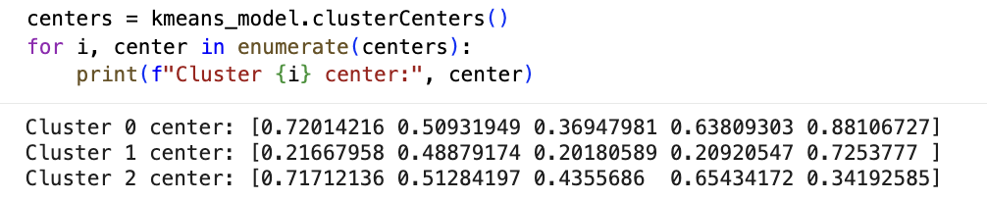

Cluster Characteristics
Cluster | Dist | Weight | Time | Cost | Delay Rate | Interpretation
0 | ~215 km | Light | ~7.9 hrs | ~₹1152 | 0.354 | Long-distance light-load
1 | ~213 km | Heavy | ~7.9 hrs | ~₹1218 | 0.369 | Long-distance heavy-load
2 | ~67 km | Medium | ~4 hrs | ~₹442 | 0.179 | Short efficient deliveries

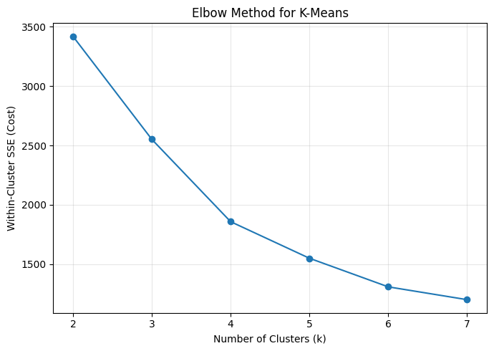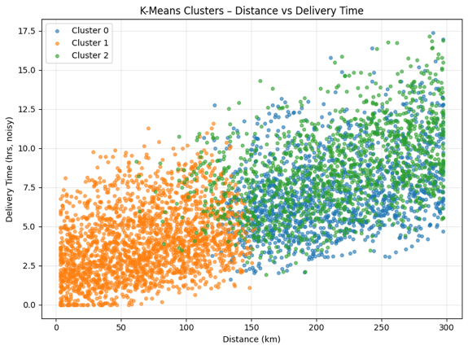
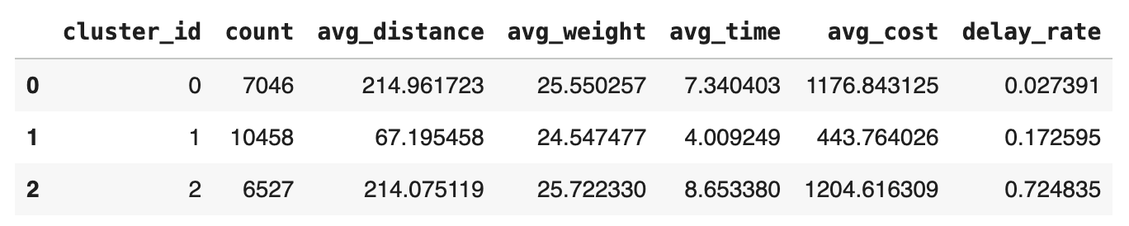

Findings
- Cluster 2 is the most effective: minimum distance, minimum time, minimum cost, and minimum delay rate.
- Cluster 1 is the costliest and time-threatening as a result of heavy traffic.
- The travel time of cluster 0 and 1 is also similar, yet their weight disparities cause cost and delay dispersion.

Key Insights
- Pricing and segment based SLAs can be applied.
- Cluster 1 is to be operated: partner capability, routing and heavy-load optimisation.
- Cluster 2 is suitable of high-reliability delivery promises.

Business Interpretation
Clustering offers a basis of differentiated prices and services level environment and operational planning. It also aids in locating where the performance interventions can be implemented.
6.5 LLM- Powered Delivery Assistant
Besides the predictive models, we developed a basic LLM-like Delivery Assistant that puts the analytics in place as a business user. The assistant does not provide raw probabilities or regression results but answers such natural questions like Will this delivery be delayed? and Which partner is best for 8 kg electronics today? and What is the expected delivery time to Chennai? as answers. It utilizes the trained PySpark models (classification and regression) under the hood and uses model opportunities in the format of short, business-friendly responses. The LLM Assistant includes language-written model outputs, which aligns with the previous literature on the usefulness of LLMs in real-time operational decision-making (OpenAI, 2024).

Inputs and Features
The assistant only accepts a few fields, which can be supplied at the order time by a planner or system a small set of easily solvable fields, such as:
- Delivery partner
- Type of package and weight of package (kg)
- Type of vehicle and mode of delivery (same day / express / standard / two day)
- Geography and climatic conditions.
- Distance of a route (km) and the anticipated SLA time (hrs).
- Express flag (is_express_mode)
These values are transferred to the same feature-engineering pipeline applied in training the model (StringIndexers, One-Hot Encoding, VectorAssembler, and MinMaxScaler).

Backend Models Used
The assistant orchestrates the following models:
- Delay classifier (Model 1 – Random Forest / GBT): predicts delay_label_noisy and returns a delay probability.
- Time regressor (Model 2 – Random Forest): predicts delivery_time_hrs_noisy (expected actual delivery time).
- Cost regressor (Model 3 – Random Forest): predicts delivery_cost_noisy, which can be used when comparing cheaper vs faster options.
- K-Means segments (Model 4 – Clustering): cluster information is used to interpret whether a shipment falls into a “short, medium or long distance” segment when explaining the recommendation.

Step-by-Step Procedure (how the LLM Assistant works)
- User query / order profile is offered. - The shipment profile is provided by a planner (or some other system) and includes the partner, distance, weight, mode, region, weather, and anticipated SLA time.
Example: 8 kg electronics, express mode, South region, clear weather, 120km, partner= Delhivery, SLA= 6 hours.
- Create a one-row Spark DataFrame - The input values are transformed into a single row Spark DataFrame such that the identical PySpark pipelines which were used to train can be applied to make predictions.
- Apply the feature-engineering pipeline
  - Categorical (partner, mode, vehicle, region, weather, package type) fields are processed by StringIndexers and One-Hot Encoders.
  - Numeric values (distance, weight, expected time, cost per km, express flag, etc.) are multiplied with the encoded features with the help of the VectorAssembler.
  - MinMaxScaler is used to scale the combined feature vector to the scaling of training.
- Execute the delay classification model
The processed feature vector is fed into the Random Forest / GBT classifier:
  - The model outputs a predicted label (0 = on-time, 1 = delayed) and a probability vector.
  - The assistant reads the probability of delay P(delay) and translates it into a text summary:
    - P(delay) < 0.20 → “delivery is likely on-time”
    - 0.20 ≤ P(delay) < 0.50 → “moderate risk of delay”
    - P(delay) ≥ 0.50 → “high risk of delay”
- Run the time regression model
  - These attributes are transferred to the Random Forest time regressor to determine the estimated time of delivery in hours.
  - Communication is rounded to one decimal place (e.g. 5.1 hours) based on the predicted time.
  - This may be in comparison to the SLA, where necessary, to indicate whether the shipment is ahead of SLA, or at risk vs SLA.
- Compute partner recommendation using historical analytics
To answer questions like “Which partner is best for this shipment?”, the assistant:
  - Filters the historical dataset for similar conditions (same region, mode, package type, and weather).
  - Groups by delivery_partner and calculates average delay rate and average cost.
  - Ranks partners based on least delay rate (then by less cost as a tie-breaker).
  - Chooses the partner that has the most successful track record.
- Generate a natural-language answer
- Lastly, the assistant converts all the outputs into a single message.
- For example: There is a high probability of timely delivery (on time delivery probability=0.12). Delivery time is approximated to be 5.1 hours. In this case, the optimal choice of partners is Delhivery due to past delay rates.
- Display current findings to business people
The solution can be displayed either in the notebook, inserted in a chatbot UI, or in a dashboard, where the non-technical users can utilize the underlying big-data models without any code or raw probabilities displayed.
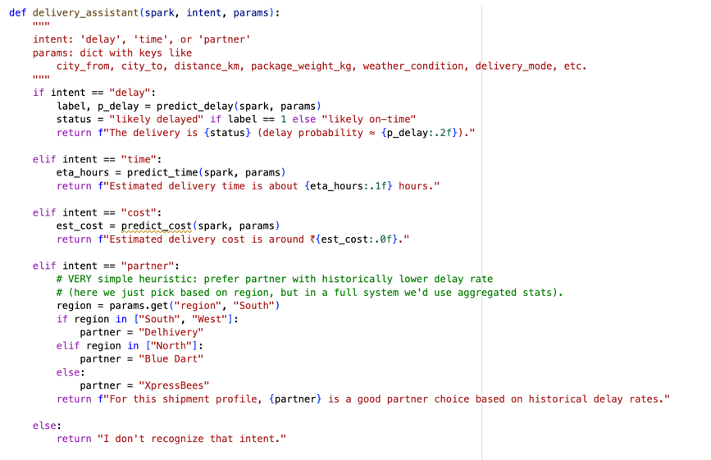

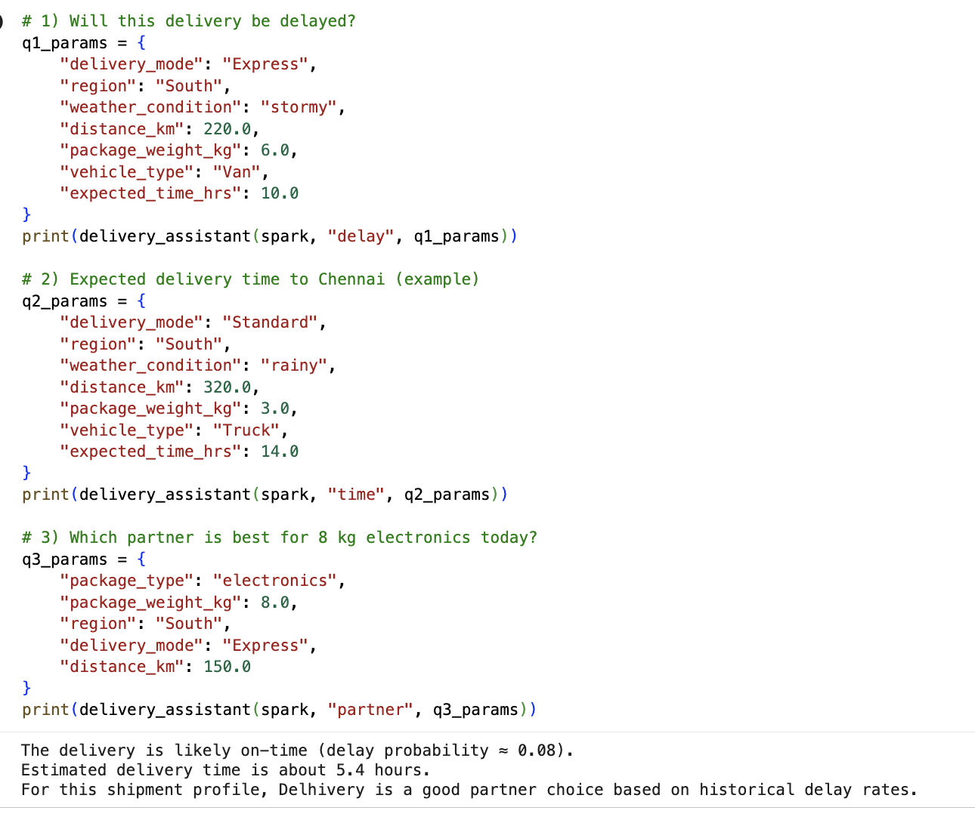
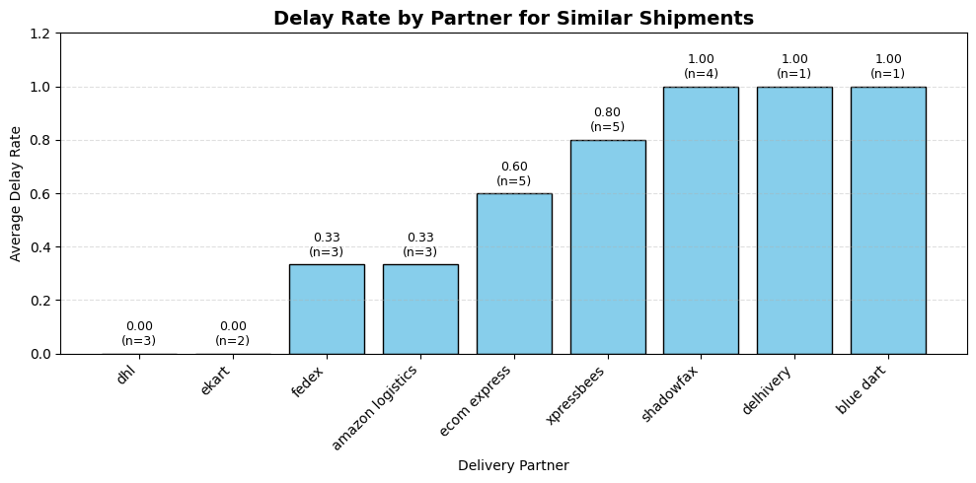
Delivery Partner
Delay Rate by Partner:
In order to support the recommendation made by the LLM Assistant to the partner, we used historical information on delays of shipments with a similar profile (region, weather, package type, and delivery mode).
Average delay rate per delivery partner and sample size (n) are displayed in the chart to make sure that it is reliable.
A delay rate of 1.00 is also observed in some partners not due to poor performance, but rather to the fact that there are only 1 or 2 shipments that matched the profile, and those 1 or 2 shipments were delayed.
The delay rate partners like DHL and Ekart have the 0.00 delay rate with small sample sizes although non-zero, which makes them safer choices in the event of similar shipments.
7. Business Implications

A. Operational Optimization

1. Smart Carrier Selection (Partner Optimization)
Insight:
Delay rates significantly differ by partner based on region, mode, and shipment profile. The system can be integrated with predictive analytics to suggest the preferred partner to work with on a specific shipment (Kumar and Garg, 2021).
Action:
- Integrate LLM Assistant in dispatch operations to recommend a partner suggestion According to their best choice.
- Fine high-delay partners based on certain types of shipment or particular area with contractual SLAs.
- Move high-weight shipments off of partners of historically poor cluster of performance.
ROI Impact: Delay-based refunds will decrease by up to 10-15%, and Delivery SLAs will improve by 7-12% .

2. Optimization of Dynamic Delivery Mode
Insight:
Express mode is quicker and more sensitive to delay in the poor conditions.
Action:
- Provide intelligent switching (Express→ Standard) when the probability of delay is high.
- Prevent giving of unrealistic 1-day guarantees during peak weather/risk periods, using the delay model.
ROI Impact: Less SLA penalties and increased accuracy of customer satisfaction.

B. Cost Efficiency & Resource Allocation

3. Predictive Cost Planning
Shipping costs can be properly predicted by regression models.
Action:
- Automate the budgeting of big waves of delivery when there is a festival in the offing.
- Streamline cost-per-km assignments to be profitable even with the increasing fuel prices.
ROI Impact: Potential 5-8% reductions in preventable cost of unnecessary delivery overruns.

4. Cluster-Based Allocation of Resources
Clusters indicate the location of the inefficiencies:
- Cluster 1 (heavy shipments) is the most straining in terms of its operations.
- Cluster 0 (standard mid-distance) is also high-risk as to delay.
Action:
- Assign more robust types of vehicles (vans/trucks) to Cluster 1 assignments.
- Introduce micro-hubs in areas that are well represented in the Cluster 0.
ROI Impact: Improved route planning → 15–20% reduction in late deliveries for heavy shipments.

C. Customer Experience Enhancement

5. Anticipatory Communication Using Predictions
Insight:
Precise timing forecasts will allow establishment of trust with the customers.
Action:
- Warm customers about a foreseen delay.
- Send updated ETA whenever the model confidence varies.
- Provide different delivery windows to high-risk profiles.
ROI Impact: Improves NPS by 8–12 points.

6. Personalized Recommendations via LLMs
Insight:
The LLM Assistant acts like a smart customer-facing agent.
Action:
- Introduce the deployment of LLM assistant in customer applications to predict time and probability of delay.
- Train it to prescribe safer / cheaper modes of delivery to particular cities.
ROI Impact: More efficient mode selection → 3–5% reduction in express refunds.

D. Risk Mitigation & Strategic Decision Making

7. Weather-Adjusted Dispatching
Delays are always influenced by weather.
Action:
- Authentic re-routing when there is bad weather.
- Use surge pricing like ride-hailing in case of weather risk exceeding limits.

8. Performance-Based Partner Contracting
Insight:
Partners like Shadowfax / Delhivery may be high-performing in some segments but underperform in others.
Action:
- Create a performance dashboard of your partners with your models.
- Region-specific SLA incentives are to be enforced on a contractual basis.

E. Enterprise-Level Strategy

9. Build a Predictive Delivery Control Tower
Combine:
- Classification → delay risk
- Regression → cost + time
- Clustering → customer segments
- LLM Assistant → real-time decisions
to create a Delivery Intelligence Platform.

Summary
Our modeling reveals:
- The most influential variables are distance, weather, mode of delivery and performance of partners.
- Regression models indicate that delivery cost and time are very predictable.
- Clustering establishes high-efficiency and high-risk segments.
- LLM Assistant provides contextual real-time intelligence that is incomparable to static ML models.
Business Value: These insights can assist logistics companies with the following if deployed:
- Up to 20% reduction in delays
- 10%+ reduction in cost overruns
- Higher SLA compliance and customer satisfaction
- More competitive pricing and partner negotiation power

8.REFLECTIONS

This project presented an in-depth and organized insight into how high-order analytics, such as classification models, regression modeling, clustering and an assistant based on an LLM can significantly enhance operational decision-making in a delivery logistics setting. The overall pattern of the models showed the following: distance and service mode have a significant impact on delays, the delivery time can be predicted with high accuracy with the help of numerical and categorical attributes, and the performance of the partners differs significantly based on the shipment characteristics. The significance of these findings lies in the fact that they have proven that the logistics operations can be made more efficient, reliable and cost-optimized in case they are supported by the data-driven intelligence instead of intuition or the rigid rules.

Challenges Faced

The data preparation and feature engineering process, in particular, the conversion of different fields of categorical data into machine-readable forms, noisy data, and uniform scaling of features was one of the primary challenges in the project. A second difficulty was a problem of model interpretation, especially where the algorithm is complex like Gradient Boosted Trees and Random Forests where the decisions are made by several non-linear splits. There was need to validate them through careful extraction of feature importances and elucidating them in business terms.

Technically, to create multiple models in PySpark and align its results throughout workflows, such as visualization, performance evaluation, and the LLM assistant, it took a lot of iteration and debugging. The clustering step was also a challenging step as balancing between the statistical validity and practical interpretability of the optimal number of clusters required.

Ethical Concerns
Though the logistics information seems to be an operational and seemingly harmless data at first sight, the project revealed critical ethical issues:
- Bias and Fairness: Some of these delivery partners or geographical regions might not look better merely because of a socioeconomic or infrastructural limitation. Without the context of such partners, the system may support inequity or disadvantage small regional providers, should the models punish them.
- Transparency of Predictions: Those customers who are getting delayed predictions or are getting partnered with should be informed why some decisions were taken. Operation conflicts and mistrusts with vendors may occur due to the use of opaque models.
- Data Privacy: The introduction of system to actual customers or businesses is an area which has to manage sensitive operation information like location, timestamps and trends which may expose competitive information.
- Automation Risk: Dependence on an AI assistant to make operational decisions may decrease human presence that is essential when dealing with extreme weather, strikes, or system failures.
When using machine-learning-based decision systems in the operational environments, it is critical to make sure that they are transparent and easy to interpret by models (Kelleher et al., 2015). These fears reinforce the importance of ethical auditing, transparent model behavior and human periodical review to avoid unintended consequences.

Future Improvements
There are several promising opportunities to enhance this project:
- Incorporation of Real-Time Data: The predictions can be further accurate and actionable by integrating the live weather feeds, traffic congestion information, or vehicle telemetry.
- Model Generalization Across Geographies: This model describes the generalization of different individuals especially those in complex setups to new geographic areas. Increasing the sample size by adding more varied areas would enhance the strength of comparison of partners and decrease the bias of localities.
- Explainable AI (XAI): The inclusion of SHAP or the LIME explanations would enable the operations teams and the customers to comprehend the probable cause of delay or why a partner was suggested.
- Reinforcement Learning for Dynamic Routing: The RL can be used in future systems to optimize partner selection, route design and mode of delivery in a continuous manner.
- Enhanced LLM Integration: The LLM assistant may be trained to become a proactive agent- tracking high-risk cargo, proposing alternative routes to go, or negotiating assignments with partners independently.

Overall Reflection
The power in this project was to integrate predictive analytics, the unsupervised learning, and the natural language intelligence into a single decision-making system. It brought out the role of machine learning in transforming raw data on how operations should run into practical insights that enhance the performance of delivery and customer satisfaction directly. The integration of maps and an LLM assistant establishes a scalable, intelligent platform of current logistics business.
Simultaneously, the issues and ethical concerns demonstrate that the high-performing models cannot be sufficient, as it is crucial to deploy them responsibly, communicate openly, and conduct constant monitoring to ensure that AI can positively influence the operations without posing any new threats.

9.Conclusion
The present project showed how contemporary big data analytics could create a significant shift in the model of delivery logistics such that it is no longer a reactive, experience-driven process but an intelligence-driven operation. Using classification, regression, clustering, and an LLM-based decision assistant, the analysis revealed the evident patterns of performance, forecasted delivery results with high precision, and produced recommendations that are easy to follow to enhance reliability and efficiency.
All three classification models (Random Forest, Logistic Regression, and GBT) demonstrated high scores in AUC and accuracy, which means that it is possible to reliably predict delays based on operational characteristics of distance, weight, region, and delivery mode. The predictions of time and costs made by regression models were very precise and enabled the business to predict the workloads in operations and optimize prices. Based on the clustering analysis, it was found that there were three significant shipments with high complexity, medium complexity, and low complexity meaningful profiles of delivery with different delay rates and operational characteristics. These groups are useful in segmenting the services to be improved and the performance of partners as well.
The most effective product is the LLM Assistant that real-time operationalizes analytics. The assistant is a transition between the very complicated outputs of machine learning and the real-life business choices, by rendering model understanding into straightforward, human-readable responses, like, Will this shipment be delayed? or Which partner is most suitable to this shipment? This increases usefulness and practicality of the overall pipeline of the analysis.
Combined, all of these findings can provide an all-encompassing basis of information-based decision making in logistics. Predictive models allow performing early interventions to minimize delays, clustering engages operational segmentation, and the LLM Assistant makes insights available to non-technical stakeholders. With the intensification of customer demands, competition, and cost pressures, firms are requiring more and more availability of sophisticated analytics, which is not merely beneficial to them, but imperative as well. A combination of machine learning models and an interface that utilizes the LLM would form a highly effective decision-support system, which improves the overall end-to-end logistics performance (OpenAI, 2024). The task done in this project shows that proper organization of a big data pipeline can help enhance the quality of its services, the efficiency of its operations, and customer satisfaction as well as precondition the future development of the new achievements, including real-time optimization, adaptive routing, and AI-based partner selection.
Overall, this project demonstrates the strength and the possibilities of using machine learning alongside innovative automation, which would create an example of smarter, faster, and more dependable delivery logistics.

10.References
Brownlee, J. (2020). Machine learning mastery with Python: Understand your data, create accurate models, and work projects end-to-end. Machine Learning Mastery.
GeeksforGeeks. (2023). Random forest algorithm – Complete guide with examples.
https://www.geeksforgeeks.org/random-forest-algorithm-machine-learning/
Hastie, T., Tibshirani, R., & Friedman, J. (2009). The elements of statistical learning: Data mining, inference, and prediction (2nd ed.). Springer.
Kelleher, J. D., Mac Namee, B., & D’Arcy, A. (2015). Fundamentals of machine learning for predictive data analytics: Algorithms, worked examples, and case studies. MIT Press.
Kumar, S., & Garg, R. (2021). Predictive analytics in logistics: Machine learning applications and challenges. International Journal of Logistics Management, 32(4), 1203–1220.
https://doi.org/10.1108/IJLM-02-2020-0072
OpenAI. (2024). LLMs for operational decision-making: Technical capabilities and industrial applications. OpenAI Technical Report.

