DSCI 5360 DATA VISUALIZATION
Analytics on Olympics data: A Comprehensive Analysis of Olympic Trends and Medal Success


Analytics on Olympics data: A Comprehensive Analysis of Olympic Trends and Medal Success
INTRODUCTION

The largest global sporting event in the world, the Olympics attracts millions of viewers and thousands of athletes from all over the globe. The sheer amount of data this spectacular event generates facilitates constructive insights like spotting sports trends, analyzing athlete performance where they can be potentially improved, etc. The data gives a compiled view of Countries — performance along with sports evolution over the years which researchers and sports experts can use to find trends. For coaches and sports experts trying to improve ways of training/programs and increase medal prospects. This information is vital as it can give those details on how to fine-tune their training plans and assist the athlete in areas where he lacks.
Context and Importance:
The use of data has become a necessity in this all-close-to-competing world. An Olympic dataset with rich features on several medals, participation in various events, and statistics of the athlete's demographics. Focusing on the Dataset will let us understand how different factors influence our sports performances and help in decision-making more enhanced for Athletic Training. Olympics data from 2000 to 2016 is good for studying the effect of age, gender, and nationality on performance. Such information is, quite literally, gold dust to coaches, gangs, and other sporting bodies as they contemplate ways of making athletes optimal.
Objectives and Questions:
Objectives
1. Explore Trends: Examine the trends in medal distribution and athletic performance by nationality, age, and gender.
2. Provide Recommendations: Provide tactical recommendations so as to present informed decisions on how best to enhance athletic performance and guide talent development within competitive sports.
Key Questions
Following is a summary of the kind of research questions or hypotheses pursued in the study:
1. Demographic Impact: How does age, gender, and nationality influence the likelihood of winning an Olympic medal?
2. Trends in National Performance: What are the trends that we could notice about how different nations perform in different kinds of sports and competitions?
3. Evolution of involvement: What are the implications of changes in the performance and involvement of athletes across time for the next Olympic Games?
Benefits
It also gives the much-needed residual evidence and insight into historical performance graphs. The research imparts knowledge to future sports science studies and algorithms designed to predict athletic performance in spiking analytics in sport.

Strategic Implications for Sport Management: These findings can enable coaches, sport managers, and legislators to be more informed when making decisions on athlete development, training, and resource allocation. By identifying the components relevant to Olympic performance, countries can not only attain the best possible competitive standing but also optimally strategize their respective sport programs.
Training Effects: Identifying critical training or demographic factors that help achieve better athletic performance can be useful, not only for the local athletes but also helpful for trainers around the world. Now, analyses can result in training plans and enhancements of personal performances by highlighting the positive directions.

Objectives and Goals
The objective of the data set will be the analysis of performance and participation trends in the Olympic Games by athletes and countries, with an emphasis on key patterns in medal distributions, demographic characteristics of successful athletes, and changes in participation across different sports and regions over time.

Project Objectives:
Primary Goals Addressing Business Problems
Participation Trends Analysis: The participation trends, which are represented by time comparisons, give a record of the number of athletes and the gender representation for each Olympics.
Dominant Countries in Sports Identification: It also shows the countries that dominate certain sports through their medal winnings and performances.
Demographics of Successful Athletes: Following are the scatter plots and distribution charts drawn highlighting the age, height, and weight profiles of medal-winning athletes that shall help talent scouting and training programs.

Visualization Objectives:
The following graphs outline the trends in the number of participants across all years for the athletes participating, along with shift observed in the gender representation and country-level participation.
- Total Distribution of the Medal of the Countries: The mapping of medal distribution among countries along with pie charts will highlight which countries are the top performing and the dominant type of their sports.
- Athlete Demographic Patterns: Age, Height, and Weight distribution plots hint at which of these attributes are typical in successful athletes of various sports.
Solution to Problems:
Enhanced Training Programs: These physical profiles of medal-winning athletes will make targeting of training programs more effective.
Strategic Focus for Countries: The strategic focus for countries comes from insights into the dominant sports for the country, helping national Olympic committees focus resources on those sports that offer high medal potential.
Discovering New Patterns: Visualizations may reveal some of the trends, which otherwise are unexpected, such as countries emerging in new sports and changes to be observed in athlete demographics over time.

Impact:
Contributions to Solving Problems: This gives very valuable insight for sports federations and analysts in understanding the trends of participation and performance factors that will, in the long run, assist in resource allocation and athlete support.

Target Audience: This would help them understand the trend of the successful athlete's profile to guide the training and development programs.
Informs strategic decisions about funding and training programs that will maximize medal potential. Provides a meaningful understanding of the history of the Olympic Games and the development of athletes over time.

Measuring Success:These would include feedback on the success of the project from sports professionals, practical use of insights within the real world, whether in TV or other areas, and if the project drives strategy and decisions.

DATASETS
Sources and Credits
In the following analysis we have used a dataset of data come from different places like Kaggle, Wikipedia, SportsDataIO and the GitHub repository by DjangoMustang2. Here we employ a kaggle dataset with the title "120 years of Olympic history: Athletes and results" that has been compiled out of different data collectors for which the accuracy had been checked by members of the Kaggle data science community. The dataset that this paper is going to use is pretty good because more information was sought from the International Olympic Committee website, which provides official records for FIS and OIS history. We have used Wikipedia and complemented the data in order for the numbers of medals to match. SportsDataIO API The SportsDataIO API powered the deepest coverage of Olympic Games - providing real-time and historical data. Django Mustang repository of GitHub – Full history of Olympic winners from 1896 to 2024 (both the summer and winter games).

Key Variables of the dataset
1. ID: A unique identifier for each athlete entry, which helps in distinguishing each separate record.
Significance: It helps in correct counts of athletes since it ensures that individuals are not counted more than once and is key for filtrations or groupings without duplicates, particularly in career-related analyses.
2. Name: Full name of each participating athlete
Significance: Relevant for an athlete-level analysis, where one is interested in the trend of a particular athlete's performance, his or her longevity in the sport, and other athlete-specific trends.
3. Sex: The gender of the athlete, represented as "M" for male and "F" for female.
Significance: This gives the basis of analyzing gender representation, trends of participation, and comparisons of performance between/among genders within different sports.
4. Age: This denotes the age of the participant participating in the particular Olympic event.
Significance: It helps plot age groups, finds peak performance age, and analyzes age-specific performance across sports. It provides the very basis of some visualizations like "Age Group-wise Medal Count."
5. Height and Weight: The physical attributes, measured in centimeters (height) and kilograms (weight), of the participating athletes.
Significance: This is crucial for the visualization of physical attributes by sport that are indicative of success, and secondly for the visualization of those attributes indicative of medal success.
6.Team: Country/Region representation of the athlete
Importance: Shall help in country-level visualizations like "Medal Success Rate by Country" and "Dominant Medals by Country" for performance trend analysis and medal efficiency analysis by country.
7. NOC: Three-letter abbreviation for each country's National Olympic Committee.
Usefulness: This is a unified way of referring to countries in cross-national analyses, and most importantly, necessary for geographic visualizations like maps.
8. Games: The year and season of the Olympics in which competition took place was held (e.g., "2000 Summer").
Usefulness: It allows data filtering, hence, by year and by season, and it is necessary for time-based analyses and visualizations showing performance development in successive Olympic events.
9.Year: Year in which the Olympic Games took place.
Significance: Will be useful when doing time series analyses and attempting to identify a longitudinal trend in the performance of the athletes, medal counts, and country dominance.
10.Season: Whether the Olympic Games were Summer or Winter.
Importance: Helps to identify if the Olympics were Summer or Winter; it enables the user of this information to limit his search and analyses to seasonal events only, therefore underlining what sports relate to each season.
11.City: Where the Olympic Games took place in any given year.
Significance: This would put all the geographic analyses and visualizations, such as mapping host cities or exploring location-based trends, into context.
12. Sport: The general category to which each sport belongs, such as Athletics or Swimming.
Significance: Central to visualizations that focus on sport-specific trends, allowing comparisons in athlete characteristics, medal counts, and gender participation within each sport.
13. Event: The specific name of the event within the sport where the athlete competed; for example, "Men's 100m Freestyle".
Significance: Sport level has detailed granularity to analyze it on a sport level. For instance, dominant events could be identified by country or age group.
14. Medal: Kind of medal the athlete won, if any. Possible values are "Gold," "Silver," "Bronze," or NULL (no medal).
Significance: This is necessary for any analysis to be done, from medal achievements to country performance and "Dominant Medals by Country" and equally useful in the calculations regarding metrics such as the weighted medal score or success rates.

- Derived Attributes: In Tableau, we computed additional fields such as Gold count, silver count, bronze count, dominant medal type, Sports per country and age group to perform more detailed performance by country-wise and demographics-based analysis. This allows to easily recognise trends and correlations which would not be so self-evident when looking at the original data.

Scope and Dimension

Covering the period 2000–2016, it contains over 150,000 records for countries across the globe as well as multiple Olympic Games. This broad reach allows us to analyse the global competitiveness, performance and demographics of multiple sports.

How Useful the Data Is

This is the right dataset that will help us to achieve our core objectives like analysing medal distribution patterns with respect to age, gender and nationality. It can compare countries and provides high-level and granular trends in sports performance internationally. But there are some limitations to it:
Missing Data: Some demographic information, like the age of some athletes, wasn’t available, which might affect the accuracy of age-related analyses.
Limited Historical Context: The dataset only covers from 2000-2016, so it doesn’t include earlier years, which might limit the analysis of long-term trends.
Data Cleaning and Preparation
We’ve cleaned it before making sure the data was ready for analysis, which included deleting incomplete records, normalizing country names and making event types consistent across all rows. Here are the steps we took to prepare our data:
• Filtering: Include records from the time 2000 to 2016, to capture Olympic Games of recent times.
• Reshape: We transformed the raw data with new calculations, such as calculating medal percentages by gender or average ages of athletes, using Tableau tools to extract insights on demographic changes and performance advancements.
These cleaning and pre-processing steps prepared the data for visualization and analysis which increased the quality of insights while eliminating any noise that would otherwise distort results. Through the generation of new and projection of existing attributes, it allowed for a more contextual foundation to be built from both datasets so that meaningful interpretations could be made with regards to our key questions on the project.
Visualization, Design, and Discussion
- Age Distribution by Gender
Question: "How does the age distribution of athletes differ by gender across various age groups?"
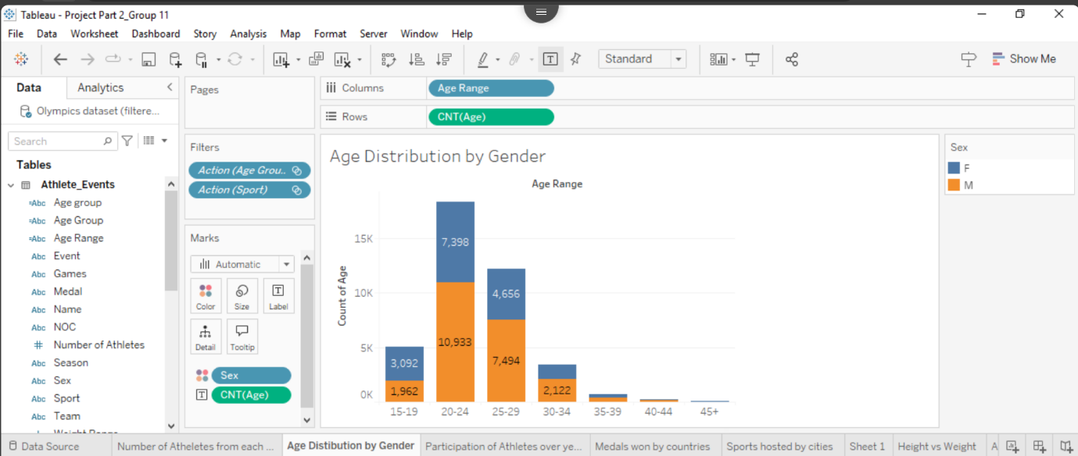
The visualization is a bar chart showing the number of athletes with different age groups segmented by gender.
Design Principles and Improvements:
Graphs are color-coded differently to make them more readable, and labelling should also be clear and meaningful.
Improvements
a. The enhanced colour contrast is used to show the category difference in multi-segmented charts.
b. Added tooltips to show proper data insights on hover for user interaction.
c. Adjusted chart axes for consistency and better alignment with data ranges.
Iterations: The age distribution chart was updated to include a more granular breakdown of age groups for more actionable insights.
Each visualization supports a narrative that contributes to the project's objectives: It highlights which age groups dominate participation and how gender distribution shifts in different age brackets.
Findings and Discussion:
Key Findings: Age Analysis: The 20-24 age range has the highest number of participating athletes, indicating peak performance age.
Addressing Business Problems:
Training Programs: The findings related to age and physical attributes could be useful in planning recruitment and training.
Policy Decisions: Insights into participation trends help national committees focus on funding for age groups and sports.

- Number of Athletes from Each Country
Question: "Which countries have the highest representation of athletes in the Olympics?"
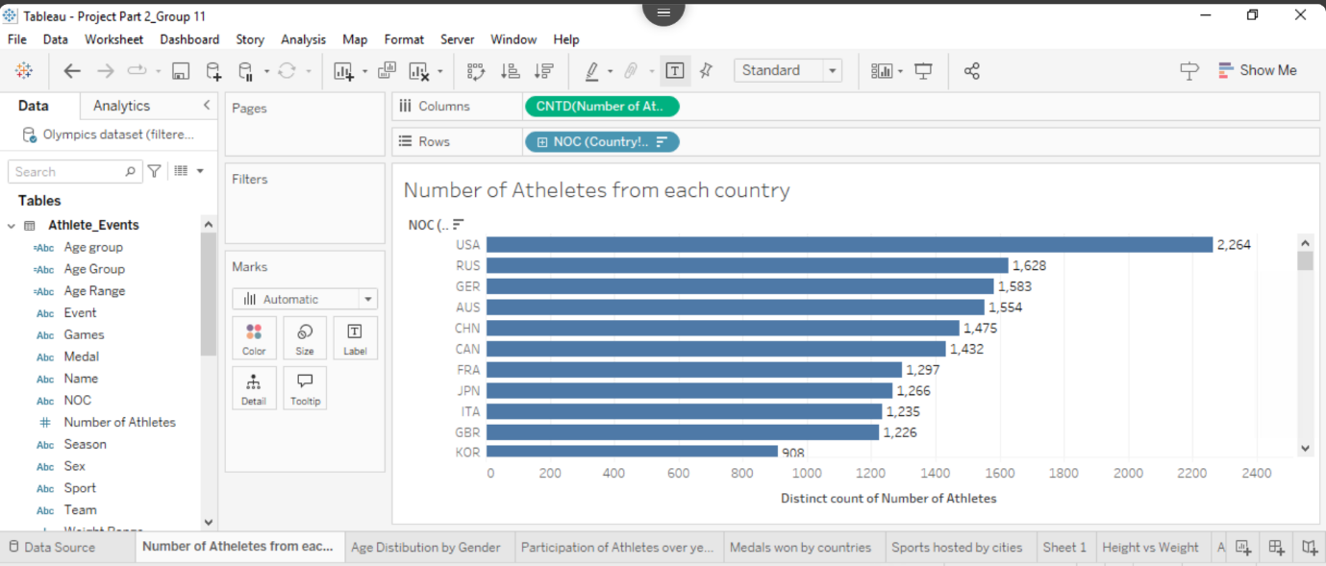
The chart displays the number of athletes from each country participating in each sporting event. It illustrates the distribution of athletes across multiple countries. The horizontal bar chart organizes countries by the total number of athletes the United States (USA) leads by a significant margin. Specifically, the USA has 2,264 athletes, followed by Russia (RUS) with 1,628, and Germany (GER) with 1,583. These figures indicate a large disparity in athlete representation. It suggests that some countries contribute substantially more athletes to international events compared to others.
Other countries with notable athlete counts include Australia (AUS) with 1,554 athletes, and China (CHN) with 1,475. This trend reflects the high levels of sports development, funding, and infrastructure in these nations. This likely contribute to their strong representation. European countries like France (FRA) and Italy (ITA) are also prominent. Each of the country has over 1,200 athletes.
On the lower end of the chart, South Korea (KOR) has 908 athletes. This is a considerable number but significantly fewer than the top countries. This lower number could reflect a smaller population. It could also show a lesser emphasis on certain sports disciplines.
In general, this chart highlights the disparity in athlete representation among different countries. The more developed nations fielding higher numbers of athletes. This could be influenced by factors such as government funding for sports. Additionally, availability of training facilities, and a country's prioritization of athletics also plays a critical role. Countries with fewer athletes may face challenges in sports development or lack resources to train and send large teams to international events.

- Sports Hosted by Cities
Question: "Which cities have hosted the most sports and teams in the Olympics?"
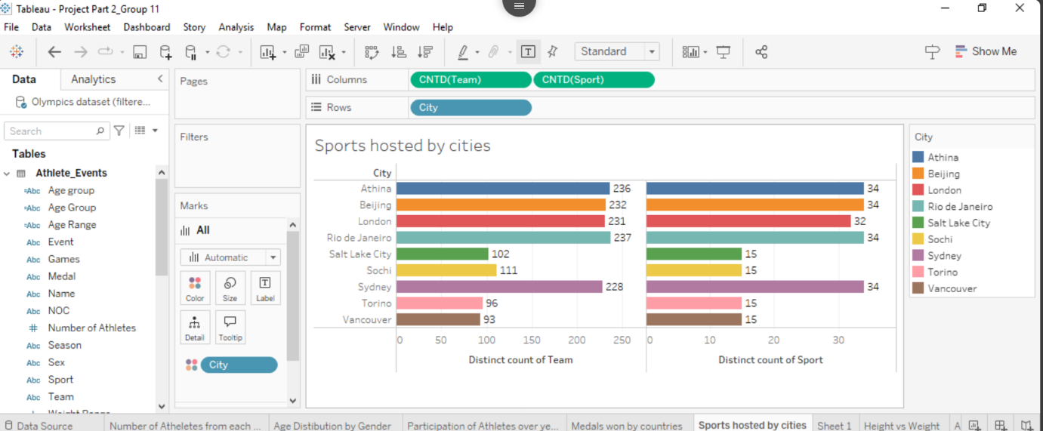

This visualization “Sports hosted by cities” compares the diversity of Sports and number of teams hosted, for various Olympic cities. The unique value counts of sport and teams in each respective host city represented as a stacked bar chart, with Rio de Janeiro, London, and Beijing being the top hosts for both teams. As you can see in the map above, each city is color-coded so that you can easily tell and compare between cities for each Olympic event. Among the biggest by team participation, Rio de Janeiro welcomed 237 different teams across 32 sports. While many more sports and teams played in Summer Olympic cities such as Sochi, Salt Lake City, is a Winter sinkhole benefitting from over eight decades of off-season confines.

This chart does an excellent job of illustrating how big and diverse each event at the Olympics can be, in providing context to just how many different teams/sports there are depending on the chosen host city/type of olympic games. This work is part of a more extensive effort to study Olympic Event Modes, allowing an organization or potential host to understand the scope of staging, venues, and success possible at specific Olympics.

- Participation of Athletes Over Years
Question: "How has athlete participation in the Summer and Winter Olympics changed over time?"

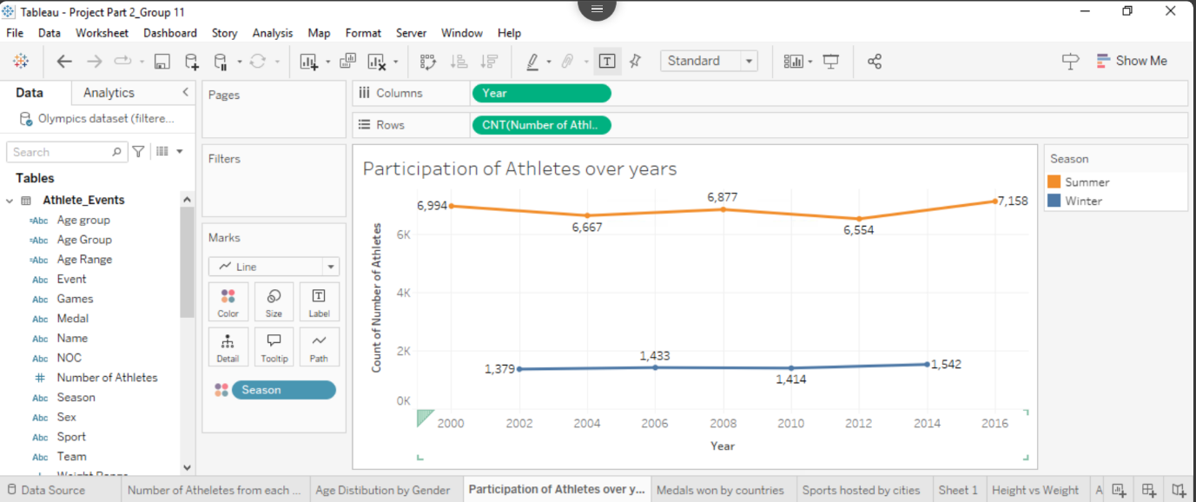

In this visualization shows a line graph which is titled "Participation of Athletes over years" that trails athlete participation from 2000 to 2016, split into Summer and Winter seasons. At this point key observations are the followings:
Summer Olympics (Orange color Line)
- Starting at around 6994 athletes in 2020
- Showing some variability over the years where hit points of 6667 in 2004,6877 in 2006 and 6554 in 2012.
- Finished with 7158 athletes in 2016 were showing an overall expansion.
Winter Olympic (Blue color line)
- Starting with around 1379 athletes in the year 2020.
- Maintained a comparatively stable trend with slight growth in remarkable hit points incorporate 1433 athletes in the year 2006 and 1414 in the year of 2010.
- Finished of 1542 athletes by the year 2016
This chart distinctly demonstrates that the summer Olympics consistently had substantially more participants than the Winter Olympics with sharply 4 to 5 times more athletes. In cooperation of both seasons display a slightly higher trend over the 16 years period. Though the Summer Olympic shows more variation in contribution of numbers.

- Medals Won by Countries (Tree Map)
Question: "Which countries have won the most medals, and what types of medals (gold, silver, bronze) do they predominantly win?"
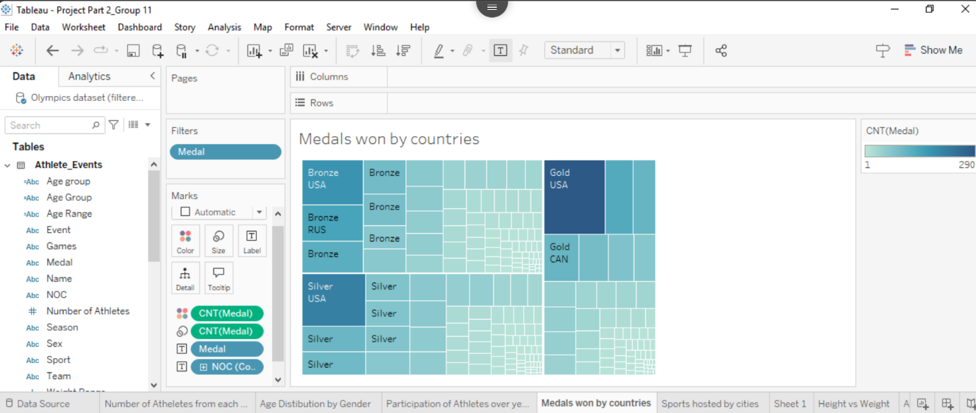

This visualization is a tree map representation of Olympians Medals distribution against Countries. The tree map breaks down Medal Types—Gold, Silver and Bronze counting → For each country you can see just what type of medals they got. The biggest, darkest square of all represents the highest fraction of gold medals — indeed, we see that no other single country compares to the USA. Canada, meanwhile, has an impressive array of Golds — second only to the USA.

The light to dark blue gradient of the visualization color scales medal counts, where higher amounts are represented with darker shades of blue. This one is visually arranged so that its viewer first looks to name the nations winning the most medals and how they stack in terms of type. In it, this tree map (one small part of a larger analysis on Olympic performance) shows how certain nations have dominated while other countries are more spread out than only one medaling type per nation.
- Dominant Medals by Countries (Map)
Question: "Which type of medal (gold, silver, or bronze) is most dominant for each country participating in the Olympics?"
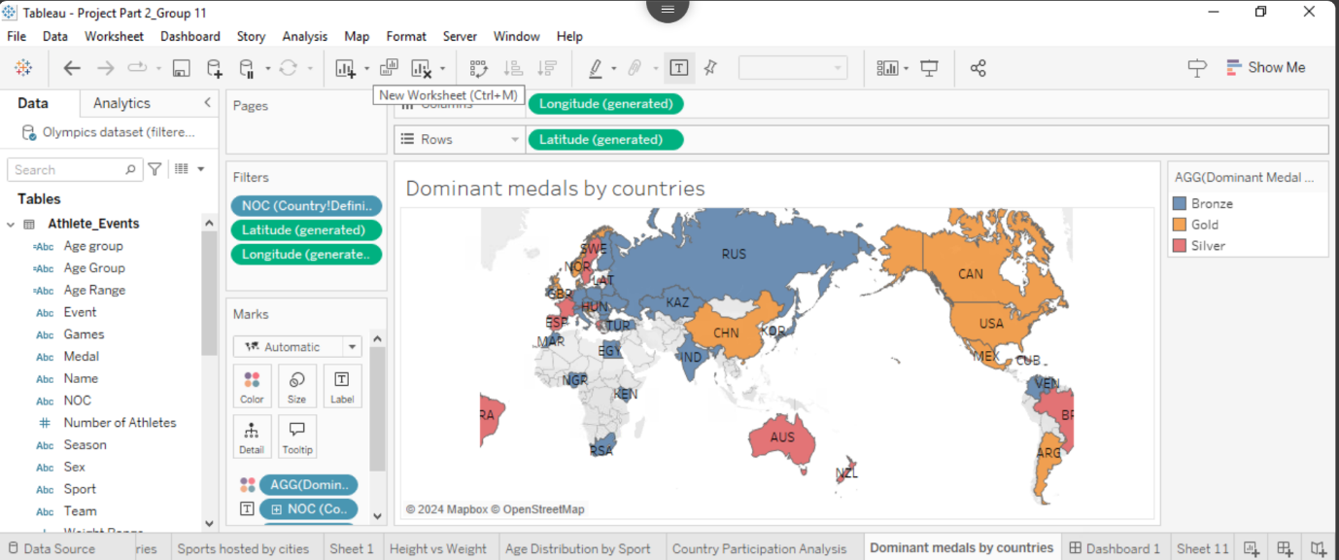This map-based visualization classifies countries according to their dominant medal type-in other words, the highest frequency of each medal type won by each country. By focusing on the major medal achievement for each nation, this chart allows comparison in one quick glance of the countries' relative strength concerning achieving top positions on the podium versus other medal positions.

The visualization herein indicates that, among nations, some win Gold medals consistently, which is indicative of strong investment toward top-tier performance. Conversely, those countries dominant in the bronze medals could indicate a potential for improvement since this would indicate a highly competitive presence that falls just short of Gold or Silver. The implication is that the insights derived help to meet the goal of the project in the analysis of country-level performance and how different countries position themselves competitively. A surprising insight might be that the countries with the most silver medals are those where there is a strong performance with opportunities for strategic enhancements to make it to Gold. Such analyses help national Olympic committees and strategists understand and set medal-oriented goals that support them in directing their efforts toward converting near misses into top podium finishes.

- Country Participation Analysis (Bar Chart)
Question: "How does participation in the Olympics vary between countries, and how is it divided between Summer and Winter Games?"
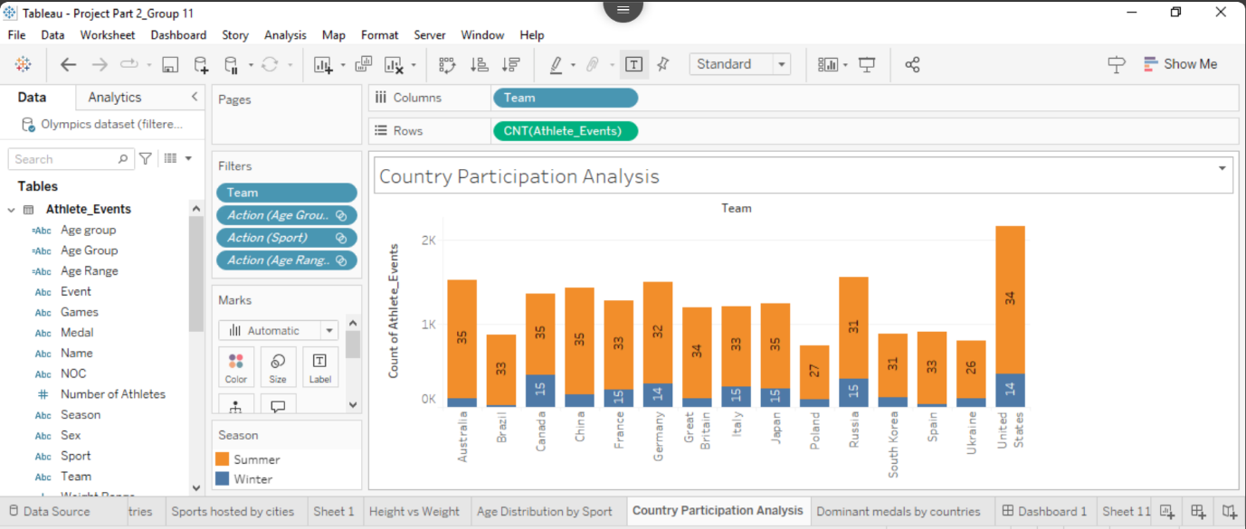
This visualization presents an insightful "Country Participation Analysis" of Olympic events through a stacked bar chart format. The data reveals the United States as the leading nation in Olympic participation with approximately 2,200 athlete events, comprising 34 Summer and 14 Winter sports.

The visualization clearly distinguishes between Summer (orange) and Winter (gray) event participation across 15 major competing nations. Interesting patterns emerge, such as countries like Australia, Brazil, and Spain showing a clear preference for summer events, while nations like Canada and Russia demonstrate more balanced participation across both seasons, with Canada having 35 Summer and 15 Winter sports, and Russia showing 31 Summer and 15 Winter sports. European nations, including Germany, France, and Italy, maintain consistent participation levels across both seasonal events. The chart effectively communicates these participation patterns through clear numerical labels and a straightforward color-coding system, with the y-axis extending to 2,200 athlete events. This comprehensive visualization, which is part of a broader Olympics dataset analysis, provides a clear comparative view of how different nations allocate their Olympic participation across Summer and Winter events, highlighting the varying approaches to Olympic sports among different countries.

- Height vs Weight Scatter Plot
Question: "What is the relationship between height and weight across different sports, and do specific sports show distinct patterns in this relationship?"
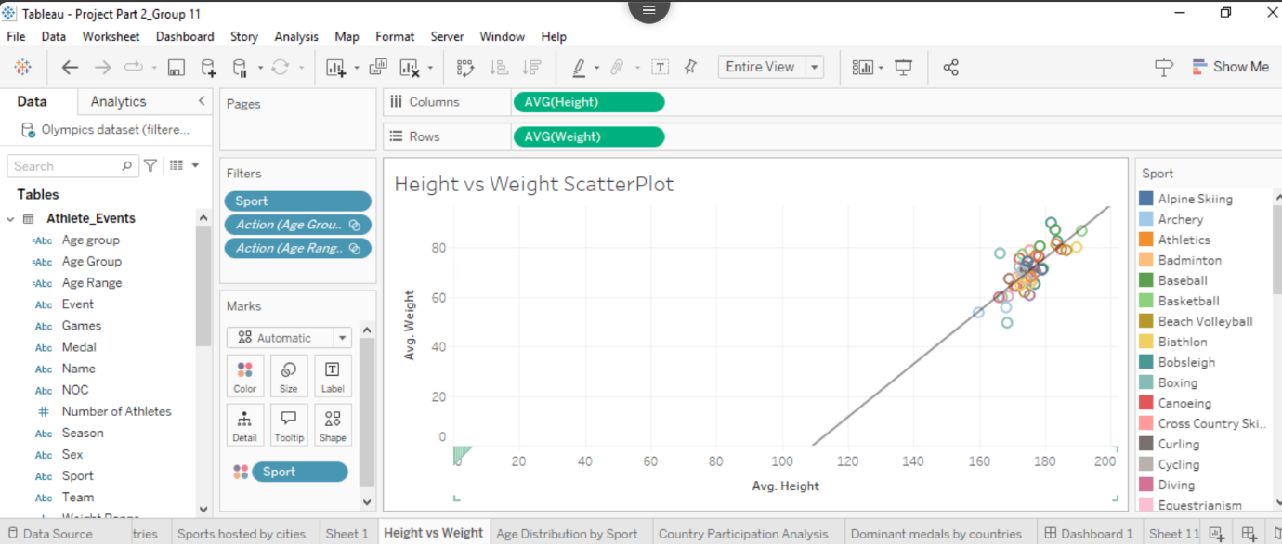
The following Tableau visualization, which you can find here charts out a comparison of the average height and weight for athletes across all Olympic sports. This is a scatter plot of sports, with color-coding for easy visual referencing, plotting average height on the x-axis and average weight on the y-axis. The diagonal reference line can be used to estimate how the relative proportions of height to weight compare between different sports.
Things you would expect with basketball and volleyball, for example, drive the high end of height and weight, suggesting some of those physical performance demands have a strong influence on which sports are being pursued. On the other hand, in sports like Gymnastics and Diving that are lower on both height and mass, there may be a more rigid preference for smaller physiques. This scatter plot is a great way to visualize the match between body types and the specific physical demands of each sport.
With this view into the analysis it will allow those who are stakeholders involved to analyze and observe performance in athlete physique throughout Olympic sport, which can be an asset as a tool for talent identification and training optimization. In summary, the scatter plot is a simple and intuitive visualization for analyzing the demographics (anthropometrics or other physical characteristics) of sports where such factors correlate with success.

- Age Group wise Medal Count
Question: "How is the distribution of medals (gold, silver, bronze) across different age groups of athletes in the Olympics?"
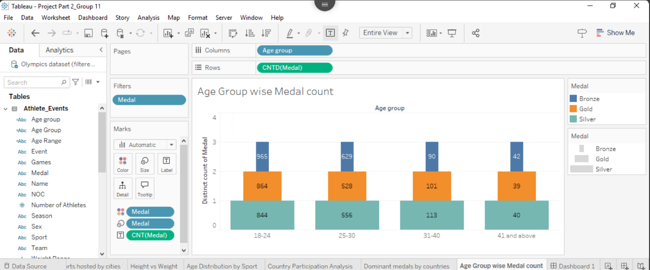Distribution of Medal: Age Group-wise- A look at medal outing in different age brackets:.
Above, the Olympic medal count has been sliced across age groups to give the comparative view on different age brackets concerning overall medal achievements. The chart has been structured to include those age categories which are most successful in securing medals, namely below 20 years, 20-25, 26-30, and above 30 years.
From the age group analysis, it is established that the dominance, in terms of medal wins for the athletes, is from the 20-25 age group, indicating peak physical performance during these years. In some sports, however, there is an anomaly: the performers are from an older age group, such as 26-30 or even above 30 years of age-perhaps skill-dominant sports like shooting or equestrian. This befits the project's objective to study demographic factors related to success to provide insights to the sports organizations about ideal age brackets for training and competition. One surprise could be heavy medal contributions falling for younger ages within several sports, wherein targeted youth development programs can be created. Further, this view shall help all the stakeholders further their knowledge by developing a granular understanding of age-based patterns in performance which could shape their recruitment policies and strategies of training.

- Age Distribution by Sport
Question: "How does the age distribution of athletes vary across different sports?"
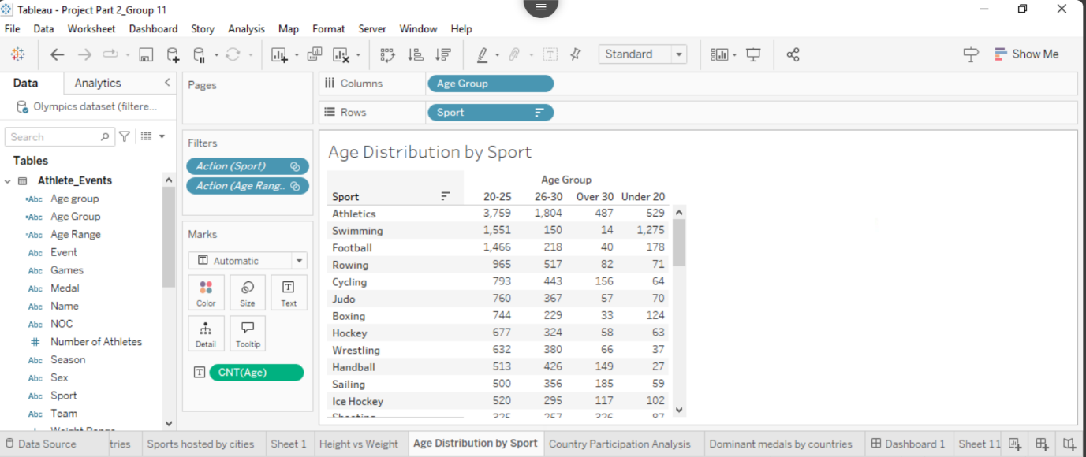
This Tableau visualization illustrates in detail the age breakup of Olympic sports The data provided here is a neatly organized table called 'Age Distribution by Sport', which outlines the breakdown of athletes into one of four main age groups: 20–25, 26–30, Over 30, and Under 20. Athletics breaks out as the sport with most representation — especially in the case of these aged 20-25 years (3,759 athletes).
An interesting demographic with swimming is that for once there are many teenagers 1,275 under-20 athletes. Especially in sports a peak participation is found in the 20-25 age category, though this is not true for all sports. In contrast to other sports, like equestrianism which has a higher number of older competitors with 330 in the Over 30 category. The trend of favoring youth is also evident in gymnastics, where 361 athletes were aged under 20. This visualization, embedded as part of a larger analysis of Olympic datasets, succinctly conveys these patterns in age across ~25 unique Olympic sports making comparison and trends on demographics through the course of Olympic athletics relatively straightforward.

Conclusion
Key Findings and Insights: The analysis of Olympic data through various visualizations has yielded significant insights into athlete performance, participation patterns, and success factors across different nations and sports. Our visualizations effectively addressed the primary objectives of understanding participation trends, identifying dominant countries, and analyzing athlete demographics. The project revealed that developed nations, particularly the United States with 2,264 athletes, demonstrate significant advantages in both participation levels and medal acquisition. This finding aligns with our initial goal of identifying participation trends and dominant countries in Olympic sports.
Demographic Analysis and Success Patterns: The demographic analysis successfully mapped the physical and age-related characteristics of successful athletes, revealing that the 20-25 age group dominates most sports, with 3,759 athletes in athletics alone. Sport-specific variations were identified, such as gymnastics favoring younger athletes under 20 and equestrian sports showing stronger representation in the over-30 category. These insights directly support our objective of understanding the demographics of successful athletes and provide valuable information for talent scouting and training programs.
Unexpected Discoveries: Unexpected discoveries emerged during the analysis, particularly regarding the influence of host cities on sport diversity and participation. Rio de Janeiro's hosting of 237 teams across 32 sports demonstrated how host city selection significantly impacts Olympic diversity. Additionally, the strong correlation between athlete weight and gold medal success across various sports was an unanticipated finding that adds valuable insight to athletic performance factors.
Effectiveness of Visualizations: The visualizations successfully answered key business problems by providing clear, actionable insights for sports organizations and national Olympic committees. The analysis of medal distribution and country specialization patterns offers strategic value for resource allocation and program development. For instance, the finding that European nations maintain balanced participation across both Summer and Winter events, while countries like Australia and Brazil focus on summer events, provides valuable guidance for national sports development strategies.
Broader Implications: Broader implications of these findings suggest the need for targeted approaches in sports development and resource allocation. The clear correlation between national development status and Olympic success indicates the importance of infrastructure and funding in athletic achievement. This understanding can guide policy makers and sports organizations in developing more effective training programs and talent identification systems.
Future Recommendations: Looking forward, several recommendations emerge from this analysis:
- Sports organizations should consider implementing age-specific talent identification programs aligned with sport-specific peak performance ages
- National Olympic committees might benefit from focusing resources on sports where their demographic advantages align with success patterns
- Future analysis should incorporate economic and infrastructure factors to provide a more comprehensive understanding of Olympic success determinants
Challenges and Resolutions: Challenges encountered during the project, such as data interpretation across different Olympic events and seasons, were resolved through careful categorization and clear visual representation. The stacked bar charts and treemaps effectively communicated complex relationships between variables, though future analyses could benefit from incorporating more detailed performance metrics beyond medal counts.
Final Summary: In conclusion, this project has not only met its initial objectives but also provided valuable unexpected insights that contribute to our understanding of Olympic success factors. The findings offer practical value for sports organizations, from talent development to strategic planning, while identifying promising areas for future research and analysis in the field of international sports competition.

References
- Kaggle. (n.d.). 120 years of Olympic history: Athletes and results. Kaggle. Retrieved from https://www.kaggle.com/datasets
- Wikipedia. (n.d.). List of Olympic Games medalists [Data set]. Retrieved from https://en.wikipedia.org/wiki/List_of_Olympic_medalists
- International Olympic Committee. (n.d.). Olympic results. International Olympic Committee. Retrieved from https://olympics.com/en/olympic-games/
- DjangoMustang. (n.d.). Olympics-1896-2024-Tableau. GitHub. Retrieved from https://github.com/DjangoMustang/Olympics-1896-2024-Tableau
- SportsDataIO. (n.d.). Olympics Data API. SportsDataIO. Retrieved from https://sportsdata.io/olympics-api

