Julian Burton

Graduate Division Program Tutorial

Table of Contents
-Section 1: Format of Input Data
-Section 2:Reading Appropriate File
-Section 3: Day 1 Window
-Section 4: Write To File
-Section 5: Merge File
-Section 6: Day 2 Window
-Section 7: Final Report

Section 1: Format of Input Data
To be fully functional and pull data effectively, the appropriate fields must be labeled as: student_id, orient_id, last_name, first_name, Class level, School, email_address, Region, Major, and Register. This program searches for the student_id field and pulls the data according to the next few fields as it looks for those headers in columns.

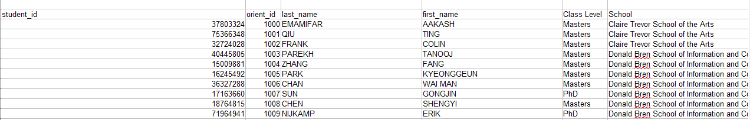
To be able to pull the data from the file, the file must be of type .CSV as this is a comma delimited file.

CAUTION: No commas can be present within any cells of this input file. The program looks for commas so if any are present, it will skip over and alter the data in ways where students are stored incorrectly within the program.

Section 2:Reading Appropriate File

Upon starting the program, click File To Read From as this will open a dialogue window for you to search your computer for the input file. The file can be read from anywhere. It is advised that you store the Check-In Program and the input data file in the same place. Later in the tutorial, the reasoning behind this will be explained.

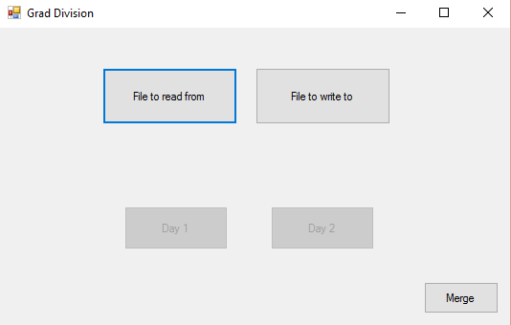

Upon clicking, File to read from, a window of files is brought up to ensure you can find the correct file.
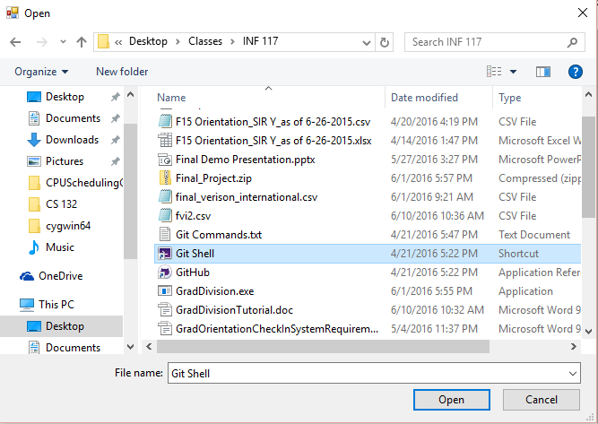
In this example, I am going to select fvi2.csv because this is the correctly formatted input file.
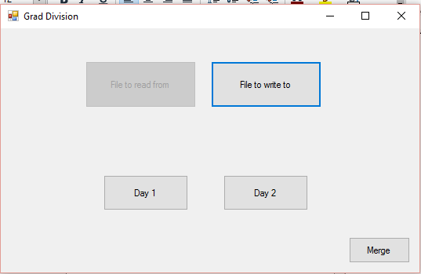
Once the file has been read, the Day1 and Day2 buttons have been unlocked to start the program.

Section 3: Day 1 Window
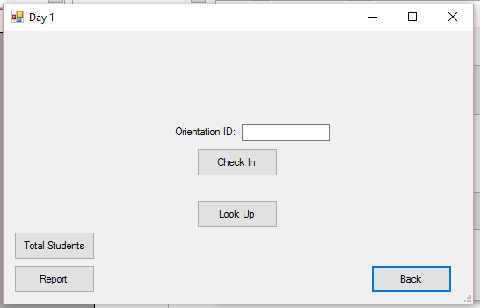
Upon Clicking Day 1, the user is brought to this window. To check in a student, a user will either search up a student by their Orientation Identification Number or by clicking the Look Up button.
EX: Checking in student 1000, their profile is brought up saying they have been checked in.
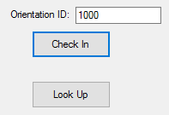
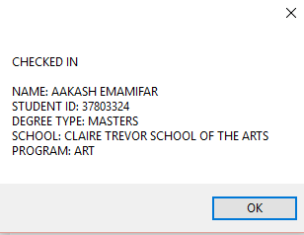
The purpose of the Look Up Button is to search for a student who has either forgotten their Orientation Identification Number or who is considered a Walk-Up on that day.
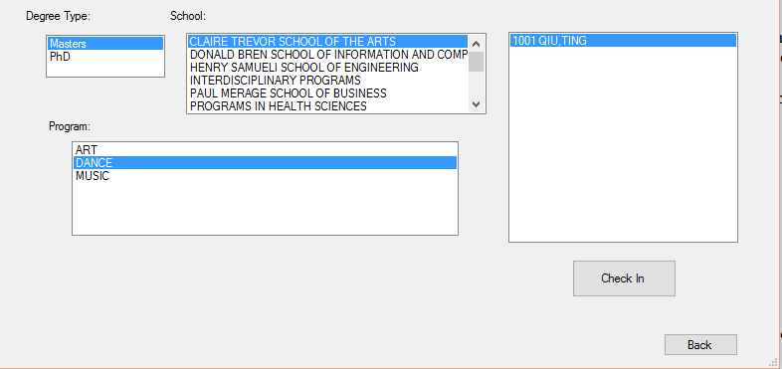
After designating the specific fields and finding their name, the user will click Check In and then Back to return to the initial Day 1 menu. Within this Look Up window, any number of students can be checked in but only one at a time upon searching.

After clicking Total Students, a total number of the students who have checked in on this specific computer will be outputted in a window for viewing.
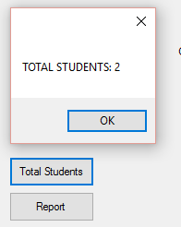
By clicking the Report Button, a full report breakdown from this specific computer is written. Some listed fields include breakdown by school and subsequent major, while others include specific percentage calculations of Total Registered students, Attendees who registered, Attendees who did not register (Walk-ups).

After clicking Back, the user is brought to the initial menu where they will choose File To Write, then by typign a specific name, a list of every student who has checked in will be written. The user can specify any location for the file to be written to.

For example, we will title the new file this1.csv. The program defaults the file to be written as a .CSV for convenience sake.

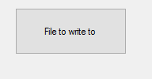
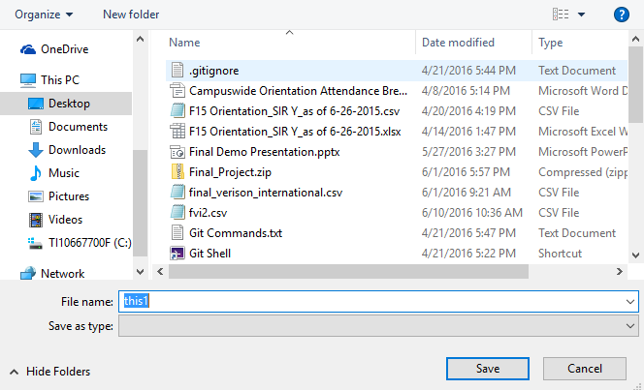
IMPORTANT: By logic design, if a student is REGISTERED and decides to look themselves up, they will NOT BE CONSIDERED A WALK-UP ATTENDEE but if a student is NOT REGISTERED to attend and looks themselves up, they WILL BE COUNTED AS A WALK UP.

Here is an example of the outputted file that is written when File to Write to is selected.

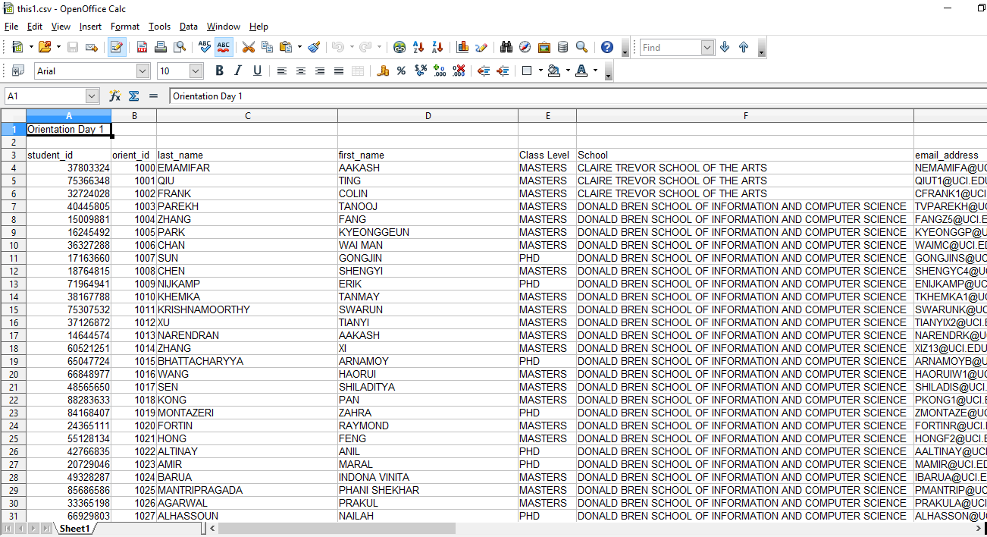
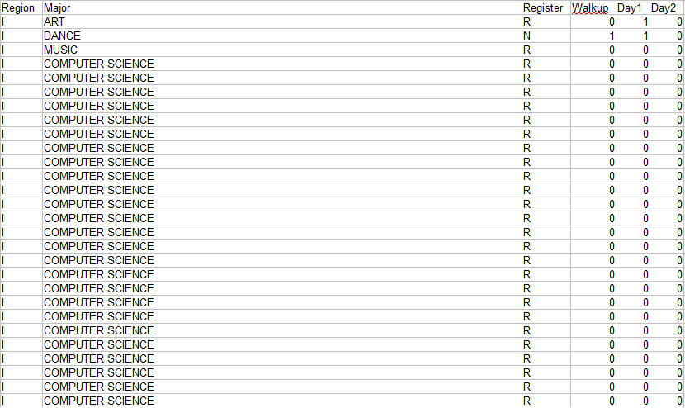
-Unnecessary fields have been removed, such as city, while new fields have been added such as Walk up, Day1, Day2. These serve a purpose when rereading this file into the program for Day 2 check-in.

Section 5: Merge File

After completing that above mentioned steps on multiple computer, you will have written an arbitrary amount of files which consist of all of the students who have registered on Day 1 or Day 2. All of the files will contain the same students but depending on which computer the student checked in on, they will only be inside of that file.

EX: Lets say student A checks in on computer A and student B checks in on computer B. This means that 2 files are outputted with both student A and B in them but one is checked in on one, same with the other. Clicking Merge will allow for both students to be listed in one file.

Important: If no file has been written already, a window will be brought up asking to Save File? If none is needed to be saved, clicking No will suffice. The point of this button is to not only be used while the program is running but also if it is only desired for files to be merged.
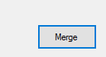
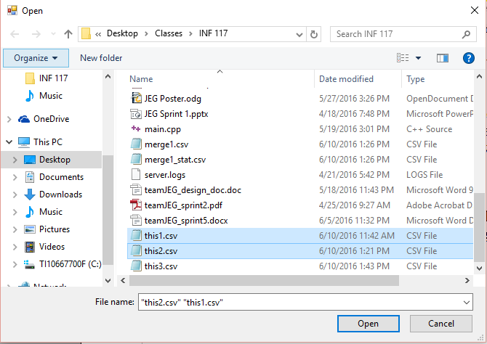
After selecting the files, a Window is then brought up specifying a name of file to be outputted. When typing the name, two files are then written: one being the list of all students checked in so far, and the statistics of the merged file check in.

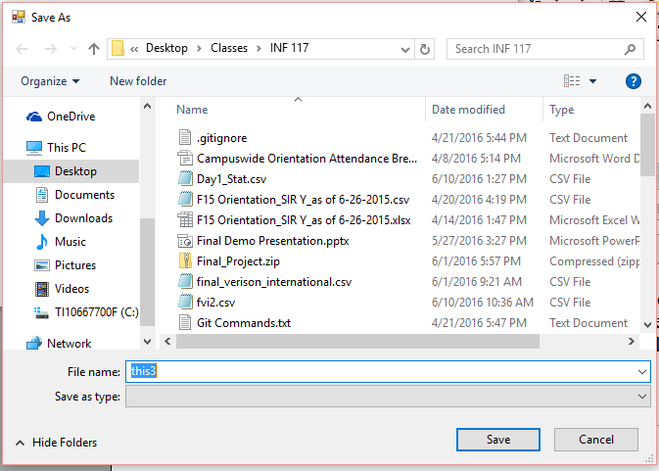

The files that are written are .CSV files so Microsoft Excel, Open Office Calc, etc. must be used to properly view them.

This window is displayed to show the path in which the files exist and also which files have been written.

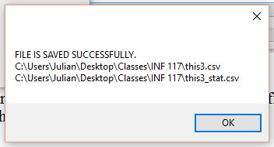
Section 6: Day 2 Window

The Day 2 Window mirrors the Day 1 window in terms of functionality. Can refer to Section 3: Day 1 Window for help on functionality of the window.

Only difference is that Domestic AND International Students can be checked into the orientation while only international can be checked in on Day 1.

Section 7: Final Report

By Checking the statistics file that was written, it is displayed that the full breakdown of attendees are able to be shown with percentages, breakdowns of individual schools, and individual programs.

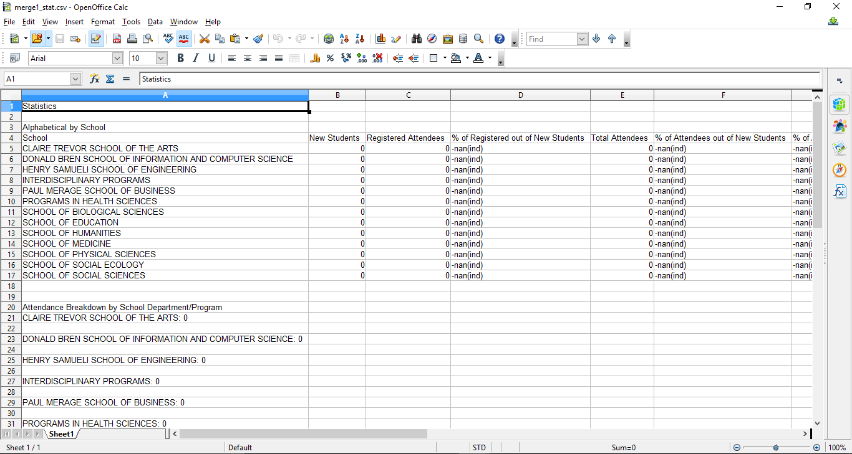

That marks the end of this tutorial

