

**OOP FINAL PROJECT DRAFT**

CS213: Object Oriented Programming Group 10

Dr Govindha Yeluripati Cohort C

April 3rd, 2024

**TEAM MEMBERS**

Andre Akrofi Ayiku–84272026

Zoie Maabena Atakora-Nsiah-78612026

Gilbert Andrew Tetteh-70282026

Sedem Abla Agudetse-93822026

# Ghana's Forests: A Tale of Two Axes - Planting Hope, Clearing the Path

Afforestation and deforestation are two important factors that significantly influence the climate change dynamics in various regions around the world, including Ghana. Afforestation refers to the process of establishing new forests or woodland areas, often in areas that were previously devoid of trees. Deforestation, on the other hand, involves the removal or clearing of forests and woodlands, usually for agricultural, industrial, or urban development purposes. Ghana has a diverse landscape that includes tropical rainforests, savannas, and coastal regions. Over the past few decades, Ghana has experienced significant changes in Ghana's forest cover, both through afforestation and deforestation, which have significant implications for the country's climate change dynamics. Forests play a crucial role in regulating the climate by absorbing and storing carbon dioxide, the primary greenhouse gas responsible for global warming (IPCC, 2021). Deforestation leads to the release of stored carbon into the atmosphere, thereby contributing to increased greenhouse gas emissions and accelerating the pace of climate change.

On the other hand, afforestation efforts can help mitigate the effects of climate change by enhancing the carbon sequestration potential of the land, reducing atmospheric carbon dioxide levels, and improving overall ecosystem resilience (Kuuire et al., 2018). Additionally, forests can influence local and regional weather patterns, such as precipitation and temperature, which can have broader implications for the climate changes in its forest cover due to both afforestation and deforestation efforts.

The idea of the "Tale of Two Axes," which symbolizes the interaction between afforestation and deforestation—two critical factors influencing climate change—serves as the inspiration for this project. By leveraging data analysis and visualization techniques, this system aims to shed light on the current state of deforestation and facilitate the exploration of potential solutions through afforestation initiatives.

This code for “Ghana’s Forests: A Tale of Two Axes” is designed to analyze Ghana’s changing forest cover. It is achieved by creating a data model based on locations, forest data, deforestation events, and afforestation projects. Locations are specific areas in Ghana and have attributes such as latitude, longitude, and total area. A forest data object keeps track of the tree cover percentage in locations over time. For some points, it may include information about the historical deforestation rate. Deforestation events bindingly encode the cause, approximate start and end date, if any, and the deforested area for locations. Afforestation projects contain their location, name, the desired number of trees, and the planted number.

Based on this data model, the separate analysis classes can be implemented. They process the following corresponding data: this is the total deforested area and deforestation rate in some locations over time. It is negligent to reuse the algorithm for afforestation analysis, which will also be based on total trees planted and project success rate. Beyond that, this code can be extended to introduce the reading from external, report, and visualisation functionalities to show even more what is happening with the forest cover in Ghana.

CLASSES:

DataReader: This class serves as the foundation for reading and parsing data from CSV files. It provides methods to read data from files and find specific rows based on a given name or index.

RegionData: This class extends the DataReader class and handles the retrieval and display of deforestation data by region or location. It allows users to search for and view detailed information about tree cover extent, tree cover loss, and related metrics for a specific region.

TreeLossPerYear: Extending DataReader, this class manages the retrieval and display of deforestation data by year. Users can explore the tree cover loss figures for a specific year or range of years.

ForestLossPerYear: Similar to TreeLossPerYear, this class focuses on retrieving and displaying data related to forest loss per year, providing insights into the overall forest cover decline over time.

DeforestationAnalyse: This class analyzes and presents comprehensive deforestation results by integrating data from both the RegionData and ForestLossPerYear classes. It calculates and displays deforestation rates for trees and forests, enabling users to understand the extent of deforestation across different regions and time periods.

AfforestationAnalyse: This class allows users to project and analyze potential afforestation efforts. It takes into account user-provided inputs, such as the number of trees to be planted and the desired timeframe, and calculates the afforestation rate. Additionally, it compares the projected afforestation rate with the current deforestation rate, providing insights into the effectiveness of the proposed afforestation initiative.

DataDisplay: This class serves as the main entry point for the application. It provides a user interface (console or GUI) where users can interact with the system, select desired operations, and view the corresponding output.

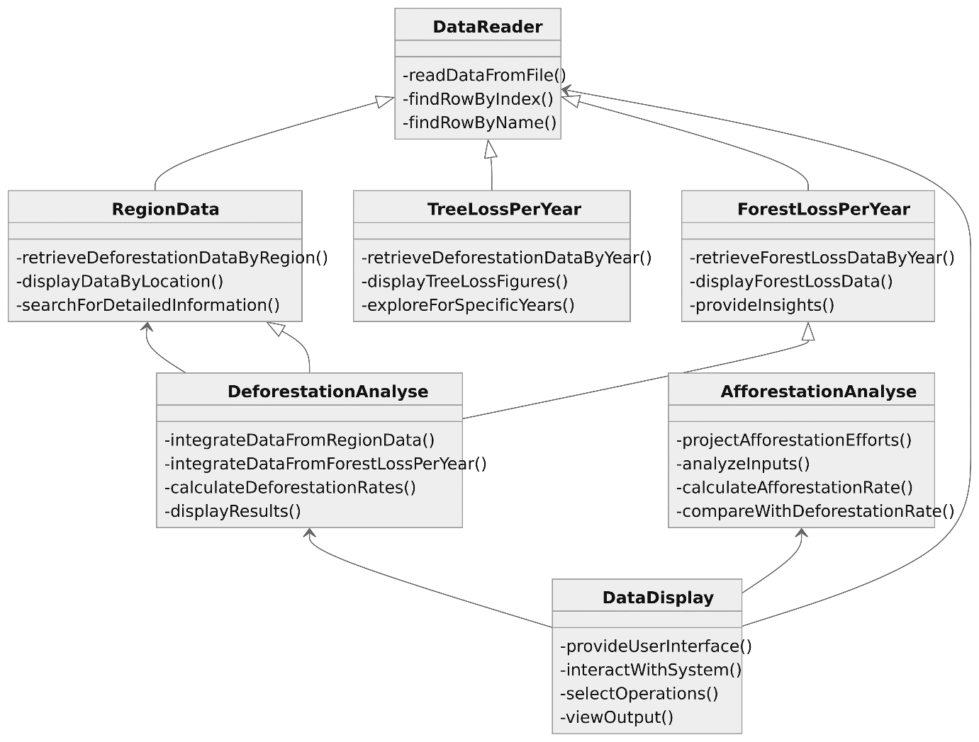

References

[One Tree Planted]. (2020, April 28). What is Deforestation? | Eco Facts | One Tree Planted [Video]. Youtube.com. <https://www.youtube.com/watch?v=vJnnrpSDWPI>

[SIMPLECODE]. (2015, September 12). Learn JAVA: Open Youtube video in browser [Video]. Youtube.com. <https://www.youtube.com/watch?v=Nm-e9aWPH8U>

(n.d.). Deforestation statistics for Ghana. Worldrainforests. <https://worldrainforests.com/deforestation/archive/Ghana.htm>