TIC Performance Assessment
By: Nestor Garcia
Date: January 21st, 2025

Testing Methodology
To evaluate the performance of Thermal Instrumentation Cards (TICs) in measuring and converting temperature data, a test was designed to isolate any observed errors or deviations to the TICs. The setup consists of an Isothermal Junction Box (IJB) with two sets of reference resistors and five thermocouples, connected to two TICs (refer to figure 1 below).

Testing Process

Initial Configuration
- IJB A was connected to TIC 0, and IJB B was connected to TIC 1.
- Temperature readings were recorded for some duration.

Connector Swap
- The connections were swapped: IJB A was connected to TIC 1, and IJB B was connected to TIC 0.
- Temperature readings were recorded again for the same duration.

Repetition for Stability
- The connections were swapped back to the original configuration after some time, and the process was repeated.

Rationale and Logic

Isolating Measurement Errors:
- Each IJB and its thermocouples should produce consistent temperature signals, regardless of the TIC it is connected to.
- If a given IJB reports different temperatures when connected to two different TICs, the variation can reasonably be attributed to differences in the TICs' performance.

Consistency in Testing:
- Swapping connections ensure that each TIC measures the same signals from the IJBs, allowing direct comparison of TIC performance under identical conditions.
- Repeating the test multiple times reduces the possibility of random noise or environmental factors affecting the results.

Controlled Environment:
- The testing assumes stable environmental conditions and consistent connections to avoid introducing external variables.
By systematically swapping the connections between the IJBs and TICs (figure 1), any deviations observed in temperature readings can be attributed to the TICs' performance. This approach isolates potential errors to the measurement devices (TICs) and provides a reliable method for assessing their accuracy and consistency.
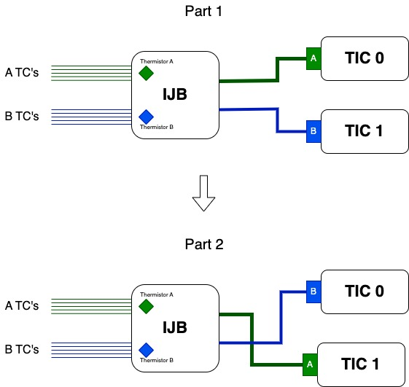
Figure 1: Diagram depicting swap of IJB connections to TIC connections.

Testing Results

1. Introduction
- Objective: To assess the performance of the Thermal Instrumentation Cards (TICs) under two distinct temperature conditions:
  - Room Temperature (~20°C)
  - High Temperature (Goal: 1180°C)
- Purpose: Verify the accuracy and consistency of the TICs across the temperature range relevant to a furnace casting.

2. Testing Setup Recap
Swapping connections between Isothermal Junction Boxes (IJBs) and TICs to isolate measurement deviations.
- Testing conducted:
  - IJB A connected to TIC 0, and IJB B to TIC 1.
  - Reversed configuration: IJB A to TIC 1, and IJB B to TIC 0.
  - Reversed back to initial configuration.
- Environmental conditions for each test:
  - Room temperature test: Meter cubed furnace stable at approximately 20°C.
  - High-temperature test: Meter cubed furnace stable at approximately 1180°C.

3. Results Overview
- Room Temperature (~20°C):
  - Swapping thermocouples resulted in consistent temperature deltas, indicating no significant drift in TIC performance.
    - Differences between positive and negative deltas suggest very slight offsets between TICs (in the range of hundredths of °C).
    - Repeatability across swaps suggests stable TIC operation.
    - Variability across TICs is likely due to reference voltage discrepancies. Calibration focused on reducing minor reference voltage discrepancies will be implemented and is likely to improve overall consistency.
  - Repeatability testing after 24 hours showed similar delta ranges, indicating good stability over time.
- High Temperature (~1180°C):
  - The observed temperature deltas, with some in the range of tenths of a degree Celsius, are higher than those recorded at room temperature.
  - Despite the larger deltas, the relative stability of temperature readings across swaps indicates that TIC performance remains reliable under high-temperature conditions.
  - Swapping thermocouples consistently produced comparable deltas, supporting the conclusion that the TICs operate stably and predictably, even when measuring high temperatures.

4. Detailed Analysis
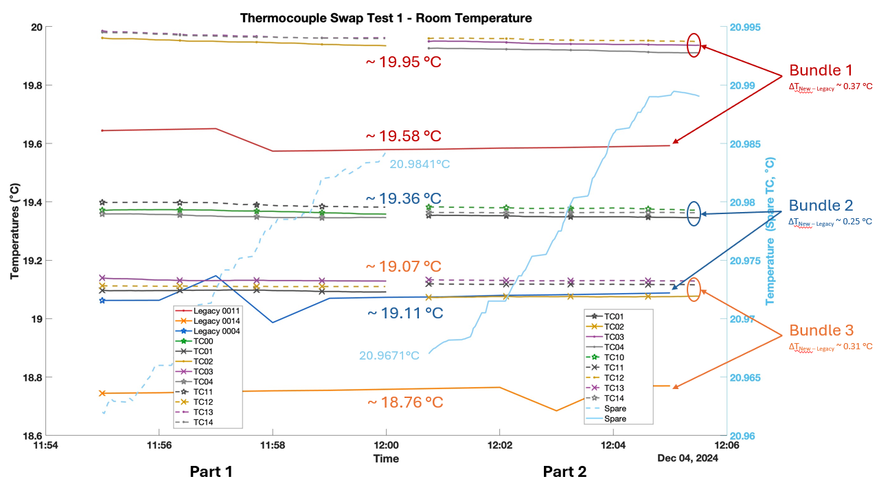
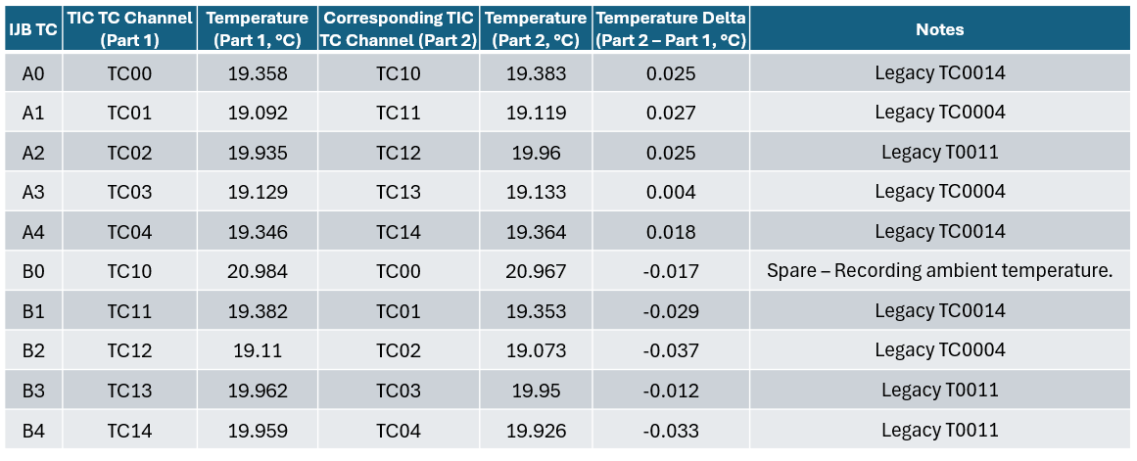
Tables and plots at room temperature:
Figure 2: Plot of recorded tempratures and deltas between TIC0 and TIC1 at room temperature.
Figure 3: Plot of recorded tempratures and deltas between TIC0 and TIC1 at room temperature.
Table 1: Recorded temperatures and deltas between TIC0 and TIC1 at room temperature.
Detailed Analysis of Room Temperature Results
- Magnitude of Temperature Deltas
  - The temperature deltas in this test are in the range of ±0.03°C, with the largest delta being -0.037°C and the smallest delta being 0.004°C.
  - These deltas indicate excellent agreement between the TICs, with deviations small enough to suggest high repeatability and minimal measurement error at room temperature.
- Consistency Across Channels
  - The deltas for IJB A (A0–A4) and IJB B (B0–B4) demonstrate consistent performance between the two TICs:
    - IJB A: Deltas range from 0.004°C (A3) to 0.027°C (A1), with an average delta of 0.020°C.
    - IJB B: Deltas range from -0.037°C (B2) to -0.012°C (B3), with an average delta of -0.026°C.
  - The similarity of temperature readings between TICs supports their reliability at room temperature.
- Spare Channel (Ambient Temperature Monitoring)
  - The spare channel (B0) recorded ambient temperature:
    - Part 1: 20.984°C
    - Part 2: 20.967°C
    - Delta: -0.017°C
  - This minimal delta further validates the stability of the TICs in recording consistent measurements under static conditions.
- Legacy Performance
  - Legacy thermocouples (TC0014, TC0004, and TC0011) exhibit variability among themselves, with the highest observed difference being 0.82°C (between TC0011 and TC0014).
  - The average difference between temperatures reported by the legacy system and the new system is approximately 0.3°C for any given bundle.
    - This consistent difference suggests stability across both systems.
    - The data indicates that the minor differences between the two TICs are not significant contributors to variability. Instead, the observed discrepancies across systems appear to originate from subtle differences in the physical characteristics of the thermocouples themselves.
- Key Observations
- Minimal Variation Across Channels:
  - Variability in temperature deltas across all channels is exceptionally low, confirming consistent performance.
- Accuracy and Stability:
  - Deltas remain well within the acceptable range for this temperature measurement system.
  - Absolute accuracy is still in question given the deviation between the new and legacy system temperatures. The data seems to indicate that significant deviations stem from the physical characteristics of the thermocouples themselves.
- Performance Validation:
  - Swapping connections between TICs yielded consistent temperature readings, reinforcing the absence of significant drift or noise in either TIC.

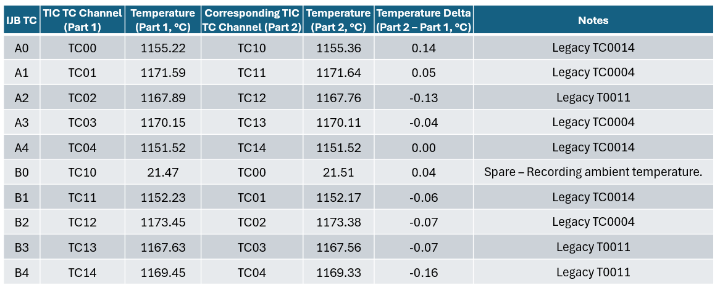
Tables and plots at goal temp = 1180 °C:
Table 2: Recorded temperatures and deltas between TIC0 and TIC1 at goal temp = 1180 °C .
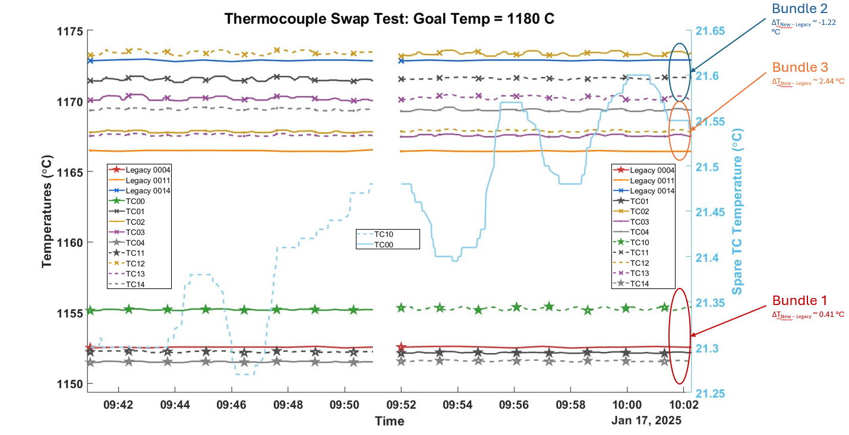
Figure 3: Plot of recorded tempratures and deltas between TIC0 and TIC1 at at goal temp = 1180 °C.

Detailed Analysis of 1180 °C Data:
- Magnitude of Temperature Deltas
  - The temperature deltas ranged from -0.16°C (B4) to 0.14°C (A0), reflecting very small deviations between measurement cycles at extreme temperatures.
  - The average delta magnitude across all thermocouples was approximately 0.07°C, suggesting a consistent level of accuracy across the system.
  - These small deltas demonstrate that both TICs (Thermal Instrumentation Cards) maintained a high degree of precision measuring high temperatures.
- Consistency Across Channels
  - The deltas for IJB A (A0–A4) and IJB B (B0–B4) are slightly higher than at room temperature but still demonstrate consistent performance between the two TICs:
    - IJB A: Deltas range from -0.13°C (A3) to 0.14°C (A1), with an average delta magnitude of 0.072°C.
    - IJB B: Deltas range from -0.16°C (B2) to -0.04°C (B3), with an average delta magnitude of -0.08°C.
  - Ambient temperature readings (B0: TC10 then TC00) remained stable with a delta of only 0.04°C, showcasing the system's robustness even for non-extreme conditions during a casting cycle.
- Legacy Performance
  - The legacy thermocouples (TC0014, TC0004, and TC0011) exhibited noticeably higher variability, particularly at elevated temperatures. The maximum observed differences between legacy thermocouples reached approximately 20°C (e.g., between TC0004 and TC0014).
    - Given the comparable stability of the new system, it is reasonable to attribute these differences to the deteriorating performance of thermocouples at higher temperatures, combined with actual localized temperature gradients within the meter cubed furnace.
  - When compared to the new system, the average difference between the legacy thermocouples' readings and the new TICs' readings ranged from approximately -1.22°C to 2.44°C, depending on the thermocouple bundle.
- Key Observations
- Low Temperature Drift:
  - The small deltas observed in the new TIC data confirm minimal drift across TICs, even at extreme temperatures.
- Thermocouple Stability:
  - Differences in temperature readings across thermocouples appear to stem from inherent variability in the thermocouples themselves rather than the TICs.
- System Reliability:
  - Both TICs performed consistently, with repeatable results that highlight the system's stability under demanding conditions.
Summary
- Temperature Deltas:
  - At room temperature, deltas ranged from -0.037°C to 0.027°C, averaging 0.02°C, reflecting excellent consistency.
  - At 1180°C, deltas were larger, ranging from -0.16°C to 0.14°C, averaging 0.07°C, but still demonstrated high precision given the extreme temperatures measured.
- Consistency Across Channels:
  - At room temperature, TIC consistency was excellent, with minimal variation of thermocouples temperature recorded by two different TICs.
  - At 1180°C, consistency remained strong, though slightly higher variability was noted.
- Legacy Performance:
  - At room temperature, legacy thermocouples showed reasonable performance, but slight offsets compared to the new TICs.
  - At 1180°C, legacy thermocouples exhibited significant variability (up to 20°C differences), however these temperatures coincided with data from the new system.
- Key Observations:
  - The new TIC system-maintained stability and precision at both temperature extremes, with minimal drift across TICs.

5. Additional Data
IJB Thermistors:
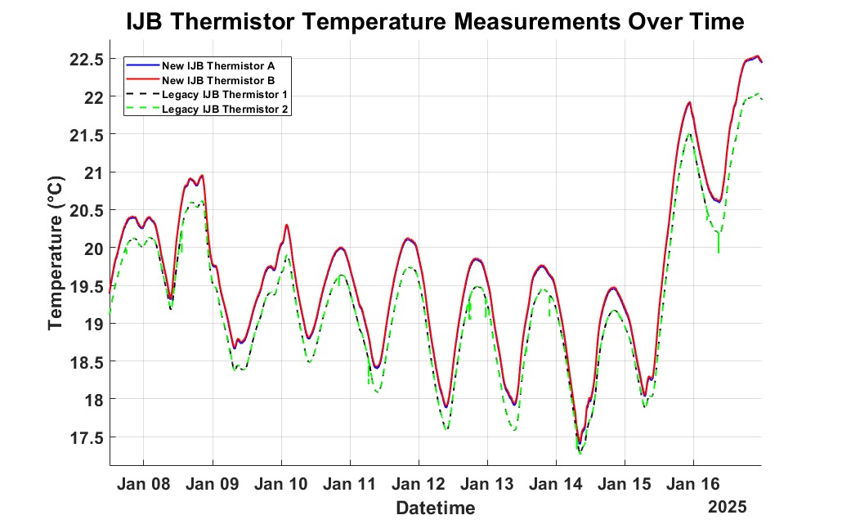
Figure 4: Plot of IJB thermistor temperatures across all devices.
The thermistor temperature data reveals several key observations:
- Consistency Within Each IJB:
  - The two thermistor temperatures in the legacy IJB are nearly identical, overlaying each other precisely. This indicates highly consistent performance and uniform physical conditions within the legacy system.
  - Similarly, the thermistor temperatures in the new system's IJB demonstrate comparable consistency, with maximum differences measured in the range of hundredths of a degree Celsius.
- Temperature Trends:
  - Both the legacy and new system’s IJB temperatures display a sinusoidal pattern with a 24-hour period. This behavior is likely attributable to ambient temperature variations in the building over the course of a day, suggesting the system is sensitive enough to detect these environmental fluctuations.
TIC 4 Data (shorting plug installed):
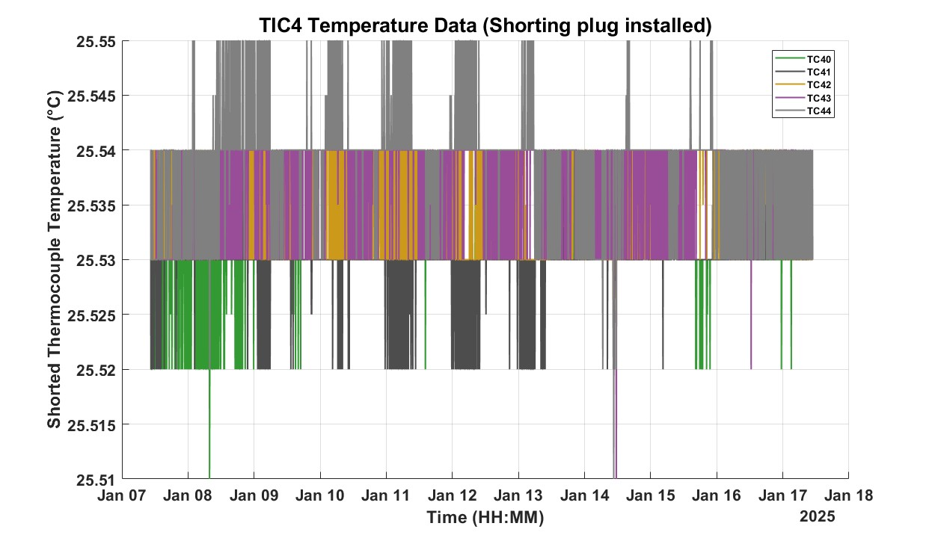
Figure 5: Plot of TIC 4 thermocouple data with a shorting plug installed in place of an IJB connection.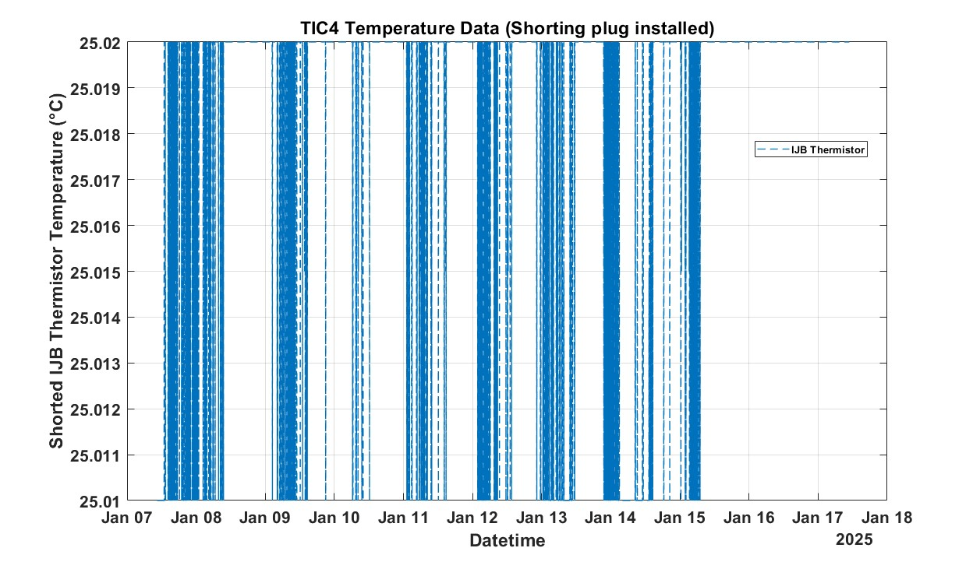
Figure 6: Plot of TIC 4 thermistor data with a shorting plug installed in place of an IJB connection.
Figures 5 and 6 highlight the stability of a given Thermal Instrumentation Card (TIC). This conclusion is supported by the following observations:
- Both the reported thermocouple and thermistor temperatures from the TIC with a shorting plug (replacing an IJB connection) show excellent consistency.
- The average deviation in the simulated temperatures across all measurements is just 0.01°C, over a 2-week period, underscoring the TIC's high level of precision and stability under these controlled conditions.
This analysis reinforces the reliability of the TIC in accurately maintaining and reporting stable temperature readings, even in a simulated setup.
Thermocouple Swap Between New and Legacy Systems
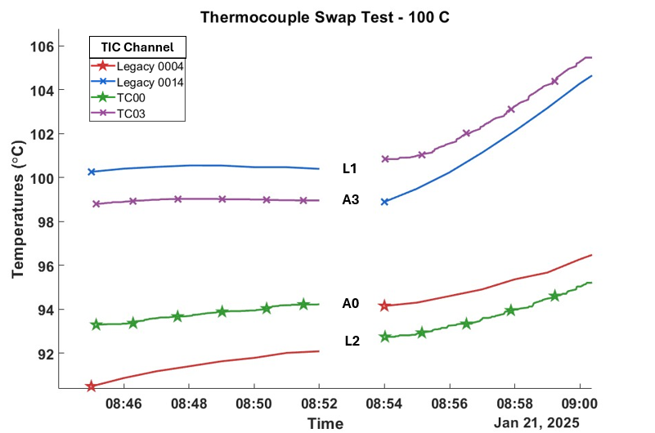
Based on prior observations, deviations in temperature readings appear to primarily originate from the physical properties of the thermocouples themselves. Figure 7 below illustrates the reported temperatures of four thermocouples in the meter-cubed furnace: A0, A3, L1, and L2. Thermocouples L1 and A3 are bundled together, as are A0 and L2. During this test, the thermocouples connected to TIC channel TC00 (new TIC 0, channel 0) and legacy TIC channel 0014 (legacy TIC 1, channel 4) were swapped, along with TIC channels TC03 and legacy TC0004.
Figure 7: Plot of 4 thermocouples temperatures read with 2 different systems.
Figure 7 reinforces the observation that notable deviations in temperature readings within the same bundle largely originate from the thermocouples themselves. For instance:
- Thermocouple L1: When measured with the legacy system (channel 0004), the reported temperature was 100.40°C. When connected to the new TIC 0, channel 0, the temperature increased to 100.80°C, resulting in a difference of 0.40°C between the two systems.
- Thermocouples A3, A0, and L2: These thermocouples yielded respective differences of -0.07°C, -0.07°C, and 0.66°C across the two systems.
In contrast, the temperature differences between thermocouples within the same bundle (L1-A3 and A0-L2) were approximately 2°C for both bundles, a significantly larger variation.
These findings suggest that the precise and consistent temperatures produced by individual thermocouples across both systems indicate that both TICs exhibit comparable levels of precision. Consequently, the observed deviations in temperature readings for thermocouples within the same bundle are more likely due to inherent thermocouple variability rather than inconsistencies in the TICs themselves.

