Clueless

Software Design Document

The Butler Did It



# Platform

After performing some industry analysis, The Butler Did It arrived at the conclusion that Apple’s iOS platform is an emerging giant in the gaming industry and is an obvious target for the Clueless game. By implementing the game for the iOS platform, the client will have access to this burgeoning market. Since Apple released its Game Center cloud service in iOS 5, the Butler Did It Will be able to leverage this service to deliver a state of the art game which reuses the cloud service; thus, saving the client the infrastructure costs of building and hosting their own server.

The form factor of the iPad device is especially fit for the HCI Prototype designed earlier in the engineering process. The iOS framework employs the common Model View Controller pattern for its user interface. Instead of rehashing this pattern, this document will primarily address the interaction with Apple’s Game Center service. This service is central to the design of Clueless and enables the communication between players.

# Game Center

Apple’s exposes an interface to the Game Center cloud service through the iOS Game Kit framework written in Objective C. The Clueless game will also be written in Objective C and will use Game Kit framework classes, patterns, and interfaces in order to use the Game Center service.

## Game Center Services Used

Apple’s Game Center service offers a number of features and only some are applicable to the first release of Clueless. Of interest, is the centralized authentication, matchmaking, and turn based match features. Since players will authenticate to Apple Game Center, a well known and trusted feature of the iOS platform, this lowers the barrier to entry for players to start using Clueless and frees the development team from re implementing authentication. Game Center has a powerful matchmaking feature built in for players to create matches and find other players to face off with. Game Center uses a common interface for matchmaking and the following sequence diagram shows how Clueless uses this feature.

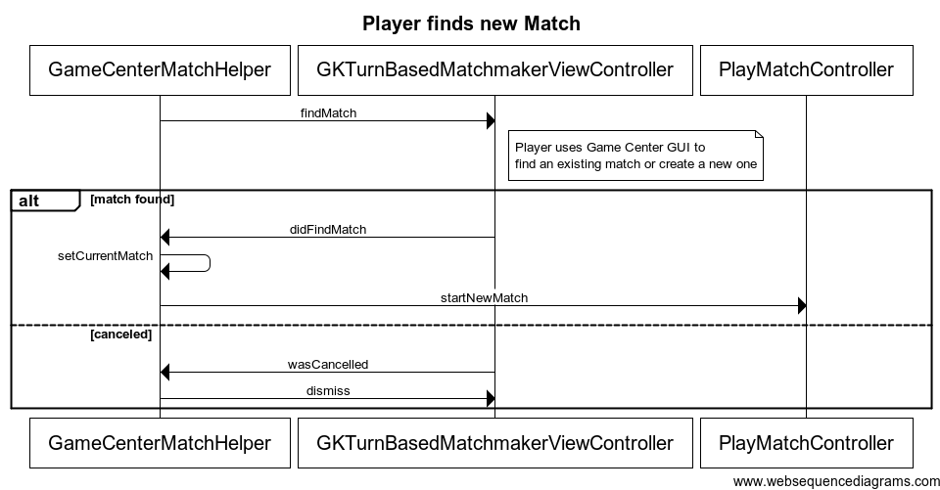

## Turn Based Matches

Apple’s Game Center supports the development of turn based games such as Clueless. Due to the nature of a turn based game, only one player may affect the state of the game at any given time. Since all players must be in a match simultaneously, players may participate in many matches at once. Apple’s Game Center will store the matches that players are participating in along with the state of each match.

At the beginning of a match, the current participant uses the Clueless GUI to take their turn. After they have finished, Clueless updates Game Center with the new Game State and determines which player will receive control of the match next. Game Center then notifies the new current participant that it is their turn and updates the Game State for all participants.

Clueless interfaces with the Game Center service using framework classes and event listeners. The interaction between the Game Kit framework and the Clueless game is shown in the following class diagram. The Game Kit classes begin with “GK” and are implemented by Apple.

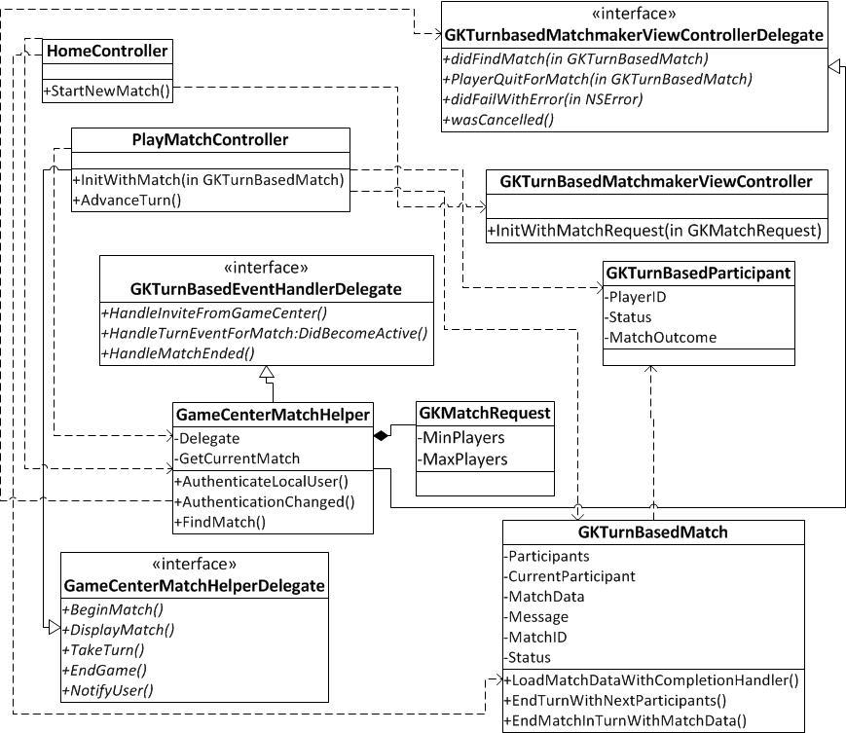

Game Center stores a snapshot of the state of each match and is responsible for synchronizing, but not affecting, this state between all players. The match state is defined by the game leveraging Game Center. In this case, Clueless will store the match state using the domain entities in the following class diagram.

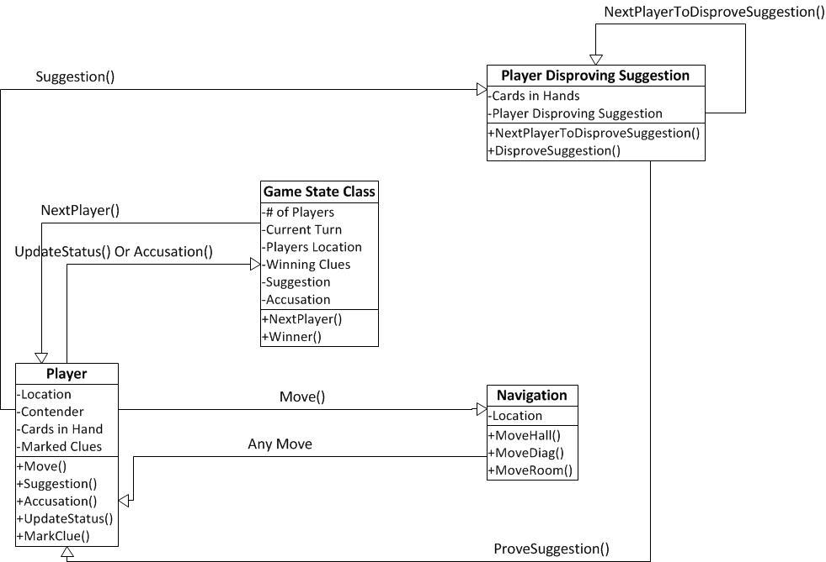

The Clueless Game State class will be serializable so that it may be written to a byte stream and stored in Game Center. Upon receiving a new match state from Game Center, Clueless will deserialize the byte stream back to Objective C objects. Reference Apple Developer Documentation for illustrations of this exchange of information.

# Citations

# Apple.com. (2012, Sep 19). From Apple iOS Developer Documentation https://developer.apple.com/library/ios/