Jim Gildersleeve

Homework 6: Earned Value Analysis

10/23/2016

CM 266

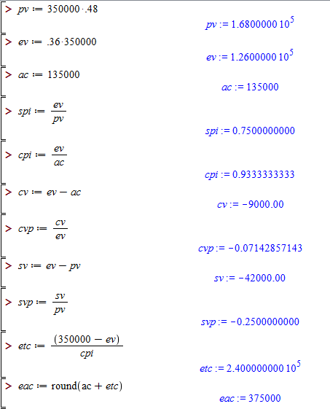

­­PV: This is that the present value of the project *should* be if it was on track.

EV: This is the estimated value of the project in its current state.

AC: This is the actual cost that we have used up so far

SPI: The schedule performance index is a measure of where you are in terms of schedule in relation to where you should be. Since out value is less than one, out project is currently behind schedule.

CPI: The Cost Performance Index is shows where you are in terms of budget compared to where you should be. Out value is less than one, indicating that our project is currently over budget.

CV: the cost variance shows the difference between where we are in cost and where we should be. Our value is negative, showing that we are currently over budget by $9000.

CVP: This shows that percentage off budget we are. Our value show that we are about %7 over budget.

SV: The schedule variance shows the difference between where we are now and where we would like to be in terms of schedule. Our value is negative, illustrating that we are behind schedule.

SVP: this shows the percentage off of schedule we are. The value that we have shows that we are currently behind by 25%.

ETC: This is an estimation for how long it will take us to complete the project if we keep with current conditions.

EAC: This is an estimation for how much the final product if we continue to work with current conditions.