run CanTransmit for 7 State, exactly 5 Data, 7 Packet

We send a packet with a legitimate checksum

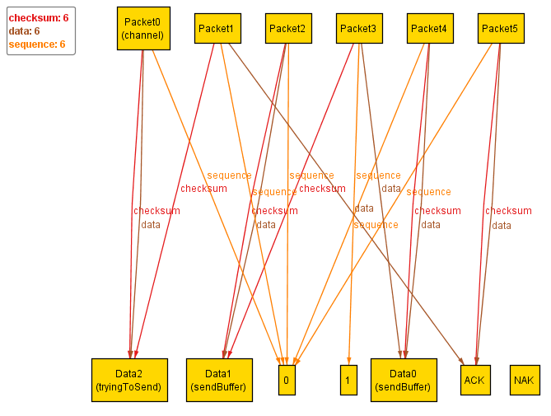

We acknowledge the good packet

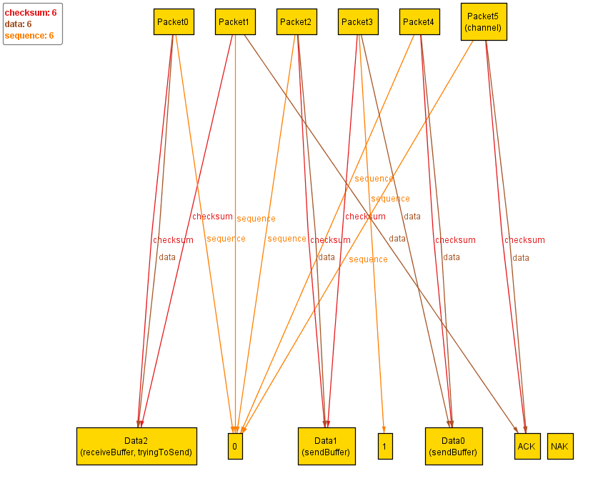

We send another legit packet

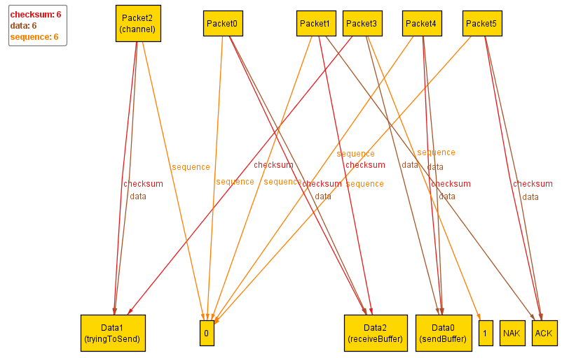

Send acknowledge packet

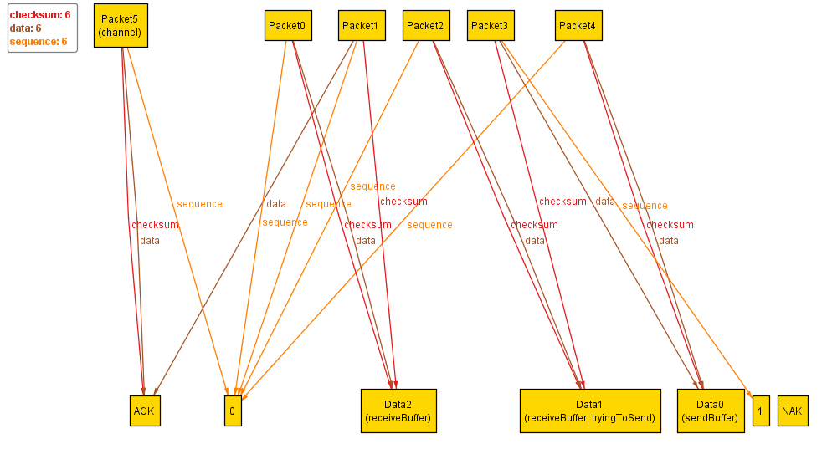

Send another packet

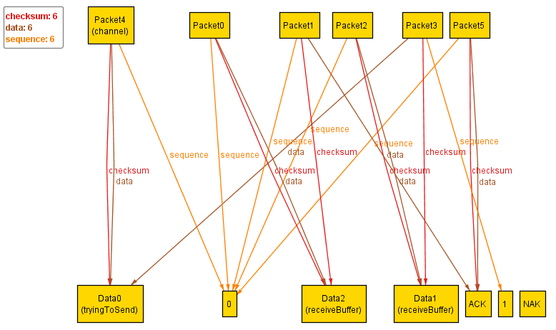

Send a fake news ACK

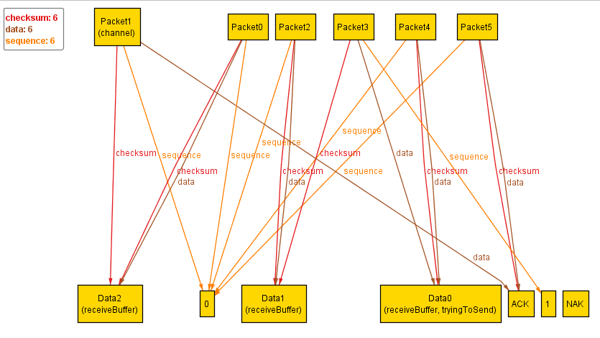

Resend the packet, everything was received

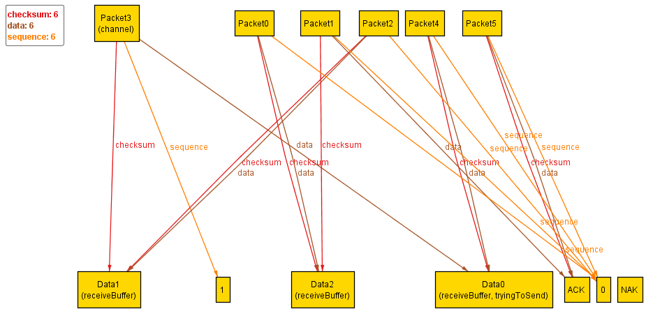

run CannotTransmit for 7 State, exactly 5 Data, 5 Packet

We send packet 2 over the wire

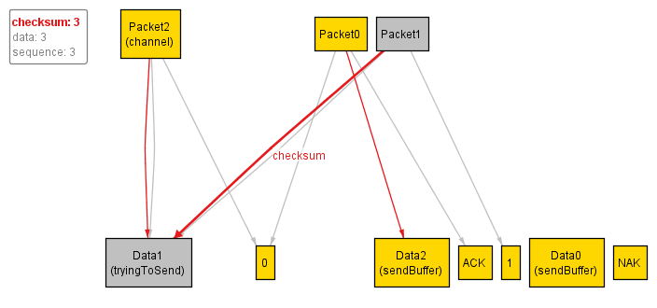

Send a corrupted ACK packet

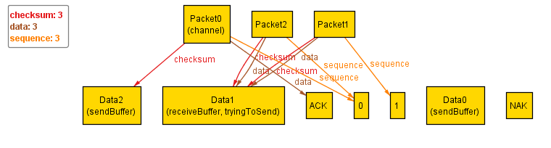

Resend Data1 since we don’t know if the ACK was legit

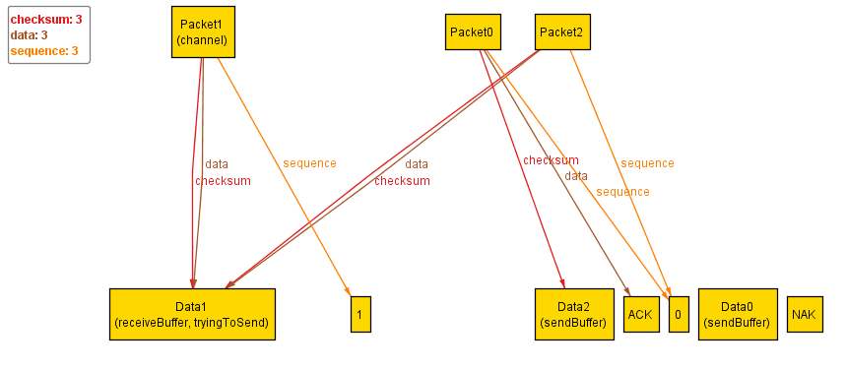

Send a fake news ACK packet



Resend Data1 

Lol, still can’t send a real ACK packet



Resend Data1, run out of time, message not received in time

