**CanTransmit:**

We start our model trying to send Packet1 over the wire with a valid checksum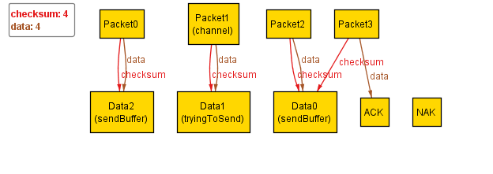

Since the checksum is valid, we send an acknowledgement packet

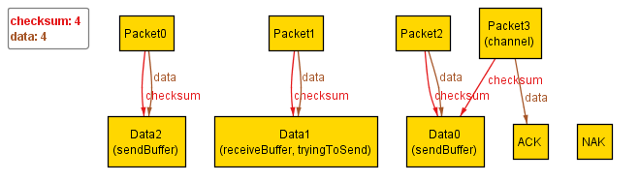

Once we know the data got there, we can send the next packet

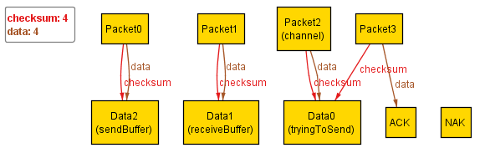

Since the checksum is valid, we send an acknowledgement packet

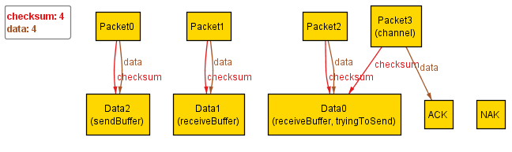

We know the data got to its destination, so we sent data 2

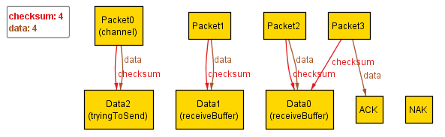

Since the checksum is valid, we send an acknowledgement packet

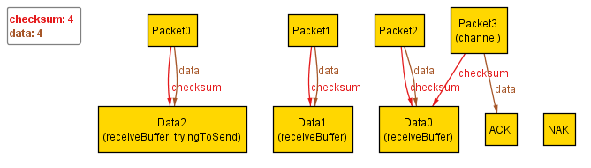

Everything is received correctly so we are good

**CannotTransmit:**

We start our model trying to send Packet1 over the wire with a valid checksum

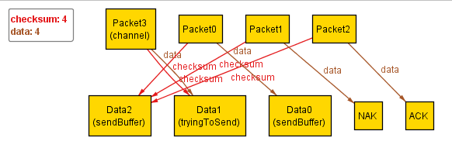

Since the checksum is valid, we send an acknowledgement packet

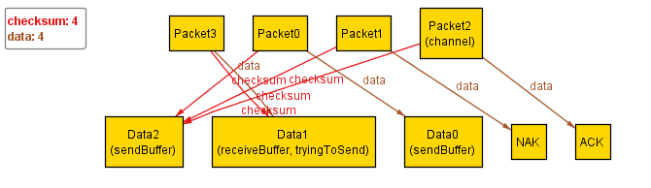

Now, we send a new packet with fake news (an invalid checksum)

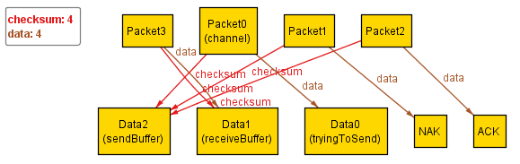

We now point out the fake news (invalid checksum) by tweeting about it (sending a NAK)

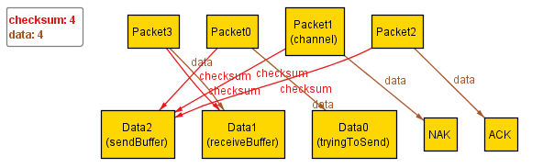

Since the NAK was received, we can try to send it again.

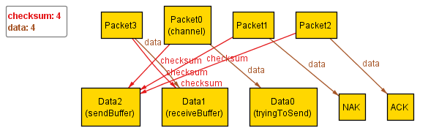

Lol, it still had a bad checksum, so we respond with a NAK

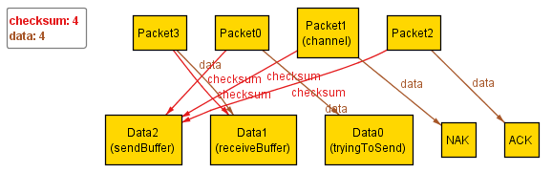

We can try to send it again…

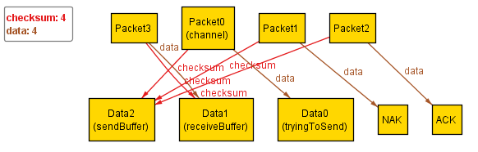

…but we are out of states so we are not able to send the message in its entirety