Run CanTransmit for 7 State, exactly 5 Data, 7 Packet

Trying to send Data1, checksum is good, hasn’t been sent before.

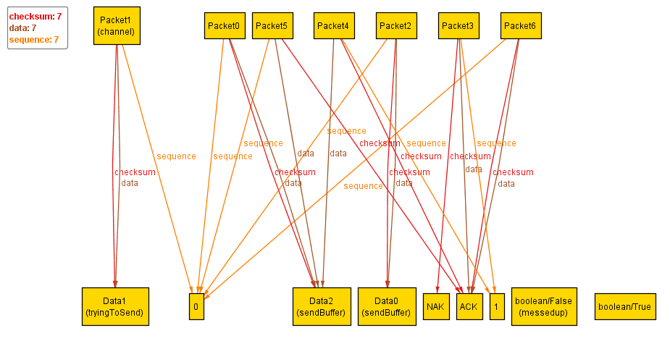

Good acknowledge sent back, hasn’t been sent before, Data1 to receive buffer.

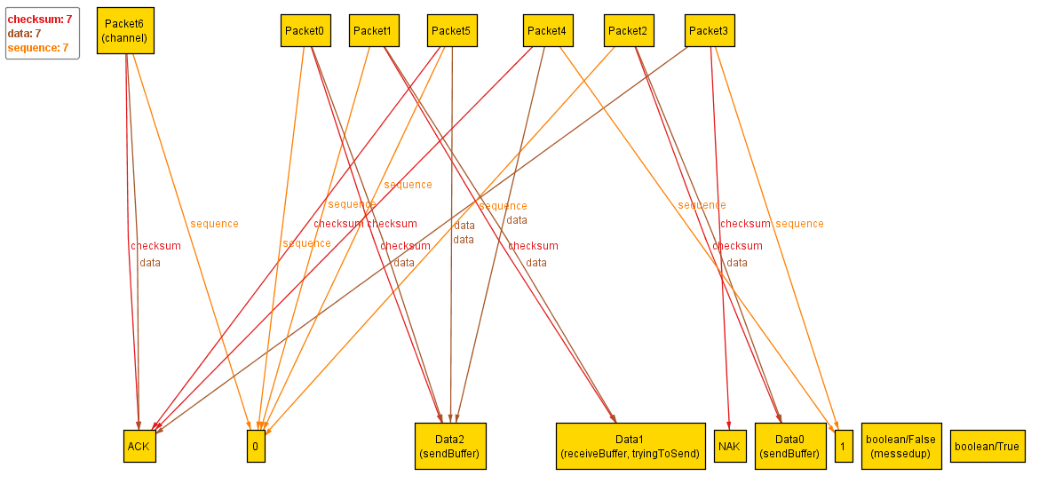

Trying to send Data0, checksum is good, hasn’t been sent before.

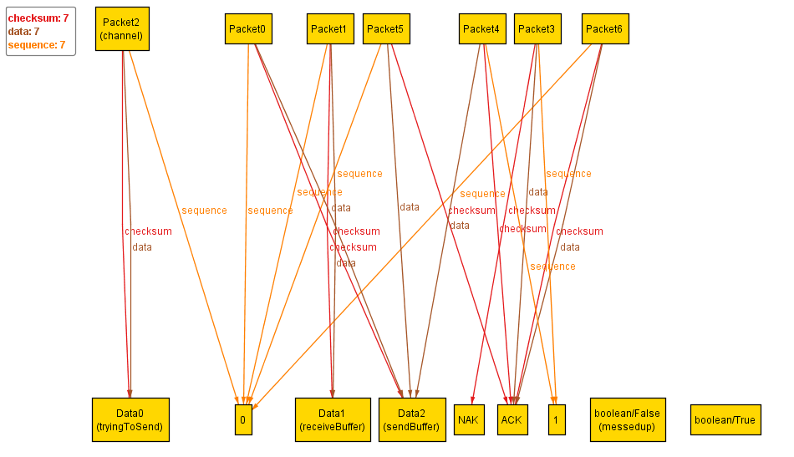

Acknowledge is good, Data0 in receive buffer, hasn’t been sent before.

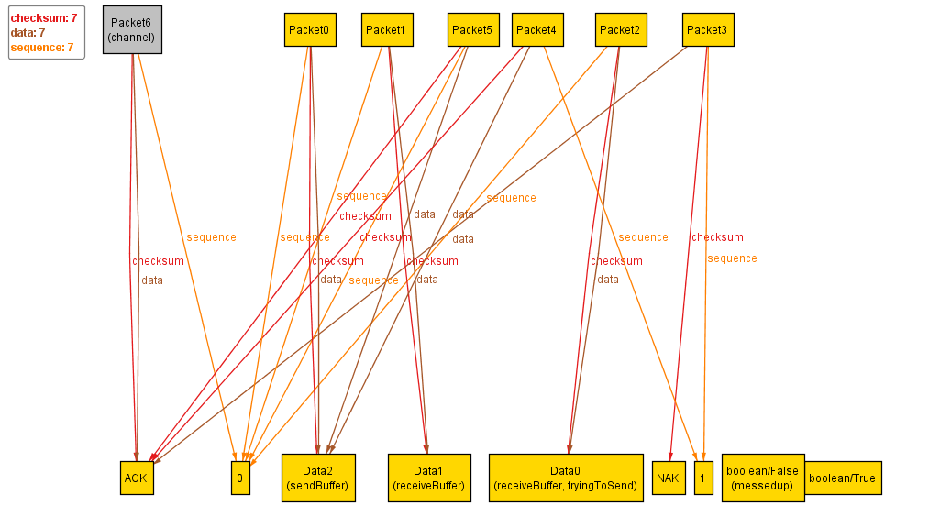

Trying to send Data2, checksum is good, hasn’t been sent before.

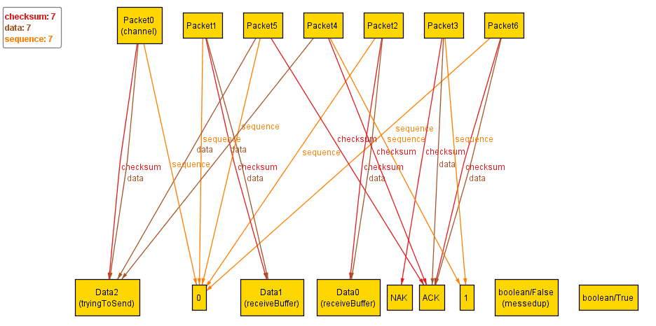

Acknowledge is bad, sequence set to one.

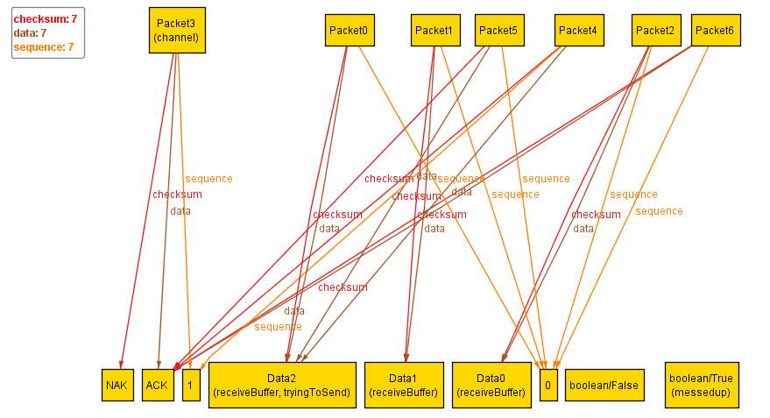

Trying to send Data2 again, already in receive buffer at end, so completed message.

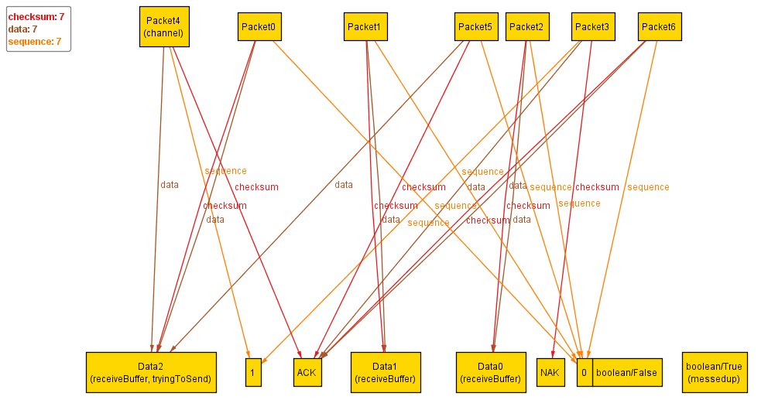

run CannotTransmit for 7 State, exactly 5 Data, 7 Packet

Trying to send Data2, good checksum, not sent before.

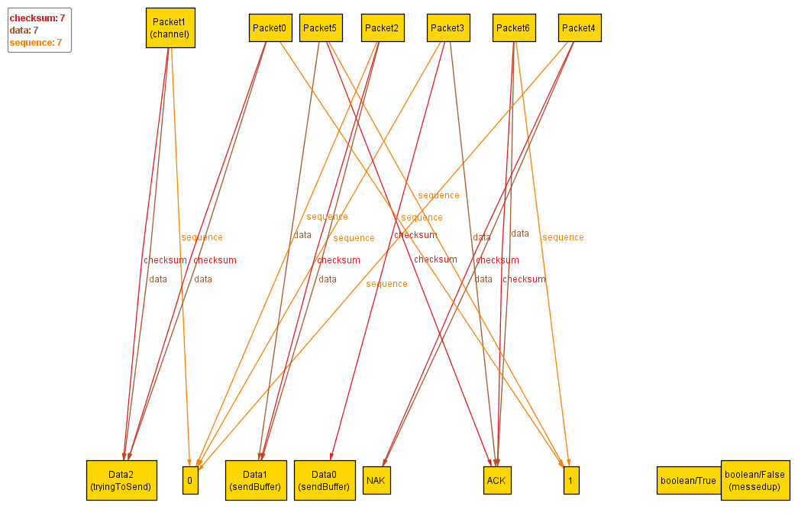

Acknowledge is bad, checksum not the same, will try to send again.

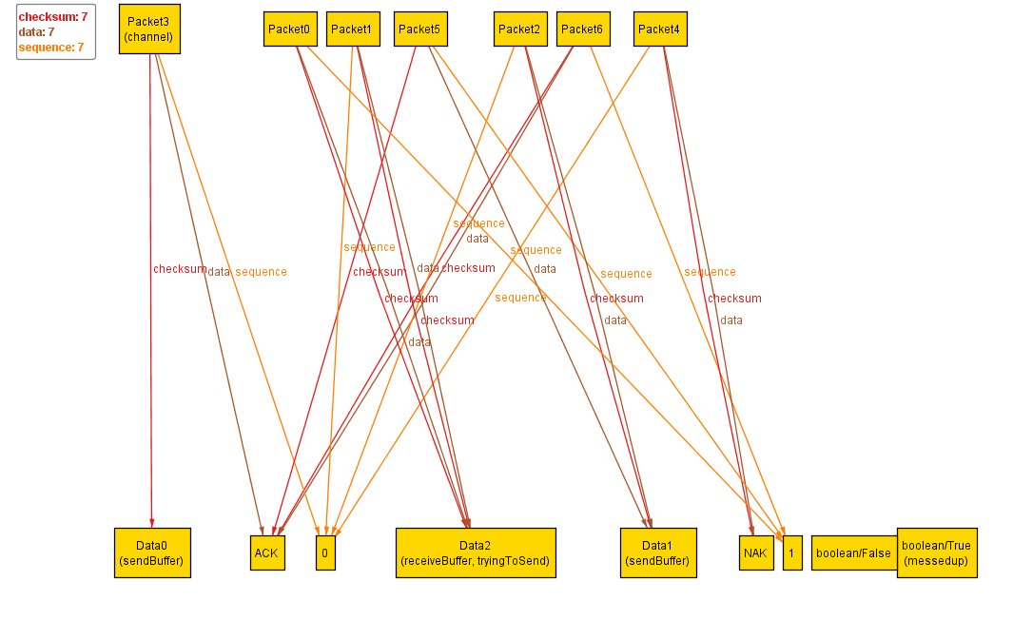

Trying to send Data2 again, messedup is set as true to signify it is being sent again.

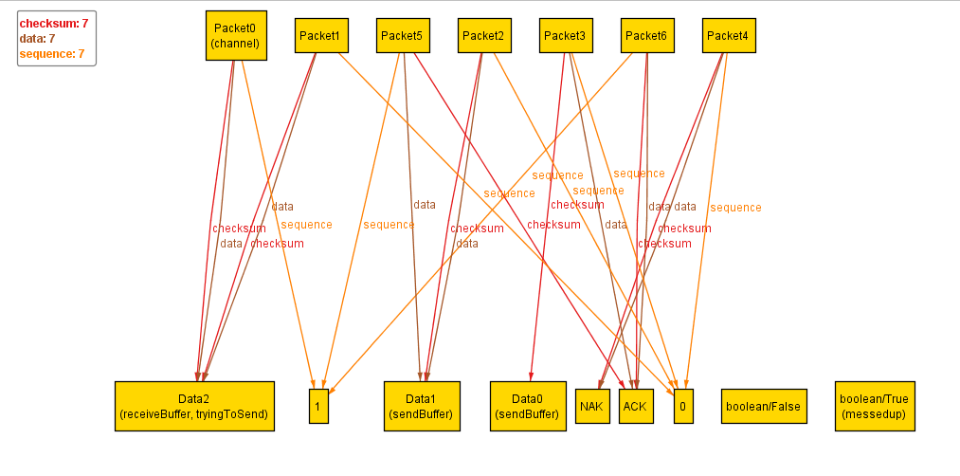

Acknowledge is good this time, Data2 received.

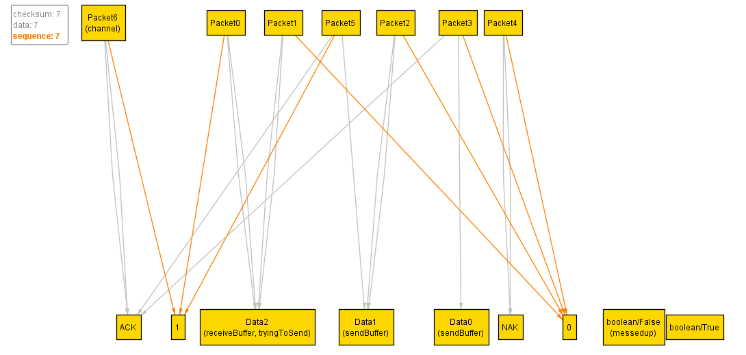

Trying to send Data1, checksum is good.

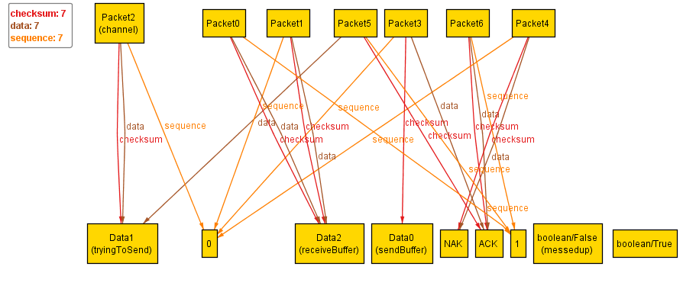

Acknowledge is bad, will attempt to resend.

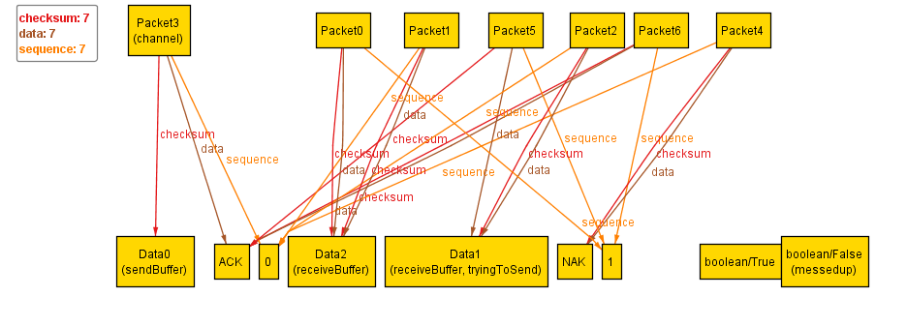

Resending Data1, messedup set as true to signify it is being sent again.

