Problem 1:

TLA+ found no bugs in the original algorithm for Natural numbers 1-5

Problem 2:

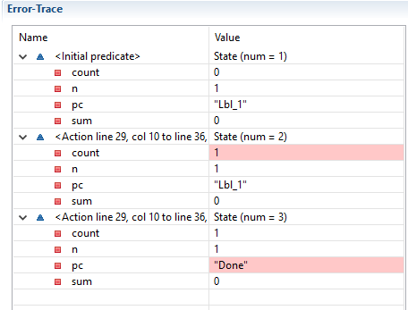

The issue here is that with the value of n = 1, sum should end up as 1, but instead it is 0. This is because in the conditional of the algorithm, it checks if the variable ‘i’ is less than ‘n’ when it should be a less than or equal comparison.

Problem 3:

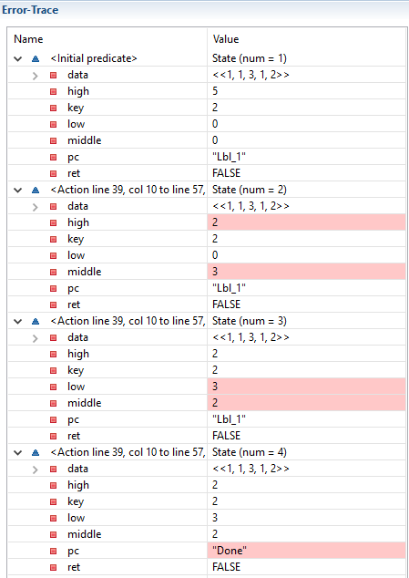

The issue with this one is that the algorithm sees the 3 in the middle and continues its search down, but the original array is not already sorted, so this algorithm will not always work