1. 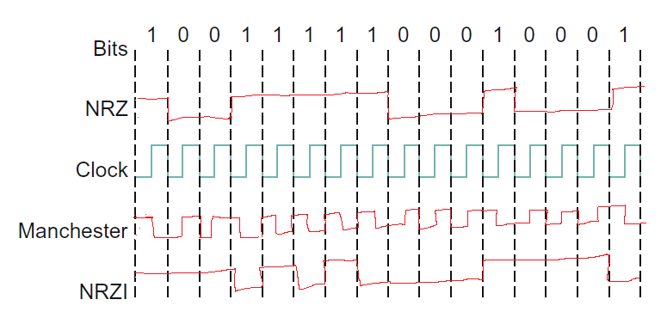Show the NRZ, Manchester, and NRZI encodings for the bit pattern shown in Figure 2.36. Assume that the NRZI signal starts out low.

1. 110101111101011111101011111110
2. 110101111110111110010111110110 I do not see any errors
3. 1. 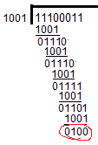
   2. It would become 110. They would know that it was corrupted since the crc that they calculate will not match the crc that we put on the end of the string
4. If two hosts on the same Ethernet share a hardware address, the network will not know where to send the messages. This is a problem because neither of the hosts will get everything that they want.
5. The hidden node problem is a thing. If there is a node that is in range of both nodes, the transmissions of one node may interfere with the other node in the overlap area.
6. In a national disaster, your base station may have failed. In a mesh, you can still have a bunch of failing nodes and still get communication.
8. 5 slots worth of data / (n/2 wasted time + 5 to actually send)