UNIVERSAL PERK
Nutrition & Lifestyle Platform
Developer Kickoff & Delivery Brief
Web • iOS • Android
Prepared for the Universal Perk development team
Project Manager / Scrum Master: Sosina Yitay
Based on the project handover brief prepared by Samuel Dereb

Purpose of this document
Give the whole team one shared understanding of what we are building, why it matters, how the work is organized, what 'Done' means, and what we must accomplish first.

1 | Project at a Glance  The simple version everyone should understand before development starts.

We are building a nutrition and lifestyle platform across web, iOS, and Android. It is designed for people preparing for surgery, recovering from surgery, or becoming more serious about weight management and healthier living.
Core product idea
A user tells us their goal and basic profile information. The platform then helps them discover relevant recipes and restaurant choices, track nutrition, and save their progress. AI features make search, assistance, imagery, and personalization smarter.

Client | Cyster, LLC - Dr. Joseph Michaels and Samantha Milton
Platforms | Responsive Web, iOS, Android
Commercial model | Fixed-fee, fixed-scope engagement
Product monetization | No subscription or paywall in this phase
Delivery model | 1-week sprints, staged UX -> development -> QA -> launch
Launch constraint | Before the US Thanksgiving holiday

2 | Who We Are Building For  The product is aimed at users at an important turning point in their health journey.

Surgery Preparation  Users getting ready for a procedure and needing more structured nutrition habits. | Recovery  Users recovering after surgery and trying to make healthier everyday choices. | Weight Loss  Users trying to reduce weight with more goal-aware food choices.
Muscle Gain  Users focusing on nutrition that supports muscle and strength goals. | Maintenance  Users maintaining progress and building consistent habits. | Lifestyle Change  Users starting to take their health seriously for the first time.

Important product boundary
This is a nutrition and lifestyle product, not a medical-advice product. The AI assistant must not provide medical advice and should answer only from approved client content.

3 | The Main User Journey  This is the experience every developer should be able to explain.

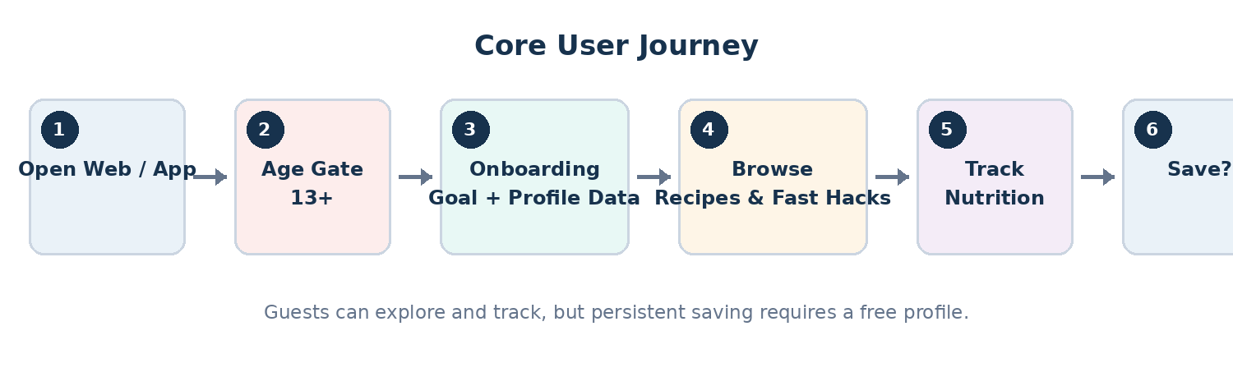
Key business rule: users may browse and track without an account, but permanent saving requires a free profile.
4 | What We Are Building  The platform is made of several connected feature areas.

Feature Area | What It Includes
Onboarding | Age gate, goal, age, height, weight, surgical context, progress indicator, resumable progress.
Recipes | Browse, filter, search, view details, save favourites.
Restaurant Fast Hacks | Goal-aware suggestions for what to order when eating out.
Nutrition Tracking | Log nutrition as a guest; prompt for profile creation when the user wants to save.
User Profile | Manage profile, goals, saved recipes, saved items, and persistent progress.
Content Management | Upload client PDFs, parse content, review it, approve it, and publish it.
Admin Analytics | Sign-ups, cross-platform events, weekly active usage.
AI Add-On | Semantic search, grounded assistant, generated imagery, personalization, progress Q&A.
5 | How the Technical Work Fits Together  Web, mobile, backend, UX and AI must move in parallel rather than waiting on each other.

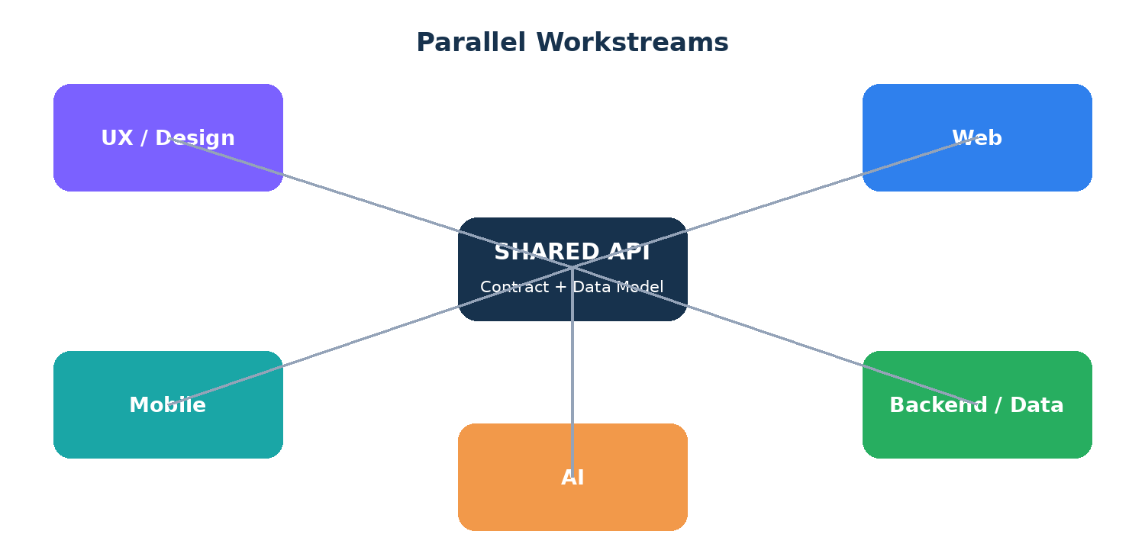
Critical dependency: API contract
Before feature development starts, the backend/technical lead must publish the agreed endpoints and request/response shapes. Web and mobile should be able to build against mocked responses while real APIs are implemented.

6 | Delivery Lifecycle  The schedule is compressed, so there is very little room for hidden delay.

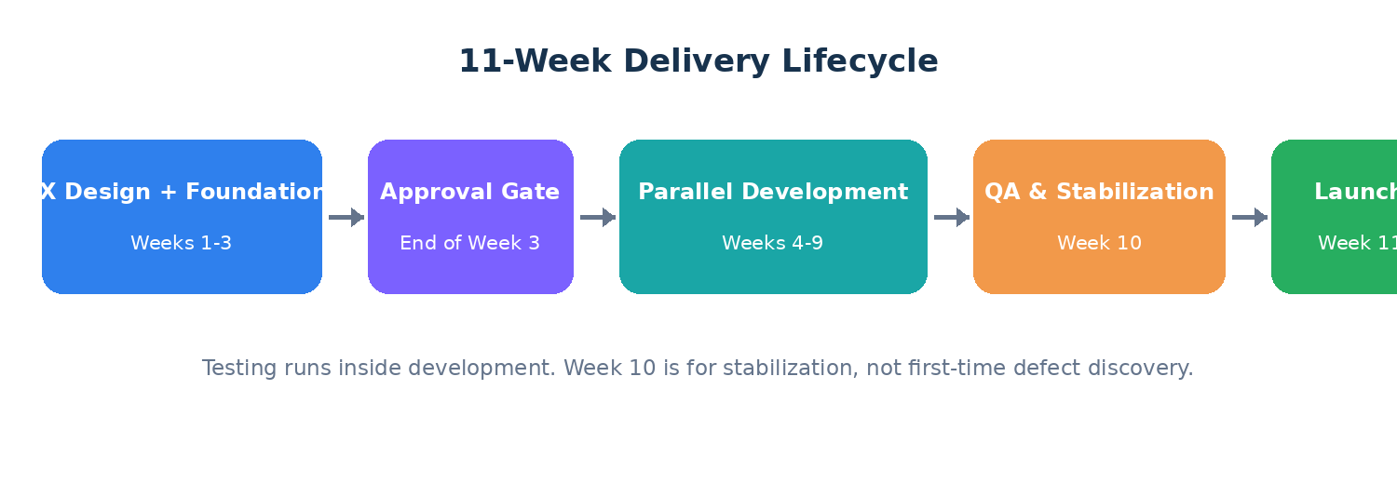
Stage | Main Output | PM Focus
UX + Foundations | Flows, design system, wireframes, prototype, boilerplate, CI/CD, data model, API contract | Clarify requirements, populate Jira, track approvals, risks and dependencies
Development | Web, mobile, backend, content pipeline and AI developed in parallel | Sprint control, QA inside every story, unblock team
QA & Stabilization | Cross-platform verification, defect fixes, security/performance checks | Defect triage and release readiness
Launch | Final approval, store submission, production release | Launch checklist, sign-off and monitoring
7 | Scope Priorities  When time becomes tight, we do not cut randomly. We use the agreed MoSCoW order.

MUST HAVE
Age gate; sign-up/sign-in; resumable onboarding; guest tracking; profile/storage; PDF content in clean UI; guided tour; legal pages; web/iOS/Android.

SHOULD HAVE
Search; admin upload/review; saving/favourites; push notifications; admin dashboard; web-to-app prompt.

COULD HAVE
Community event reporting; restaurant partnership framework; ordering deep links; educational tools; advanced UX layer; acquisition-grade analytics.

WON'T THIS PHASE
Subscription fees; medical advice; restaurant negotiations; drafting legal copy; brand naming.

Separate AI scope
The AI add-on is separately purchased scope. It still needs its own owner, capacity plan, acceptance criteria and cost-control requirements.

8 | Team & Responsibilities  Everyone should know who owns what and where to escalate.

Role | Owner | Main Responsibility
Project Manager / Scrum Master | Sosina | Backlog, ceremonies, sprint planning, reporting, risk management, QA ownership, blocker removal.
Technical Lead | Samuel Dereb | Architecture decisions, API contract, code review, infrastructure, security, technical escalation.
UX Designer | Yonathan | Wireframes, high-fidelity designs, prototype, design system.
Frontend Developer | Tinsaye | Responsive web application.
Mobile Developer | Dagim | Shared mobile codebase, iOS and Android.
Backend Developer | Wondwossen and Dagim | API, database, content pipeline, authentication, integrations.
AI Owner |  | Core AI and personalized/adaptive AI workstream. Ownership must be confirmed early.
9 | How We Will Work  Simple delivery rules that keep the project honest.

1-week sprints
Every week we plan, build, test, review and learn. The short cycle lets us see problems early instead of discovering them at the end.

Sprint Planning | Team agrees the week's scope and commitment.
Daily Stand-up | Short discussion focused on blockers, dependencies and risks.
Backlog Refinement | Prepare the next sprint's stories and acceptance criteria before planning.
Sprint Review / Demo | Show completed, tested work - not screenshots of unfinished work.
Retrospective | Identify what to improve and assign actions for the next sprint.
10 | Jira, Story Quality & Definition of Done  The board must reflect reality, not just coding activity.

Definition of Ready
A story should enter a sprint only when the requirement is clear, acceptance criteria exist, dependencies are known, required design/assets are available, and the team understands how it will be tested.

Definition of Done
A story is Done only when it is code-complete, peer-reviewed, tested, meets the 80% coverage requirement, merged, deployed to staging, verified against acceptance criteria, and demonstrable.

Recommended Jira flow: Backlog -> Ready -> In Progress -> Code Review -> Ready for QA -> QA In Progress -> Ready for Demo -> Done
Rule to remember
Code complete is not Done. Untested work is unfinished work.

11 | Quality Assurance Starts Now  There is no separate QA hire. QA is built into delivery, with developers owning automated tests and the PM owning verification and defect control.

Functional  Does the feature behave exactly as required? | Positive  Does the normal expected user journey work? | Negative  What happens with invalid, missing or unauthorized input? | Edge Cases  What happens at limits, unusual sequences or uncommon device conditions?
Integration  Do frontend/mobile and backend work correctly together? | Cross-platform  Does the feature behave consistently on web, iOS and Android? | Regression  Did this change break something that previously worked? | AI Safety / Quality  Does AI stay grounded, avoid medical advice, protect user data and behave predictably?
Defect severity
S1 Critical = blocks launch/security/data loss. S2 High = major feature broken. S3 Medium = partial failure with workaround. S4 Low = cosmetic/minor issue.

12 | Top Risks We Must Manage Early  These are project issues, not just technical issues.

Risk | Why It Matters | Impact
Client PDFs arrive late | Blocks accurate estimation and development of the content pipeline. | High
PDF structure is difficult to parse | Could create hidden backend effort and manual cleanup. | High
UX approval is delayed | Feature development is contractually blocked until approval. | Critical
API contract is late or unstable | Web and mobile can become dependent on backend progress. | High
AI owner is not confirmed | Capacity and delivery of AI work become uncertain. | High
Testing is postponed | Bugs accumulate and Week 10 becomes a discovery week instead of stabilization. | Critical
Client assets/legal/store accounts arrive late | Can block design polish, store submission or launch. | High
App Store / Google Play review issues | External review timelines are outside our direct control. | High

13 | What We Need To Do First  The first week is about alignment, foundations and removing uncertainty.

PM / Scrum Master
Confirm start date, launch date, AI owner and open client dependencies; set up Jira; create risk register; agree Definition of Ready/Done; prepare QA strategy.

Technical Lead
Confirm architecture direction, repositories, environments, CI/CD, security posture and API-contract ownership.

Backend
Start boilerplate, data model, test endpoints and API-contract draft; prepare to spike PDF parsing as soon as content arrives.

Web
Set up web application shell, routing, design-system foundation, linting and test harness.

Mobile
Set up shared mobile project, navigation, reusable components and test harness.

UX
Define information architecture, screen inventory, core flows, design system and first prototype slices.

Whole Team
Join story-writing/refinement, identify risks, participate in pre-mortem, agree working rules and surface blockers early.

14 | Developer Kickoff Meeting Agenda  Use this document as the meeting guide.

1. Why this project exists and who the client is
2. Who the product is for
3. Walk through the main user journey
4. Review the core feature areas
5. Explain the 11-week delivery lifecycle
6. Review team roles and ownership
7. Explain API-contract dependency and parallel workstreams
8. Review scope priorities: MUST / SHOULD / COULD / WON'T
9. Agree Jira workflow, Definition of Ready and Definition of Done
10. Explain QA responsibilities and testing expectations
11. Run the pre-mortem: 'Imagine we failed to launch - what caused it?'
12. Capture open questions, risks, owners and next actions
Closing message to the team
Our goal is not just to write code quickly. Our goal is to deliver small, testable, integrated pieces of a reliable product every week, make blockers visible early, and arrive at launch with very little hidden work.

15 | PM Step-by-Step Checklist  This is the simple order of work for taking ownership of the project.

1. Understand | Read the handover, proposal and contract until you can explain the project without the documents.

2. Clarify | Close open questions with Samuel and the client: dates, AI ownership, content, branding, legal, store accounts and onboarding behavior.

3. Structure | Create the project charter, requirements register, risk register, dependency tracker and decision log.

4. Align | Run the internal developer kickoff and agree how the team will work.

5. Break Down | Turn epics/features into small Jira stories with clear acceptance criteria.

6. Plan | Create the 11-week roadmap and the first one-week sprint.

7. Execute | Run planning, stand-ups, refinement, QA, review and retrospective every sprint.

8. Control | Track completion, carryover, blockers, defects, approvals and client dependencies.

9. Validate | Run staged client/UAT reviews throughout development.

10. Release | Complete production readiness, store submission, final sign-off and launch.

11. Stabilize | Support launch, verify defects, document remaining work and run a retrospective.

Shared understanding first.
Small testable stories second.
Visible delivery every week.
Universal Perk - Nutrition & Lifestyle Platform
Developer Kickoff & Delivery Brief

