A Hybrid Quantum-Inspired Evolutionary Algorithm with Adaptive Rotation-Gate Control for Many-Objective Vehicle Routing: Diagnosis, Correction, and Comparative Evaluation
Olivian-Antonio Gîlea, Adrian Florea, Claudia Banciu, Alexandru Telcean
Computer Science and Electrical Engineering Department, "Lucian Blaga" University of Sibiu, Sibiu 550025, Romania
Background and objectives. Quantum-inspired evolutionary algorithms (QIEAs) combine qubit-encoded chromosomes with rotation-gate operators to balance exploration and exploitation, and both quantum-inspired and true-quantum solvers have recently been applied to multi-objective optimization (Kotil et al., 2025; King, 2025). However, these studies remain confined to synthetic benchmarks or low-dimensional (2-3 objective) problems, and a prior single-objective QIEA applied to real waste-collection routing found that its repair step for infeasible tours collapses population diversity as instance size grows (Gîlea et al., 2026). This work extends qubit-encoded optimization to a genuinely many-objective (5-objective), real-world setting — capacitated vehicle routing for urban waste collection — and asks whether a decomposition-guided QIEA with an adaptive rotation-gate control (ARGC) mechanism can close the gap to established many-objective evolutionary algorithms.
Methodology. We propose HQIEA-ARGC: a qubit-angle chromosome decoded either by argsort (permutation, for routing) or a sine-squared mapping (continuous, for synthetic benchmarks), eliminating the repair step that caused diversity collapse in the prior study. Many-objective scalability comes from MOEA/D-style Tchebycheff decomposition (Das-Dennis weight vectors, neighborhood-restricted mating); the rotation-gate step size decays across generations but is boosted, together with the mutation rate, whenever population diversity stalls — the ARGC mechanism. We formulate Sibiu’s waste-collection routing as a 5-objective CVRP (distance, time, cost, emissions, workload balance) and validate on the ZDT/DTLZ/WFG synthetic suites, four CVRPLIB instances, and three real Sibiu routes, against NSGA-II, SPEA2, MOEA/D, and RVEA (pymoo). We report the full-scale protocol: 30 independent runs and 500 generations per instance, scored by hypervolume, spacing and spread, with Wilcoxon and Friedman tests.
Key results. At full scale, HQIEA-ARGC initially lost to all four baselines on every one of the seven CVRP instances (hypervolume ratio to the best baseline: 0.17–0.45). A generation-wise diagnostic traced this to a hard, early hypervolume plateau: the ARGC stagnation-escape essentially never triggered under its original threshold, leaving the fixed-size decomposition population with no source of renewed diversity once converged. A plateau-gated diversity-reinjection scheme — reseeding half of the decomposition subproblems once the archive stalls for 10 generations — produced large, statistically significant hypervolume gains on all seven instances (+27.7% to +66.0%, Wilcoxon p<0.005 throughout), the most consistent effect found in our tuning study. Figure 1 shows the result: HQIEA-ARGC’s mean ratio to the best baseline rose to 0.48 (range 0.30–0.58), and it now statistically ties NSGA-II on one instance (route1_334, p=0.237) — its first tie against any baseline at full scale — while remaining significantly behind MOEA/D and RVEA specifically on all seven.
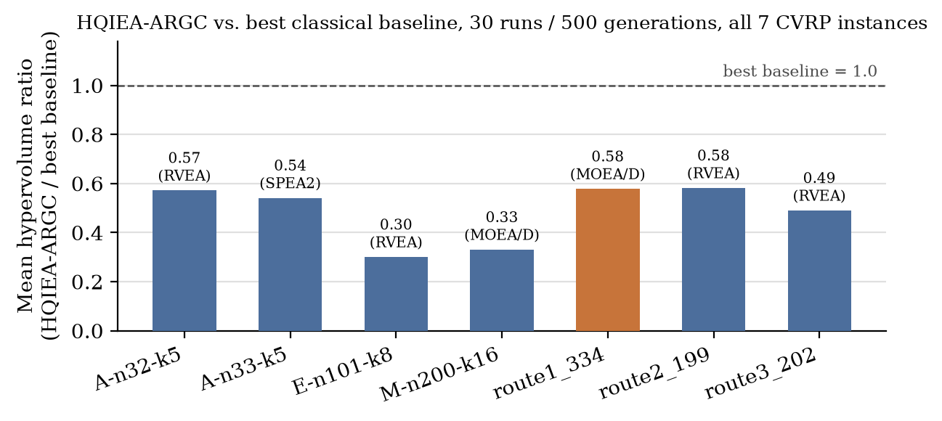
Figure 1. Mean hypervolume ratio of HQIEA-ARGC to the best-performing classical baseline, per instance, at the full validation protocol (30 runs, 500 generations). The highlighted bar (route1_334) marks the one instance where HQIEA-ARGC is statistically indistinguishable from a baseline (NSGA-II, p=0.237), even though MOEA/D still leads there in mean hypervolume.
Significance and impact. To our knowledge, this is the first evaluation of a qubit-encoded evolutionary algorithm on a genuinely many-objective (5-objective), real-world routing problem, rather than a synthetic or 2–3 objective case. Two findings generalize beyond this application: a repair-free permutation decode removes the diversity-collapse failure mode reported for qubit chromosomes at scale, and an explicit diagnose-then-fix methodology for a stalled stagnation-escape mechanism yields the largest, most reproducible gain in the study. The remaining, still-significant gap to decomposition- and reference-vector-guided baselines identifies population/decomposition granularity as the priority lever for future work bridging quantum-inspired representations with many-objective decomposition methods.
Keywords: quantum-inspired evolutionary algorithm; many-objective optimization; capacitated vehicle routing; MOEA/D decomposition; adaptive rotation-gate control
References
[1] Kotil, A., Pelofske, E., Riedmüller, S., Egger, D. J., Eidenbenz, S., Koch, T., & Woerner, S. (2025). Quantum Approximate Multi-Objective Optimization. arXiv:2503.22797 [quant-ph].
[2] King, A. D. (2025). Multi-objective optimization by quantum annealing. arXiv:2511.01762 [quant-ph].
[3] Koch, T., Bernal Neira, D. E., Chen, Y., Cortiana, G., Egger, D. J., Heese, R., et al. (2026). The Quantum Optimization Benchmarking Library. Nature Computational Science. https://doi.org/10.1038/s43588-026-00991-1
[4] Gîlea, O.-A., Florea, A., Banciu, C., & Telcean, A. (2026). Scalable Quantum-Inspired Evolutionary Algorithm for Multi-Objective Optimization: Real-World Problems. Manuscript in preparation, "Lucian Blaga" University of Sibiu. [confirm venue/status before citing]
[5] Ghlib, R., Bouhadouza, R., & Hnaien, F. (2026). Scalable multi-objective genetic algorithm for quantum circuit optimization. Scientific Reports, 16, 17977. https://doi.org/10.1038/s41598-026-47674-5

