**Return to Home (Search Page)**

Click Here to look up data content

**Step 1: Choose 1 of 2 data type options**

The search query will be based on the type chosen.

**Become a user/editor of the system**

Click Here to join!

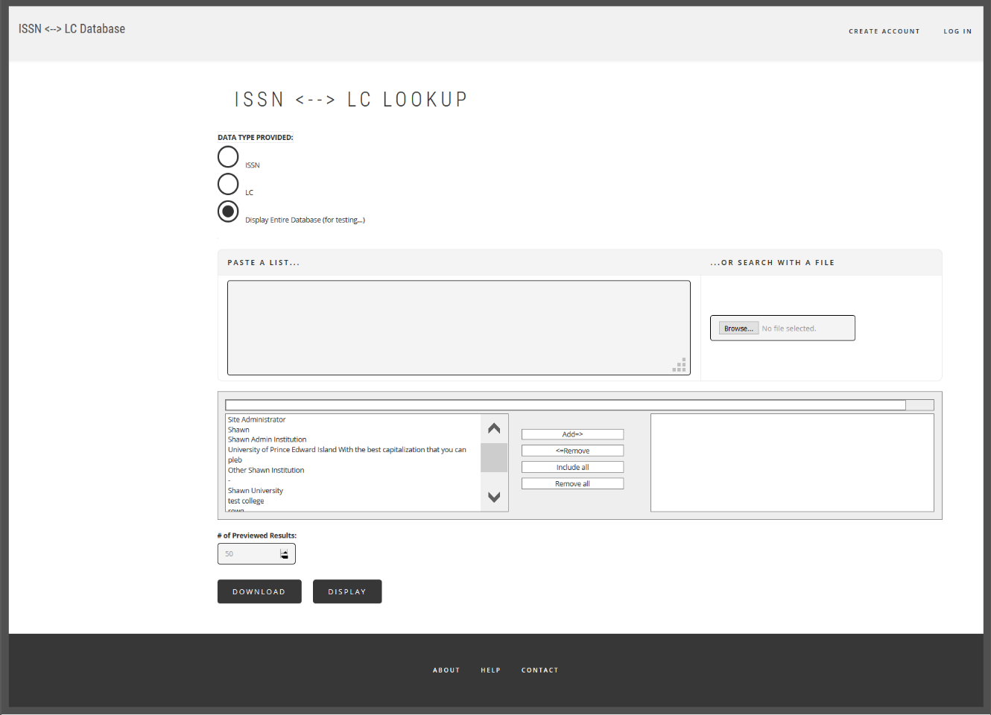

**Step 5 (Final):**

Download: save a copy of the search result in different file formats.

Display: to view the search result on browser.

**Step 3: Institution Filter**

To find specific data collections that are owned by institution(s).

Make use of this quick search above the selectbox to find the names

**Step 2: Make a List in the textfield -OR- Upload a file**

It is important to input data based on the type you have chosen in **Step 1**.

**Step 4: Data Units per Page**

This number will be used to list a data unit per line in one page.

The higher the number, the longer it takes to load.(Please be patient when it happens.)