(Source: <https://images.slideplayer.com/26/8833305/slides/slide_3.jpg>)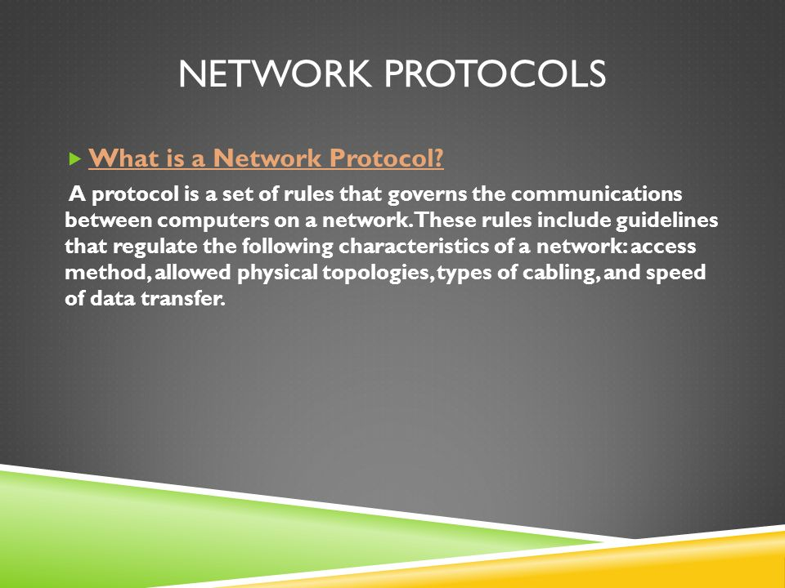

The first computer network was designed in 1969, called ARPANET, with NCP(Network Control Program) as a protocol. It used packet-switching technology to format and transfer data, which is still used today.

As computer technology became widely popular and commercial, there was a need to standardize the network protocols.

Some of the first network protocols are:

- Ethernet (1973) - standard LAN protocol

- TCP/IP (1978) (Transmission Control Protocol/Internet Protocol) - standard Internet protocol

- UDP (1980) (User Datagram Protocol) -Internet protocol

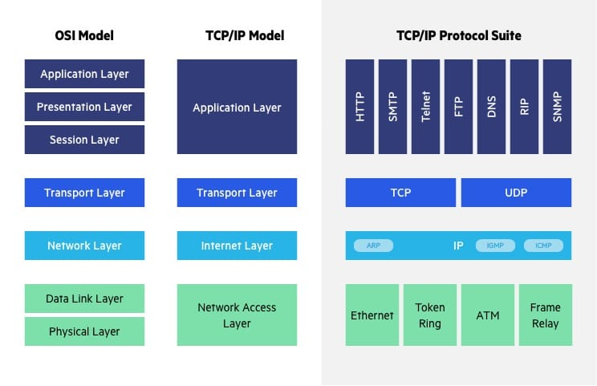

(Source: <https://www.imperva.com/learn/wp-content/uploads/sites/13/2020/02/OSI-vs.-TCPIP-models.jpg>

OSI (Open Systems Interconnection) model is a standard model describing how computer systems communicate over a network. Introduced in 1983 and made an international standard in 1984. Although the Internet is based on TCP/IP model, the OSI model is still referred to for explaining and troubleshooting network issues. (<https://www.imperva.com/learn/application-security/osi-model/> )

OSI model describes data formatting and transfer in 7 layers. The many different network protocols work in different layers.

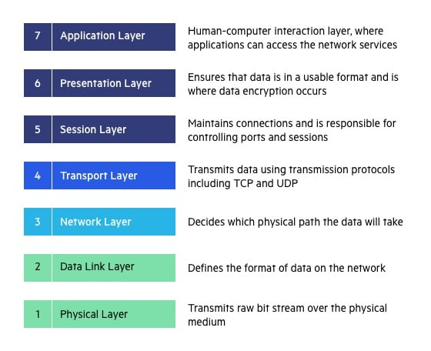

(Source:

<https://www.imperva.com/learn/wp-content/uploads/sites/13/2020/02/OSI-7-layers.jpg> )

Cloud Computing

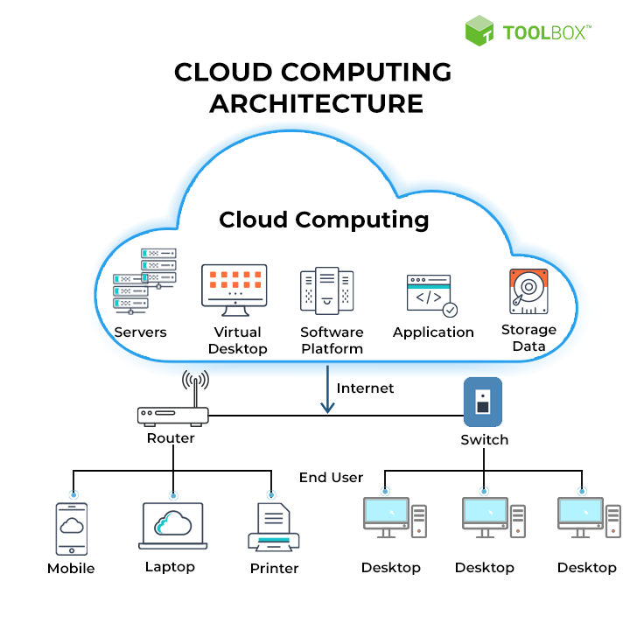

(Source: <https://pimages.toolbox.com/wp-content/uploads/2021/07/09134159/38-3.png> )

Cloud computing is the use of IT resources (data storage, servers, databases, networking or software) over the internet. The data is stored on physical servers, which are maintained by a cloud service provider. Computer system resources, especially data storage and computing power, are available on-demand, without direct management by the user in cloud computing. (<https://www.spiceworks.com/tech/cloud/articles/what-is-cloud-computing/>)

The idea of cloud computing, or access to data or compute power from anywhere by anyone, was envisioned since the start of computer networks. With the expansion of the Internet worldwide and the increased computing and data storage power of computers, cloud computing is made possible today. (<https://www.dataversity.net/brief-history-cloud-computing/>)

Cloud services can be accessed from anywhere with a viable Internet connection. They are a great benefit to organizations that don’t want to invest in traditional network infrastructure; cloud services can also be scaled based on business demand, further cutting costs.

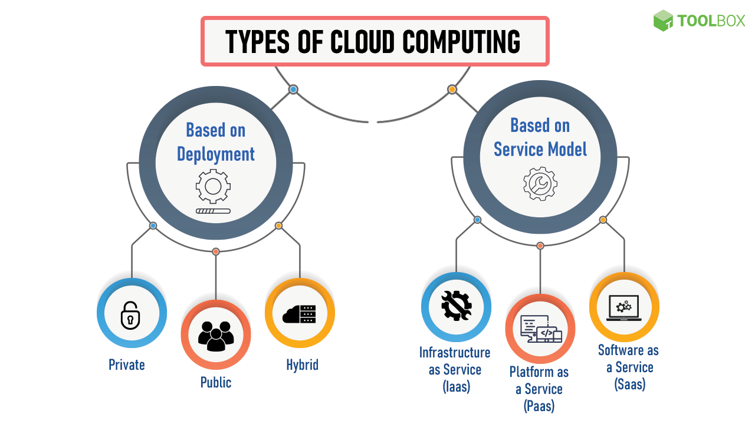

(Source: <https://pimages.toolbox.com/wp-content/uploads/2021/07/02105247/Cloud-Computing.png> )

A private cloud is a cloud computing service dedicated to a single organization. It is a logical network where all the services are run in the cloud. The network components are similarly termed as the physical components of a traditional network, except private cloud components are virtual (logical entities in a server of the cloud computing provider).

One of the leading cloud services providers today is AWS (Amazon Web Services), which offers the Amazon VPC (Virtual Private Cloud) <https://aws.amazon.com/console/>