

Combine your financial tools into one powerful online wallet!

Business Plan

December 2005

Prepared by Yafit Rossen
תוכנית עסקית ישראל
www.Israel-Business-Plan.com

Disclaimer

This document details OnlineCash’s business plan for initiating internet payment services for small business and customers. The document outlines the need of small business and private users to send and receive Internet payments securely, conveniently and cost-effectively, the eCommerce market and description of the Company’s unique solution. The document also details financial forecasts of the proposed operation for the next 5 years based on assumptions, market data, and company’s opinions.

The Business Plan is built to reflect in a reasonable and rational way, a plan that is accurate for a certain time, based on known information, assumptions and forecasts of the company. As all business plans, its results are based on information that was available at the time of preparation, by its accuracy, and its reliability and based on the assumptions made. Changes in the economical factors as well as additional information or various economic or business events, can change the assumptions and as a result also the conclusions.

The business plan itself is not a guarantee for its execution. Therefore it is possible that the business plan will not be executed as planed.

CONFIDENTIAL INFORMATION

All information contained herein contains copyrighted © information that is proprietary, privileged or confidential. Any unauthorized review, reproduction, distribution, copying of, or reliance upon this document and any included exhibits is strictly prohibited.

Index

1. The Company 4

2. The Team 6

3. The Market 7
3.1 Internet Usage 7
3.2 eCommerce Market Growth 7
3.3 eCommerce Products 8
3.4 Purchasing Habits 8
3.5 Payments methods 9
3.6 Online Payment Market 10

4. OnlineCash’s Solution 12

5. Competitive Analysis 15
5.1 OnlineCash Advantages for Merchants 15
5.2 OnlineCash Advantages for Buyers 15
5.3 Competition 15

6. Business Model 17
6.1 General 17
6.2 The Marketing Plan 18
6.3 Methodology 19
6.4 Revenues Forecast 20

7. Financial Forecast 23
7.1 General 23
7.2 Manpower 23
7.3 Customer Service & Support Budget 25
7.4 The Sales & Marketing budget 25
7.5 R&D Budget 25
7.6 The General & Administrative Budget 25
7.7 Profit & Loss & Cash Flow Forecast 27
7.8 Financial needs 27

1. The Company
OnlineCash integrates all existing online and offline payment methods and means into a single electronic wallet, enable any business or consumer with email, to send, receive, deposit and withdraw money easily and safely.
OnlineCash Ltd. (hereby: “OnlineCash” or “the Company”) is a start-up company providing innovative payment tools designed to enable multiple forms of secure payment. OnlineCash’s vision is to enable any business or consumer with email, to send, receive, deposit and withdraw money from the system, while using the same, safe, simple and swift interface. OnlineCash achieves this by integrating all existing online and offline payment methods and means into a single electronic wallet.

OnlineCash system builds upon the existing financial infrastructure of bank accounts and credit cards and creates a simple, swift and secure payment system. OnlineCash’s system uses the most advanced fraud prevention systems to create a safe and secure online payment solution.

Online commerce is a rapidly growing force in the 21st century. More countries, businesses and people use the various forms of electronic trade each year. Despite its flaws, credit cards are still the most convenient and favorite transaction method of this new world economy and more people are driven to use it on a daily basis. However, the credit card is not without flaws. Not everyone can obtain a credit card, and when they do, using it online leaves their card information open to fraudulent use if their credit information is somehow leaked, stolen or given to untrustworthy suppliers.

On the other side, not all merchants can deal with credit companies directly for a variety of reasons and even if they manage to enter into a Credit Card agreement, they must implement a complicated and expensive online credit card processing system, which in most cases does not even provide a solution for credit matching.
With the growth of Internet use, more traditional business expand their activities and go online, but find it is not economical to deal directly with Credit Card companies when their website’s revenues are lower than dozens of thousands of dollars per month
OnlineCash currently operates as beta in the Israeli market, which is estimated at about $500 million in 2005 (compared to $300 million in 2003). Later on, OnlineCash will expand its operation to third world countries (like India and China) in which these solutions have not been yet fully adopted.

With the growth of Internet use, more and more traditional business expand their activities and go online, in order to increase their exposure to new customers and increase revenues. Since establishing a dedicated clearance system requires installing expensive security systems, high speed servers and special certifications from the Credit Cards companies, small business find it is not economical to deal directly with Credit Card companies when their website’s revenues are lower than dozens of thousands of dollars per month. On the other hand, their customers are used to pay for services or products with credit cards. OnlineCash is therefore the perfect solution for these small businesses which offer a secure credit cards clearance system without the need to deal with credit card companies.

There are 139 thousands of small businesses in Israel, employing between 1 to 19 employees (based on Israeli ministry on Industry, Trade & Labor, 2004). The company believes that only a small portion of these companies have a website and even less offer the ability for their customers to pay online. With the growth of the Internet usage in Israel, which currently stands at about 2.2 million users (above the age of 13), and the increase of willingness to pay online, more and more businesses will find it essential to go online and offer easy, quick and secure online payments. The company believes that this trend will lead the growth of the eCommerce Industry in the coming years. This market represents a huge opportunity for OnlineCash’s services and will be the main focus of OnlineCash’s penetration.
The second largest target market for OnlineCash is the users themselves. OnlineCash enables private users to send and receive money to anyone (business or private user) with an email address.

The second largest target market for OnlineCash is the users themselves. OnlineCash enables private users to send and receive money to anyone (business or private user) with an email address. Furthermore, OnlineCash offers an easy, quick and cheap way to transfer money abroad (compared to and other available methods). For example, if a foreign worker that lives in Israel wants to transfer $500 to his family in Thailand, it will cost him $35 in Western Union and only $12 in OnlineCash.

OnlineCash provides its customers with:
- Free transfer costs within the OnlineCash system
- Lower costs on most financial transactions
- Easy financial transfers between OnlineCash accounts, bank accounts, and between various countries.
- Ability to use their OnlineCash balance to pay for goods offline (using the OnlineCash Debit card or the website).
- Payments to private and business entities without the need to engage directly with credit companies.
- Online currency exchange.
- Ability to shop online without sharing financial information with sellers or merchants

OnlineCash will enjoy a viral effect; the more people use the service, the more it becomes attractive to new users looking to buy and sell online and who have a bigger network to interact with. OnlineCash bridges the gap between merchants and customers, by providing a solution to the problems for both sides of the transaction.

OnlineCash takes online commerce one giant leap forward enabling secure, simple, and swift payments to any destination using any method the user prefers.

2. The Team
OnlineCash is a privately held company founded in March 2004 and located in Haifa. The company currently employs a team of 5 talented developers and business entrepreneurs:

xxxxxxxxxxxxxxx, Founder
[confidential]

xxxxxxxxxxxxxxx, Founder
[confidential]

xxxxxxxxxxxxxxx, Marketing Manager
[confidential]

Xxxxxxxxxxxxxxx, CTO
[confidential]

3. The Market

3.1 Internet Usage
The global Internet usage has grown significantly over the last few years. Today there are over 964 million Internet users worldwide which represent 15% of the world population. (Source: Miniwatts International, LLC. November 05). North America, Europe and Australia represent a higher penetration rate of 68%, 35% and 53% respectively. However emerging markets like Africa, Middle East and Latin America are growing fast with more than 300% accumulated growth from 2000 to 2005 as seen in the table below. Israel has about 2.2 million Internet users (which are about one third of the total population).

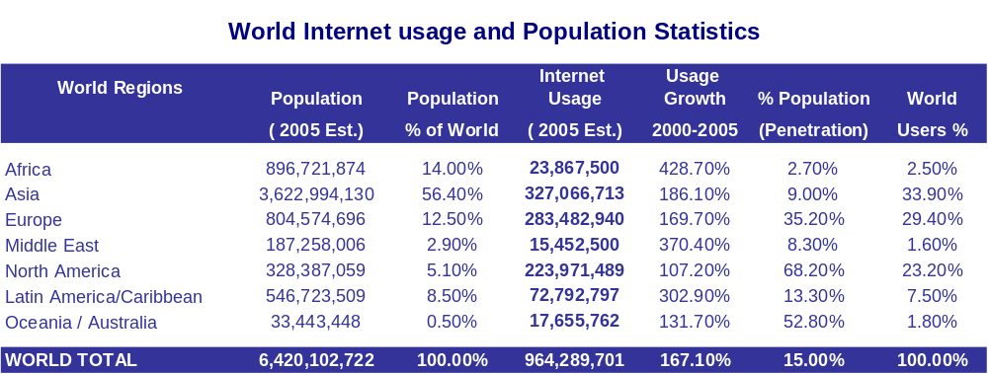

Source: Miniwatts International, LLC. November 05

3.2 eCommerce Market Growth
Though eCommerce sales represent only 1.9% of sales by U.S. retailers, eCommerce sales are growing faster than the traditional in-store credit card purchases.
In 1997, the total U.S. online consumer market was estimated at $2.4 billion (Source: Forrester Research). In 2004 it was estimated that the total U.S. business-to-consumer online sales was $144.6 billion, a six year compounded annual growth rate of 80%. Forrester also estimates that U.S. eCommerce revenues for 2005 will be $167.6 billion which represent 16% growth this year. Though eCommerce sales represent only 1.9% of sales by U.S. retailers, eCommerce sales are growing faster than the traditional in-store credit card purchases. Online sales in Europe are growing at an even faster pace. Forrester estimates that eCommerce revenues in Europe were $90.3 billion USD in 2004 and will be $127.4 billion USD in 2005. Israel’s online sales were estimated at 1.4 billion NIS (about $300 million USD) in 2003. It is reasonable to assume that the Israeli online sales will pass $500 million this year (based on an average growth rate of 30% a year).

3.3 eCommerce Products
According to a study made by ACNielsen more than 627 million people have shopped online and over 325 million within the last month, October 2005. The most popular items purchased on the Internet are books (34%), followed by videos/DVDs/games (22%), airline tickets/reservations (21%) and clothing/accessories/shoes (20%).

According to the study:
- Over 135 million people purchased DVDs and/or video games;
- Close to 135 million made plane reservations;
- Over 128 million purchased articles of clothing/accessories/shoes;
- Over 112 million paid for music downloads and/or CDs;
- Over 106 million purchased electronic devices (including cameras, etc);
- Close to 98 million bought computer hardware; and
- Over 86 million made hotel and/or tour bookings.

3.4 Purchasing Habits
Europe and North America have the highest incidence of online shoppers, with Germany, Austria and the UK topping the list, with at least 95 percent of Internet users having purchased online.

As a region, online shoppers in Europe made an average of five purchases in the last month.
Not surprisingly, Europe and North America have the highest incidence of online shoppers, with Germany, Austria and the UK topping the list, with at least 95 percent of Internet users having purchased online.

In Asia Pacific, South Korea and Taiwan rank highest, with at least 90 percent of respondents in the study claiming to have ever made a purchase online, at least six in 10 of whom have done so within the last month.

The world’s biggest online shoppers are in Germany and the UK, averaging seven and six purchases respectively in the past month. As a region, online shoppers in Europe made an average of five purchases in the last month. In fact, most of the markets in Europe display higher average purchases than North America, which showed an average of four purchases last month. In Asia Pacific, where the average number of purchases in the past month is five, online shoppers in markets like Singapore, Taiwan, Australia and China, made an average of five to six purchases in the past month. South Korea, despite its high proportion of online shoppers, generated an average of only four purchases last month. It is Latin America, however, which registers the lowest past month purchasing, with an average of only three purchases.

“Our recent e-commerce studies clearly show an upward trend in global online shopping,” said David Boyd, vice president of Internet Industry Research at ACNielsen. “While there is growth in nearly all global markets, we see that the lesser developed markets are maturing faster than many of their more developed counterparts. It will not be long before we have a nearly level playing field across the globe.”

3.5 Payments methods
Although credit cards represent about 59% of online purchases, a wide spectrum of payment options, such as debit cards, electronic checks, stored value certificates, and online payment innovations such as PayPal are emerging worldwide due to consumer and cultural preferences and differences.
One of the main requirements in e-commerce is the ability to accept a form of electronic payment. Over the years, credit cards have become one of the most common forms of payment for e-commerce transactions. In the early years of B2C, many consumers were apprehensive of using their credit cards over the internet because of fear that their credit card numbers would get stolen. However, due to increased security with credit card companies such as VISA, American Express, and MasterCard, there is widespread use of credit cards over the internet, especially in North America.

With the growth of online commerce market, business requirements and attitudes about electronic commerce have evolved. What began as an online sales experiment for many organizations has become a strategic component of their business plan. Although credit cards have long been the dominant payment method available to online purchasers (about 59% of online purchases done by credit cards), alternative consumer preferences and cultural preferences have impacted the global payment environment. A wide spectrum of payment options, such as debit cards, electronic checks, stored value certificates, and online payment innovations such as PayPal are emerging worldwide. Customers seek a greater access to international markets; Conducting online commerce internationally involves supporting more payment types, currency conversions, new payment processors and mitigating higher fraud risk.

According to the ACNielsen report, for most of the online purchases, a credit card (59%) or bank transfer (23%) were used to make the payment. In Europe, however, cash-on-delivery (COD) is the 2nd most used payment method, following credit cards, in markets like Portugal (35%), Greece (31%), Spain (29%) and Italy (28%), while almost half of online shoppers in the UK used debit cards. Cash-on-delivery is also a popular payment method used in some Asia Pacific markets, ranking 2nd to credit cards in India (29%) and Japan (25%). China is most unique with COD (34%) as the most used payment method, followed by bank transfers (31%). Credit cards rank only third (26%) in this market and is followed closely by money transfers (23%). Yet when asked about preferred methods, credit cards (24%) actually come second to COD (32%) in China, indicating an unmet need for online credit card usage in this market.

An analysis of the findings shows an unmet demand for online payment cards in such markets as Russia, France, Poland, South Korea, Japan and China. In each of these markets, a significant number of people wanted to use a payment card but had to use another method or payment. In Canada, on the other hand, there was an unmet demand for PayPal.

“Our recent regional and country-specific consumer studies show that a major concern in lesser developed markets is the safety of online--and offline-payment methods, while in more developed markets, online shoppers are demanding more sophisticated payment methods,” says Bruce Paul, vice president of Financial Services Research at ACNielsen. “This represents both a challenge and an opportunity for payment card companies and their competitors to understand exact usage drivers as they evolve differently in each market.”

In North America, while credit cards (69%) are still the more commonly used payment method, PayPal (29%) ranks second while debit cards, primarily driven by the US market, ranks third (22%). Although credit cards were also largely used in Latin America, PayPal generates high usage in Brazil, next to credit cards (usage accedes 100% because some users use more than one payment method).

3.6 Online Payment Market
The increase of eCommerce lead companies to manage financial transactions to transpire over the internet. One of the most familiar companies is PayPal (owned by eBay) which allows consumers and/or businesses to send money to anyone with an email address in 45 countries.

The online payment industry in the U.S. is projected to grow to $12.5 billion by 2005 up from $8.0 billion in 2003 according to Celent Communications (based on a survey of over 100 online payment industry executives). Online consumers are looking for additional online payment options, such as simpler ways to pay online and more payment methods (Source: Celent Communications, Feb. 2004).

PaymentOne determined in April 2003 that 24% of US consumers would like simpler and easier ways to pay online and 11% are looking for more payment methods, indicating significant opportunity for the online payments market.
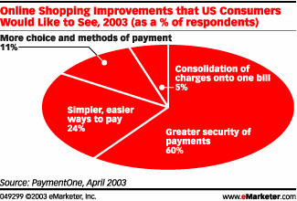

Online fraud has evolved into an organized and systemic threat to online merchants.

The growth of eCommerce has also resulted in more complexity with internal business processes. Online fraud has evolved into an organized and systemic threat to online merchants. The latest report conducted by Mindwave Research in October 2004, concluded that online sellers expected fraudulent transactions to cost them 1.8% of revenues, on average, in 2004. Though that is statistically equivalent to the direct fraud cost projected by the prior year’s survey, the data suggests that the overall cost of fraud, which includes the cost of fraud management and the rejection of good orders, continues to rise. The cost of fraud management is incurred, for example, when merchants require manual intervention, a step that slows order processing and increases costs.
Online merchants are finding the need to maintain technical and financial connections with a number of different payment processors and service providers integrate those disparate connections with a number of internal business systems, allocate manual resources to keep up with the pace of online sales, and comply with statutory requirements.
The combination of these market trends is making the management of electronic payment transactions more complex. Online merchants are finding the need to maintain technical and financial connections with a number of different payment processors and service providers integrate those disparate connections with a number of internal business systems, allocate manual resources to keep up with the pace of online sales, and comply with statutory requirements.

4. OnlineCash’s Solution
OnlineCash aims to consolidate the following methods into its electronic wallet solution:

- Credit Cards
- Debit Cards
- Bank Transfers
- Cash Deposits
- Existing electronic payment methods

OnlineCash puts order in the chaos of online payments by consolidating the various online payment methods into one simple elegant interface that users find easy to use. The system is simple and consistent all the way through. Users can view their transaction history, and analyze their spending.

OnlineCash aims to consolidate the following payment methods into its electronic wallet solution:

- Credit Cards (Visa, Diners Club, American Express, MasterCard, etc.)
- Various Debit Cards
- Bank Transfers in and out of the US
- Cash Deposits (via worldwide banks & post office locations)
- Existing electronic payment methods (PayPal, Google Wallet, AliPay etc.)

Simple and Cost Effective
OnlineCash is the ultimate solution for online merchants and provides them the best and easiest tools for online customer billing using a growing number of payment methods. OnlineCash focuses on enabling its customers to meet market requirements in a simple and cost effective manner and to provide a single source solution that simplifies and optimizes online payment.
OnlineCash will also offer a debit card to its customers, which they can use to pull cash out of their OnlineCash accounts from over 900,000 ATMs worldwide.
OnlineCash provides a faster and cheaper system. It takes less time and effort to pay via OnlineCash. The costs are considerably lower than sending money via Western Union™ or the banks. OnlineCash will also offer a debit card to its customers, which they can use to pull cash out of their OnlineCash accounts from over 900,000 ATMs worldwide.

OnlineCash users can easily transfer money to anyone with an email address by using their credit cards, bank accounts, debit card, or by depositing money into their OnlineCash account in advance (bank transfers, the local post office, etc.)

Security
With our solution businesses can concentrate on selling and marketing while OnlineCash is responsible for billing and ensuring the safety and security of the customers and the business.

With OnlineCash's solution businesses can concentrate on selling and marketing while OnlineCash is responsible for billing and ensuring the safety and security of the customers and the business.

OnlineCash uses several layers of security. Some of the security measures are technical while others are built into the business process of the system to combat online fraud, phishing and information theft.
As a basic security feature, all communications between the user and the system are encrypted with a 256 bit SSL key, for maximum security. This mechanism is known to prevent information theft, and various “man in the middle” attacks. Mail sent to users never contains sensitive information and never requires the user to either login or enter his personal details, eliminating the problem of phishing and mail based information theft.
The system is more secure than credit cards. In contrast, without OnlineCash merchants that obtain their customers’ credit card details may charge as much as they want, whenever they want and sometimes without the users’ consent.

The system is more secure than credit cards, because the user decides when and how much money to send. Both users and merchants are verified by OnlineCash. Every single transaction is verified and approved. In contrast, without OnlineCash merchants that obtain their customers’ credit card details may charge as much as they want, whenever they want and sometimes without the users’ consent. Worse still, those details may be passed on to third parties, or the details can be stolen and abused. OnlineCash protects the information transferred to it using every available security measure. No one, not even OnlineCash personnel has access to the customers’ information and the chances for fraud are dramatically reduced.

The OnlineCash website has SSL certification. To protect OnlineCash from fraudulent transaction the SafeCharge fraud detection system will be integrated into the system. This will add a series of verifications and tests to the transaction process and will create one of three possible outcomes:

- The transaction is deemed “safe” and automatically approved
- The transaction is deemed “unsafe” and is automatically rejected
- The transaction is given a "maybe" status. A decision about whether to approve the transaction can be done manually. An automatic interface to handle the "maybe" status can be developed.

OnlineCash Cards
OnlineCash has strategic cooperation with -Card, a bank in Canada, a Credit Card issuing bank.
OnlineCash offers a Debit Card that integrates seamlessly with the OnlineCash website. Card transactions are protected with a 4 digit pin code. OnlineCash has strategic cooperation with -Card, a bank in Canada, a Credit Card issuing bank. The card is issued by MasterCard International and enables the holder to perform the following actions:

- Transfer money from card to card, for the cheapest international instant cash transfers to anywhere on the planet (transfer fees as low as $4.5).
- Withdraw cash from more than 900,000 ATM machines worldwide
- Send cash from the card to another OnlineCash account
- Deposit cash into the card from an OnlineCash account or a Credit Card
- Check your card balance and view your card purchases on OnlineCash

How does it work?
OnlineCash Accounts are loaded using a credit card, bank transfer, or cash deposits. To make an OnlineCash payment a customer simply presses the button on the OnlineCash website or place a simple phone call to the OnlineCash automated teller system. Customers wishing to transfer the received funds from their OnlineCash account to a bank account must pay the transfer fee in addition to the transaction commission.

OnlineCash does not hold any of the funds transferred to it. It is a financial CHANNEL only. All funds are accumulated in a dedicated OnlineCash bank account from which money can be transferred to the customers' bank account upon request. Cost of such a transfer is transferred to the customer.

System Structure
At the first stage the system will allow online merchants to charge customer credit cards (except Diners) without dealing directly with the credit companies. Making a payment in the system creates a disposable account, used once for a specific transaction only.

Later on OnlineCash will expand the pool of services offered by the company like adding interface to existing electronic payment methods such as PayPal, AliPay, Google Wallet etc., to help achieve the OnlineCash goal of consolidating all payment methods in one Electronic Wallet.

The system includes several main components:

- Credit Card transactions charging commission from either debtor, creditor or both
- Invoice and receipt production - a PDF Invoice Creations system which operates according to Israeli accounting requirements and allows flexible production and production of copies of Invoices. The Invoices will all be electronically signed by a legally accredited entity. Invoices and receipts must be digitally signed using either a homebrewed semi secure signature or a dependant HSM mechanism that will supply unique signatures.
- Credit Guard Service Integration – Receipt and processing of information received from the Credit Card Companies via Xor's Credit Guard system
- Customer credit rating tests – testing the amount of risk involved in a transaction and approving / denying it accordingly.
- Controller Class & Feedback system - matches transaction to actual CC company payments.
- Graphic User Interface
- Transaction Rollback
- Action Rerun
- Safe Charge Service Integrating – Integrating transaction security checks into the OnlineCash Transaction process.
- Electronic security – SSL Certification for the web which insures security of data transmitted through the web site
- Electronic Signature – PKI process to electronically sign system generated invoices & receipts.

5. Competitive Analysis

5.1 OnlineCash Advantages for Merchants
- The quickest, cheapest and easiest method to start accepting credit cards online
- XML API to accept credit cards directly on the customer own website
- secure payment pages with SSL certificate
- Accept multiple payment methods on the merchant’s website in a single step
- Bill anyone with an email address

5.2 OnlineCash Advantages for Buyers
- Money transfers to anyone with an email address, 24 hours, 7 days a week
- Free money transfers within OnlineCash
- One place to manage bank accounts and credit/debit cards
- Highest level of information security. Merchants or recipients do not have access to buyers payment details
- No mail phishing, messages and notices are always kept within OnlineCash.

5.3 Competition
Even the service of the category leader PayPal, is limited to specific regions. In Israel, a PayPal user can not withdraw the money that was accumulated in his account.
There are companies operating in the online payment industry and offering services similar to the company. The most familiar company is PayPay which gained until today 86 million users. Online payment companies are very different from one another, each concentrating in a specific niche in the huge eCommerce market. For example some of these companies concentrate in clearance and billing services to very large companies (like WorldPay), other offer online payment solution on a local area basis (like nochex in UK). In recent years, with the growth of marketplace and auction websites like eBay, new kinds of online payment services are introduced offering money transfers between private people, like PayPal, ePassporte, and Click2Pay. PayPal which leads this category was established in 1998 and dominates the US and Europe markets. However PayPal’s service is limited to these specific regions, even in Israel, a PayPal user can not withdraw the money that was accumulated in his account. In countries like Eastern European countries, India, China etc. there is a real need of online payment services.

The company also competes with money transfer services like Western Union that has a dominant global presence.

Below is a brief description of the main companies that offer the online payment solutions.

PayPal
Founded in 1998, PayPal, an eBay company, enables individuals or businesses with an email address to securely, easily and quickly send and receive payments online. PayPal has become a global leader in online payment solutions with 86.6 million account members worldwide. It is available in 56 countries to buyers and sellers on eBay, online retailers, online businesses, and traditional offline businesses are transacting with PayPal.

CLICK2PAY
CLICK2PAY offers various ways of managing money transfers for end users. CLICK2PAY provides a variety of options to load funds to and withdraw funds from a CLICK2PAY account. The account and cash is accessible …. CLICK2PAY transactions can be viewed and managed in the online account-area.

ePassporte
ePassporte offers a payment system and a Visa debit card (with the ability to withdraw worldwide cash wherever Visa is recognized and acceptance. ePassorte offers a secure system. ePassporte cards are issued by St. Kitts-Nevis-Anguilla National Bank Ltd., Basseterre, St. Kitts, West Indies.

NOCHEX
NOCHEX is a privately held company based in Leeds, England. Founded in 1999, and provide electronic money services since January 2001. The services are provided to individuals and small businesses with a secure, reliable alternative payment service in the UK.

WorldPay
WorldPay is a part of The Royal Bank of Scotland Group, the 5th biggest banking group in the world. WorldPay customers accept payments over the internet, by phone, fax and mail and all the major credit cards, debit cards and local payment schemes. The system offers customers services in different currencies and languages. WorldPay has over 20,000 customers trading over the Internet and more than 1,200 strategic banking and e-commerce partners worldwide.

Western Union
Western Union Inc. is a subsidiary of First Data Corp. (public company traded on Nasdaq) and global leader in money transfer (not online). Westren Union offers consumers a quick and easy transfer of money to more than 225,000 Western Union Agent locations in over 195 countries worldwide (it has the largest network of physical money transfer). Western Union has about $3 billion in revenue a year.

6. Business Model

6.1 General
OnlineCash’s main source of income is clearance commission from websites. OnlineCash charges websites an average 4% of revenues generated by the website; about 2% of which is transfers to the credit card companies and OnlineCash has the remaining 2%.
OnlineCash’s main source of income is clearance commission from websites. OnlineCash charges websites an average [xx% confidential] of revenues generated by the website; about [xx% confidential] of which is transfers to the credit card companies and OnlineCash has the remaining [xx% confidential]. There are two main factors influencing OnlineCash’s revenues volume: The number of websites that OnlineCash offers clearance services and the average revenues generated in these websites; growth in both of these factors will increase OnlineCash’s revenues. (In some websites, OnlineCash will operate as a secondary or third clearance company and therefore will enjoy only a portion of the website’s revenues).

OnlineCash intends to position itself as a perfect solution for small businesses that want to expand their activities and go online. These businesses don’t have the resources to invest in an internal clearance system which means to deal directly with the credit card companies and invest a lot of money in security systems etc. OnlineCash is a solution for many other small businesses like free professions -accountants, lawyers etc.; OnlineCash offers them an easy and simple way to charge their customers with credit cards without any initial cost, and without special credit card related equipment (since a lot of customers prefer to pay for products and service with their credit cards). OnlineCash’s solution offers the businesses a way to increase revenues by offering their customers new ways of payment.
OnlineCash intends to position itself as a perfect solution for small businesses that want to expand their activities and go online.
The penetration of OnlineCash to more and more businesses will create a large customer base. The company believes that many customers will find OnlineCash an easy and convenient way to transfer money from one person to another person or business. This will create a viral effect that will increase significantly the exposure in the market and lead to increased revenues. This viral effect works in both sides: satisfied businesses will bring more businesses as well as end users that will bring other end users. In fact, the company has experienced this effect with its current websites; other businesses in the same field approached the company and wanted to implement OnlineCash’s clearance system.

Moving money within OnlineCash is free because it does not leave the system. However when money moves into or out of OnlineCash, certain margins are collected by OnlineCash, on top of third party costs. For example Credit Card based transfer costs are 2%-2.6%; OnlineCash charges an additional [xx% confidential] on top of that cost. When money is transferred to an external bank account, OnlineCash will charge only the bank’s transfer fees and will not add any additional costs to its customers.

The second source of income for OnlineCash will come from OnlineCash’s debit card. Any customer, business or end user, can order OnlineCash’s debit card which enables him to withdraw cash from his OnlineCash account in more than 900,000 ATM machines worldwide, as well as pay with the card in any website or any real stores (that accept MasterCard). The company will charge a customer a commission of [xx confidential] for initiating a new card (from that only [xx confidential] will remain in OnlineCash, while the rest is the credit card company commission). In addition, for every transaction made with the card, OnlineCash will charge [xx% confidential] (which is relatively low compared to the current commission other companies charge). The model assumes an average of 4 transactions per month per user holding OnlineCash’s debit card.
OnlineCash will also earn revenues from OnlineCash’s debit card - a commission of $7.5 for initiating a new card, and additional $0.3 for every transaction made with the card.
OnlineCash offers the cheapest way to transfer money from one country to another.
The third source of income will be international money transfers. OnlineCash offers the cheapest way to transfer money from one country to another compared to competitive companies, especially in small and medium size transactions. These services will offer businesses and private users the ability to transfer money easily, quickly and cheaply. OnlineCash will charge businesses a fee of [xx% confidential] commission from the total amount transferred and private people a fee of [xx% confidential] commission.

6.2 The Marketing Plan
OnlineCash plans to concentrate in the beginning on establishing high quality and unique service in Israel which will also act as a beta test. Later the company will expand its operation outside Israel.

At first, OnlineCash targets countries that do not already enjoy similar systems. A pre-pilot is being deployed in Israel, a country that has the infrastructure but lacks the service. Hundreds of auction sites and online shops exist in Israel and OnlineCash offers a service that is much needed! The next target markets are Middle East countries (the company already has a potential partner in these areas), Europe, China, Russia, US, India, Egypt & Africa and Japan. More and more people choose to do their business online, with people from further and further away. The need for an easy, affordable way to transfer money is only going to grow with time.

In Israel the company will use its connections and closeness to the market to attract hundreds of website each year. The company plans an aggressive marketing effort, reaching almost XXX websites (most of which are new website of small businesses) in the first year in order to capture a large market share and position itself as a market leader in the field of online payment in Israel. The company will use resellers to bring new customers that will enjoy a commission of [xx% confidential] on average from OnlineCash’s revenues from these customers. The model assumes that about 40% of the revenues in Israel will come from resellers. The company believes that there will be a strong viral effect of new businesses and users based on word of mouth from satisfied customers.

Outside of Israel, The Company will contract a local partner and establish a franchise which will be held XX% by OnlineCash and XX% by the local partner. The partner will also pay OnlineCash a small initial license fee of about [xx confidential]. The local partner will be responsible for all the legal and administrative activities involved in the services and manage and operate the local company including establishing marketing abilities to bring new customers and position OnlineCash as a market leader in the specific country.
Outside of Israel, The Company will contract a local partner and establish a franchise which will be held 50% by OnlineCash and 50% by the local partner.

6.3 Methodology
Since the company will initially beta in Israel, a detailed revenue model was built for revenues in Israel. With the company’s expansion to other countries, revenues are expected to rise. The revenue model for countries outside Israel was built based on the assumption that the company will establish a local franchise in each country it operates in, with a local partner that will hold XX% of the local company (meaning that OnlineCash’s share will be XX% of revenues). Expenses will occur on the local partner.

In order to estimate potential revenues in Israel, The Company divided the market into 4 groups of different kinds of websites.
- eCommerce website – websites that offer products and goods
- Non Profit Organizations – organizations that receive donations through the websites.
- P2P (person to person) website – websites that offer exchange of products between private people (like eBay).
- Small Businesses - like accountants, lawyers, Zimmers etc., that offer services to private users.

For each of these websites groups, estimations were made for each of the forecast period regarding the number of websites OnlineCash will penetrate and the average amount of revenues that each website will generate (per average month). OnlineCash revenues from clearance (only OnlineCash’s share) are [xx% confidential] of the websites’ revenues.

In addition, The Company estimates the number of websites that will order OnlineCash debit card, as a percent of total websites. The model assumes that only small business will order OnlineCash’s card, starting from X% and increasing to XX% in 2010. Further estimation was made regarding the number of users that preformed transactions in the system and the percent of them that will order OnlineCash’s debit card (from X% at the beginning of the first year and up to XX% on average). The following table presents the average purchase per user per month.

Websites Average purchase per customer
per month in NIS
eCommerce websites 300
Non Profit Organizations 200
P2P websites 200
Small Businesses 300

OnlineCash’s revenues form its debit card include [xx confidential] issued fee per new card and [xx confidential] cents per card transaction (the model assumes an average of 4 transactions per month per user).

Additional assumptions were made regarding the number of businesses and private customers that will perform international money transfers. The model assumes that xx to xx businesses per year will transfer money, and xxx up to xxx (in the fifth year) private users will transfer money per year; and the average amount of the monthly transfers estimated at $X00 per month for business and $X00 per month for private user.

6.4 Revenues Forecast
OnlineCash’s business model has three main sources of income: clearance, debit card and international money transfers. In Israel they represent an average of 78%, 16% and 7% of the total revenues in Israel respectively.
OnlineCash’s business model has three main sources of income: clearance, debit card and international money transfers. In Israel they represent an average of 78%, 16% and 7% of the total revenues in Israel respectively. The company plans to complete the development stage by the end of 2005 and start generating revenues as early as the first quarter of 2006.

Based on the marketing strategy, the company estimates it will reach xxx new websites in 2006. In 2007 the company estimates xxx new websites, xxx new websites in 2008 and xxxx new websites in 2009 and xxxx in 2010. By the end of 2010 the company expects to reach about xxxx accumulated number of websites. The model assumes churn rate of X% per year of total websites. [The numbers in the charts were hidden due to confidentiality]

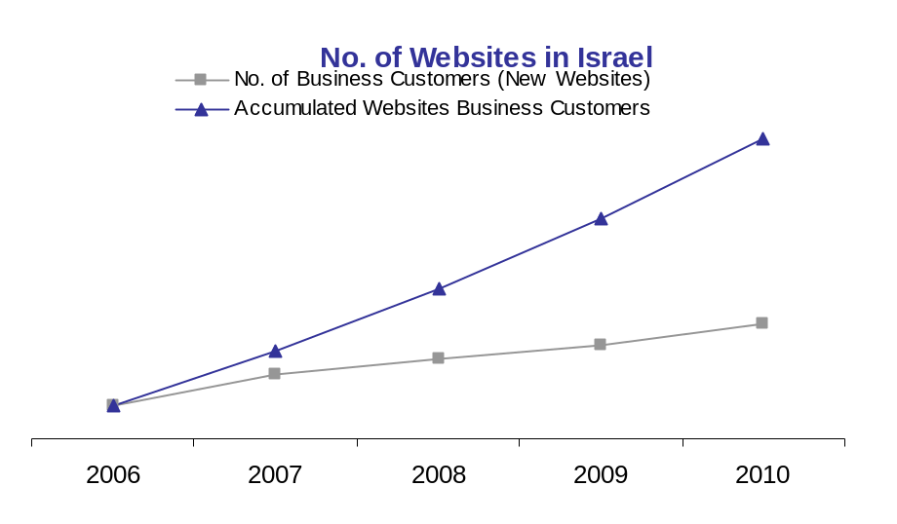
The revenue forecast assumes that new websites will split equally during the quarters. This means that the revenues from new websites will be only X% on average in the first year and XX% in the following year (since some of the new websites will be connected at the beginning of the year while others at the end of the year). The revenue model also assumes that a website that joins OnlineCash’s services will continue to use it during the next few years (with a X% churn rate).

In order to estimate OnlineCash’s share of the Israeli market, assumptions were made regarding the eCommerce market growth for the next 5 years (starting from XX% in 2006 and decreasing gradually to XX% in 2010). OnlineCash will grab market share from existing and new Israeli internet sites that use credit cards as their primary payment method. Based on these assumptions, OnlineCash is expected to capture X% of the market in 2006 and up to X% in 2010.

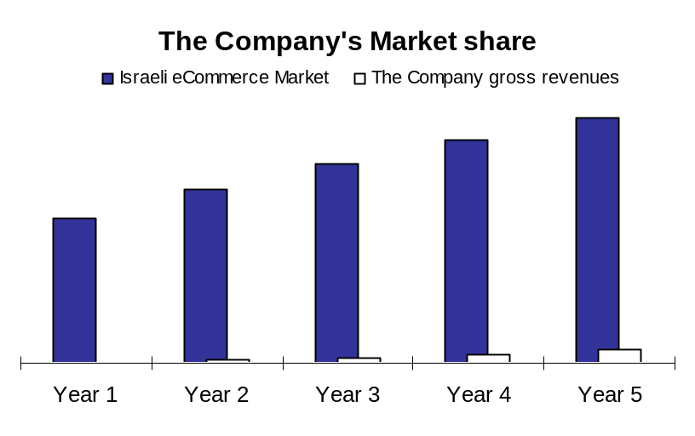

The following chart and tables present OnlineCash’s revenue forecast for the next 5 years from Israel and the Rest of the World.

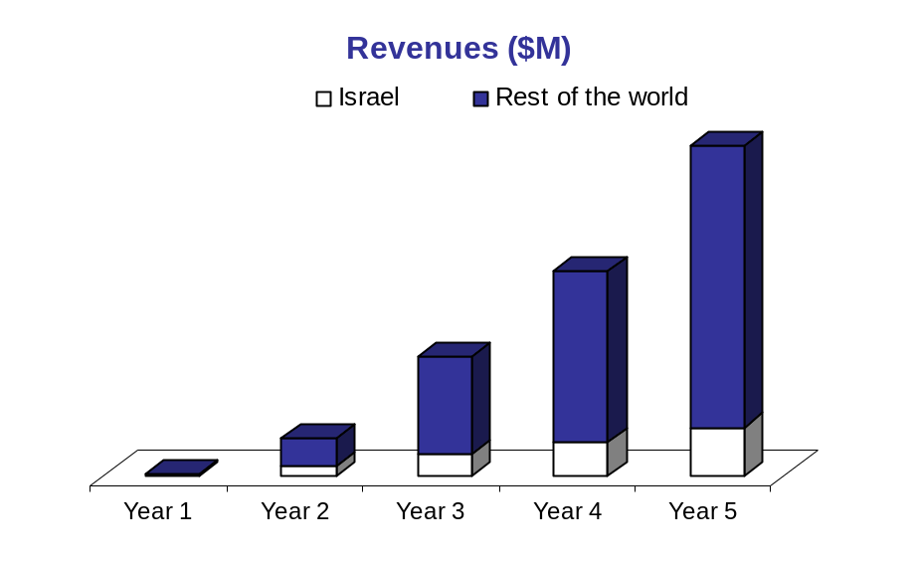

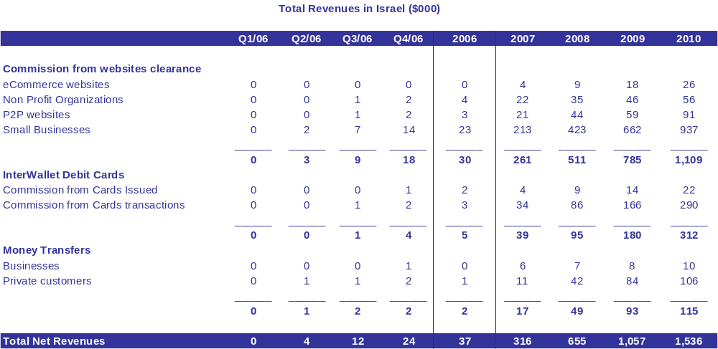

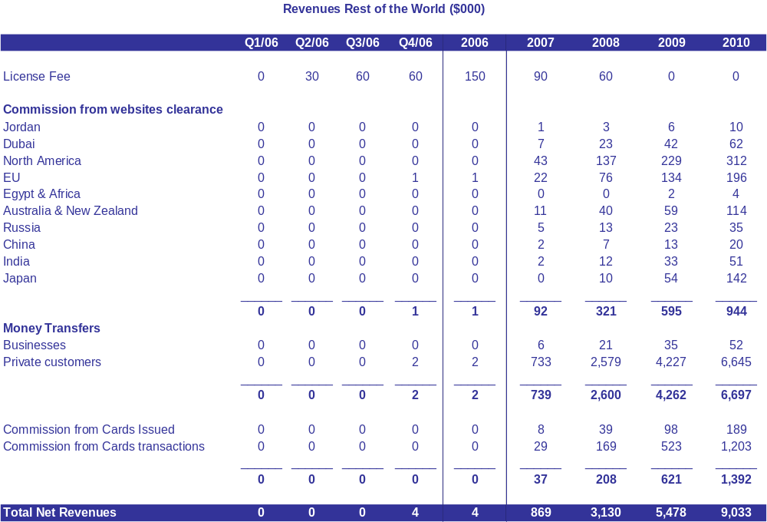

7. Financial Forecast

7.1 General
OnlineCash’s financial forecast was drawn for a 5-year period starting from FY2006 to FY2010. The first year, 2006 was presented in quarters to enable better insight of the initial stage growth pattern. All figures are stated in thousands of Dollars.

7.2 Manpower
OnlineCash’s total staff is expected to grow from 11 people at the first quarter of 2006 to 15 by the end of 2006, up to 20 people in 2007 and totaling 25 people in 2010.
The company’s manpower setup comprises of three main departments: management, marketing and R&D team. The R&D team consists of a small team of highly professional members that developed the system. This team will grow in accordance with the increase in revenues.

OnlineCash’s total staff is expected to grow from 11 people at the first quarter of 2006 to 15 by the end of 2006, up to 20 people in 2007 and totaling 25 people in 2010.

The attached tables show the projections for the number of employees and the overall wage expenses anticipated during the 5 years of operation. The salaries table includes in the left column an annual salary per position (employer cost including social benefits). The salaries at 2006 are relatively lower until the company will reach a breakeven point. From 2007 and onwards, an annual increase of 15% in all salaries is included.

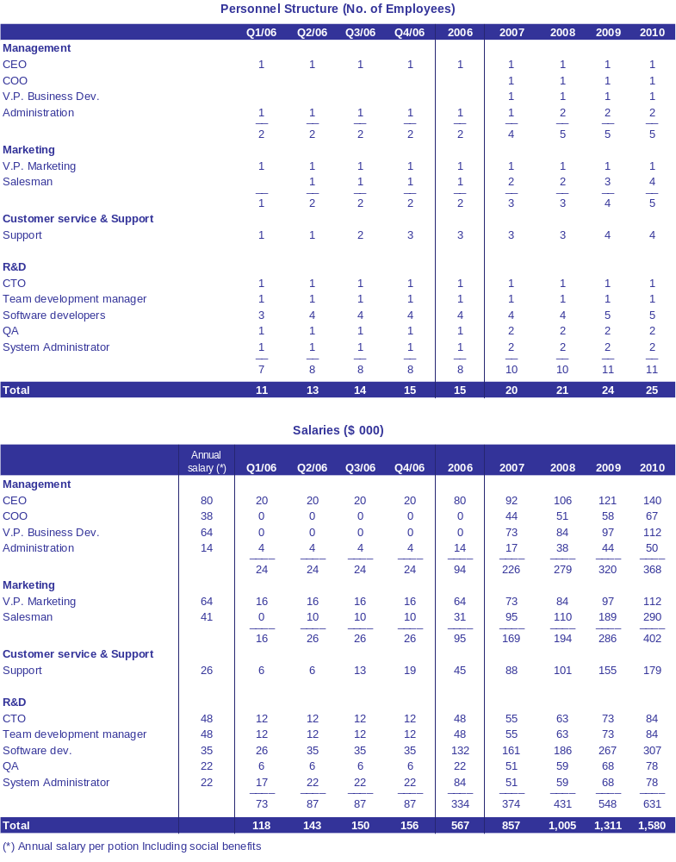

7.3 Customer Service & Support Budget
The Customer Service and Support budget includes a few technical support personnel in Israel in addition to an outsourcing company that will be responsible for telephone support at the price of 2NIS per minute. (The model assumes an average of 10 minutes customer support per customer per year including all customers, old and new). The company’s foreign franchises will have a local support service. This budget also includes servers and communication expenses and other.

7.4 The Sales & Marketing budget
The Sales and Marketing budget refers to the Israeli budget; foreign offices expenses will occur on the local partner. The S&M budget includes salaries to sales team, a large amount of commissions to resellers, travel expenses, Marketing and PR Materials and other.

7.5 R&D Budget
The R&D budget includes salaries of the R&D team, travel, training and car leasing for R&D team and other. Future development in the system includes performing transactions using a cell phone, direct bank transfers – sending an order to transfer money from a bank account to an OnlineCash account without using a visa card, technological features, and automatic transfer to customer bank account upon request.

7.6 The General & Administrative Budget
The General and Administrative budget includes mainly salaries, legal and auditing, travel expenses, and office rental and maintenance. These costs will remain relatively low until the company personnel and operation will grow over the years.

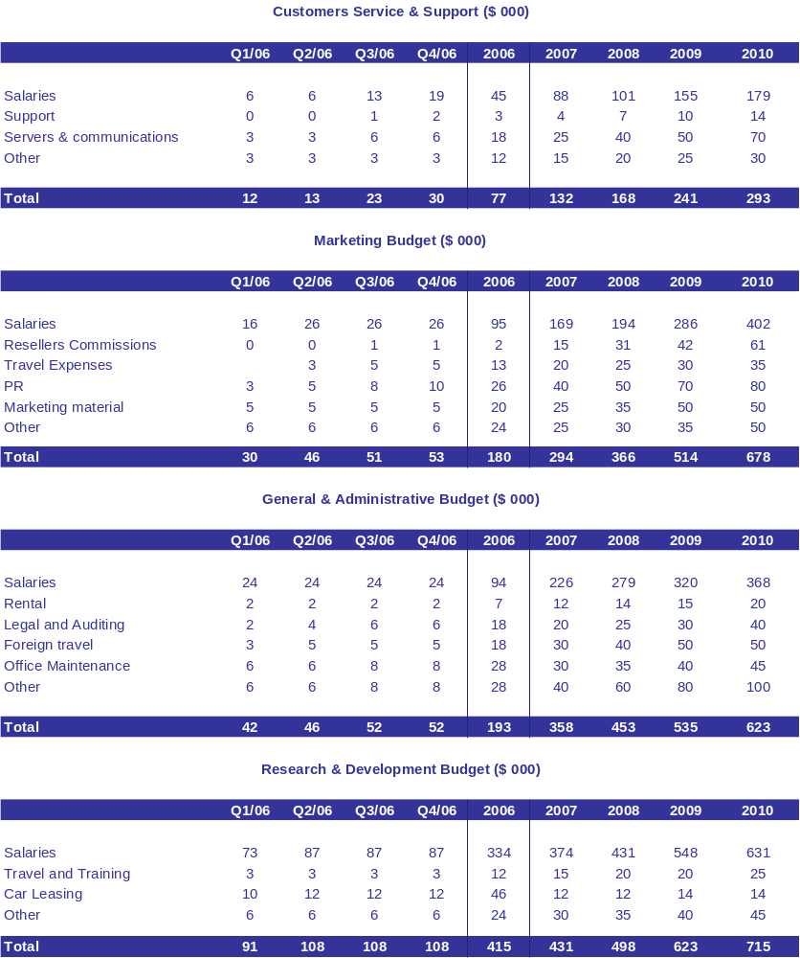

7.7 Profit & Loss & Cash Flow Forecast
In its first quarter of operation (2006), the company is expected to post a loss of $821 thousands in 2006. In 2007 the company is expected to reach a breakeven point with a small loss of $31 thousands. In 2008 the company is expected to report an operating profit of $2.3 million and an operating profit of $4.6 million in 2009 which is expected to grow to $8.3 Million in 2010.
In 2007 the company is expected to reach a breakeven point with a small loss of $31 thousands, followed by operating profit of $2.3 million, $4.6 million, and $8.3 million in the following years.

7.8 Financial needs
Management is seeking funds to support the development and marketing of its services. In addition, management will use the funds to properly implement the platform, intensive marketing and sales program, recruit additional staff, and acquire the resources needed to expand the company’s global operation. The company is looking to raise $2,000,000 in funds to meet these goals.

The following tables present the company’s Profit & Loss forecast.

