# UART(universal asynchronous receiver-transmitter)

**GENERAL**

Uart is a srerial protocol, it is used to communicate over a single wire. It takes a data byte and transmits it bit by bit. The receiver side collects data bit after bit to a complete byte.

**Specific parameters**

Each symbol is consist of:

* 1 start bit (1'b0)
* 8 data bits
* 1 stop bit (1'b1)
* (no parity)

Each bit (data, start, stop) duration is 8700ns.

Uart line is 1'b1 when Idle.

Transmitter de-assert the line to issue a start bit, then puts data bit by bit, then assert the line to issue stop bit.

Receiver waits for line to de-assert, then sample the line for each bit in the middle of the bit, then wait for stop

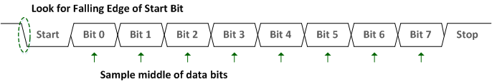

The module receives data over the **rx** input and transmit it over the **tx** output

|  |  |  |  |
| --- | --- | --- | --- |
| **module uart** | | | |
| **description** | **width** | **input/output** | **name** |
| System Clk 100ns | 1 | i | clk |
| Reset active high | 1 | i | reset |
| UART Signals | | | |
| uart Rx | 1 | i | rx |
| uart Tx | 1 | o | tx |