Rowing Training System :)

Analysis:

Introduction and justification of the program

Justification of why the problem is solvable by computational methods

Thinking WHY

Thinking Ahead

Thinking Procedurally

Thinking Smart

Stakeholders

List of stakeholders

Interviews

Interview Summary and Conclusion

Research of the problem:

Existing solutuons:

X

Y

I have Ran out of generic place holders



I hate Plotwists

Im scared of irony

AAHHHHH

Remember to delete this.

Essential features

Limitations

Hardware requirements

Software requirements

Success Criteria

# Introduction and Justification of the program

As an athlete, I can train up to 12 times a week. And there is currently no easy way to communicate (and show off) scores and results of training. There is also no easy and clear way for a coach to communicate when a session time has changed or when it is cancelled. I aim to create a website and digital system in order to allow for:

* An Easy, Clear and intuitive method for a Coach to create a training schedule
* An Easy, Clear and intuitive method for a Coach to communicate a training schedule
* An Automated system to alert effected athletes on changes to the status of a training event
* An easy and intuitive way for athletes to communicate (show off) scores and achievements from training and events to other athletes. And view others scores.
* An easy way to view a digestible training program

The website lends itself to a computational approach because in a school enviroment it is a common occurrence for athletes to be confused about whether a training session is happening, which can lead to them missing a session or arriving to a session that is not happening. By creating a website to allow athletes to view an automatically updating and easy to use and digest website instead of scouring through outdated emails, this will be prevented.

The Website also lends itself to a computational approach because the current state of students recording their training is at best taking pictures of the erg machine screen only to be lost in the void…..

By making this website scores and achievements will be easy to store and view so athletes and coaches can track their progress.

# Justification of why the problem is solvable by computational methods.

Thinking WHY.

My solution/product will aim to:

* Streamline the process of Making a training schedule in order to save coaches time and confusion.
* Allow athletes to view a time table which will avoid confusion about a schedule
* Allow athletes to communicate training scores and achievement between other athletes and coaches

The solution will Improve upon the current system of pure text, hard to digest emails.

Thinking Ahead.

I can break my inputs down into Three sections:

* Creating an account
* Creating a timetable
* Entering training data

Creating an account:

There will be 2 types of users, coaches and Althletes, however both will need similar data to create an account.

For coaches:

* First and last name
* Optional Account Description

For Althletes:

* First and last name
* Optional account description
* optional Sporting scores (e.g: rowing 2k: 6min 20)
* optional sporting achievements (e.g 2022 winner of ladies challenge cup HRR)

Creating a timetable:

When a coach creates a timetable, they will need to input data per session to create a timetable for a defined group of athletes:

* Session name
* Session type
* Session start and end time
* Session location
* Is it recurring or not, how often, (e.g. every week on a Monday) if so this will be automatically plotted)

Entering training data:

An athlete will be able to input training data in to ways. By clicking on a past session and attaching the relevant data to the session or inputting data from a session not on their timetable.

When clicking on a past session:

* Set time and distance achieved or set distance and time achieved
* Average split time.
* Optional: average stroke rate.

When inputting data from a session not on their timetable they will need all the previous data stated as well as:

* Session date and time.

Thinking Procedurally

Because of my history with rushing into things and creating a rather messy solution to things, I will approach the problems I will face with decomposition to break down the problem to try and ensure I solve the problem efficiently and effectively.

Thinking Smart

I will need to consider the use of the features I will be implementing and how they will be used in order to deliver them effectively. For example many users will need to be able to upload data and create and view timetable at the same time, so I must consider this in my approach.

# Stakeholders

My aim with the stakeholders is to present them with the best possible product, therefore I will conduct interviews with a varied group of people in order to gain a better understanding of what they want and how I can build the product to suit the users.

One of the main stakeholders will be Stefan Lawrence, he is the coach that handles almost all the rowing sessions at my school and will be one of the coaches using the product. My aim when interviewing him will be to learn about fine details that would make the current proposed product more usable and convenient for him as well as to uncover any features that he may want that I have not thought of including.

Another stakeholder will be Joshua coulter, Josh is a dedicated athlete and regularly attends training sessions but is also constantly unsure when they are, what is going to happen during them and whether recurring sessions are going ahead. This makes him an ideal stakeholder as the product aims to solve all of his problems. Josh also tracks his scores and loves to show off, so the product would streamline the process of tracking his progress and displaying it to others in his group.

The final stakeholder will be Henry Sullivan-Porteous, Henry is a slightly more casual rower and does not attend all sessions, the product will allow him to continue to be aware of sessions he does not regularly attend and has previously stated that he would find an automated system to tell him when sessions have been cancelled useful. He will also represent the need of the more casual rower and will therefore expand the target userbase therefore make a product suited for more people.

Interview with Henry Sullivan-Porteous:

1. How often do you record your data:

After most sessions

1. When you don’t record your data, why don’t you?

I Forget or can’t be bothered

1. When you cant be bothered, why?

I have Difficulty in the long current process

1. How useful would you find a website to record your data?

A Program would be helpful

1. How important is the ease of use of the website?

Streamlining the process will help and make the program appealing

1. What is your current method of recording data?

With the camera app on my phone

1. Would compatibility with photos be useful?

Yes, an easy way to transfer picture to data would be helpful

1. What would be your main objection to switching systems?

It would need to be worth the extra time using the website, ideally the process would be as quick as possible

1. Do you like to show off your athletic achievements?

I would like to however I do not have a way to efficiently show off my achievements to others, so a website to allow me to do this would be helpful

1. How do you like to organise the majority of your training data?

By date.

1. Is there any specific way you would like to show off your data?

I think a way to show the total distance rowed and total time rowed on my profile would be cool. As well as a Leaderboard in groups and global

1. What is your experience with understanding when sessions are on and when they have been cancelled?

I am often confused when sessions are on, I would like an emails system to describe all session details weekly and say if regular sessions occur or not.

Interview with Joshua Coulter:

1. How often do you record your data?

After all sessions, as much as possible.

1. What allows you to record all your data?

I record my data by taking pictures with my phone, so it Is quick and easy.

1. Would you say the speed of recording data is the most important factor when you consider how you record it?

Yes.

1. How useful would a website be to help you store your data and visualise your progress?

An easy was to see my progress over time would be great, however the value the site provides must make any extra time spent recording the data worth it.

1. Would compatibility with photos be useful?

Yes

1. Do you like to display or/and show off your athletic achievements to others?

Yes I do, however I have been told that I am not discrete in my methods so a more passive way of doing this would be useful.

1. How do you usually organise your training data?

By date, as in my experience this allows me to best see my progress.

1. What is your experience of understanding whether sessions are or aren’t occurring?

I find the current system makes it hard to find the up to date schedule and even this is sometimes incorrect.

1. Would an email system be useful in order to alert you when sessions are on or off?

Yes.

1. Would you prefer a weekly email which summarises all the sessions or a system that alerts you when sessions are cancelled?

I think a weekly email that summarises all of the sessions in the week would create a kind of one stop shop which would make it easier, although a system to alert me when sessions change would also be useful as sessions can change with late notice so the weekly summary might become outdated.

Interview with Stephan Lawrence.

How to you currently organise your training sessions?

I have a rough idea in my head of what I want to do in each session, I go from there

# Researching the problem

Existing Solutions:

Strava:

Strava is a popular Fitness website and app targeted at athletes and enthusiasts. It is focused in tracking and sharing the data from physical activities.

The site uses may pages which separate the different uses of it. This also helps the site look spacious and usable whilst also looking professional.

The Homepage looks professional and acts as a summary for the website.

It has a simple colour scheme which helps make the site easy to digest and relatively easy to navigate.

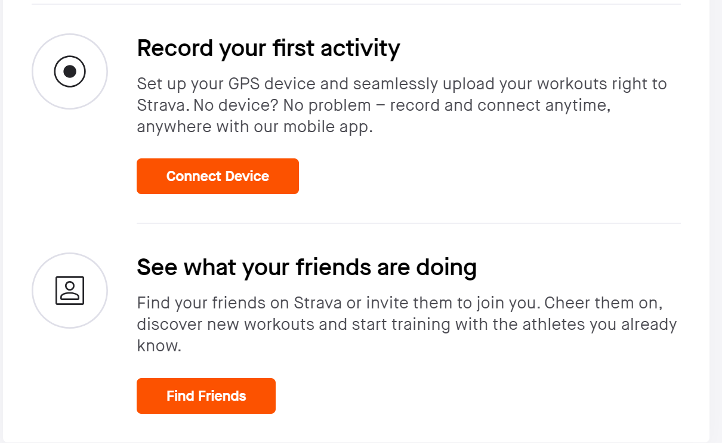

The Homepage features boxes which advertise some of the uses of the site which helps introduce new users to ensure they are not confused or overwhelmed.

The homepage features a small box in the corner displaying some basic user data, this ensures that the user knows they are logged in and makes the experience feel personal.

The training calender is spacious and intiuitive which makes the page easy to navigate, The count in the corner gives an easy way of tracking progress, by clicking on one of the month boxes you get this:

The in-depth calendar of the month features a similar design which gives it a familiar feeling which makes the pages feel connected and intuitive and easy to navigate.

The “Training Log” feature offers data visualization and analysis of inputted training data, Although this feature is behind a paywall I have managed to find and screenshot.

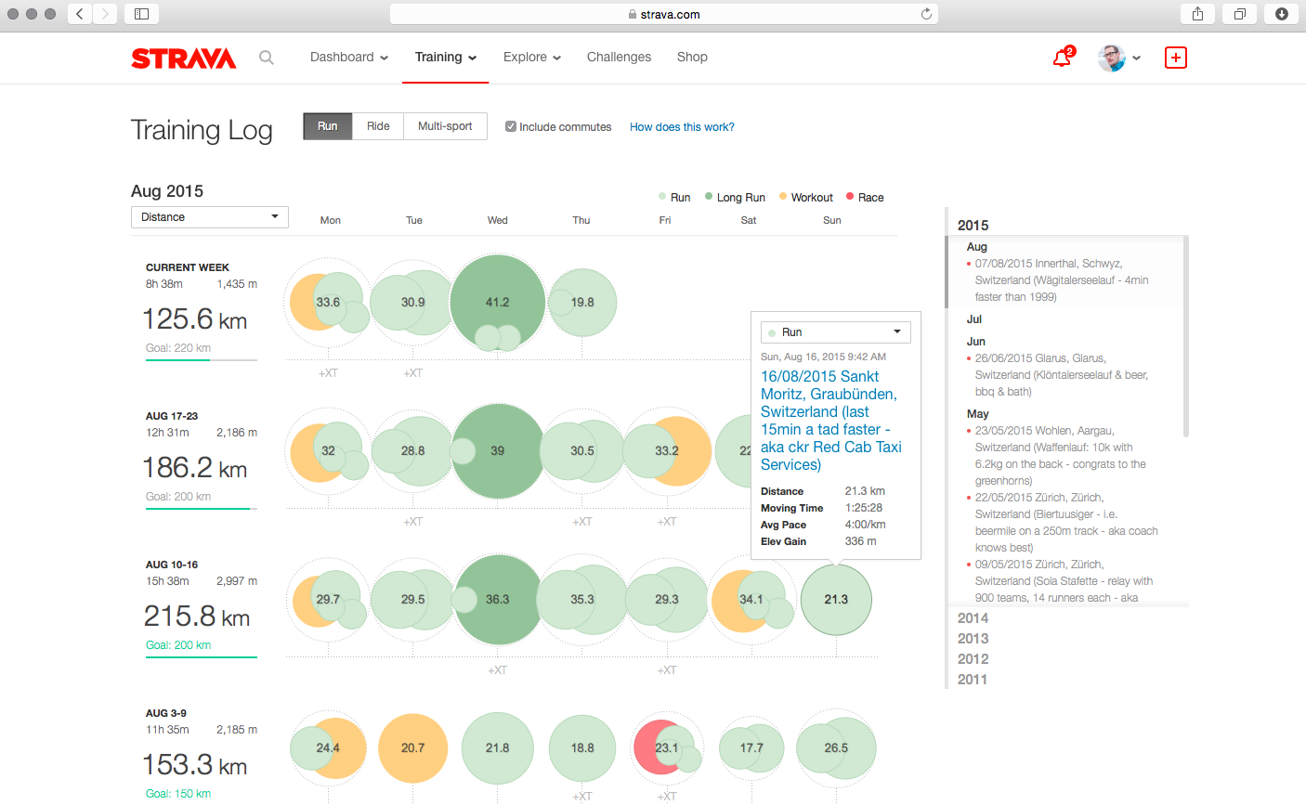

The way the data is presented provides a digestible view of training data over time and compares it to a goal.

From this website I understand that my website must be easy to navigate in order to provide a friendly user experience, and that training data must be easy to digest to allow users to analyse it easily. I also know that a homepage presenting a overview of all the uses of the website would be useful to provide a better user experience.

Socs:

Socs is a simple timetabling system used by many schools in order to show a visual time table. The schools can assign many lessons/sessions to different groups, and individuals can also add other sessions as a single or recurring event.

The main page of the website serves its main purpose of displaying a timetable. The page features a simple, soft colour scheme and a neat design.

Days are sorted into individual collums:

Which consists of a collum of activities throughout the day.

The box contains all the information about the activity including time, location and a name of the activity

The single event page (not recurring) looks like this:

The date is inputted by selecting a date when this pops up:

This method of input makes the process quick and also because it does not take in text and instead takes in the date by pressing it, ensures it is in the correct format.

The page overall is simple and therefore efficient, however is not the most digestible or visually appealing.

The reccuring page is similar:

It features the same inputs as the single event page, as well as inputs to find the date range (when it starts and stops happening), and a “recurrence pattern” input, which asks when a event repeats, e.g: it repeats every Monday.

If daily is selected, this appears:

However if weekly or biweekly is selected, this appears:

Hiding these inputs until they are necessary helps compact the page, speed up the input process and make the page more digestible.

From this website I can learn that the website must be easy to navigate and digest and consistent in design. One of the ways I can do this is by hiding unnecessary features and details unless they are needed to simplify the experience.