

Student Name | Afzal Ali Ahmed Shah
Roll no | 2024-SE-04
Semester | 4th
Instructor Name | Engr. Awais
Subject | Database Systems
Course Code | CS-2204
Credit Hours | 2+1
Lab | Open Ended Lab
Date | 21-Sep-2026
Department of Software Engineering

DATABASE MANAGEMENT SYSTEM
OPEN-ENDED LAB MANUAL
Car Rental Management System

Course: Database Management System
Lab Type: Open-Ended
Database: CarGo_Rentals

1. Objective

To design and implement a relational database for a car rental company. The system manages customers, vehicles, rentals, returns, payments and maintenance, and demonstrates normalization, JOINs, a VIEW, a TRIGGER, a STORED PROCEDURE, and optimization.

2. Database Tables
- Customers – stores customer personal and driving-license information.

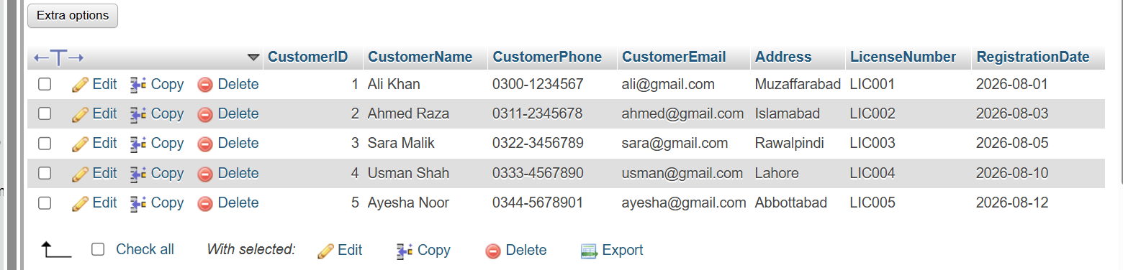
- Vehicles – stores vehicle number, model, type, year, daily rate and status.

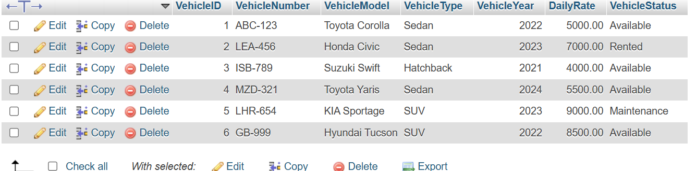
- Rentals – stores customer-vehicle rental transactions and rental charges.

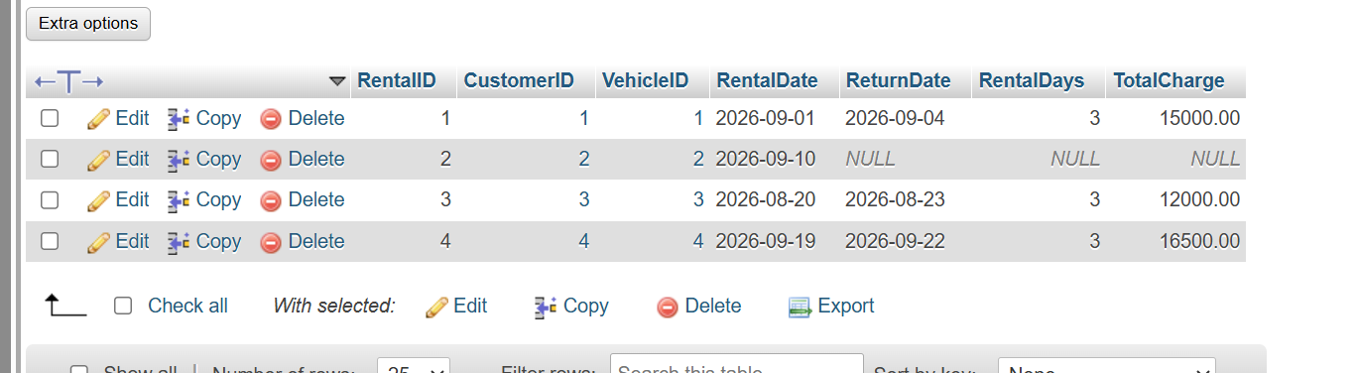
- Payments – stores payment information for rentals.
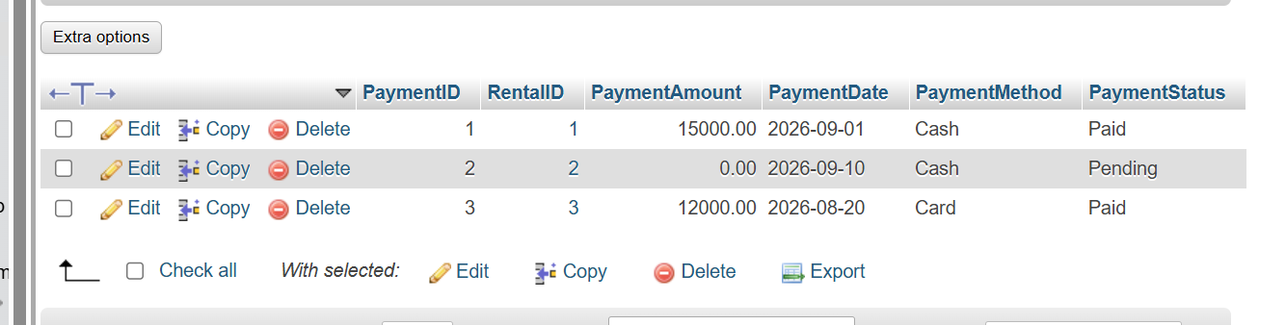
- VehicleMaintenance – stores maintenance history of vehicles.

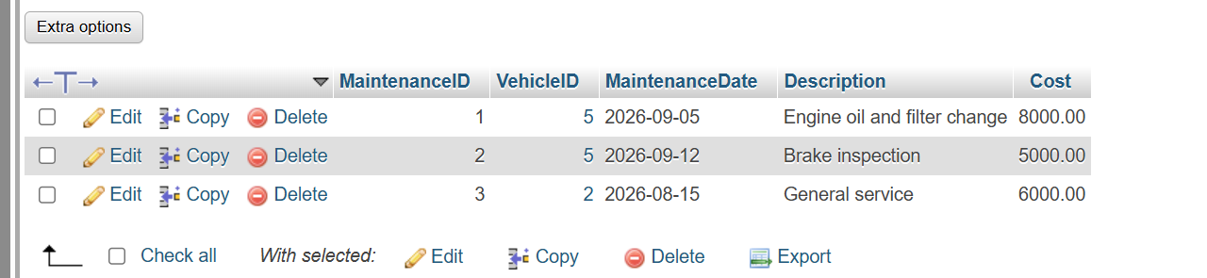
Important design decisions: Customer phone and CNIC and VehicleNumber are UNIQUE; foreign keys preserve referential integrity; CHECK constraints reject invalid rates, dates, quantities and fees; and DailyRateAtRental is stored in Rental so historical charges remain correct if the vehicle's current rate changes.

3. Relationships
One customer can make many rentals. One vehicle can be rented many times over its lifetime. Each rental belongs to one customer and one vehicle. Each rental can have one payment. One vehicle can have many maintenance records.

4. Task 1 – Database Design and Implementation
Run the supplied CarGo_Rentals_Complete.sql file in phpMyAdmin. It creates the database, tables, constraints and realistic sample data.

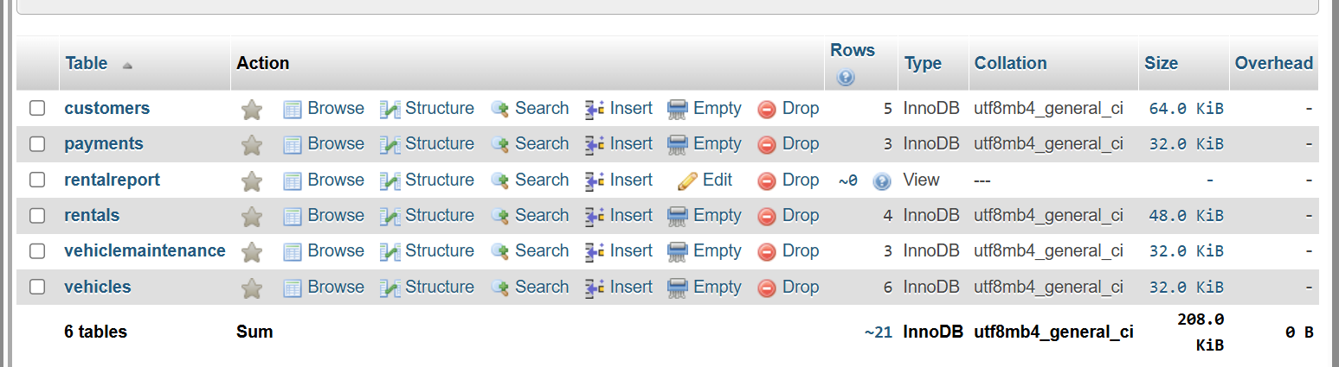

5. Task 2 – Normalization

5.1 Original Unnormalized Record
RentalID | CustomerName | CustomerPhone | VehicleNumber | VehicleModel | DailyRate | RentalDate | ReturnDate | PaymentAmount
R001 | Ali Khan | 0300-1234567 | ABC-123 | Toyota Corolla | 5000 | 2026-09-01 | 2026-09-04 | 15000

5.2 First Normal Form (1NF)
A table is in 1NF when every attribute contains atomic values and there are no repeating groups. The original rental record has atomic values, so it can be represented as a 1NF relation:
RENTAL(RentalID, CustomerName, CustomerPhone, VehicleNumber, VehicleModel, DailyRate, RentalDate, ReturnDate, PaymentAmount)
Problem remaining: customer and vehicle information is repeated whenever the same customer rents a vehicle or the same vehicle is rented again. This can cause update, insertion and deletion anomalies.

5.3 Second Normal Form (2NF)
2NF requires the table to be in 1NF and to have no partial dependency on part of a composite key. For this system, customer and vehicle details are separated from rental transactions.

CUSTOMERS(CustomerID PK, CustomerName, CustomerPhone, CustomerEmail, Address, LicenseNumber)

VEHICLES(VehicleID PK, VehicleNumber, VehicleModel, VehicleType, VehicleYear, DailyRate)

RENTALS(RentalID PK, CustomerID FK, VehicleID FK, RentalDate, ReturnDate, RentalDays, TotalCharge)

This prevents storing the same customer and vehicle details repeatedly in every rental record.

5.4 Third Normal Form (3NF)

3NF requires the table to be in 2NF and to have no transitive dependency. Customer attributes depend on CustomerID, vehicle attributes depend on VehicleID, and payment attributes depend on PaymentID/RentalID. Therefore, payment information is separated into the Payments table.

CUSTOMERS(CustomerID PK, CustomerName, CustomerPhone, CustomerEmail, Address, LicenseNumber, RegistrationDate)

VEHICLES(VehicleID PK, VehicleNumber, VehicleModel, VehicleType, VehicleYear, DailyRate, VehicleStatus)

RENTALS(RentalID PK, CustomerID FK, VehicleID FK, RentalDate, ReturnDate, RentalDays, TotalCharge)

PAYMENTS(PaymentID PK, RentalID FK, PaymentAmount, PaymentDate, PaymentMethod, PaymentStatus)

Final result: redundancy is reduced, and insertion, update and deletion anomalies are minimized.
Insertion anomaly occurs when we cannot insert some information without unnecessarily inserting other information.
Deletion anomaly occurs when deleting one record unintentionally removes other useful information.

6. Task 3 – JOIN Queries

Query 1 – Every Rental
SELECT c.CustomerName, v.VehicleNumber, v.VehicleModel,
r.RentalDate, r.ReturnDate
FROM Rentals r
INNER JOIN Customers c ON r.CustomerID = c.CustomerID
INNER JOIN Vehicles v ON r.VehicleID = v.VehicleID;

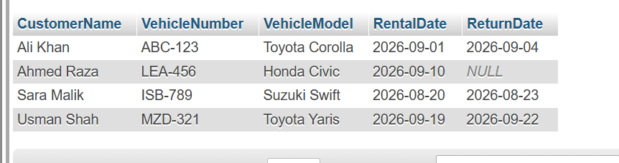

Query 2 – All Customers Including Customers With No Rentals

SELECT c.CustomerName, v.VehicleNumber, v.VehicleModel
FROM Customers c
LEFT JOIN Rentals r ON c.CustomerID = r.CustomerID
LEFT JOIN Vehicles v ON r.VehicleID = v.VehicleID
ORDER BY c.CustomerName;

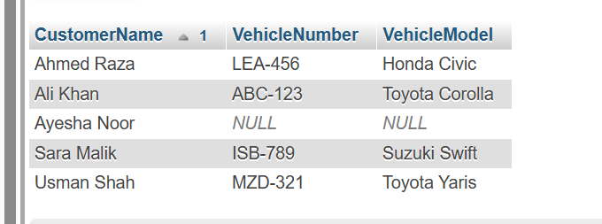

Query 3 – All Vehicles and Current Rental Information
SELECT v.VehicleNumber, v.VehicleModel, r.RentalID,
r.RentalDate, r.ReturnDate
FROM Vehicles v
LEFT JOIN Rentals r
ON v.VehicleID = r.VehicleID
AND r.ReturnDate IS NULL;
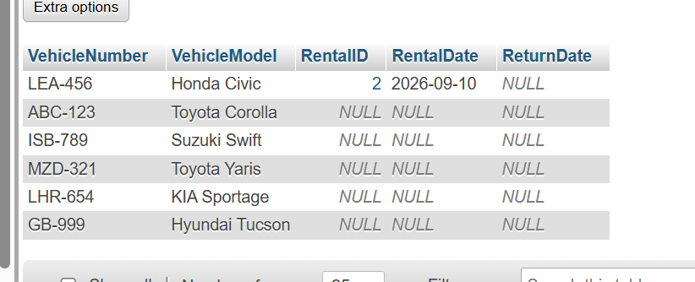

Query 4 – Total Rentals Per Customer
SELECT c.CustomerID, c.CustomerName,
COUNT(r.RentalID) AS TotalRentals
FROM Customers c
LEFT JOIN Rentals r ON c.CustomerID = r.CustomerID
GROUP BY c.CustomerID, c.CustomerName
ORDER BY c.CustomerID;

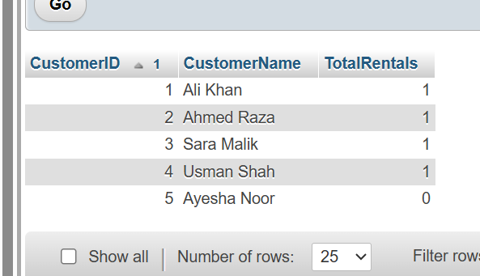

7. Task 4 – VIEW
RentalReport is a consolidated report containing customer, vehicle, rental and payment information. It simplifies reporting because management can use one view instead of repeatedly writing several JOINs.
CREATE VIEW RentalReport AS
SELECT r.RentalID, c.CustomerName, c.CustomerPhone,
v.VehicleNumber, v.VehicleModel, v.VehicleType,
r.RentalDate, r.ReturnDate, r.RentalDays, r.TotalCharge,
p.PaymentAmount, p.PaymentDate, p.PaymentMethod, p.PaymentStatus
FROM Rentals r
INNER JOIN Customers c ON r.CustomerID = c.CustomerID
INNER JOIN Vehicles v ON r.VehicleID = v.VehicleID
LEFT JOIN Payments p ON r.RentalID = p.RentalID;

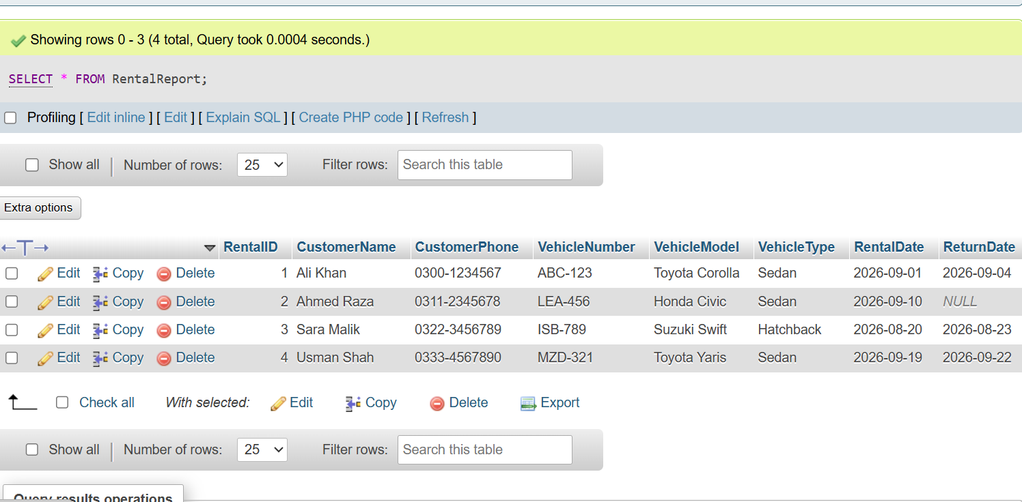

8. Task 5 – TRIGGER
The trigger prevents a vehicle from being rented again when it already has an active rental (ReturnDate is NULL).
A trigger named PreventVehicleDoubleRental was created to prevent a vehicle from being rented while it already has an active rental.
CREATE TRIGGER PreventVehicleDoubleRental
BEFORE INSERT ON Rentals
FOR EACH ROW
BEGIN
IF EXISTS (
SELECT 1 FROM Rentals
WHERE VehicleID = NEW.VehicleID
AND ReturnDate IS NULL
) THEN
SIGNAL SQLSTATE '45000'
SET MESSAGE_TEXT =
'This vehicle is currently rented and cannot be rented again.';
END IF;
END;
Test it with an INSERT for VehicleID 2, which already has an active rental. The database should reject the new rental.
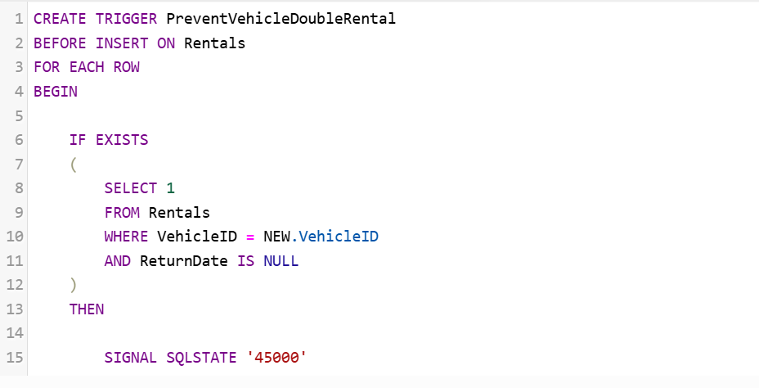

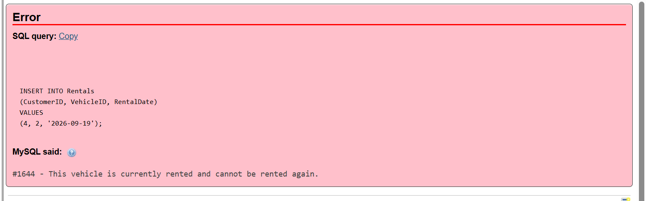

9. Task 6 – STORED PROCEDURE

RegisterRental accepts customer ID, vehicle ID, rental date and return date. It obtains the daily rate, calculates rental days and calculates the total charge before inserting the rental.
CALL RegisterRental
(4, 4, '2026-09-19', '2026-09-22');
For VehicleID 4, the daily rate is Rs. 5,500. The three-day rental charge is Rs. 16,500.
A stored procedure named RegisterRental was created to register a new rental and automatically calculate the rental charge using the rental period and vehicle's daily rate.
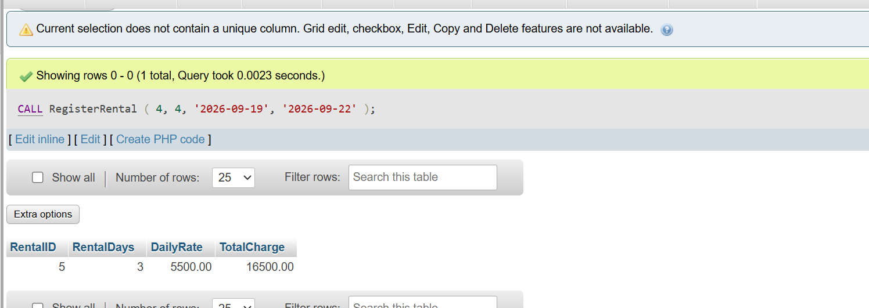

10. Task 7 – Optimization Analysis

A potential inefficiency occurs when the system frequently searches for active rentals as the rental history grows. An index on VehicleID and ReturnDate can help the database locate current rental records faster.
CREATE INDEX idx_rentals_vehicle_return
ON Rentals(VehicleID, ReturnDate);
An index named idx_rentals_vehicle_return was created on VehicleID and ReturnDate to improve the performance of queries that search for vehicle rental information.
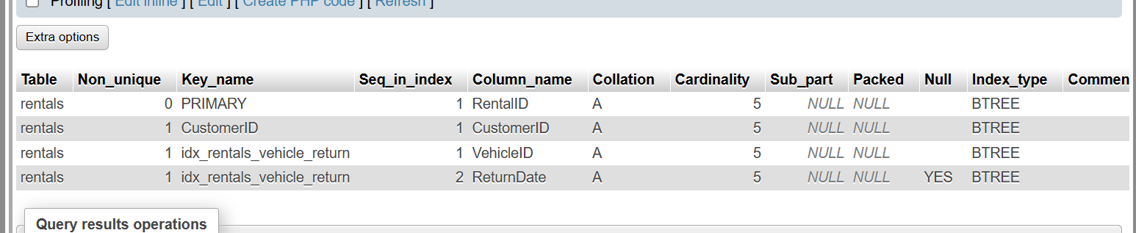

12. Conclusion

The CarGo Rentals database provides a structured relational solution for managing customers, vehicles, rentals, payments and maintenance. Normalization reduces redundancy, constraints improve data integrity, JOINs support business reports, the VIEW simplifies consolidated reporting, the TRIGGER prevents double rental, the STORED PROCEDURE automates rental-charge calculation, and the index provides an optimization.

