

Student Name | Afzal Ali Ahmed Shah
Roll no | 2024-SE-04
Semester | 4th
Instructor Name | Engr. Asma
Subject | Database System
Course Code | CS-1101
Credit Hours | 2+1
Lab | 01
Date | 11-Mar-2026
Department of Software Engineering

Computer Networks Lab Manual

Lab No: 01
Title: Installation of Cisco Packet Tracer

Objective
To install Cisco Packet Tracer software and understand the basic steps of installing a networking simulation tool.

Apparatus / Software Required
- Computer or Laptop
- Internet Connection
- Cisco Packet Tracer Setup File

Procedure (Installation Steps)
- Download Cisco Packet Tracer from the official Cisco website or obtain it from the instructor.
- Open the downloaded setup (.exe) file.
- The installation wizard will appear on the screen.
- Click Next to continue.
- Accept the License Agreement.
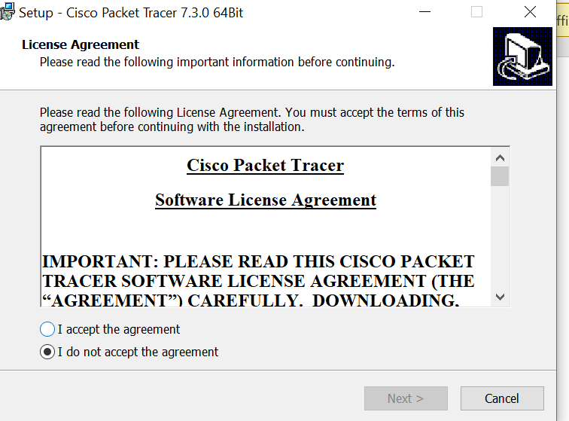
- Select the installation location on your computer.
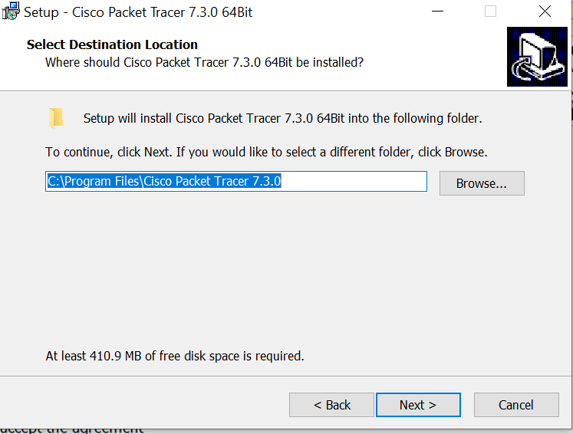
- Click Install to start the installation.
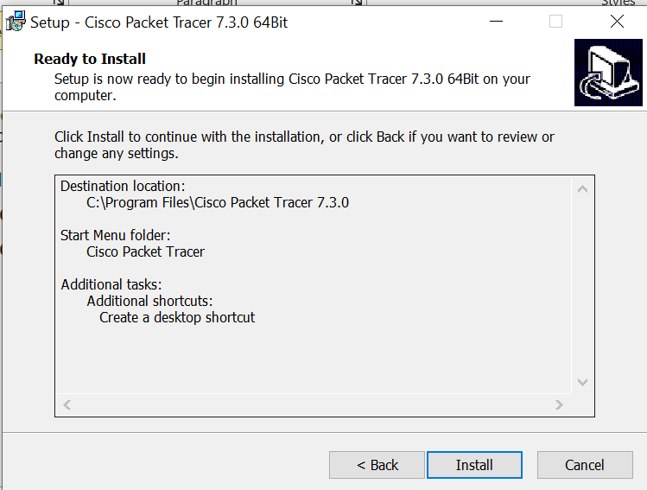

- Wait until the installation process is completed.
- Click Finish to close the installer.
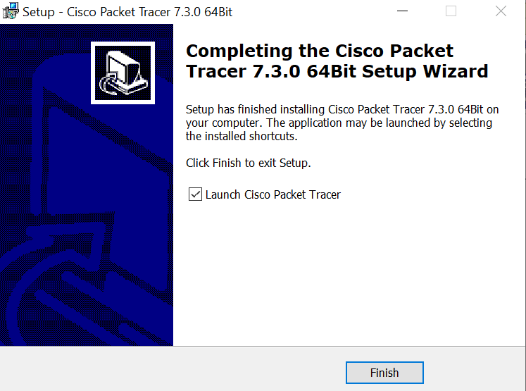
- Open Cisco Packet Tracer from the desktop icon.

Result
Cisco Packet Tracer software was successfully installed on the system.

