

Student Name | Afzal Ali Ahmed Shah
Roll no | 2024-SE-04
Semester | 4th
Instructor Name | Engr. Asma
Subject | Database System
Course Code | CS-1101
Credit Hours | 2+1
Lab | 02
Date | 11-Mar-2026
Department of Software Engineering

Computer Networks Lab Manual

Lab No: 02
Title: Creating and Testing a Simple LAN in Cisco Packet Tracer

1. Objective
• To understand the Cisco Packet Tracer interface.
• To create a simple LAN topology using a switch and PCs.
• To configure IP addresses manually.
• To test connectivity using basic CLI networking commands.

2. Apparatus / Software Required
• Computer or Laptop
• Cisco Packet Tracer Software
• Basic knowledge of networking

3. Theory
A Local Area Network (LAN) connects computers within a limited geographical area such as a room, building, or campus. Devices communicate using IP addresses. In this lab, two PCs are connected through a switch and assigned IP addresses manually to test connectivity.
Network Address: 192.168.1.0
Subnet Mask: 255.255.255.0

4. Procedure

Screenshot 1 – Connecting PCs to Switch
Insert Screenshot Here
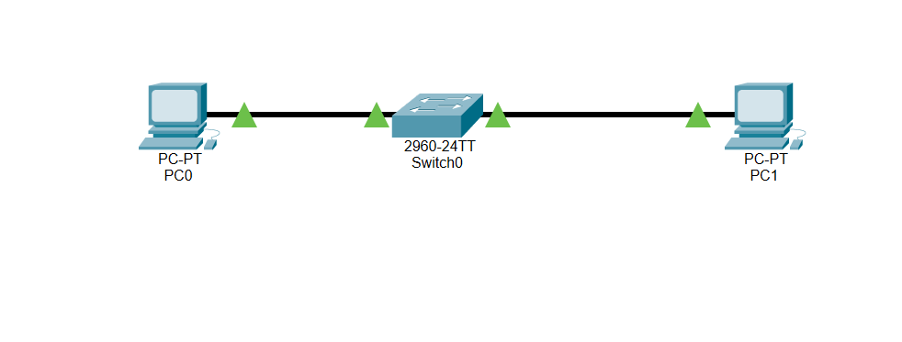

Screenshot 2 – PC0 IP Configuration (192.168.1.1)
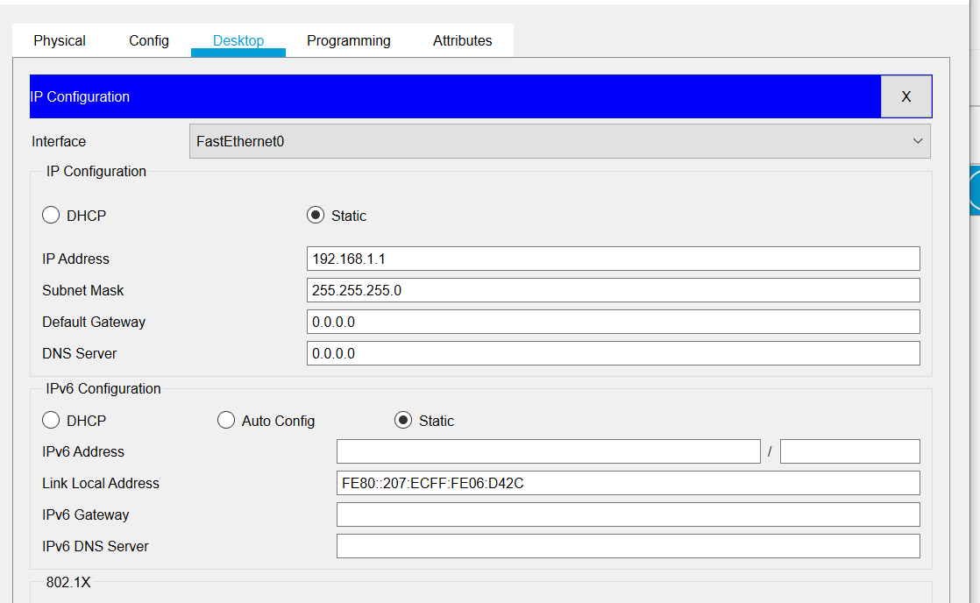

Screenshot 3 – PC1 IP Configuration (192.168.1.2)
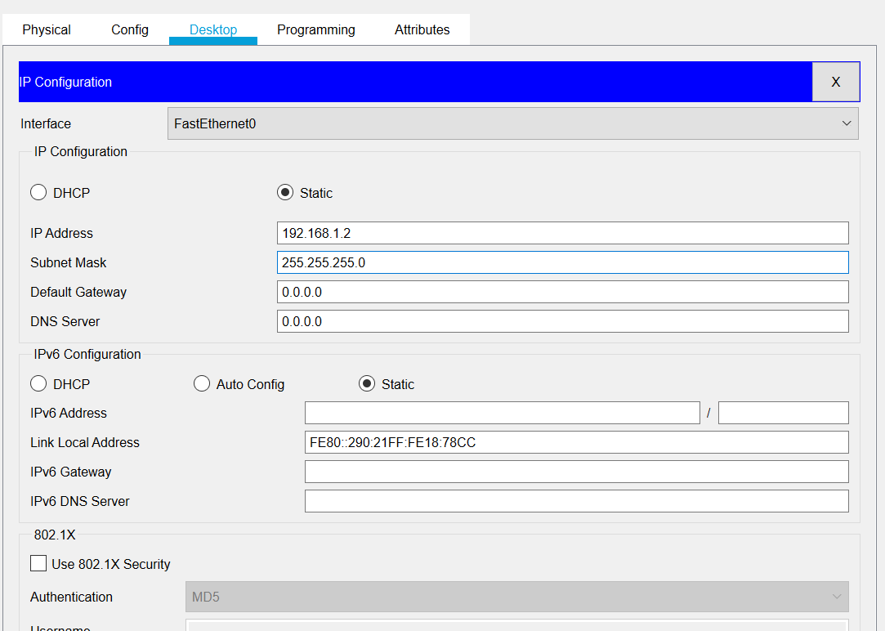

Screenshot 4 – ipconfig Command
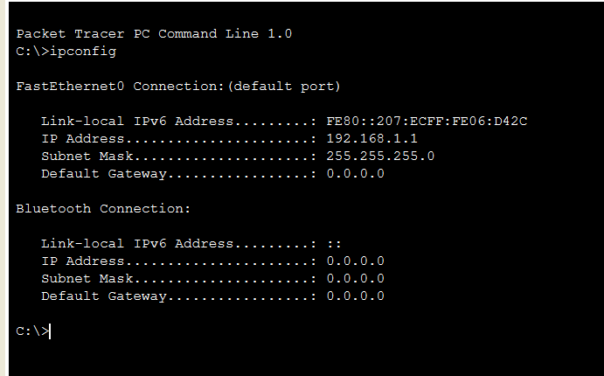
Explanation (2–4 lines):
In Packet Tracer, when the ipconfig command is executed in the Command Prompt of a PC, it displays information such as:
- IP Address – The unique address assigned to the device on the network.
- Subnet Mask – Defines the network and host portion of the IP address.
- Default Gateway – The router address used to send data to other networks.

Screenshot 5 – ping Command
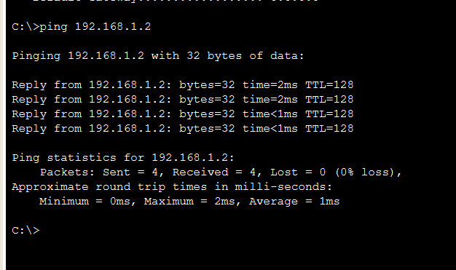
Explanation (2–4 lines):
The ping command helps to:
- Check if a device is connected to the network
- Test communication between two devices
- Identify network connectivity problems

Screenshot 6 – tracert Command
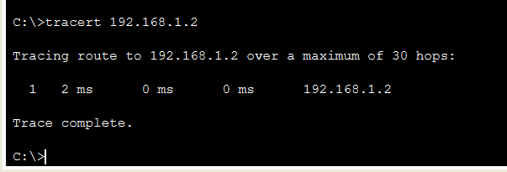
Explanation (2–4 lines):
The tracert command helps to:
- Identify the path taken by data packets in a network
- Detect where a network delay or failure occurs
- Troubleshoot routing and connectivity problems

Screenshot 7 – arp -a Command
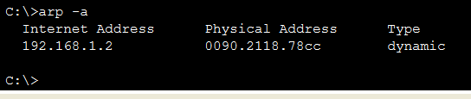
Explanation (2–4 lines):
The arp -a command helps to:
- View the MAC addresses of devices in the local network
- Understand how IP addresses are mapped to physical addresses
- Troubleshoot network communication problems between devices

Screenshot 8 – netstat Command
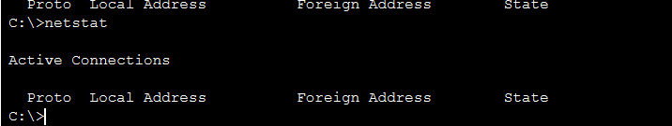
Explanation (2–4 lines):
The netstat command helps to:
- View active network connections
- Monitor network activity
- Troubleshoot network and connection problems

5. Result
The simple LAN network was successfully created in Cisco Packet Tracer. IP addresses were configured and connectivity between PCs was tested using networking commands.

6. Conclusion
This lab helped in understanding the Packet Tracer interface, creating a basic network topology, assigning IP addresses, and testing communication between devices.

