


The University of Azad Jammu and Kashmir
Department of Software Engineering

Student Name | Afzal Ali Ahmed Shah
Roll no | 2024-SE-04
Semester | 5th
Instructor Name | Engr. Fahad Nisar
Subject | Digital Image processing
Course Code | CS-3112
Credit Hours | 2+1
Lab | 02
Date | 27-Oct-2026
Software Engineering

1. Objective
To load, inspect, convert, transform and analyze a digital image using NumPy, OpenCV and Matplotlib, and to demonstrate histograms and bit depth.

2. Environment Setup & Verification
Explanation / Analysis
A dedicated Python virtual environment (.venv) was successfully initialized using python -m venv .venv to ensure isolated package management. The required core libraries—numpy, opencv-python, and matplotlib—were installed inside the environment. Successful installation and module availability were verified by executing an inline import verification script (python -c "import cv2, numpy, matplotlib; print('OK')"), which confirmed all dependencies are correctly configured.
A .gitignore file containing .venv/ was created so the virtual environment is not submitted.

Code Snippet:
# Activate the virtual environment
# Windows:
.venv\Scripts\activate
# Verify installed packages
python -m pip check

Output / Screenshot:
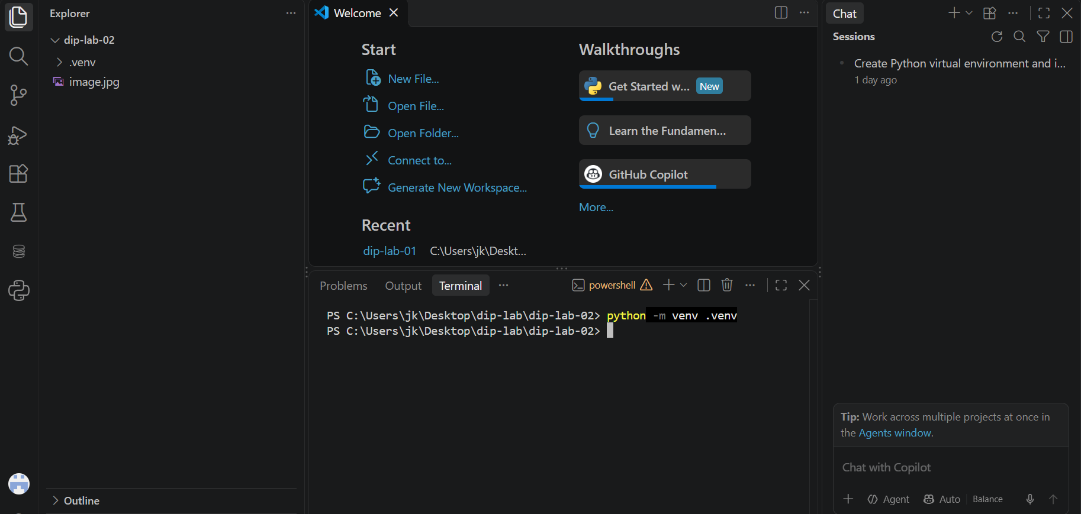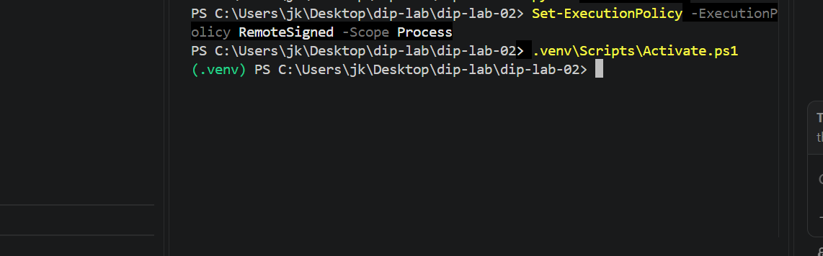
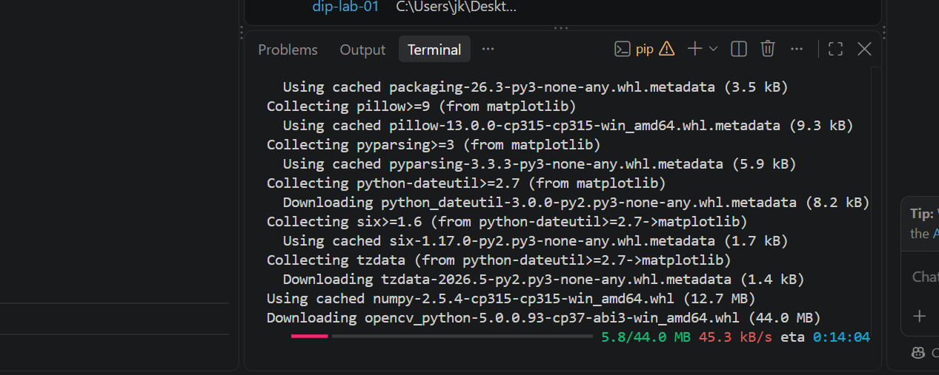

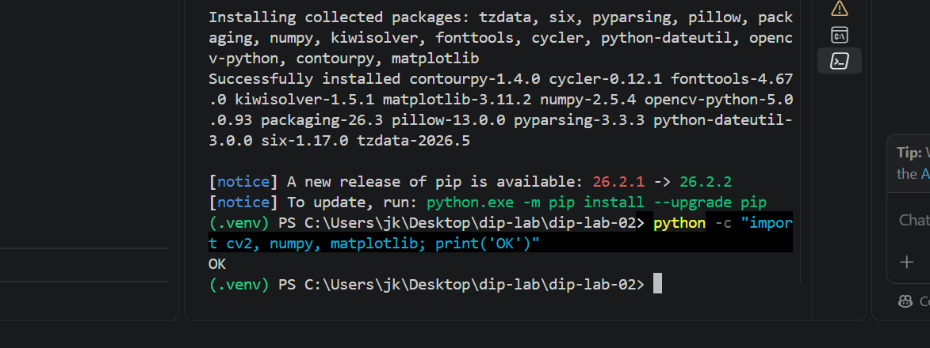
Figure 1: Import Verification
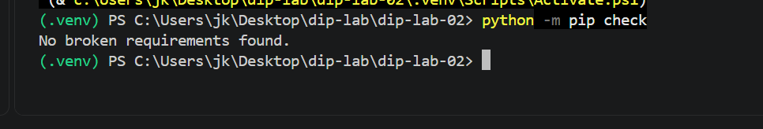
Environment Setup Screenshot

3. Step 2: Image Loading and Properties
Explanation / Analysis
The target image was loaded into memory using OpenCV's cv.imread() function. Inspecting .shape revealed dimensions of (678, 452, 3), which corresponds to a vertical spatial height of 678 pixels, a width of 452 pixels, and 3 color channels. The .dtype property returned uint8, confirming an unsigned 8-bit integer representation per pixel channel with intensity values ranging from 0 to 255.
Code Snippet:
import cv2 as cv
import numpy as np
import matplotlib.pyplot as plt

# Step 2: Load the Image and Print Properties
image_path = 'image.jpg'
image = cv.imread(image_path)

if image is None:
raise FileNotFoundError(f"Image not found at {image_path}")

print("--- Step 2: Image Properties ---")
print("Image Shape:", image.shape)
print("Image Data Type:", image.dtype)

Output / Screenshot: Terminal screenshot showing the `Image Shape` and `Image Data Type` output.
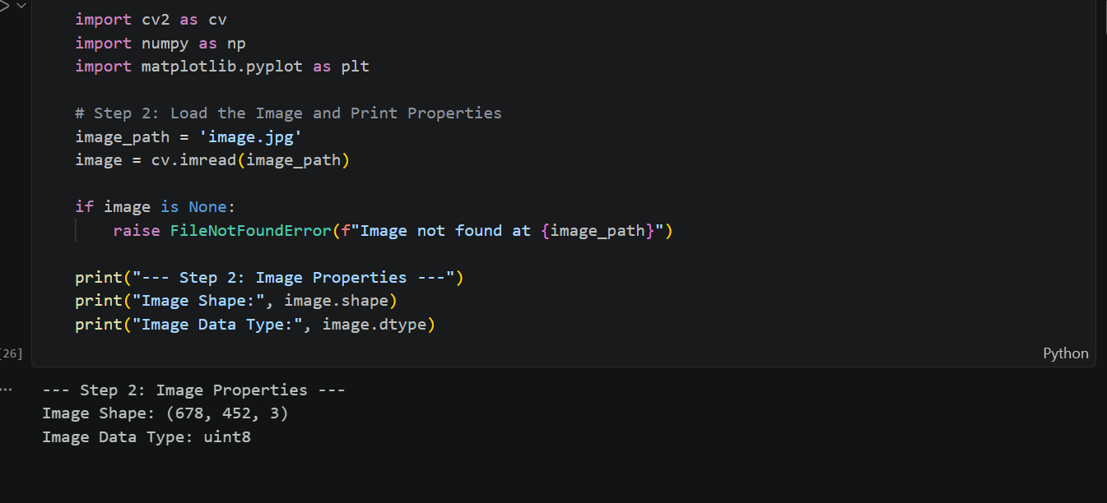
Image Loading Output Screenshot

4. Step 3: Image Inspection
Explanation / Analysis
Pixel values were accessed via standard 2D matrix indexing image[row, col] using NumPy. The top-left corner pixel [0, 0] recorded a BGR tuple of [11, 79, 92], while the center pixel [339, 226] returned [46, 57, 61]. Global minimum (0) and maximum (255) statistics confirmed full utilization of the 8-bit dynamic range across the Blue, Green, and Red channels.
Code Snippet: Step 3 Python code block.
# Step 3: Inspect the Image
height, width, channels = image.shape
print("\n--- Step 3: Image Inspection ---")
print(f"Height: {height}, Width: {width}, Channels: {channels}")

# Top-left and center pixels using [row, column] indexing
top_left_pixel = image[0, 0]
center_row = height // 2
center_col = width // 2
center_pixel = image[center_row, center_col]

print(f"Top-Left Pixel [0, 0] (BGR): {top_left_pixel}")
print(f"Center Pixel [{center_row}, {center_col}] (BGR): {center_pixel}")

# Global and per-channel min/max values
print(f"Global Minimum: {np.min(image)}, Global Maximum: {np.max(image)}")
print(f"Blue Channel - Min: {np.min(image[:, :, 0])}, Max: {np.max(image[:, :, 0])}")
print(f"Green Channel - Min: {np.min(image[:, :, 1])}, Max: {np.max(image[:, :, 1])}")
print(f"Red Channel - Min: {np.min(image[:, :, 2])}, Max: {np.max(image[:, :, 2])}")

Output / Screenshot: Terminal screenshot showing the height, width, channels, top-left/center pixels, and global/per-channel min/max values.
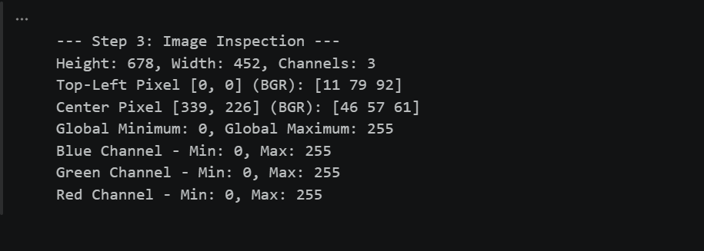
Image Inspection Output Screenshot

5. Step 4: Color Conversion and Channel Analysis
Explanation / Analysis
BGR vs. RGB Explanation: OpenCV natively imports and processes color images in BGR order, whereas Matplotlib expects channels in RGB order. Displaying an unconverted BGR image directly in Matplotlib causes channel mismatch, swapping red and blue channels and rendering unnatural blue/yellow tinting.
The BGR image was converted to RGB via cv.cvtColor(image, cv.COLOR_BGR2RGB) for faithful display, transformed to single-channel Grayscale using COLOR_BGR2GRAY, and separated into individual R, G, and B single-channel matrices using cv.split(). Converting the center pixel's RGB tuple (61, 57, 46) into hexadecimal yielded #3d392e.
Code Snippet: Step 4 Python code block.
# Step 4: Convert Colors, Separate Channels, and HEX Conversion
# Convert BGR to RGB
image_rgb = cv.cvtColor(image, cv.COLOR_BGR2RGB)

# Convert to Grayscale
gray_image = cv.cvtColor(image, cv.COLOR_BGR2GRAY)

# Separate individual channels from the BGR image
b, g, r = cv.split(image)

# Convert center pixel from BGR to RGB, then to HEX
center_bgr = image[center_row, center_col]
# BGR to RGB for center pixel: element-wise reverse
center_rgb_val = (center_bgr[2], center_bgr[1], center_bgr[0])
center_hex = "#{:02x}{:02x}{:02x}".format(center_rgb_val[0], center_rgb_val[1], center_rgb_val[2])
print(f"\n--- Step 4: Center Pixel HEX Value ---")
print(f"Center Pixel RGB: {center_rgb_val}")
print(f"Center Pixel HEX: {center_hex}")

# Create a 2 x 3 figure
plt.figure(figsize=(12, 8))

# 1. RGB Display
plt.subplot(2, 3, 1)
plt.imshow(image_rgb)
plt.title("RGB Display")
plt.axis('off')

# 2. Red Channel
plt.subplot(2, 3, 2)
plt.imshow(r, cmap='gray')
plt.title("Red Channel")
plt.axis('off')

# 3. Green Channel
plt.subplot(2, 3, 3)
plt.imshow(g, cmap='gray')
plt.title("Green Channel")
plt.axis('off')

# 4. Blue Channel
plt.subplot(2, 3, 4)
plt.imshow(b, cmap='gray')
plt.title("Blue Channel")
plt.axis('off')

# 5. Grayscale Image
plt.subplot(2, 3, 5)
plt.imshow(gray_image, cmap='gray')
plt.title("Grayscale Image")
plt.axis('off')

# 6. Unconverted BGR Display (using matplotlib directly without conversion)
plt.subplot(2, 3, 6)
plt.imshow(image)
plt.title("Unconverted BGR Display")
plt.axis('off')

plt.tight_layout()
plt.show()

Output / Screenshots:
1. Terminal screenshot showing the Center Pixel RGB and HEX value.
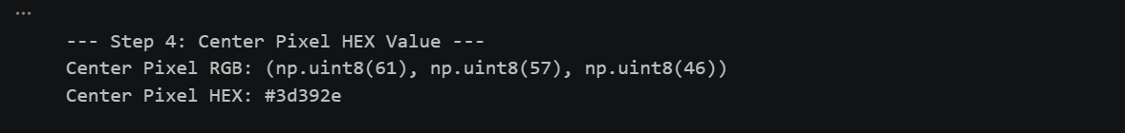
Center Pixel RGB and HEX Screenshot
2. 2 × 3 Matplotlib figure screenshot (the peacock grid showing RGB, R, G, B, Grayscale, and unconverted BGR).
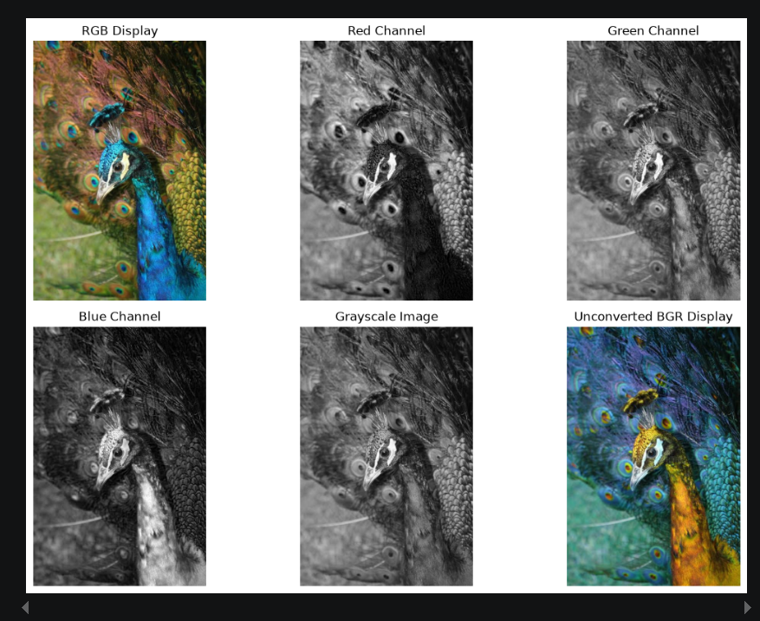
2 × 3 Color Channel Analysis Figure

6. Step 5: Crop, Resize, and Save
Explanation / Analysis
A 100 x 100 region of interest (ROI) centered around pixel [339, 226] was extracted using NumPy matrix slicing image[289:389, 176:276]. Using cv.resize(), the crop was enlarged to 200 x 200 pixels. To save the output accurately, resized_rgb was converted back to BGR (cv.COLOR_RGB2BGR) before passing it to cv.imwrite('resized_crop.png', resized_bgr), ensuring proper channel alignment in the saved PNG file.
Code Snippet: Step 5 Python code block.
# ==========================================
# Step 5: Crop, Resize, Display, and Save
# ==========================================

# Crop an exact 100 x 100 region using the center of the image
y_start = center_row - 50
y_end = center_row + 50
x_start = center_col - 50
x_end = center_col + 50

cropped_image = image[y_start:y_end, x_start:x_end]
print(f"\n--- Step 5: Crop and Resize ---")
print("Crop Shape:", cropped_image.shape)

# Resize the cropped image and convert to RGB for the display and saving workflow
resized_rgb = cv.resize(
cv.cvtColor(cropped_image, cv.COLOR_BGR2RGB), (200, 200)
)
print("Resized Crop Shape:", resized_rgb.shape)

# Display original image, crop, and resized image side by side using Matplotlib
plt.figure(figsize=(12, 4))

plt.subplot(1, 3, 1)
plt.imshow(cv.cvtColor(image, cv.COLOR_BGR2RGB))
plt.title("Original Image")
plt.axis("off")

plt.subplot(1, 3, 2)
plt.imshow(cv.cvtColor(cropped_image, cv.COLOR_BGR2RGB))
plt.title("100x100 Crop")
plt.axis("off")

plt.subplot(1, 3, 3)
plt.imshow(resized_rgb) # Display resized_rgb directly (no extra cvtColor)
plt.title("200x200 Resized Crop")
plt.axis("off")

plt.tight_layout()
plt.show()

# Convert the resized RGB image back to BGR and save it as resized_crop.png
resized_bgr = cv.cvtColor(resized_rgb, cv.COLOR_RGB2BGR)
success = cv.imwrite("resized_crop.png", resized_bgr)
print("resized_crop.png saved successfully:", success)

Output / Screenshot: Side-by-side Matplotlib figure screenshot showing the Original, Crop, and Resized Crop.
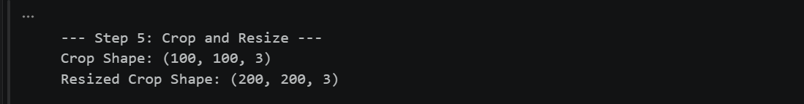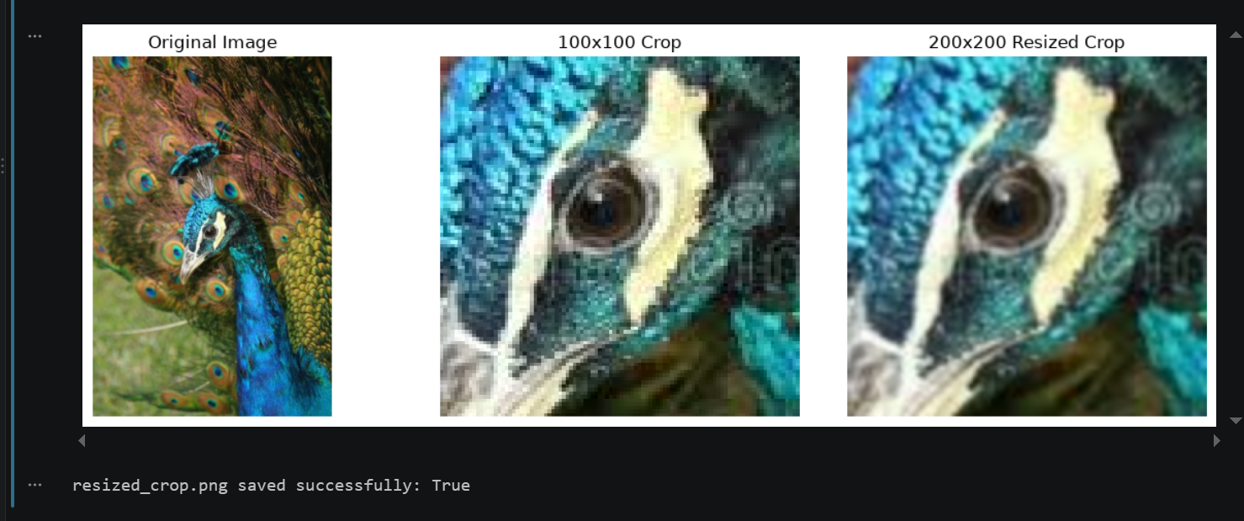
Original, Crop, and Resized Crop Figure

7. Step 6: Create a Histogram
Explanation / Analysis
Histogram Analysis & Interpretation:
The grayscale histogram peaks around intensity 100, and most pixels fall between about 10 and 180. Only a very small number of pixels appear near 250. This shows the image is mainly mid-to-dark and not bright. It is reasonably balanced in contrast, but shifted toward the darker side.

Code Snippet: Step 6 Python code block.
# Step 6: Create a Histogram
# Flatten the grayscale image and plot a 256-bin histogram
plt.figure(figsize=(8, 5))
plt.hist(gray_image.ravel(), bins=256, range=[0, 256], color='black')
plt.title("Grayscale Histogram of Image")
plt.xlabel("Pixel Intensity (0-255)")
plt.ylabel("Frequency (Pixel Count)")
plt.grid(True, linestyle='--', alpha=0.5)

# Save the plot as grayscale_histogram.png
plt.savefig('grayscale_histogram.png', dpi=300, bbox_inches='tight')
plt.show()

print("\n--- Step 6: Histogram Completed ---")
print("Histogram saved as 'grayscale_histogram.png'")

Output / Screenshot: Saved histogram plot (`grayscale_histogram.png`) or its screenshot.
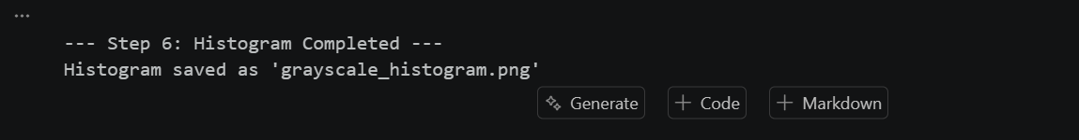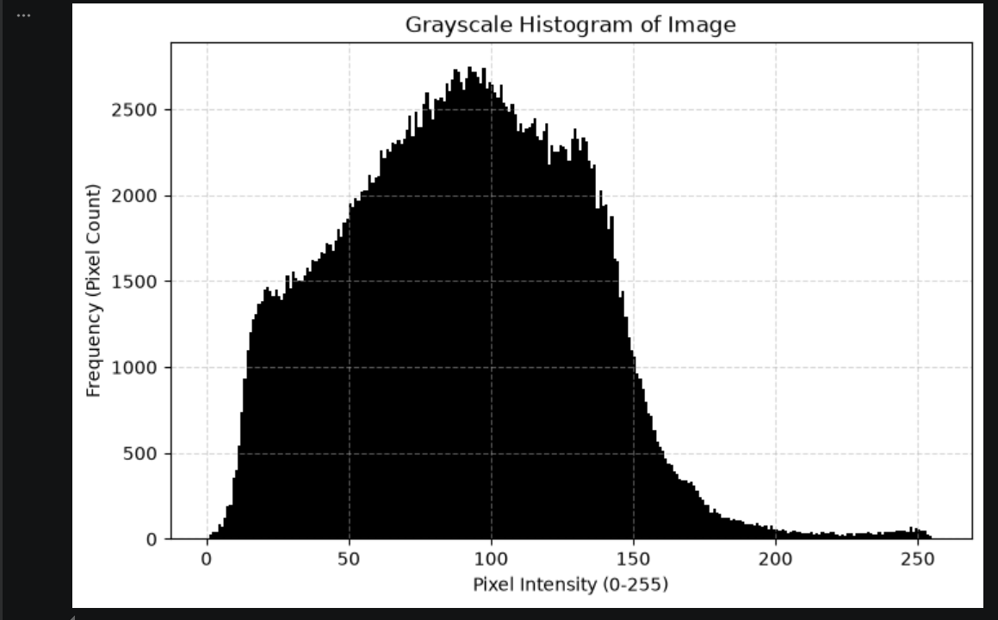
Grayscale Histogram

8. Step 7: Demonstrate Bit Depth
Quantization & Resolution Explanation: Quantization reduces the number of allowable gray levels represented by an image without altering its grid resolution. An 8-bit gradient provides 2^8 = 256 continuous gray levels. Downsampling to 4-bit (2^4 = 16), 2-bit (2^2 = 4), and 1-bit (2^1 = 2) results in false contouring and step banding.
Spatial Resolution vs. Bit Depth: Spatial resolution refers to the physical grid size and pixel density (N x M matrix dimensions). Bit depth determines the amplitude or intensity resolution per pixel (k bits, yielding 2^k available intensity levels).
Code Snippet: Step 7 Python code block.
import matplotlib.pyplot as plt
import numpy as np

# Create an 8-bit horizontal grayscale gradient from 0 to 255 (width=256, height=50)
gradient_8bit = np.tile(np.linspace(0, 255, 256, dtype=np.uint8), (50, 1))

# Corrected quantization function
def quantize_image(img, bits):
levels = 2**bits
step = 256 // levels
# Scale down to discrete levels, then stretch back to span the full 0-255 range
quantized = (img // step) * (255 // (levels - 1))
return quantized.astype(np.uint8)

gradient_4bit = quantize_image(gradient_8bit, 4)
gradient_2bit = quantize_image(gradient_8bit, 2)
gradient_1bit = quantize_image(gradient_8bit, 1)

# Print unique value counts
print("\n--- Step 7: Bit Depth Unique Values ---")
print("8-bit unique values:", len(np.unique(gradient_8bit)))
print("4-bit unique values:", len(np.unique(gradient_4bit)))
print("2-bit unique values:", len(np.unique(gradient_2bit)))
print("1-bit unique values:", len(np.unique(gradient_1bit)))

# Display original and quantized gradients in one figure
plt.figure(figsize=(10, 6))

plt.subplot(4, 1, 1)
plt.imshow(gradient_8bit, cmap='gray', vmin=0, vmax=255)
plt.title(f"8-bit Gradient (Unique values: {len(np.unique(gradient_8bit))})")
plt.axis('off')

plt.subplot(4, 1, 2)
plt.imshow(gradient_4bit, cmap='gray', vmin=0, vmax=255)
plt.title(f"4-bit Gradient (Unique values: {len(np.unique(gradient_4bit))})")
plt.axis('off')

plt.subplot(4, 1, 3)
plt.imshow(gradient_2bit, cmap='gray', vmin=0, vmax=255)
plt.title(f"2-bit Gradient (Unique values: {len(np.unique(gradient_2bit))})")
plt.axis('off')

plt.subplot(4, 1, 4)
plt.imshow(gradient_1bit, cmap='gray', vmin=0, vmax=255)
plt.title(f"1-bit Gradient (Unique values: {len(np.unique(gradient_1bit))})")
plt.axis('off')

plt.tight_layout()
plt.show()

Output / Screenshots:
1. Terminal screenshot showing the unique value counts (`256, 16, 4, 2`).
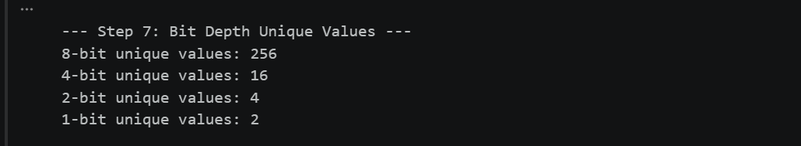
Unique Gray-Level Counts Screenshot
2. 4-tier gradient visualization screenshot.
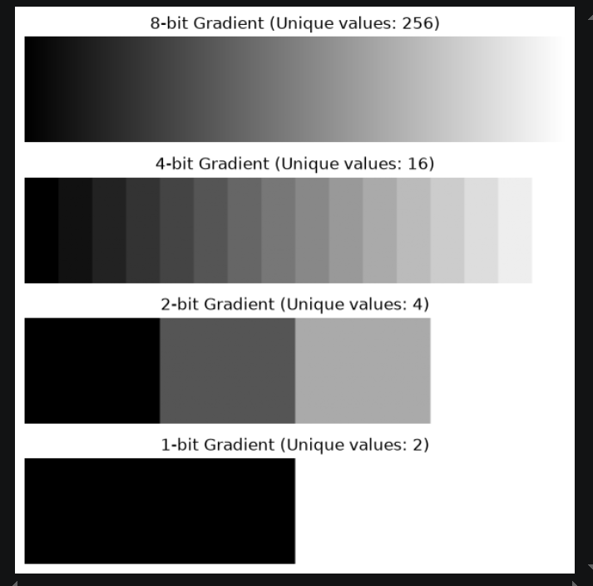
4-Tier Gradient Visualization

9. Step 8: Final Run
The complete notebook lab02.ipynb was executed from top to bottom inside the activated .venv using Run All, with no errors. All outputs above come from this run, and resized_crop.png and grayscale_histogram.png were saved successfully.
