

DEPARTMENT OF SOFTWARE ENGINEERING
Student Name | Afzal Ali Ahmed Shah
Roll no | 2024-SE-04
Semester | 5th
Instructor Name | Engr. Fahad Nisar
Subject | Digital Image processing
Course Code | CS-3112
Credit Hours | 2+1
Lab | 01
Date | 22-Oct-2026
Software Engineering

DIGITAL IMAGE PROCESSING
LAB REPORT
Lab 01 — Python Environment Setup and Basics

1. Objective
The objective of this lab was to set up a Python programming environment in Visual Studio Code, run a basic Python program, practise fundamental Python concepts, and install and import libraries used for digital image processing.

2. Software and Tools
- Microsoft Windows
- Python (installed on the computer)
- Visual Studio Code with the Python extension
- PowerShell / integrated VS Code terminal
- Python libraries: NumPy, Pillow, and Matplotlib

3. Procedure and Tasks Performed

3.1 Create the lab folder and Python files
A folder named dip-lab-01 was created on the Desktop and opened in Visual Studio Code. Python files were created inside the folder to keep the lab exercises together.
Files used: hello.py, basics.py, and lab01_imports.py.

3.2 Run the first Python program
The following code was entered in hello.py and executed from the terminal:
# My first Python program
print('Hello, Digital Image Processing!')
Expected output:
Hello, Digital Image Processing!

3.3 Python basics exercises
The following six exercises were added to basics.py and run successfully. The terminal output was checked after execution.
- Exercise 1 — Variables and data types
Created variables for image width, height, filename, and a Boolean colour flag; displayed their values and types; calculated total pixels (640 × 480 = 307200).
- Exercise 2 — if, elif, and else
Classified pixel intensities as invalid when outside 0–255, dark below 128, and bright at or above 128. Test values included -1, 0, 127, 128, 255, and 256.
- Exercise 3 — for and while loops
Used a for loop to classify sample pixel values and a while loop to print the counter values 0, 1, and 2.
- Exercise 4 — Functions
Defined is_bright(pixel, threshold=128) and tested values 127, 128, and 200 with a threshold of 210. The results were False, True, and False.
- Exercise 5 — Lists and tuples
Accessed a list item, changed a list value, appended another value, calculated list length, and unpacked a tuple containing image dimensions.
- Exercise 6 — Dictionaries and sets
Stored image width and height in a dictionary, added the RGB mode, and used a set to remove duplicate labels from a list. Three unique labels remained.

3.4 Install the required libraries
The following command was used in the VS Code terminal to install the libraries:
python -m pip install numpy pillow matplotlib
The packages were then checked using pip and an import/version test. Record the actual package versions from the terminal if your instructor requires them.

3.5 Verify library imports
The lab instruction for lab01_imports.py specifies import statements only, without printed output. The file was saved and run from the project folder. Returning to the command prompt without an error indicates that the imports completed successfully.
import numpy as np
from PIL import Image
import matplotlib.pyplot as plt

3.6 Brief explanation: Python, pip, and imports
Python is the programming language used to write and run the lab programs, while pip is the package installer used to install third-party libraries such as NumPy, Pillow, and Matplotlib. Import statements make library functionality available to a Python program; for example, NumPy provides arrays, Pillow provides image handling, and Matplotlib provides plotting tools.

4. Results
The Python environment was configured in Visual Studio Code. The hello.py program ran successfully, the six Python basics exercises produced the expected outputs, and the required image-processing libraries were installed and imported without an error.

5. Screenshot Evidence Checklist
Insert your actual screenshots in the spaces below before submitting the report. Use readable screenshots that show the relevant code and terminal output. Do not leave placeholders in the final submitted copy.
Figure 1. Running hello.py
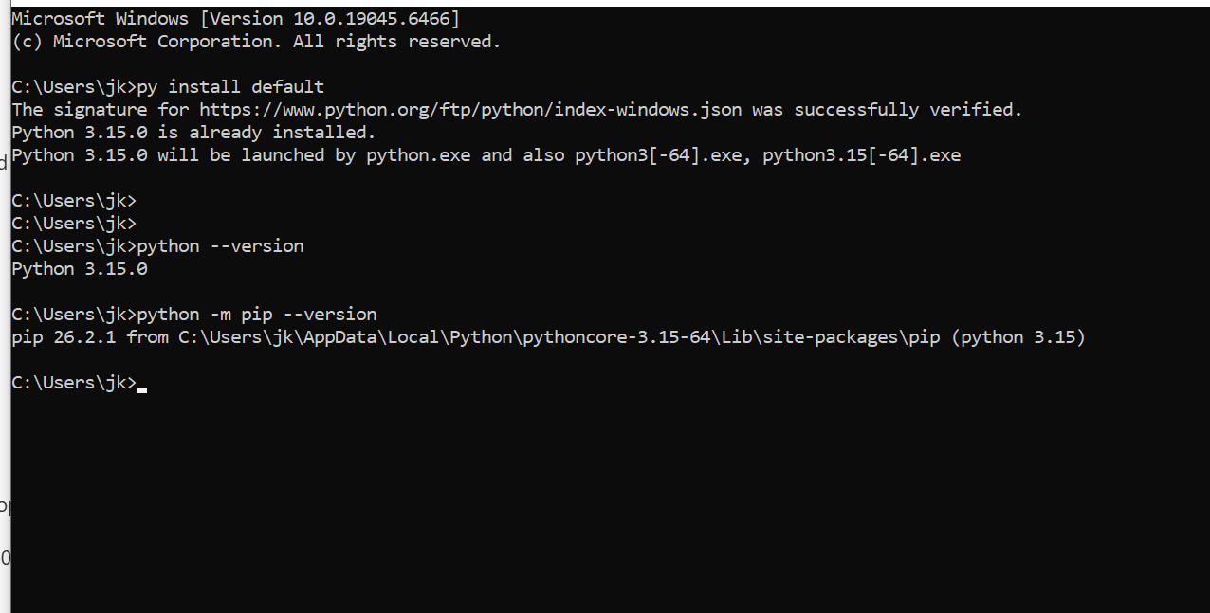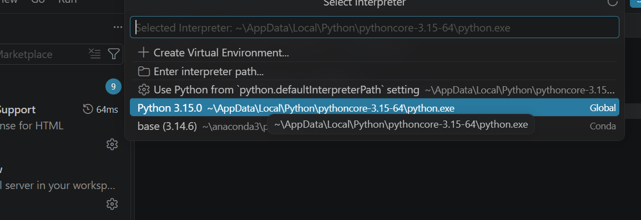
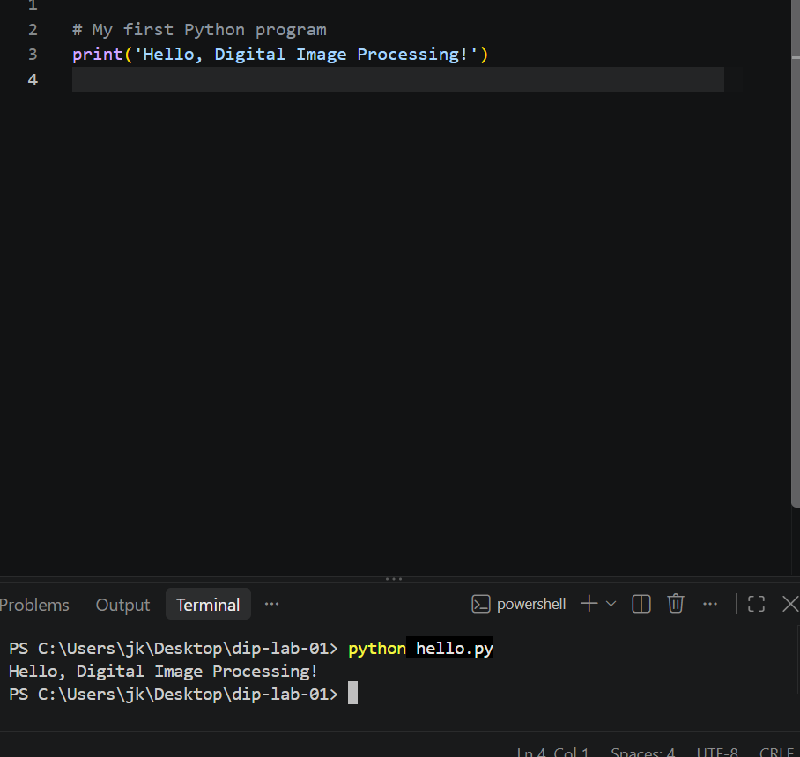
Figure 2. Exercise 1 — Variables and data types
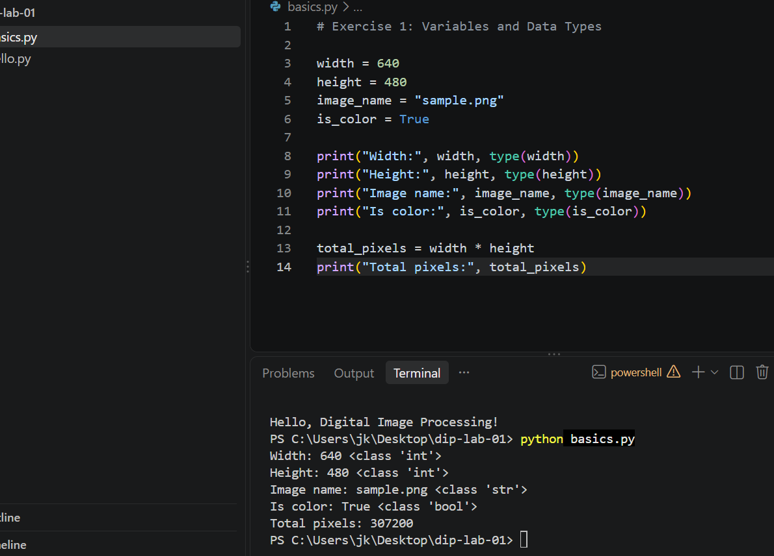
Figure 3. Exercise 2 — Conditions
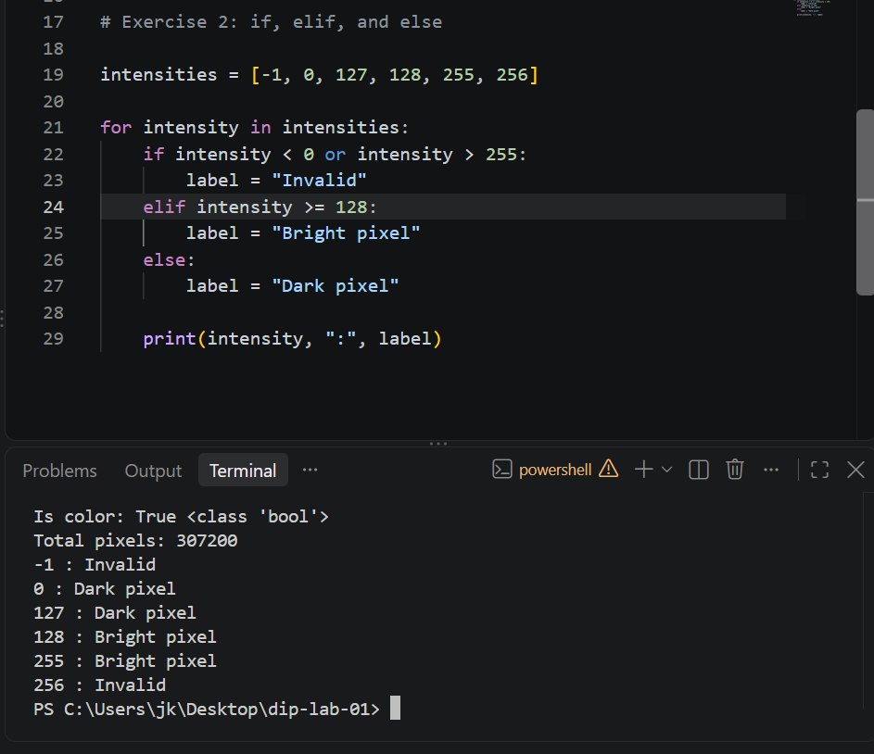
Figure 4. Exercise 3 — Loops
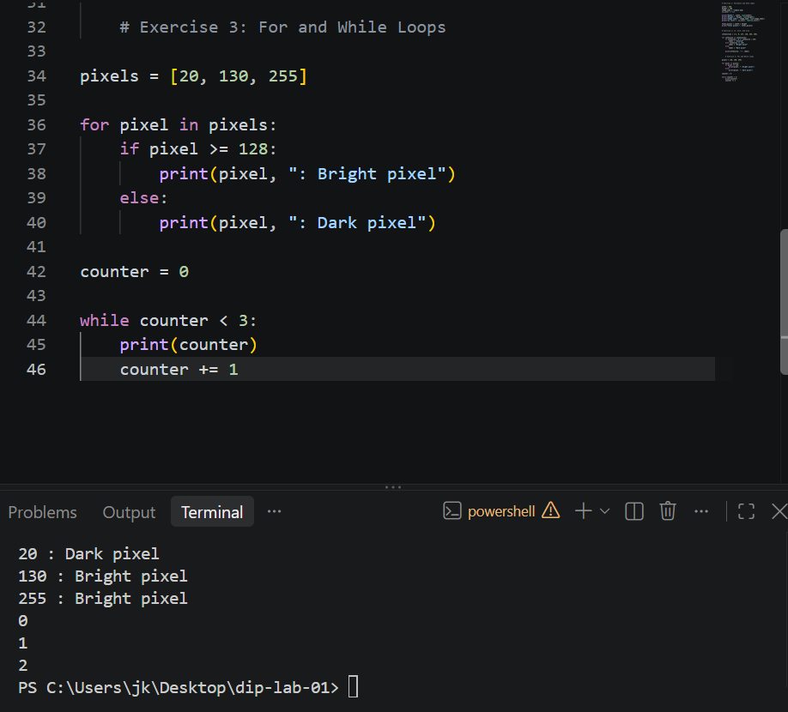
Figure 5. Exercise 4 — Functions
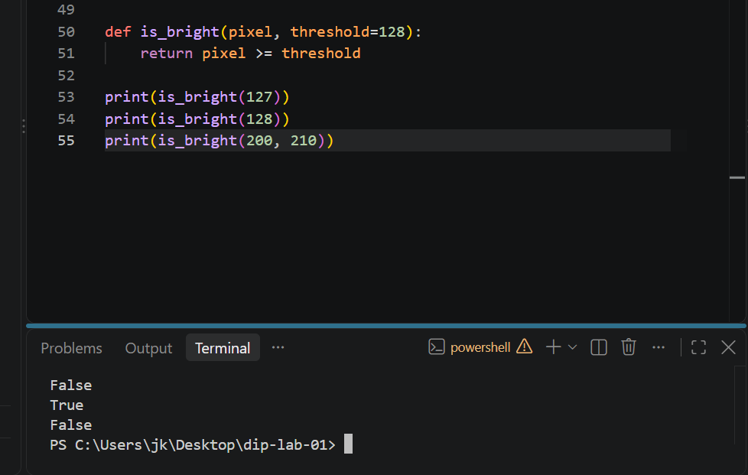
Figure 6. Exercise 5 — Lists and tuples
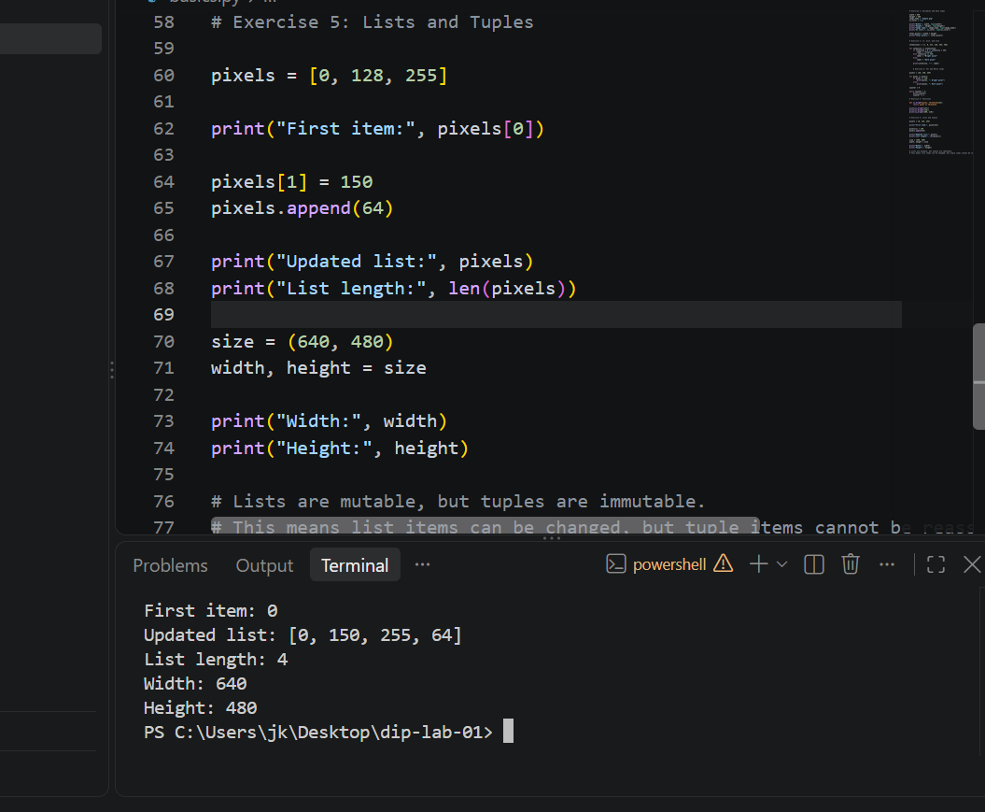
Figure 7. Exercise 6 — Dictionaries and sets
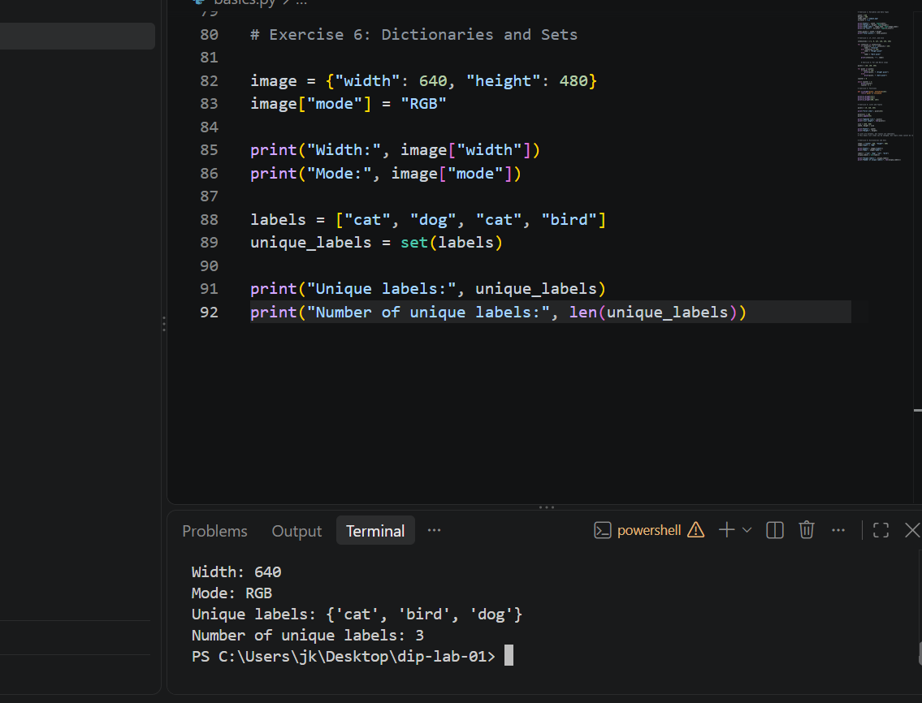
Figure 8. Installing/verifying NumPy, Pillow, Matplotlib
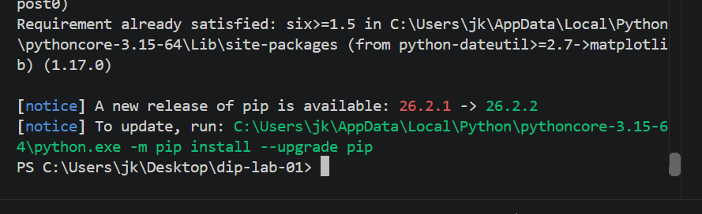
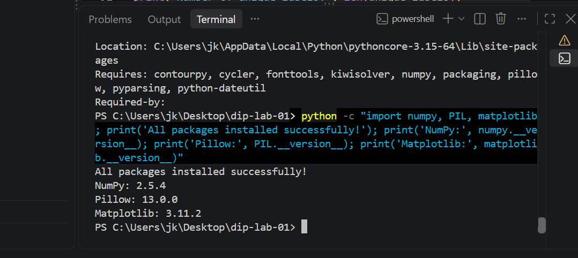
Figure 9. Running lab01_imports.py without errors
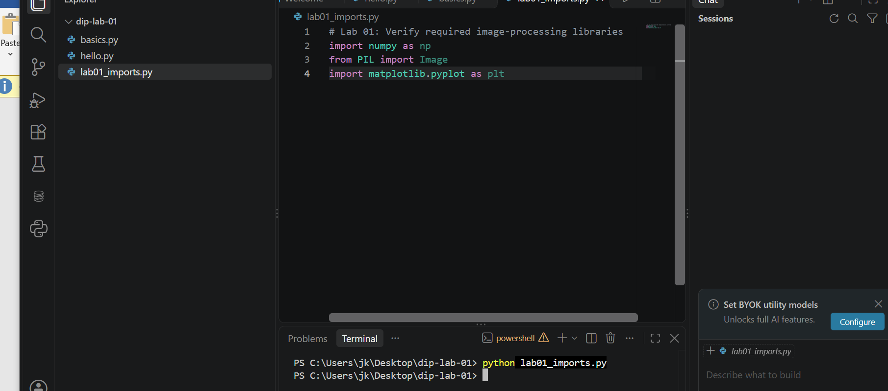

6. Conclusion
This lab provided practice in setting up a Python development environment, running Python scripts, using variables and data types, conditional statements, loops, functions, lists, tuples, dictionaries, and sets. The required NumPy, Pillow, and Matplotlib libraries were installed and their imports were tested. The environment is now ready for subsequent digital image processing tasks.

— End of Report —

